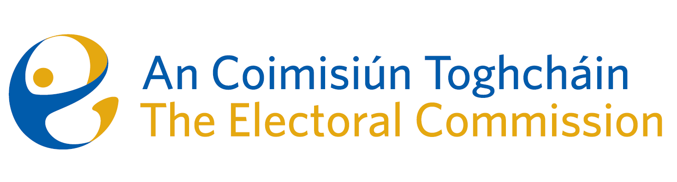
Draft Minutes - Incorporeal Meeting of An Coimisiún Toghcháin (ACT), The Electoral Commission.

Conducted via email from Friday 13th October to Monday 16th October

Note from Art O’Leary to the Commission: Justice Marie Baker (Chairperson), Maura Quinn, Alex Attwood, John Curran, Peter Finnegan, and Prof. Caroline Fennell.

An Coimisiún Executive: Tim Carey, Karen Kehily, Aoife O’Sullivan and Andrea Jones.

Conflict of Interest
One Commission member recused themselves from the matter due to the possibility of a perceived conflict of interest. This recusal was noted by the Chairperson and the Commission members.

Freedom of Information Request No. 2023-005
Commission members gave consideration to Freedom of Information request no. 2023-005 and came to a consensus that the records concerned fall within section 29 (1) of the Freedom of Information Act 2014, deliberations of FOI bodies.

For this reason, the decision of the Commission that the records should not be released is noted and agreed.

------------------------------------

