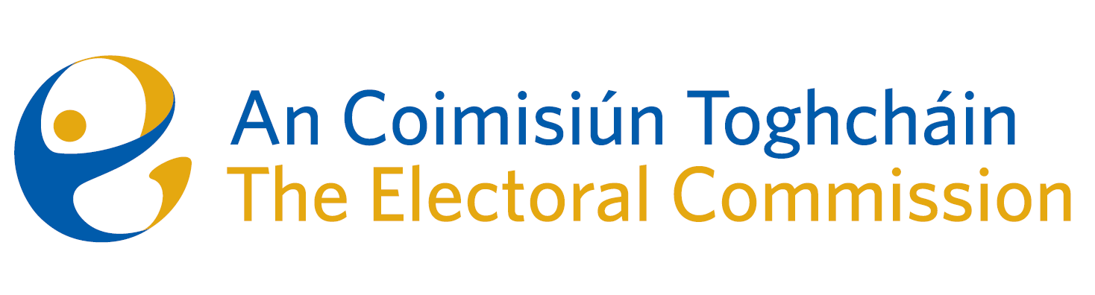
Meeting of An Coimisiún Toghcháin (ACT), The Electoral Commission.

Held in the Radisson Blu Hotel, Golden Lane, 8.30am – 13th December 2023

In attendance:
Justice Marie Baker (Chairperson), Maura Quinn(MQ), Alex Attwood (AA), John Curran (JC), Ger Deering (GD) and Prof. Caroline Fennell (CF)*.

Apologies:
Peter Finnegan (PF)

An Coimisiún Executive: Art O’Leary (AOL), Tim Carey (TC), Mary Clare O’Sullivan (MCOS), Karen Kehily (KK), Brian Dawson (BD), Nick Callan (NC)*, Sarah Keaveney (SK)*, Eunice Delaney (ED)*, Aoife O’Sullivan (AOS)* and Andrea Jones (secretariat)

*Prof. C Fennell, Nick Callan, Sarah Keaveney, Eunice Delaney and Aoife O’Sullivan attended the meeting remotely

------------------------------------
- Welcome
The Chairperson welcomed members.

- Conflict of Interest
No conflict of interest was declared.

- Presentation by the Director of the National Cyber Security Centre
Eileen Barrington (Senior Counsel) and Raymond Byrne (Barrister) presented the Commission members with a legal overview and perspective of the proposed thirty-ninth amendment of the Constitution (The Family) Bill 2023, and the fortieth amendment of the Constitution (Care) Bill 2023. The referendums will be held on 8 March 2024.
The Bills propose for two amendments to the Constitution which will:
- amend Article 41 of the Constitution to provide for a wider concept of Family; and
- delete Article 41.2 of the Constitution to remove text on the role of women in the home, and insert a new Article 42B to recognise family care.
The Commission discussed the campaign for the proposed referendum and the key dates in order to fulfil the statutory requirement to publish and distribute referendum information.

Bills passed by the Houses of the Oireachtas - no later than 23 January;
Polling Day Order and sample ballot papers - no later than 23 January;
Final info booklet text to the printer - no later than 26 January;
Booklets to An Post for nationwide delivery - no later than 9 February.

AOB
- Date of next meeting Wednesday 10th January 2024 (TBC)

__________________

Ms. Justice Marie Baker (signed)
Chairperson

