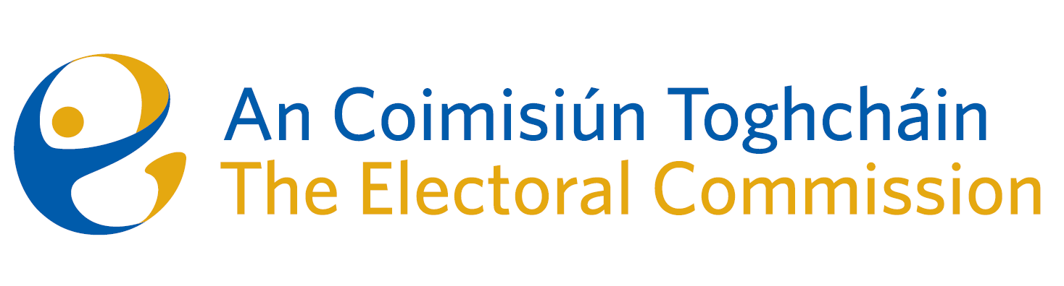
Meeting of An Coimisiún Toghcháin (ACT), The Electoral Commission.

Held in the Radisson Blu Hotel, Golden Lane, 8.00am – 7th December 2023

In attendance:
Justice Marie Baker (Chairperson), Maura Quinn(MQ), Alex Attwood (AA), John Curran (JC), Ger Deering (GD), Peter Finnegan (PF), and Prof. Caroline Fennell (CF).

An Coimisiún Executive: Art O’Leary (AOL), Tim Carey (TC), Mary Clare O’Sullivan (MCOS), Karen Kehily (KK), Nick Callan (NC, agenda item 3) *, Sarah Keaveney (SK, agenda item 5), Seamus Byrne (SB, agenda item 5), Eunice Delaney (ED, agenda item 6) *, Anthony Trindle (AT, agenda item 6), Aoife O’Sullivan (AOS, agenda item 7), Frank Daly (FD, agenda item 7) and Andrea Jones (secretariat)

*Nick Callan attended item 3 remotely

------------------------------------
- Welcome
The Chairperson welcomed members.

The minutes from the previous meeting were approved.

- Conflict of Interest
No conflict of interest was declared.

- Presentation by the Director of the National Cyber Security Centre
Mr. Richard Browne presented the Commission members with an overview of the NCSC and its role in providing incident response services to Government networks, and to lead on the national response to cyber risk. The Commission were also provided with examples of international election process vulnerabilities, and the role of digital service providers, social media, online platforms and messaging service providers in identifying and taking action on deliberately misleading disinformation campaigns.

- Referendum Campaign
On the 7th of December the Government approved the publication of the thirty-ninth amendment of the Constitution (The Family) Bill 2023 and the fortieth amendment of the Constitution (Care) Bill 2023.
The referendums will be held on 8 March 2024.
The Bills propose for two amendments to the Constitution which will:
- amend Article 41 of the Constitution to provide for a wider concept of Family; and
- delete Article 41.2 of the Constitution to remove text on the role of women in the home, and insert a new Article 42B to recognise family care.
The work to date and critical timelines for ACT to carry out its statutory functions in relation to the referendums were discussed and noted by the Commission.

- Education Programme
Section 67 (1) of the Electoral Reform Act 2022 sets out the responsibility of the Commission in promoting public awareness of the State’s electoral and democratic processes and encouraging the public to vote at electoral events, through educational and information programmes. A discussion paper was provided to the Commission which outlined the scale of the task, the importance of identifying and working with the many potential stakeholders and strategic partners, and the next steps and future plans for the project.

- Post Electoral Reviews
Section 68 (2) of the Electoral Reform Act assigns a function to the Commission to prepare and publish Post Electoral Event Reviews. There is a separate requirement (Section 39) for a report on how the Commission performs its referendum functions.
The Commission were provided with a potential timetable of electoral events for the coming year, and the work plan for the first scheduled PEER, which is due to take place following the referendums in March 2024.

- Electoral Register Update
On the 14th November 2024, an informal ACT survey circulated to 31 registration authorities seeking information and input on the challenges faced in maintaining the electoral register, and to provide an outline of the proposed reporting template that registration authorities will be required to submit to the Commission in 2024.

The Commission was provided with a paper on the responses received, the proposed next steps for the development and issuing of the template, and the preparation of the oversight report of the Commission.

- Statement of Strategy
The Commission noted the further development of the statement of strategy, and agreed to consider it further at a later meeting.

- Draft Terms of Reference
The development of the draft terms of reference for the Commission was noted, and each member of the Commission was asked to forward observations or comments for further discussion.
AOB
- Date of next meeting Wednesday 13th December

__________________

Ms. Justice Marie Baker (signed)
Chairperson

