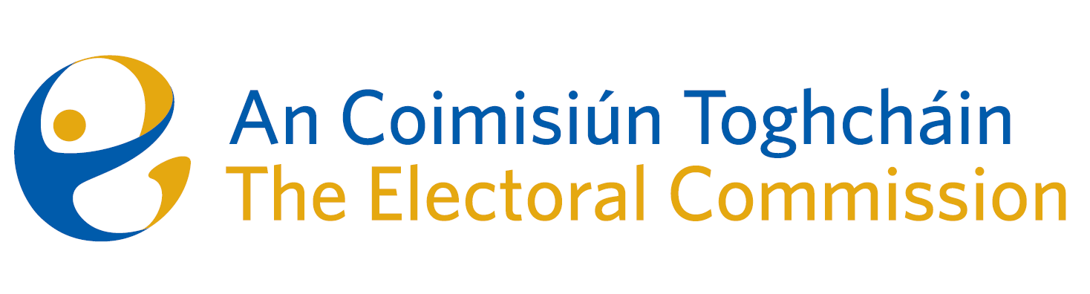
Agenda
Meeting #3/24, 8.00am 15 February 2024 (3 hours)
Venue – ACT Boardroom – Dublin Castle & Radisson Blu Hotel (Sky Suite)
- Minutes of previous meetings (4)
- Conflicts of Interest
- Referendum campaign update (20 minutes)
- Research Programme – Review of Submissions (40 minutes)
- 6-month meeting schedule (10 mins)
- AOB (5 mins)
- Post-Election Event Reviews – introduction & training (75 mins)
- Training will be held in the Radisson Blu Hotel (with all ACT staff).
- The Chair and comms staff have referendum campaign events in Meath & Cavan later in the day and must leave no later than 10.45 a.m.

For noting:
- Staffing/Budget Updates
- Commission Terms of Reference
- ACT ARC Committee meeting minutes – 2nd October 2023

