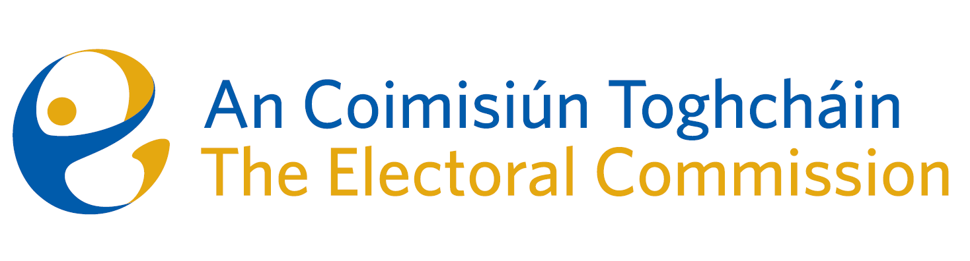
Meeting of An Coimisiún Toghcháin (ACT), The Electoral Commission.

Held in the ACT Boardroom, Dublin Castle, 8.00am – 15th February 2024

In attendance:
Justice Marie Baker (Chairperson), Maura Quinn(MQ), Alex Attwood (AA), John Curran (JC), Ger Deering (GD), Peter Finnegan (PF) and Prof. Caroline Fennell (CF).

An Coimisiún Executive: Art O’Leary (AOL), Tim Carey (TC), Mary Clare O’Sullivan (MCOS), Karen Kehily (KK), Anthony Trindle (item 4) and Andrea Jones (secretariat)

------------------------------------
- Welcome
The Chairperson welcomed members.

The minutes from previous meetings were approved.

- Conflict of Interest
No conflicts of interest were declared.

- ACT Referendum Campaign - Update
The Commission were updated on the public information campaign for the two Constitutional Referendums, which officially launched in TU Dublin on the 25th January.
Distribution of the information booklet has commenced, and it is expected a copy will have been delivered to each home in the country by 1st March.
- Research Programme
The Commission were advised that 61 submissions have been received following publication of the Draft Research Programme in November 2023. The submissions were from Groups & Organisations and individuals that provided initial reaction to the number of potential research topics identified in the Draft Research Programme and further suggested topics.
The Research Advisory Group will consider these submissions and a report on their review and recommendations will be brought to the Commission in the coming weeks.
- Commission Meeting Schedule
The Commission agreed the dates for the regular Commission meetings which will take place during 2024.
- Post-Election Event Reviews
Padraig Hughes provided an introduction and training on Post-Election Event Reviews to the Commission members and ACT staff, which took place in the Radisson Blu Hotel.

- Noted by the Commission

- Staffing/Budget Updates
- Commission Terms of Reference (draft)
- ACT ARC Committee meeting minutes – 2nd October 2023

AOB
- Deadline to apply as a temporary Approved Body for the duration of the Referendum Campaigns is 5.00pm on Friday 16th February
- Publication of wording for the Forty-first Amendment of the Constitution (Agreement on a Unified Patent Court) Bill 2024
- Date of next meeting 14th March 2024

__________________

Ms. Justice Marie Baker (signed)
Chairperson

