Figure 6.2: A Maltese STV ballot paper

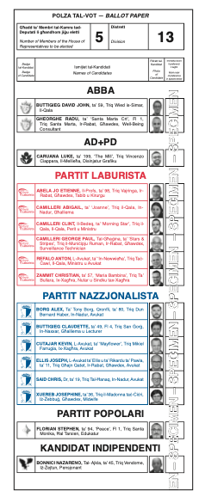

Figure 6.4: An Australian Senate STV ballot paper

Source: E. Carter, D. Farrell, G. Loomes, Electoral Systems: A Global Perspective, London: Bloomsbury, 2024 (in press).

