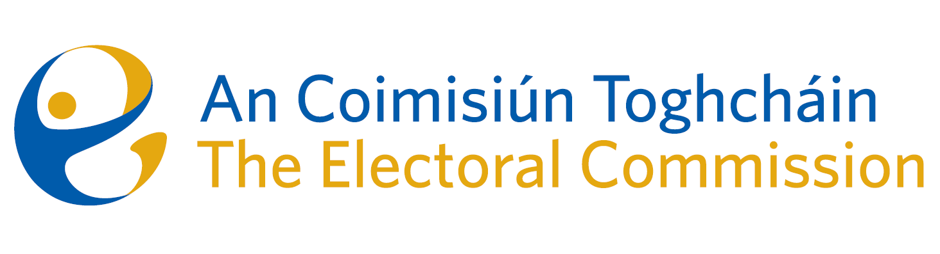
Agenda
Meeting #5/24, 10.00am 10 April 2024 (2 hours)
Venue – ACT Boardroom – Dublin Castle

- Minutes of previous meeting
- Conflicts of Interest
- Referendum on Unified Patent Court – update
- PEER Letter to the Minister
- Research Programme – update
- Statement of Strategy
- ACT Self-assessment questionnaire
- AOB
- ARC Meeting Report – 20th March 2024
- Minutes of ARC meeting – 11th December 2023
- Date of next meeting 16th May 2024

