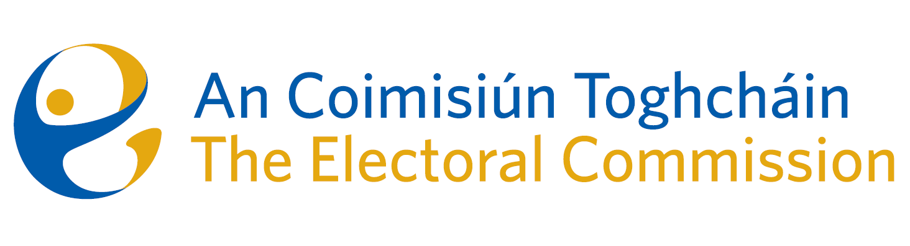
Agenda
Meeting #4/24, 10.00am 14 March 2024 (2 hours)
Venue – ACT Boardroom – Dublin Castle

- Minutes of previous meeting
- Conflicts of Interest
- Referendums on Family & Care – campaign and post-electoral event review
- Referendum on Unified Patent Court – update
- Research Programme – update
- Irish Electoral Integrity Accord
- Risk Management Policy (Risk Appetite – for decision)
- AOB

