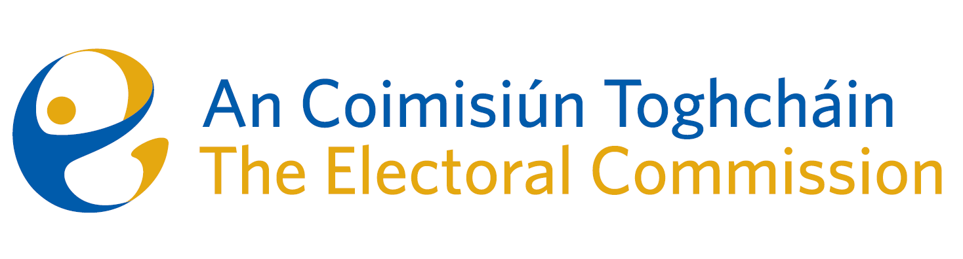
Meeting of An Coimisiún Toghcháin (ACT), The Electoral Commission.

Held in the ACT Boardroom, Dublin Castle, 10.00am – 10th April 2024

In attendance:
Justice Marie Baker (Chairperson), Maura Quinn(MQ), Alex Attwood (AA), John Curran (JC), Ger Deering (GD) and Caroline Fennell (CF).

An Coimisiún Executive: Art O’Leary (AOL), Mary Clare O’Sullivan (MCOS), Karen Kehily (KK), Tim Carey* (TC), Brian Dawson (BD), Annmarie Power (AMP) and Andrea Jones (secretariat)

Apologies:
Peter Finnegan (PF)

*Tim Carey attended the meeting remotely

------------------------------------
- Welcome
The Chairperson welcomed members.

The minutes from previous meetings were approved as amended.

- Conflict of Interest
No conflict of interest was declared.

- Referendum on Unified Patent Court
The Commission gave continued consideration to the proposal to hold a constitutional referendum on Ireland’s participation in the Unified Patent Court.
- PEER letter to the Minister
The Commission were updated on the development of the post electoral event review (PEER) draft report, following the recent referendums held on 8th March 2024. In advance of the draft report publication date in July 2024, ACT will write to the Minister for Housing, Planning, Local Government and Heritage to highlight the preliminary findings of the review, to assist the Minister in planning and addressing voter concerns in advance of the 7th June electoral events.

- Research Programme
The Commission received an update on the ACT Research Advisory Group (RAG) which met on the 25th March 2024 to review and discuss the 61 submissions received following publication of the Draft Research Programme in November 2023. The RAG will prepare a report on their review and recommendations which will be brought to the Commission in the coming weeks.

- ACT Assessment
The Corporate Governance Standard for the Civil Service states that the Commission should arrange a periodic self-review/assessment to measure delivery, performance and effectiveness against its terms of reference. The Commission agreed to begin this process, which will be progressed in the coming months.

AOB
- Date of next meeting 16th May 2024

_________________
Ms. Justice Marie Baker (signed)
Chairperson

