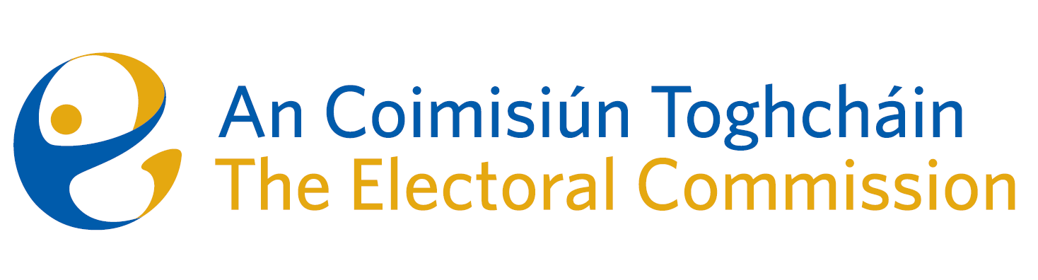
Meeting of An Coimisiún Toghcháin (ACT), The Electoral Commission.

Held in the ACT Boardroom, Dublin Castle, 10.00am – 14th March 2024

In attendance:
Justice Marie Baker (Chairperson), Maura Quinn(MQ), Alex Attwood (AA), John Curran (JC), Ger Deering (GD), Peter Finnegan (PF).

An Coimisiún Executive: Art O’Leary (AOL), Mary Clare O’Sullivan (MCOS), Karen Kehily (KK), Eunice Delaney (ED) (item 3), Nick Callan (item 6) and Andrea Jones (secretariat)

Apologies:
Prof. Caroline Fennell (CF) and Tim Carey (TC)

------------------------------------
- Welcome
The Chairperson welcomed members.

The minutes from previous meetings were approved.

- Conflict of Interest
Prior to the discussion of an agenda item under AOB, one Commission member notified the Chair of the possibility of a perceived conflict of interest. In the presence of the Commission member, the Commission:
- Agreed there was a possibility of a perceived conflict of interest.
- The Commission member recused themselves while this discussion segment was discussed.

- Referendums on Family & Care – campaign and post-electoral event review (PEER)
Following the referendums on the thirty-ninth amendment of the Constitution (The Family) Bill 2023 and the fortieth amendment of the Constitution (Care) Bill 2023 held on the 8th March 2024, the Commission discussed and reviewed the ACT information campaign. The campaign included a number of nationwide in-person events and sixty plus national and local media events. In addition to the delivery of over 2.3 million information booklets to every home in the country, there were over 200,000 engagements with the ACT website during the campaign.

The findings of the PEER and the preliminary results from polling data were also discussed by the Commission, and the value each will hold to ACT in planning and identifying voter trends and concerns for future electoral events.

- Referendum on Unified Patent Court – Update
On the 23rd January 2024 the government approved a proposal to hold a constitutional referendum in June on Ireland’s participation in the Unified Patent Court. The referendum is to be held alongside the European and local elections.

This matter will be further discussed by the Commission in the coming weeks.

- Research Programme
The Commission were updated on the ACT Research Advisory Group (RAG) which held its first introductory meeting on 4th March 2024. The RAG will reconvene on the 25th March 2024 to review and discuss the 61 submissions received following publication of the Draft Research Programme in November 2023.

The RAG will prepare a report on their review and recommendations which will be brought to the Commission in the coming weeks.

- Irish Electoral Integrity Accord
The Commission discussed a letter from the Minister for Housing, Planning Local Government and Heritage and the Minister of State for Nature, Heritage and Electoral Reform, seeking the support of ACT to lead the development of a new Irish Election Integrity Accord. A response to this request was considered, and a written reply will issue to Ministers in the coming days.

- Risk Management Policy

The draft Risk Policy was reviewed and discussed by the ACT Audit & Risk committee late 2023. The Commission were asked for input on the draft document, in particular, the risk appetite across six key areas. The Commission’s observations will be presented at the next Audit & Risk committee meeting on Wednesday 20th March.

AOB
- A bye-election to fill the vacancy in the Seanad caused by the resignation of Senator Niall Ó Donnghaile will be held on Monday 29th April;
- Request from Office of the Information Commissioner for access to records;

- Date of next meeting 10th April 2024.

_________________
Ms. Justice Marie Baker (signed)
Chairperson

