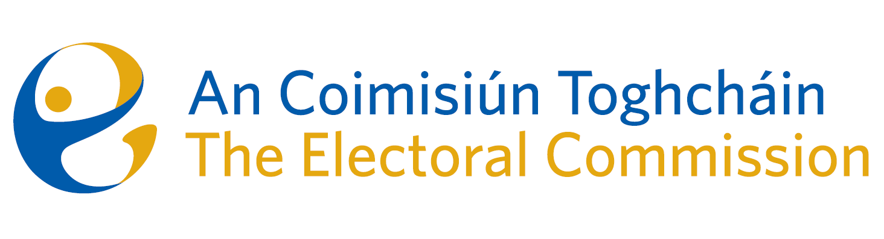
Agenda
Meeting #6/24, 10.00am 16 May 2024 (2.5 hours)
Venue – ACT Boardroom – Dublin Castle

- Minutes of previous meeting
- Conflicts of Interest
- Local & European Parliament campaign update
- Review of March ’24 Referendums
- ACT Members’ self-assessment questionnaire – update
- Finance and HR update
- AOB
- Research Programme update
- Date of next meeting 13th June 2024
- PEER Routes – June ‘24
- Appeal against National Party registration decision*

* The Chief Executive will absent himself for this agenda item

