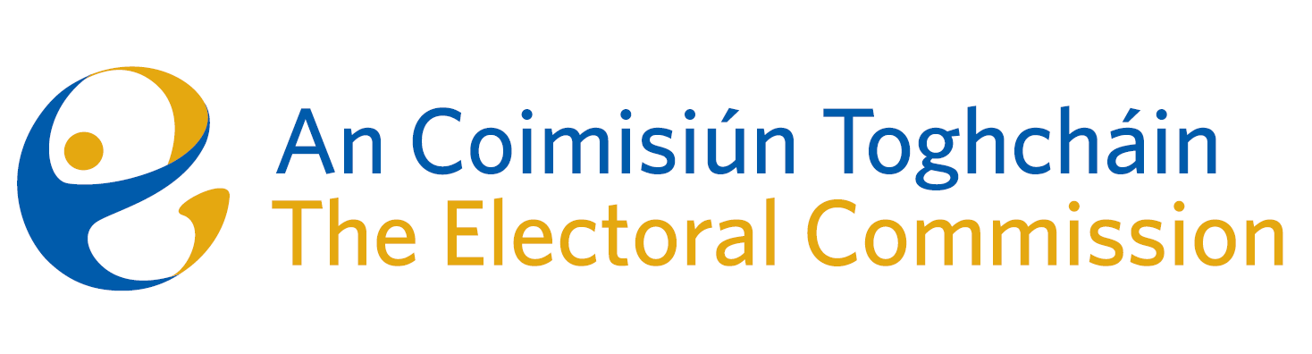
Meeting of An Coimisiún Toghcháin (ACT), The Electoral Commission.

Held in the ACT Boardroom, Dublin Castle, 10.00am – 16th May 2024

In attendance:
Justice Marie Baker (Chairperson), Maura Quinn (MQ), Alex Attwood (AA), John Curran (JC), Ger Deering (GD), Caroline Fennell* (CF) and Peter Finnegan* (PF).

An Coimisiún Executive: Art O’Leary (AOL), Mary Clare O’Sullivan (MCOS), Karen Kehily (KK), Tim Carey (TC), and Andrea Jones (secretariat)

*Caroline Fennell and Peter Finnegan attended the meeting remotely

------------------------------------
- Welcome

The Chairperson welcomed members.
The minutes from previous meetings were approved.

- Conflict of Interest

Prior to the discussion of agenda item number eight, the Chief Executive notified the Chair and the Commission members of a conflict of interest. The Commission members acknowledged the conflict of interest and the Chief Executive recused themselves from the discussion.

- Local & European Parliament Campaign

The Commission were updated on the public information campaign for the Local and European elections, and the Mayoral Election in Limerick, which will be held on Friday 7th.

- Review of March ’24 Referendums
The Commission were updated on the development of the draft report on the proposed thirty-ninth amendment of the Constitution (The Family) Bill 2023, and the fortieth amendment of the Constitution (Care) Bill 2023. The referendums for both proposed amendments were held on 8 March 2024. The draft report will be brought to the Commission in the coming months.

- ACT Members’ self-assessment questionnaire

The Corporate Governance Standard for the Civil Service states that the Commission should arrange a periodic self-review/assessment to measure delivery, performance and effectiveness against its Terms of Reference. Consideration was given to the Commission members responses to the self-assessment questionnaire, which circulated late April. The Commission agreed to establish a working group to assist members understand how the Commission is performing and to identify key areas for further development. This working group will hold its first meeting in the coming weeks.

- Finance and HR update

A financial overview and report for Q1 of 2024 was provided to the Commission. Commission members also received a briefing for Q1 2024 Human Resources priorities, which included an update on current and next phase recruitment, learning and development and wellness of staff.

- AOB – Research Programme Update

The Commission were updated on the work of the ACT Research Advisory Group (RAG), and the development of the draft Research Programme, which will be brought to the Commission in the coming weeks.

- Appeal against National Party registration decision

Commission members considered an appeal received on 30th April 2024 against the National Party registration decision. This matter will be further considered by the Commission in the coming weeks.

Date of next meeting – 13th June 2024

_________________
Ms. Justice Marie Baker (signed)
Chairperson

