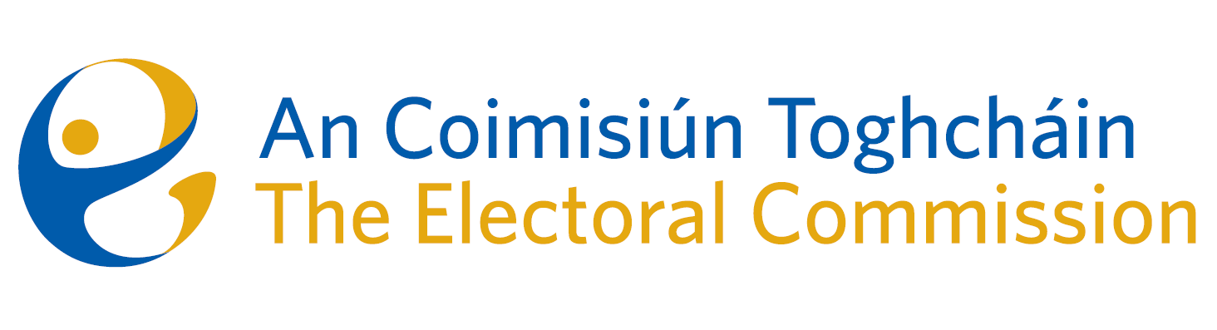
Agenda
Meeting #7/24, 10.00am 13th June 2024 (2.5 hours)
Venue – ACT Boardroom – Dublin Castle

- Minutes of previous meeting
- Conflicts of Interest
- Local and European Elections – campaign and post-electoral event review
- March Referendum – early draft report on the Information campaign
- Draft Research Programme
- Draft Annual Report
- AOB
- Date of next meeting 11th July 2024
- Appeal against National Party registration decision*

For noting:
- ACT ARC Committee meeting minutes – 20th March 2024
- ACT ARC Meeting Report – 11th June 2024 (to follow)

* The Chief Executive will absent himself for this agenda item

