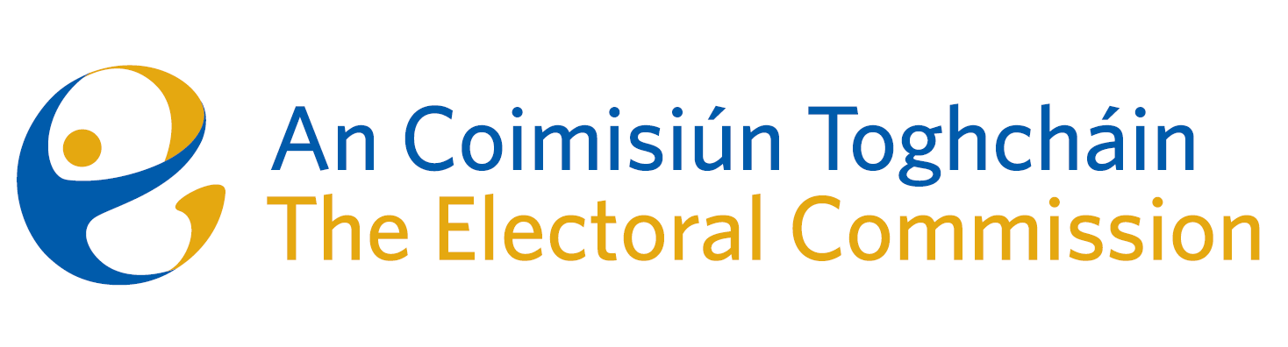
Meeting of An Coimisiún Toghcháin (ACT), The Electoral Commission.

Held in the ACT Boardroom, Dublin Castle, 10.00am – 13th June 2024

In attendance:
Justice Marie Baker (Chairperson), Maura Quinn (MQ), Alex Attwood (AA), John Curran (JC), Ger Deering (GD), Caroline Fennell (CF) and Peter Finnegan (PF).

An Coimisiún Executive: Art O’Leary (AOL), Mary Clare O’Sullivan (MCOS), Karen Kehily (KK), Tim Carey (TC), Adam Whittle (AW – item 5), Helen Codd (HC – item 6) and Andrea Jones (secretariat)

------------------------------------
- Welcome

The Chairperson welcomed members.
The minutes from previous meeting were approved.

- Conflict of Interest

Prior to the discussion of agenda item number eight, the Chief Executive notified the Chair and the Commission members of a conflict of interest. The Commission members acknowledged the conflict of interest and the Chief Executive recused himself from the discussion.

- Local & European Elections – campaign and post-electoral event review

The Commission were briefed on the public information campaign for the Local and European elections, and the Mayoral Election in Limerick, which were held on Friday June 7th.
The campaign included a number of nationwide & local media and radio events, discussions and meetings with minority groups, visits to Limerick for the Mayoral Election campaign and special initiatives to reduce the number of invalid votes and to encourage Leaving Cert students to vote.

The findings of the PEER were also discussed by the Commission, which will assist ACT in planning and identifying voter trends and issues for future electoral events.

- March Referendum - Report on the Information campaign
The Commission considered a draft report on the proposed thirty-ninth amendment of the Constitution (The Family) Bill 2023, and the fortieth amendment of the Constitution (Care) Bill 2023. The referendums for both proposed amendments were held on 8 March 2024. The report will be finalised by the Commission in the coming months.

- Research Programme

The Chair of the ACT Research Advisory Group (RAG) presented the first draft of the ACT Research Programme, which sets out the proposed ACT Research priorities commencing in 2024, and further planned research for 2025 and 2026. The final Research Programme report will be published in July.

- ACT Annual Report 2023

The Commission considered a draft of the 2023 ACT Annual Report. The Report will be finalised and laid before the Houses of the Oireachtas begore the deadline at the end of June.

- AOB

ACT ARC Committee meeting minutes – 20th March 2024
ACT ARC Meeting Report – 11th June 2024 (to circulate by email by Friday 14th June)

- Appeal against National Party registration decision

Commission members considered an appeal received on 30th April 2024 against the National Party registration decision. This matter will be further considered by the Commission in the coming weeks.

Date of next meeting – 11th July 2024

_________________
Ms. Justice Marie Baker (signed)
Chairperson

