Semi-rigid Dáil Éireann constituencies: how would they turn out to be?

Iulen Tazueco Manrique

Bachelor’s Degree in Law and Business | University of Zaragoza | Spain
Master’s Degree in Political Analysis | Open University of Catalonia | Spain
PhD student | University of Zaragoza | Spain

Abstract

The Irish PR-STV electoral system combines both reapportionment and redistricting so as to avoid excessively oversized constituencies. Electoral schemes are also subject to the principle of equal representation, which bans any purely territorial representation or trace of malapportionment. Although these principles are in line with democratic standards, the constituency revision process affects both representatives’ and electors’ territorial bases, as well as alignment between different administrative levels. This paper discusses how the current method can be adjusted to adapt Irish constitutional and statutory requirements to a more systematic and rigid one. Evidence shows that thorough electoral division-based delimitation cannot entirely prevent the highest ratio deviations, as a low constituency size is a significative cause of inequality. Hence, this paper aims to keep a more unbiased apportionment method which, at the same time, allows higher district magnitudes and less casuistic boundaries. The outcoming proposal sets a 172-member Dáil Éireann, returned from 34 constituencies that mostly match local electoral areas and the newly created local administrative units: municipal districts. The main drawback lies in the lack of such a level within the most populated, urban counties, although some provisional divisions have been set until implementation of municipal districts is carried out within them.

Keywords

Constituencies, Dáil Éireann, Ireland, reapportionment, redistricting.
Introduction

The principle of equal representation, also known as ‘one man, one vote’ is materialised into proportional seat reapportionment between constituencies so as to avoid inequalities in voters’ representation. It is acknowledged in several jurisdictions, albeit it shows different degrees of accuracy: while the US Supreme Court rule in Wesberry v Sanders

[1964] required an almost equal population-to-representatives ratio, it is more common to restrict ratio inequality up to an acceptable limit. The American paradigm is the single-
member district system counterpart of a former, less-known Irish legal case: O’Donovan

v Attorney General [1961], which applied to a multimember district system. While the

first case mandates redistricting whenever a constituency population shift is ascertained, the second does not necessarily imply it.

Unlike party-list PR systems, where reapportionment replaces redistricting, the Irish PR- STV system limits Dáil constituencies magnitude to five members. Technically, STV can work under a district magnitude as large as the assembly size. This was Hare’s proposal for Britain (Droop, 1881:180), in contrast to current single-number magnitudes pattern (Farrell et al., 1996:31). Although higher district magnitudes are advisable to reduce ratio inequalities, as it will be explained later on, oversized constituencies are needless under any form of STV. Given a Droop quota (Gallagher, 1992:480), vote transfers allow three- seaters to translate around three quarters of the valid poll into representatives, while a nine-seater is enough to represent around a 90% of it. On the contrary, non-transferable vote systems can leave a sizeable number of votes without representation regardless of the district magnitude.

For instance, three-seat Segovia constituency in the Spanish lower chamber turned out to represent just the 60.92% of the valid poll after the 2015 general election, 14.08 points below the value of three full Droop quotas. Earlier that year, five-seater Soria represented
the 68.02% of the valid poll after the Castilian-Leonese regional election, 15.31 points below the value of five Droop quotas. Six-seater Albacete represented the 70.51% of the valid poll in that year’s Castilian-Manchegan regional election, 15.20 points below the value of six Droop quotas. In all of these cases, the breakup of a formerly bipartisan electorate into a multi-party one affected its representation, with no chance of vote transferences between leftist Podemos and the Labour Party, nor between centre-right Citizens’ and People’s Parties. In case these elections had been conducted under PR-STV, representativeness would have been higher without the need for larger district magnitudes. I find in this, and not in the counting process simplification, a reason to justify the STV systems choice of smaller constituencies, and thus, the need to combine reapportionment and redistricting whenever the former cannot ensure a certain maximum magnitude. Even so, higher minimum magnitudes are desirable so as to minimise ratio divergences among constituencies. I discuss later why lower magnitudes are more likely to result in higher ratio divergences even for unbiased, strictly proportional reapportionment formulae.

Having made clear that Irish constituencies must be able to undergo redistricting, it does not mean it can be abused of. Unlike Britain and mainland Europe, Ireland does not follow a strong ideological vote model despite its electorate’s increasing positioning on the left- right spectrum (McElroy, 2017:79). Since candidates’ individual stances guide voters’ choices to a greater extent, constant constituency redrawing causes candidate turnout to happen more frequently in bordering areas, which do not settle in a specific one. Instead, they are being constantly moved between districts to adjust population-to-representatives ratio at every Census update. A more territorially-coherent constituency scheme can be achieved despite the historical lack of relevant second-order administrative divisions in Ireland, which is anomalous in comparison with other European states. Instead, current
Dáil constituencies rely on ‘microunits’ (Coakley, 2015:534) such as electoral divisions, townlands and statistical small areas. None of them constitute recognisable administrative nor natural territorial units, unlike many European municipalities or bigger cities districts.

The aim of this paper is, thus, twofold. On the one hand, it intends to establish a systematic apportionment procedure between Dáil constituencies whenever a revision is carried out, allowing extra seats addition to the most underrepresented constituencies if it contributes to a decrease in ratio divergences and maintain a population-monotonic apportionment. On the other hand, it aims to establish stricter redistricting criteria, following a principle of necessity and employment of recently created municipal districts instead of microunits.

Originally, this paper was my master’s degree dissertation, which I submitted before the

2022 Census preliminary figures were published. Hence, I faced a serious difficulty: the lack of updated, constitutionally relevant figures, which I managed to overcome by using CSO estimates for 2021. Despite the current Census data availability, I could not ascertain suggested County Cork constituencies population figures, as some electoral divisions (the smallest territorial unit for which data are available as of late 2022) are split between Co. Cork and Cork City administrative counties. Nevertheless, it has been verified that both proposed Co. Cork constituencies would have maintained their number of TDs. Besides, none of them would have fallen into the most extreme ratios range in spite of a sizeable error margin. Finally, there has been a need for some microunit-based adjustments within Co. Dublin, which lacks a municipal district scheme. In contrast with the current Dáil constituency scheme, my proposal is almost entirely based on local electoral areas within Co. Dublin, although certain adjustments have been made. While Cork City and Galway City lack municipal districts as well, they would have remained undivided in my proposal. A further point should be made of dismissing fixed-boundary constituencies, due to their uselessness under a PR-STV system and their inconsistency with the Irish Constitution.
Theoretical framework

The principle of equal representation in Ireland

Article 16(2) of the 1937 Irish Constitution mandates a national ratio between 20,000 and
30,000 inhabitants per TD, as the preceding 1922 Constitution did. This ratio shall, so far as it is practicable, be the same throughout the country. The implementation of this rule was controversial during the first decades after independence, being O’Donovan a turning

point. Its casus belli was the Electoral (Amendment) Act, 1959, which would eventually

be annulled by the High Court. This case is the only direct judicial intervention in a Dáil constituency scheme up to date, although later cases have taken a stance on issues which are related to the breach of the equal representation principle, that is, malapportionment.

The High Court ascertained severe ratio divergences in the 1959 Act, which deepened the difference between Western, rural constituencies and Eastern, urban constituencies, being the latter within Co. Dublin. Considering the 1956 Census figures, Dublin South (West) ratio was 23,128 inhabitants per TD, in contrast with 16,575 in Galway South. It implied that the former was 1.3954 times more underrepresented than the latter; thus, it was found to breach the aforementioned constitutional rule. The Court also found malapportionment in the unequal seat distribution between regions: while the Western seaboard (Donegal, Mayo, Galway and Kerry) had 583,531 inhabitants and 30 TDs altogether (instead of 29), Co. Dublin had 705,007 inhabitants and 31 TDs (instead of 35). The Government justified this malapportionment in the need to facilitate constituency work in sparsely populated areas. However, the Court ruled that it lacked explicit constitutional protection.

The case, which was later appealed and withheld by the Supreme Court, acknowledges a

de facto impossibility of a strict equal representation paradigm due to mathematical and
administrative difficulties. Regarding microunits, the High Court suggested using them for ratio adjustments, although it did not oppose certain coherence between constituency boundaries and administrative limits e.g., county boundaries. Apart from active electoral geometry (as the Commission of Venice defines it in its 2017 report, on page 13), passive
electoral geometry caused malapportionment to happen even after O’Donovan. This is to

say that former revision frequency (twelve years) impeded constituencies from reflecting population shifts accurately. This frequency was de facto shortened in the 1960s, yet no
judicial ruling made it explicit until O’Malley v An Taoiseach [1990]. This case arose

after a snap election was called in 1989 with unrevised constituencies despite the major population changes reported by the 1986 Census. Since then, Dáil constituency revision must be carried out whenever such changes occur.

Both judicial intervention and more frequent revisions have effectively contributed to lessening inequality. There is a third factor which has been found relevant in explaining ratio divergences: the average constituency magnitude. As a consequence of a progressive maximum magnitude decrease from nine in 1923, to seven in 1935, to five from 1947, prospective six, seven, eight or nine-seaters have been divided into three, four or five- seaters. Given the fact that the largest ratio divergences are found in the lowest district magnitudes, average magnitude has a negative effect on inequality: the lower the former is, the higher the latter is. Before I move on to a mathematical explanation of constituency magnitude effect on ratio divergence, the former theoretical reasoning must be translated into a quantitative model so as to ascertain its validity.

I have elaborated two simple linear regression models for both MAXQUO and MAXDEV dependent variables. MAXQUO is the quotient between the highest and the lowest ratio found at every Census publication. MAXDEV is the maximum percentage ratio deviation from the national average, disregarding negative signs. The three independent variables
are: (1) direct judicial intervention, which I have translated into a dummy variable (named

COURT), whose value equals one in every constituency scheme passed after O’Donovan;

(2) number of years which separate a Census publication from the latest Dáil constituency

scheme (DIFFER); and (3) average constituency magnitude (AVCON).

CENSUS  1926 | MAXQUO  1.3033 | MAXDEV  0.1722 | COURT  0 | DIFFER  3 | AVCON  5.25
1936 | 1.5920 | 0.4187 | 0 | 1 | 4.06
1946 | 1.8739 | 0.4237 | 0 | 1 | 3.68
1951 | 1.8050 | 0.4872 | 0 | 4 | 3.68
1956 | 3.1978 | 1.2902 | 0 | 9 | 3.68
1961 | 1.3191 | 0.2048 | 1 | 0 | 3.79
1966 | 1.7462 | 0.4570 | 1 | 5 | 3.79
1971 | 1.5292 | 0.3456 | 1 | 2 | 3.43
1979 | 2.3274 | 0.6059 | 1 | 5 | 3.52
1981 | 1.2497 | 0.1499 | 1 | 1 | 4.05
1986 | 1.4560 | 0.2524 | 1 | 3 | 4.05
1991 | 1.2299 | 0.1167 | 1 | 1 | 4.05
1996 | 1.2699 | 0.1587 | 1 | 1 | 4.05
2002 | 1.3703 | 0.2073 | 1 | 4 | 3.95
2006 | 1.3562 | 0.2124 | 1 | 1 | 3.86
2011 | 1.2308 | 0.1058 | 1 | 2 | 3.86
2016 | 1.1568 | 0.0728 | 1 | 3 | 3.95
2022 | 1.1446 | 0.0686 | 1 | 5 | 4.10

MAXQUO MAXDEV

*** 1.6423 **
Intercept | 3.8973
COURT | -0.5186
DIFFER | 0.1251
AVCON | -0.5880

** -0.3198 **
*** 0.0687 ***
** -0.3271 **

Adj. R2 0.7510 0.7628
p-value < 0.0001 *** < 0.0001 ***

Figure 1. Linear regression models for MAXQUO and MAXDEV. ** 99.90% *** ~100%. Data source: CSO.
Both models ignore former University constituencies. A point has to be made of DIFFER: almost all Censuses have ascertained previous schemes population data. The 1946 Census worked the other way round, as it took the 1947 scheme as a reference. Although it might sound contradictory, there was a three-year delay in that Census publication. Hence, new data were used to redraw constituencies. This negative time difference should have led to a decrease in ratio divergences, as then-in-charge Government accessed updated figures. However, inequalities in the 1947 scheme were higher than in the former ones. This is to say that the 1947 revision was equivalent to an unrevised scheme withholding in terms of MAXQUO and MAXDEV values increase. This justifies my choice of deeming DIFFER value positive regarding the 1946 Census.

In sum, there are three main implications of both models. First, the ruling in O’Donovan

has set a precedent which has successfully prohibited constituency schemes bias towards rural, sparsely populated areas: while in the 1926-1956 period average MAXQUO value was 1.9544 and average MAXDEV value was 0.5584, in the 1961-2022 period both have dropped to 1.4143 and 0.2275, respectively. Second, there is a direct relationship between
the delay in constituency revision and ratio inequalities. Before O’Malley, constituencies

remained unrevised 8.57 years on average. This has fallen to 4.86 after the High Court ruling. Average MAXQUO and MAXDEV values have fallen from 1.7636 to 1.2512 up to 1991, and from 0.4371 to 0.1346 since then. Finally, the higher the average magnitude is, the more the equal representation principle is satisfied. All schemes whose AVCON <
4 result in an average MAXQUO = 1.7193 and an average MAXDEV = 0.4012. In those whose AVCON falls between four and five, average MAXQUO = 1.3237 and average MAXDEV = 0.1942. In the only case whose AVCON > 5, average MAXQUO = 1.3033 and average MAXDEV = 0.1722.
Regarding these three statistically significant variables, the quantitative aim of this paper is to maintain COURT = 1, to achieve DIFFER = 0 and to increase AVCON considerably (at least above five). COURT = 1 means avoiding any bias in the apportionment formula, which is mathematically possible. DIFFER = 0 implies automatic revision once a Census is published. Finally, increasing AVCON implies increasing the maximum magnitude, as current five-seat limit forces division of possible larger constituencies. In my proposal, it is raised up to seven as a general rule, allowing eight and nine-seaters exceptionally. Thus, unavoidable divisions into three-seaters are intended to cease: six-seaters would no longer divided into two three-seaters, and seven-seaters would avoid division into a three-seater and a four-seater. Eight and nine-seaters can avoid division into three-seaters. This higher
limit would just require a reform of the Electoral Reform Bill, 2022 once its Section 57

is commenced. It would also specify both the apportionment formula and the highest admissible ratio deviations, an unresolved issue by both Courts and legislators up to date.

The anomalous Irish constituencies volatility

Under single-member constituency systems, redistricting is the only method to eliminate malapportionment after population shifts are ascertained. Malapportionment is linked to single-member districts more frequently (Samuels & Snyder, 2001:665) because they are more likely to become obsolete. In contrast, it is a minor problem for many multi-member constituency systems, as they undergo reapportionment. Fixed boundaries are the norm e.g., Article 68(2) of the Spanish Constitution states provinces and autonomous cities are the lower chamber constituencies. No boundary alteration is allowed. Handley (2008:267) notes that some multi-member systems allow redistricting. This is the case of Article 25 of the Finnish Constitution, which only sets the number of constituencies into which the national territory must be divided. It is the Electoral Act no. 714/1998 the statute that sets
out which municipalities merge into each constituency. Redistricting is not frequent, yet it is a possibility, and it is mostly based on relevant administrative divisions. This category of systems cannot be deemed variable, but semi-rigid.

There are few exceptions to the dichotomy between variable, single-member constituency schemes and fixed or semi-rigid, multi-member constituency schemes, being Ireland one of the most well-known because of its PR-STV voting method. As it renders large district magnitudes useless, redistricting is more frequent. In turn, Dáil constituencies are rather volatile, being the 1923 scheme the only one which substantially matched administrative county boundaries and local electoral areas (Coakley, 2015:537-538). All later revisions have systematically detached themselves from territorially-coherent criteria. For instance,
current Dáil scheme, as defined by the Electoral (Amendment) (Dáil Constituencies) Act,

2017, is excessively casuistic and refers to thorough division criteria. Some examples are:

(1) the four-way division of Co. Meath, whose 2016 population should have only admitted a division into two constituencies, given the current five-seat limit; (2) the transfer of the southernmost parts of Co. Donegal to Sligo-Leitrim, despite the county population being enough to constitute a single five-seater; and (3) the use of the M-50 motorway to divide some constituencies within Co. Dublin, breaching its administrative counties boundaries, and even some of its electoral divisions. Yet, some constituency descriptions still mention former rural districts, ignoring most recent municipal districts.

Constituency volatility is not uncommon. Some of them have even been altered at every revision during a long period. This is the case of Dublin West, which changed boundaries seven consecutive times since its establishment in 1980 (Kavanagh, 2014:229). Coakley (2015:544) explains that these adjustments have traditionally been justified by the need for lower ratio divergences, although it is useless if low district magnitudes are the norm, as the former sub-section models have shown. Kavanagh (2003) discusses the effects of
candidates’ territorial bases in depth. Considering its aforementioned importance due to the lack of a strong ideological vote model, it is discussed that bordering areas face a risk of marginalisation and turnout decrease. However, there might be other factors that have influence on them (Kavanagh, 2003:94), as some of the most volatile districts turned out to be more disadvantaged in socioeconomic issues. What it important to remark is the fact a more stable constituency scheme is justified by the need for legal certainty, candidates’ platforms stability and a better alignment of national and local policies, matching electoral
demarcations at both levels. By no means does it mean contravening O’Donovan, which

ruled out the possibility of a territorial or sectorial representation constitutional right. On

the contrary, it did not oppose territorial coherence. A later case, Murphy v Minister for

Environment [2007] admitted some ratio variance if it ensured adherence to recognisable

boundaries. Moreover, the Electoral Act, 1997, not yet repealed, actually states that the

breaching of county boundaries shall be avoided as far as practicable. This rule has been flagrantly infringed in practice. Most administrative counties integrity is disrespected in the current Dáil constituency scheme, and the only county divided into constituencies without adding neighbouring areas is Dún Laoghaire-Rathdown.

The importance of counties in Ireland is sacrosanct, as they are a natural local government unit (Callanan, 2018:590), as well as the territorial base for community identity. However, Irish local institutions are rather powerless, in contrast with their European counterparts. Coakley (2015:538) considers this fact anomalous in comparative perspective. The trend towards local government centralisation since independence (Ogbazghi, 2020:5) has left Irish counties in a curious position: although they represent local divisions, their sizeable extension and population are more similar to mainland European regional divisions. For instance, the least populated Irish county (Co. Leitrim, 35,087 inhabitants), proportionally equals a 325,000-inhabitant Spanish division. While only the top-11 most populated local
authorities in Spain are above this figure, the smallest regional division (La Rioja) is near it. Despite this anomaly, recent introduction of municipal districts in most Irish counties can reorient constituency commissioners’ redistricting criteria.

Municipal districts do not constitute a new local government tier (Boyle et al., 2020:6), yet they have been aligned with local electoral areas boundaries. I find them fit for the formerly stated aim to co-ordinate local and national policies. Besides, their population figures are more similar to mainland European municipalities. The least populated district is Ballinamore (Co. Leitrim, 10,836 inhabitants). Such figures permit thorough boundary adjustments or county divisions without recurring to microunits, whenever one or several full-county constituencies exceed the maximum magnitude. A main inconvenient is that not all counties have been divided into municipal districts: both cities of Cork and Galway and the four administrative counties in Co. Dublin lack a proper municipal scheme. Both Cork and Galway fall below the maximum magnitude in my proposal, but this is not the case for Co. Dublin, where around 1.45 million inhabitants live. I have mostly followed
2019 local electoral areas, although minor microunit-based adjustments have been made. In case municipal districts are implemented in any of these, proposed Dáil constituencies are expected to be redrawn accordingly, since these adjustments are provisional.

By following this proposal, constituencies will get rid of their quasi-permanent volatility, making Irish electoral institutions approach the mainland European paradigm by reducing abuse of redistricting and establishing more coherent, more stable and more recognisable semi-rigid Dáil constituencies. Municipal district-based constituencies are to fully replace current microunit-based schemes once a complete municipal division is carried out.
Methodology

Apportionment formula and maximum ratio deviations

Any constituency revision implies an explicit (reapportionment) or implicit (redistricting) allocation of si seats to each district. Balinski & Young (1982:96) define apportionment formulae as the allocation of ∑ si = s seats by dividing each pi-population by a d-divisor, obtaining an exact qi-quota. Each qi must be translated into an integer si. The manner this is done sets a difference between quota-based formulae and divisor-based formulae.

Quota-based formulae determine a fixed d-divisor and allocate as many seats as integer qi-quotas each pi returns. Any remaining seats are distributed by the means of a rounding- up rule. Typically, qi-quotas with the highest fractional values are rounded up to the next integer. This is why quota-based formulae are also known as largest remainder formulae. Their main drawback is the fact there is no fixed rounding-up rule, as the lowest fractional value to return an additional seat will vary in each population distribution, which can lead to apportionment paradoxes: there might be a case where a given pi population increases, and so does its qi-quota, but also the rounding-up threshold, so formerly rounded-up qi- values can actually lose a seat. Conversely, a given pi population and its qi-quota might decrease, but also the rounding-up threshold, so formerly truncated qi-values can gain an extra seat. By no means is this acceptable from the logics of equal representation. In fact, it is a form of malapportionment, because not always a relative population increase means an equal or higher representation share, and certain relative population decreases might be rewarded. Both authors (1982:70) discard quota-based formulae for this reason.

Divisor-based formulae determine a fixed rounding-up rule (which I name β). Fractional

values of qi which equal or exceed β are allocated an extra seat. In case the apportionment
is not satisfied because there are remaining seats, the divisor value is modified until there are no vacant seats. Unlike quota-based formulae, divisor-based formulae never reward a relative population decrease, and neither punish a relative population increase. This is due to an unaltered β-value, this is, the rounding-up threshold is the same for every population distribution. In mainland Europe, divisor-based formulae are alternatively described as a quotient succession, where each pi is divided by (0+β), (1+β), (2+β), and so on. Then, the s-highest quotients are chosen, and each pi obtains as many seats as s-highest quotients it has. Any other mathematically equivalent succession can be used e.g., the Sainte-Laguë formula is often described as a division by 1, 3, 5, … instead of a division by 0.5, 1.5,
2.5, and so on.

The most known divisor-based formulae besides Sainte-Laguë (β = 0.5) are D’Hont (β =

1) and Adams (β = 0). D’Hont never rounds up, as it requires qi to obtain the next integer for an extra seat. Adams always rounds up, as it does not require any fractional qi values to gain an additional seat. In fact, if qi = 0, si = 1, so it has a bias towards lower pi-values, just the opposite case of D’Hont, which has a bias towards higher pi-values. Sainte-Laguë follows a standard rounding-up rule, which lies between both formulae. Consequently, it is considered unbiased (Balinski & Young, 1982:76) and closer to an equal representation ideal. Once the mechanics of divisor-based formulae, it is possible to find the maximum theoretical values of MAXQUO and MAXDEV, which I will name δ and γ, respectively.

I start with δ. Given a certain divisor-based formula, si is allocated whenever the qi-quota satisfies that (si–1)+β ≤ qi ≤ si+β. It occurs whenever [(si–1)+β]d ≤ pi ≤ (si+β)d, so possible ratio values fall between [(si–1)+β]d/si and (si+β)d/si. As the latter value is always higher than the former, MAXQUO equals (si+β)d/si divided by [(si–1)+β]d/si, which is the same as (si+β) divided by [(si–1)+β]. The lower si and β are, the higher the outcome is and, thus, maximum theoretical extreme ratios quotient can be found just by knowing both β-value
and the minimum district magnitude, which I name M. Hence, δ = (M+β)/[(M–1)+β]. For

Sainte-Laguë and M = 3, δ = 1.40. It falls to δ = 1.2857 if we increase M by one member.

Theory shows ratio divergence between three-seaters can be up to 40%, while this value decreases to less than a third in four-seaters. It is possible to lessen δ in three-seaters so as to match that in four-seaters. This is done by setting an initial β rounding-up rule to achieve M = 3, while any si > M will be obtained if β’ = 0.5 is reached. This is to say that (M+0.5)/[(M–1)+β] = [(M+1)+0.5]/(M+0.5). If we solve it, we obtain β = 13/18 = 0.7222. It means that three-seaters can only have 2.7222 ≤ qi ≤ 3, while four-seaters, five-seaters, and so on are expected to follow the standard rounding-up rule. This slight bias is deemed to be an exceptional remedy for three-seaters in case they are implemented, as β = 0.5 can increase MAXQUO substantially.

I have to point out that, whenever β is altered, δ ceases to be a one-variable function. This has an important consequence: δ is not calculated solely with both limits of the ratio range for a single magnitude. For instance, given d = 30,000 and β = 0.7222, the ratio range for M = 3 is 27,222–35,000. If β’ = 0.5 for higher district magnitudes, the ratio range for si =
4 is 26,250–33,750. The real δ-value is 35,000 divided by 26,250, which is 1.3333, above its predicted value, yet lower than 1.40. It might happen if a three-seater and a four-seater almost equal qi = 3.50. Under such circumstances, a manual adjustment e.g., adding one additional seat to the least favoured constituency, could be admissible to reduce inequality to a lower value. In my proposal, it has happened to initially three-seat Sligo-Leitrim: its initial ratio of 34,969 contrasted with the four-seater Kildare North (26,373), which left the former 1.3259 times more underrepresented than the latter. Both ratios were extreme because their qi-values were close to 3.50, the quantitative limit between three and four- seaters. Later, I added an extra seat to Sligo-Leitrim, which eventually happened to have the lowest ratio (26,227). The new highest ratio (33,123) belonged to five-seater Carlow-
Kilkenny, and the new δ equalled 1.2629, below the predicted value of δ=1.2857. I have verified that this later adjustment has resulted in a population-monotonic apportionment.

I continue with γ. Given any range of ratios between [(si–1)+β]d/si and (si+β)d/si, d falls somewhere between both values. It implies that d ≥ [(si–1)+β]d/si and that d ≤ (si+β)d/si. Absolute ratio deviation from the divisor is, thus, the maximum value between these two: d – [(si–1)+β]d/si and (si+β)d/si – d. If both are divided by d to obtain the relative figures, MAXMED = max. [(1–β)/si ; β/si]. It increases whenever si decreases, so maximum ratio deviation from the national divisor corresponds to the minimum magnitude M. Regarding β, MAXMED has a convex plot, whose minimum is achieved at β = 0.5. Both reasonings lead to γ = (1–β)/M if β ≤ 0.5 and to γ = β/M if β ≥ 0.5. For Sainte-Laguë and M = 3, it is verified that γ = ⅙ = 0.1667. It falls to γ = ⅛ = 0.1250 for M = 4.

A question might arise regarding the suggested effect of an initial β = 0.7222 on γ, as this is expected to raise its value, contravening this slight bias intention of reducing inequality in three-seaters. It would, indeed, if β = 0.7222 was also used to obtain si = 4, as the most extreme deviations occur in the upper population limit whenever β > 0.5. In other words, the prediction would be true if M = 3 is allocated to any 2.7222 ≤ qi ≤ 3.7222. However, this paper proposal allocates M = 3 to any 2.7222 ≤ qi ≤ 3.50, so the highest ratio deviation is not 0.7222/3 = 0.2407, but 0.50/3 = ⅙ = 0.1667. This is to say that ratio deviations from the national divisor are never to exceed one-sixth of its value. This limit is similar to that
proposed by the attempted Third Amendment of the Constitution Bill, 1968, although it

was calculated regarding the national ratio (which is similar, but not equal to the divisor). In contrast with that proposal, mine does not admit any higher deviation, as the 1968 Bill
intended to so as to avoid complying with the rule in O’Donovan. In sum, my proposal is

intended to limit MAXQUO below 1.2857 and MAXDEV below one-sixth of the divisor.

Although real values can be lower, both δ and γ values are designed to be the first explicit
mathematically-reasoned levels of ratio divergence tolerance, which would put an end to a restless controversy over what is deemed acceptable and what is not.

Estimating Irish population before and after preliminary Census figures publication

The rule in Murphy clearly stated that the only constitutionally relevant population figures

for constituency revision purposes are those deemed definitive by an official Census. Not even precise estimations or even more precise preliminary figures suffice. This has been a serious difficulty I had to face, as I submitted the original dissertation before any access to the 2022 Census preliminary figures was made public, so I initially had to work with other recent CSO data. I chose to work with 2021 population and migration estimates. It was challenging due to the fact that the only territorial disclosure was actually made at a NUTS-3 regional level. I estimated regional growth rates, and I did so by initially dividing the estimate population of each region by its 2016 Census population. Then, I calculated
their fifth root, and I raised them to the sixth power to simulate a six-year period growth.

Region  Border | Est. 2021  412,600 | Pop. 2016  394,333 | Est. rate  5.58 %
Dublin | 1,426,000 | 1,347,359 | 7.04 %
Mid-East | 738,700 | 688,857 | 8.74 %
Midland | 307,200 | 292,301 | 6.15 %
Mid-West | 491,100 | 473,269 | 4.54 %
South-East | 443,400 | 422,062 | 6.10 %
South-West | 720,200 | 690,575 | 5.17 %
West | 472,300 | 453,109 | 5.10 %
Ireland | 5,011,500 | 4,761,865 | 6.32 %

Figure 2. Estimated population growth rate by region (2016-2022). Data source: CSO.
I applied these growth rates to the 2016 Census figures returned by each proposed Dáil constituency. In case a microunit-level adjustment was necessary, I was able to access the SAPMAP tool, where lower territorial level figures could be checked. Finally, I rounded figures up to the nearest thousand.

Once preliminary 2022 Census figures have been disclosed, it has been possible to access county, current Dáil constituency and electoral division-level data. In most cases, it has posed no problem, although I have had to refer to other criteria in South Dublin and Co. Cork. In the former, Dublin Mid-West constituency maintains its current boundaries, so I have checked its preliminary 2022 population. I have simply subtracted its population from the entire administrative country figure to obtain Dublin South-West population, as its proposed boundaries (1) do not match the current ones and (2) include parts of electoral divisions which are actually split among it and Dublin Mid-West, and the Census has not made lower-level figures public yet. In the latter, I have not been able to calculate the exact figures for both proposed Cork North-East and Cork South-West constituencies:
their municipal districts were altered by the Local Government Act, 2019 to transfer parts

of them to Cork City. This led to certain electoral divisions partition, so I have applied the actual county growth rate (not the stated in Figure 2) to the 2016 figures for the lowest territorial levels accessible through the SAPMAP. Although these figures are not exact, this fact does not interfere with the proposal results assessment. First, both constituencies are expected to return six TDs each even with a margin of error as considerable as ±10,000 inhabitants. Second, in case such an error occurred, their ratios would not constitute the most extreme cases, so there would not be any change in the predicted δ and γ values.

As a result, I calculated 5,062,800 inhabitants, 60,736 less than the actual 5,123,536. The average absolute error has been 1.75%, having Longford-Roscommon incurred in the highest value (4.65%). The most accurate estimates have been Mayo and Kerry (less than
0.05% error). Although further details are provided in the next section, the most important consequence is that, while the pre-Census proposal comprised a 169-seat Dáil, a 172-seat Dáil has been proposed after the Census preliminary figures were first made public. There might be differences regarding forthcoming definitive figures, although not that sizeable.

Semi-rigid Dáil constituencies proposal

This proposal prioritises reapportionment over redistricting. However, the latter is needed to draw the initial constituency scheme, which is expected to undergo reapportionment at the next Census publication. Before I explain the proposed divisions for the 2022 Census, I shall make a point of the only cases where redistricting is deemed mandatory. First, if a constituency returns qi < 2.7222, a merger with other constituencies is required. To avoid odd fusions, constituencies made out of internal divisions of an administrative county can be redrawn within the limits of the latter. For instance, if Galway West obtained less than
2.7222 exact quotas, it should incorporate neighbouring municipal districts in Co. Galway instead of those in Co. Mayo. Full-county mergers are expected to respect either regional divisions or long-time current or past constituencies e.g., current Carlow-Kilkenny, which falls entirely in the South-East region; Longford-Roscommon, which do not share region, yet it corresponds to a former Dáil constituency which existed between the 1990 and 2005 revisions. County-and-municipal-district mergers should be preferably avoided e.g., the restoration of former Sligo-North Leitrim and Roscommon-South Leitrim constituencies. However, Galway West combines Galway City and the municipal district of Conamara. It has been deemed appropriate because the latter is separated from the rest of Co. Galway by the Lough Corrib. Besides, Galway West has existed since the 1935 revision and, in this proposal, falls entirely within the traditional county, which encompasses both County Galway and Galway City.
Second, if a constituency returns 7.50 ≤ qi < 9.50, division is only mandatory if it remains between these values for a second consecutive Census. This is suggested to avoid creating one-term constituencies in case this population increase above the limit is temporary, and it only exceeds it in one or two seats. This could be the case of Meath: suppose it increases its population by ± 5,000 inhabitants after the next Census, becoming an eight-seater. In case it loses population after the following Census, it might become a seven-seater again. Instead of dividing the county for just a Dáil term, it is more advisable to confirm whether there has been or not a consolidated, significant population change, or just a temporary gain. Another reason not to divide an eight or nine-seater is the fact that outcoming ratio inequalities might be higher because of their inverse relation to constituency magnitude.

Finally, if a constituency returns qi ≥ 9.50, division is always mandatory. Starting from a ten-seat magnitude, divisions into five, six and seven-seaters are possible, without the risk of large ratio deviations (which are more likely in three and four-seaters). No one-Census deferral is advised due to a change from the advisable maximum qi ≤ 7.50 to qi ≥ 9.50 is sizeable, as it exceeds a 25% increase. Therefore, it is not a limit case that might produce one-term constituencies. It is expected to remain, at least, during several Census periods.

Constituencies in Co. Dublin have faced the lack of municipal districts. In South Dublin and Dún Laoghaire-Rathdown, proposed constituencies align with current local electoral areas. In Fingal, Swords local electoral area has been split between two constituencies so that the divisions of Airport, Kilsallaghan and Turnapin are part of Dublin West because of their proximity to Dublin City and its western hinterland. In contrast, the eastern part of Swords LEA constitutes a different population centre, closer to northern seaside towns. In Dublin City, territorial transfers have been made to establish a straightforward division: north of the Liffey areas have been mainly divided by the R132 road (which avoids oddly- shaped constituencies), while the R137 road is the main reference south of the river. There
are two further adjustments: Phoenix Park ED has remained undivided (unlike in current local electoral areas scheme) and Chapelizod has been entirely deemed to be in a southern Dublin constituency, despite the fact a small portion of it is actually in the northern side.

Regarding reapportionment, the divisor value is the highest integer which sets the national ratio below the constitutional limit of 30,000. This is done to avoid an oversized Dáil. For the 2022 Census preliminary data, it has been 30,140, returning a national ratio of 29,962. The further adjustment made to Sligo-Leitrim has increased the Dáil size by one member, so the actual ratio is 29,788. It is counted separately because such an adjustment may not happen at every revision. The following figure shows 2022 figures (including estimates for both Co. Cork constituencies), deviation from my dissertation figures, number of TDs and percentage deviation from the national ratio of 29,788 (which is close to the divisor):

Constituency  Carlow-Kilkenny | Population  165,616 | Difference  -84 | TDs  5 | Ratio  33,123 | Deviation  11.20 %
Cavan-Monaghan | 146,033 | 833 | 5 | 29,207 | 1.95 %
Clare | 127,419 | 3,219 | 4 | 31,855 | 6.94 %
Cork City | 222,333 | 533 | 7 | 31,762 | 6.63 %
Cork North-East | 182,813 | 4,013 | 6 | 30,469 | 2.29 %
Cork South-West | 176,085 | 5,785 | 6 | 29,348 | 1.48 %
Donegal | 166,321 | -1,779 | 6 | 27,720 | 6.94 %
Dublin Bay North | 197,323 | 1,223 | 7 | 28,189 | 5.37 %
Dublin Bay South | 112,841 | -3,059 | 4 | 28,210 | 5.30 %
Dublin Central North | 148,921 | -3,279 | 5 | 29,784 | 0.01 %
Dublin Central South | 129,148 | -252 | 4 | 32,287 | 8.39 %
Dublin Mid-West | 130,415 | 4,115 | 4 | 32,604 | 9.45 %
Dublin North | 188,694 | 6,994 | 6 | 31,449 | 5.58 %
Dublin Rathdown | 113,520 | 1,620 | 4 | 28,380 | 4.73 %
Dublin South-West | 169,378 | -2,722 | 6 | 28,230 | 5.23 %
Dublin West | 140,524 | 5,424 | 5 | 28,105 | 5.65 %
Dún Laoghaire | 119,937 | -1,463 | 4 | 29,984 | 0.66 %
Galway East | 151,816 | 3,816 | 5 | 30,363 | 1.93 %
Galway West | 124,635 | 1,435 | 4 | 31,159 | 4.60 %
Kerry | 155,258 | -42 | 5 | 31,052 | 4.24 %
Kildare North | 105,493 | 1,493 | 4 | 26,373 | 11.46 %
Kildare South | 141,484 | 3,484 | 5 | 28,297 | 5.01 %

Laois-Offaly | 174,325 | 1,625 | 6 | 29,054 | 2.46 %
Limerick | 205,444 | 1,744 | 7 | 29,349 | 1.47 %
Longford-Roscommon | 116,629 | 5,429 | 4 | 29,157 | 2.12 %
Louth | 139,100 | -1,000 | 5 | 27,820 | 6.61 %
Mayo | 137,231 | 31 | 5 | 27,446 | 7.86 %
Meath | 220,296 | 8,196 | 7 | 31,471 | 5.65 %
Sligo-Leitrim | 104,906 | 1,906 | 4 | 26,227 | 11.95 %
Tipperary | 167,661 | 861 | 6 | 27,944 | 6.19 %
Waterford | 127,085 | 3,785 | 4 | 31,771 | 6.66 %
Westmeath | 95,840 | 1,640 | 3 | 31,947 | 7.25 %
Wexford | 163,527 | 4,627 | 5 | 32,705 | 9.79 %
Wicklow | 155,485 | 585 | 5 | 31,097 | 4.39 %
Total Ireland | 5,123,536 | 60,736 | 172 | 29,788 | 0.00 %

Figure 3. Proposed Dáil constituencies, according to 2022 Census preliminary figures. Data source: CSO.

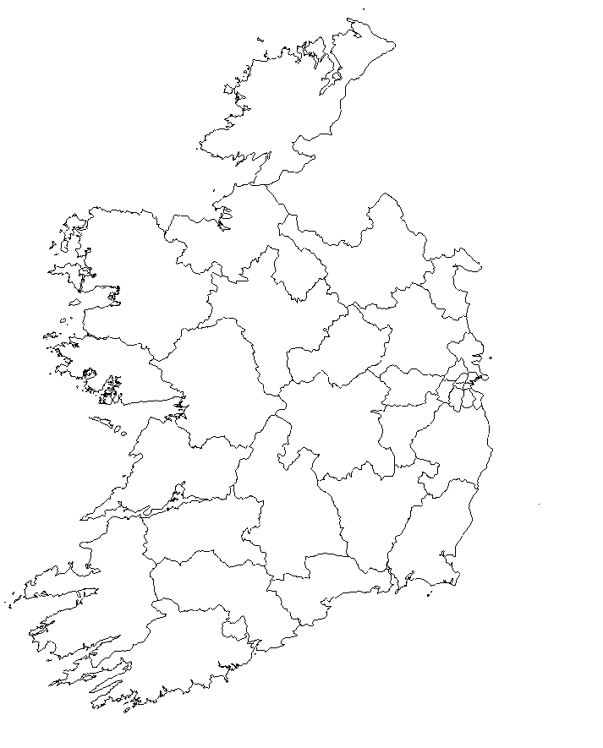

Figure 4. Proposed Dáil constituencies map. Source: own work.
In total, 172 seats are distributed between 34 constituencies, being the average magnitude

5.06, almost a seat above the current one (4.10). The highest quotient of ratios is 1.2629, and the highest ratio deviation from the national one is 11.95% (Sligo-Leitrim). There is only one three-seater (Westmeath) and eleven four-seaters (1.50 times less than under the current scheme), while almost two-thirds of the constituencies have five or more seats, in contrast with the current one-third proportion. Constituency descriptions and divisions are detailed in the Schedule. Before moving to the conclusions, I would like to justify my opposition to a fixed-boundary constituency scheme from a constitutional perspective.

The constitutional equal representation principle in Ireland has three main implications:

equal or not excessively diverse constituency ratios, a national ratio between 20,000 and

30,000 inhabitants and a minimum district magnitude of three. Its reform is controversial and attempts to make current limits less strict have been rejected (Gallagher, 2000:87). A reform to establish fixed-boundary constituencies could be discarded on similar grounds, as it would relax the principle of equal representation to favour territorial representation. Not only would it contravene current constitutional setting, but also this proposal targets.

First, it would entitle each constituency a minimum magnitude. Hence, δ and γ would be infinite. In practice, ratio deviations might not be that high, but they would not be limited: in case the least populated constituency became almost uninhabited, it would be entitled to a minimum representation. Territorial representation always implies higher deviations. For example, provincial constituencies in the Spanish lower chamber are allocated two seats at least (one in the case of the autonomous cities of Ceuta and Melilla). In the last general election, the ratio in Madrid (177,786) was four times the ratio in Soria (44,800). The national ratio was 133,494. An even more extreme case is observed in the insular constituencies to the Canary Islands regional parliament, where the minimum magnitude is three seats regardless of the population. In the last regional election, the ratio in Tenerife
(60,314) was almost seventeen times higher than the ratio in the tiny El Hierro (3,599). The regional ratio was 34,880 (30,396 if at-large seats are included). Any fixed-boundary constituency scheme would be inadmissible in Ireland, where it would constitute a serious
infraction of the rule in O’Donovan.

Second, some constituencies would experience a sizeable magnitude increase. While this might not pose a problem under party-list PR systems, it has already been explained why this is needless under PR-STV. However, this would not be unconstitutional. What would be is a maximum magnitude limit for fixed-boundary constituencies. For instance, if it was nine seats, the national divisor would be calculated in such a manner that it ensured the most populated constituency would not exceed that limit. However, the resulting Dáil might vulnerate the constitutional ratio of 20,000–30,000 inhabitants per TD because an excessively high divisor would allocate a lesser number of seats and, thus, would increase the national ratio. It is possible to alter the current constitutional ratio, which has remained unchanged for a century in spite of the population increase since independence. Even if such a reform was carried out, it would not ensure constituencies a minimum three-seat magnitude, and if such a minimum was eliminated, apportionment theory shows that inequalities increase proportionally to minimum magnitude decrease. In sum, under no circumstances would fixed-boundary constituency schemes be compatible with the Irish Constitution, while semi-rigid ones can ensure both territorial coherence and adaptability to population change.
Conclusion

The Irish Dáil electoral system is a particular case from a comparative perspective due to its particular combination of limited reapportionment and frequent redistricting. Both the PR-STV voting method and the strict equal representation principle interpretation has led the Irish Government (and, later, constituency commissioners) to alter the electoral map constantly. Although O’Donovan does not require mathematical precision, Ireland lacks,

sixty years later, any criteria to determine which ratio inequality level should be ruled out. Moreover, certain attachment to administrative limits is deemed acceptable. The effect of this High Court ruling has been deemed significantly effective in reducing divergences, as well as a more frequent constituency revision (in fact, it has dropped to half the period it used to take). However, the abuse of three and four-seaters leads to extreme ratios. This has been quantitatively measured through the variable ‘average constituency magnitude’.

In view to the next Dáil constituency boundaries revision, it is possible to set a procedure which avoids casuistic, rather volatile districts, which actually are in flagrant violation of current statutes. Not only constituency schemes are contrary to them, but also some parts of them: there is no point in mandating territorial coherence and, at the same time, such a low maximum magnitude, as it favours redistricting over reapportionment. Figures show the impact of avoidable divisions on equal representation: three-seaters are more likely to cause inequalities, although they represent almost a quarter of the total. While some minor territorial adjustments seem reasonable to avoid impractical, entangled, long vote counts in oversized constituencies, it is not worth establishing constituencies which are obsolete from one to another Census. My proposal brings a flexible, but more systematic, revision procedure, which would bring another desirable consequence: new scheme readiness for
any possible snap election after a Census publication. This issue was raised in O’Malley:

in the event of a snap election, most mainland European countries face no problem. They
just carry out an automatic reapportionment, while in the Irish case excessive delay might result in unconstitutional constituencies actually returning newly elected TD. It cannot be acceptable from a constitutional perspective.

Current try-and-error revision would be replaced by the use of an unbiased divisor-based formula (slightly corrected to avoid excessive divergences in the lowest magnitudes) and a district level demarcation, which follows a double principle of necessity and territorial coherence. This semi-automatic process would lead to less submissions and complaints, as municipal districts have already been constituted considering local identities, policies, and territorial issues. While a fixed-boundary scheme is counterproductive for a PR-STV system (and unconstitutional), a semi-rigid approach brings gains in revision quickness and effectiveness. Besides, co-ordination between local and national representatives can increase coherence between government levels and representatives’ and voters’ bases stability, as well as legal certainty.

This proposal would only require statutory changes, avoiding constitutional amendments. Its codification can set the criteria for future revisions, changing current rules in a subtle, moderate manner. Resulting constituency magnitudes would be no larger than those used for local elections in recent years, so the only actual innovation is introducing a formula which effectively and explicitly limits deviation, putting an end to decades of controversy.
Recently (and partially) commenced Electoral Reform Bill, 2022 is expected to regulate

forthcoming Dáil constituencies revision. A reform on its Section 57(2) would suffice to incorporate, once and for all, a more rational paradigm which puts an end to unnecessary constituency volatility.
References

Balinski, M. L. & Young, H. P. (1982). Proportional Representation. Meeting the ideal of One Man, One Vote. Yale University Press, New Haven.

Boyle, R. et al. (2020). Municipal Districts: A Review. Local Government Research

Series, 18. Institute of Public Administration, Dublin.

Callanan, M. (2018). The sanctity of the county in Irish public life: here to stay or passed
its ‘sell-by’ date? Irish Political Studies, 33(4), 589–607. https://doi.org/10.1080/07907184.2018.1465412

Central Statistics Office (multiple years). Census Reports. Dublin.

Coakley, J. (2015). Fixed-Boundary Constituencies and the Principle of Equal
Representation in Ireland. Irish Political Studies, 30(4), 531–554. https://doi.org/10.1080/07907184.2015.1099040

Droop, H. R. (1881). On Methods of Electing Representatives. Journal of the Statistical

Society of London, vol. 44, no. 2, 141-202.

Farrell, D. M. et al. (1996). Designing Electoral Institutions: STV Systems and their

Consequences, Political Studies, 44 (1), 24-43.

Gallagher, M. (1992). Comparing Proportional Representation Electoral Systems: Quotas, Thresholds, Paradoxes and Majorities. British Journal of Political Science, 22(4),
469–496.

https://doi.org/10.1017/s0007123400006499

Gallagher, M. (2000). The (Relatively) Victorious Incumbent under PR-STV: Legislative Turnover in Ireland and Malta. In Bowler, S., & Grofman, B. N. (2000). Elections in Australia, Ireland, and Malta under the Single Transferable Vote: Reflections on an embedded institution, pp. 81-113. University of Michigan Press.

Government of Ireland (2018). Local Electoral Area Boundary Committee No. 1 & No.

2 Report 2018. Available at: https://boundarycommittee.ie/

Handley, L. (2008). A Comparative Survey of Structures and Criteria for Boundary Delimitation. In Grofman, B. & Handley, L. (2008). Redistricting in Comparative Perspective, pp. 265–283. Oxford University Press, New York.
Kavanagh, A. (2003). The Constituency Commission. Irish Political Studies, 18(2), 89–

99. https://doi.org/10.1080/1364298042000227677

Kavanagh, A. (2014). All changed, changed utterly? Irish general election boundary amendments and the 2012 Constituency Commission Report. Irish Political Studies,
29(2), 215–235. https://doi.org/10.1080/07907184.2013.827667

McElroy, G. (2017). Party Competition in Ireland: The emergence of a left right dimension? In Marsh, M. et al.: A Conservative Revolution? Electoral Change in 21st Century Ireland (pp. 61-82). Oxford University Press.

Ogbazghi, P. B. (2020). Breaking the mould of centralization? Path dependence and Local Government Reform in Ireland: 1898–2014. International Journal of Public Administration, 45(4), 346–363.
https://doi.org/10.1080/01900692.2020.1765797

Samuels, D. & Snyder, R. (2001). The value of a vote: Malapportionment in comparative perspective. British Journal of Political Science, 31(4).
https://doi.org/10.1017/s0007123401000254

Venice Commission. (2017). Report on Constituency Delineation and Seat Allocation.

Additional bibliography

Bowler, S. & Grofman, B. N. (2000). Elections in Australia, Ireland, and Malta under the Single Transferable Vote: Reflections on an embedded institution. University of Michigan Press.

Coakley, J. (2008a). Does Ireland need a constitution commission? Administration, 55 (4): 77-114. Institute of Public Administration, Dublin.

Coakley, J. (2008b). Electoral Redistricting in Ireland. In Grofman, B. & Handley, L. (2008). Redistricting in Comparative Perspective (pp. 265–283). Oxford University Press, New York.
Farrell, B. The Irish general election, 1977. (1978). Parliamentary Affairs, 22-36. https://doi.org/10.1093/oxfordjournals.pa.a054240

Farrell, D. M. (1998). Comparing Electoral Systems, MacMillan Press, London.
Mair, P. (1986). Districting Choices Under the Single Transferable Vote. In Grofman, B. N. & Lijphart, A. (1986). Electoral Laws and Their Political Consequences, pp. 289-307. Agathon Press, New York.

Paddison, R. (1976). Spatial bias and redistricting in Proportional Representation Election Systems: A case-study of the Republic of Ireland. Tijdschrift Voor Economische En Sociale Geografie, 67(4), 230–241.
https://doi.org/10.1111/j.1467-9663.1976.tb00115.x

Quinlivan, A. (2015). The 2014 local elections in the Republic of Ireland. Irish Political
Studies, 30(1), 132–142. https://doi.org/10.1080/07907184.2014.990959

Quinlivan, A. (2017). Reforming local government: Must it always be democracy versus efficiency? Administration, 65 (2), 109-126.
http://dx.doi.org/10.1515/admin-2017-0017
SCHEDULE

Proposed Dáil constituencies:

CARLOW-KILKENNY. The county of Carlow and the county of Kilkenny. CAVAN-MONAGHAN. The county of Cavan and the county of Monaghan. CLARE. The county of Clare.
CORK CITY. The city of Cork.

CORK NORTH-EAST. In the county of Cork, the municipal districts of: Cobh, East Cork, Fermoy and Kanturk-Mallow.
CORK SOUTH-EAST. In the county of Cork, the municipal districts of:

Bandon-Kinsale, Carrigaline, Macroom and West Cork. DONEGAL. The county of Donegal.
DUBLIN BAY NORTH. In the city of Dublin, the electoral divisions of:

Ayrfield, Ballybough A, Ballybough B, Beaumont A, Beaumont B, Beaumont C, Beaumont D, Beaumont E, Beaumont F, Clontarf East A, Clontarf East B, Clontarf East C, Clontarf East D, Clontarf East E, Clontarf West A, Clontarf West B, Clontarf West C, Clontarf West D, Clontarf West E, Drumcondra South A, Drumcondra South B, Edenmore, Grace Park, Grange A, Grange B, Grange C, Grange D, Grange E, Harmonstown A, Harmonstown B, Kilmore A, Kilmore B, Kilmore C, Kilmore D, Mountjoy A, Mountjoy B, North City, North Dock A, North Dock B, North Dock C, Priorswood A, Priorswood B, Priorswood C, Priorswood D, Priorswood E, Raheny-Foxfield, Raheny- Greendale, Raheny-St. Assam, Rotunda A, Rotunda B and Whitehall D.

DUBLIN BAY SOUTH. In the city of Dublin, the electoral divisions of:
Mansion House A, Mansion House B, Pembroke East A, Pembroke East B, Pembroke East C, Pembroke East D, Pembroke East E, Pembroke West A, Pembroke West B, Pembroke West C, Rathfarnham, Rathmines East A, Rathmines East B, Rathmines East C, Rathmines East D, Rathmines West A, Rathmines West B, Rathmines West C, Rathmines West D, Rathmines West E, Rathmines West F, Royal Exchange A, Royal Exchange B, Saint Kevin’s, South Dock, Wood Quay A and Wood Quay B.

DUBLIN CENTRAL NORTH. In the city of Dublin, the electoral divisions of:

Arran Quay A, Arran Quay B, Arran Quay C, Arran Quay D, Arran Quay E, Ashtown A, Ashtown B, Ballygall A, Ballygall B, Ballygall C, Ballygall D, Ballymun A, Ballymun B, Ballymun C, Ballymun D, Ballymun E, Ballymun F, Botanic A, Botanic B, Botanic C, Cabra East A, Cabra East B, Cabra East C, Cabra West A, Cabra West B, Cabra West C, Cabra West D, Drumcondra South C, Finglas North A, Finglas North B, Finglas North C, Finglas South A, Finglas South B, Finglas South C, Finglas South D, Inns Quay A, Inns Quay B, Inns Quay C, Phoenix Park, Whitehall A, Whitehall B and Whitehall C.

DUBLIN CENTRAL SOUTH. The city of Dublin, except the parts thereof which are comprised in the constituencies of Dublin Bay North, Dublin Bay South and Dublin Central North.

DUBLIN MID-WEST. In the county of South Dublin, the electoral divisions of:

Clondalkin-Cappaghmore, Clondalkin-Dunawley, Clondalkin-Moorfield, Clondalkin-Rowlagh, Clondalkin Village, Lucan-Esker, Lucan Heights, Lucan-St. Helens, Newcastle, Palmerston Village, Palmerston West, Rathcoole, Saggart;
and that part of the electoral division of Clondalkin- Monastery situated west of a line drawn along the M50
Western Parkway.
DUBLIN NORTH. In the county of Fingal, the electoral divisions of: Balbriggan Rural, Balbriggan Urban, Baldoyle, Balgriffin,

Ballyboghil, Balscadden, Clonmethan, Donabate, Garristown, Hollywood, Holmpatrick, Howth, Kinsaley, Lusk, Malahide East, Malahide West, Portmarnock North, Portmarnock South, Rush, Skerries, Sutton, Swords Village, Swords-Forrest, Swords-Glasmore, Swords- Lissenhall and Swords-Seatown.

DUBLIN RATHDOWN. In the county of Dún Laoghaire-Rathdown, the electoral divisions of:

Ballinteer-Broadford, Ballinteer-Ludford, Ballinteer- Marley, Ballinteer-Meadowbroads, Ballinteer- Meadowmount, Ballinteer-Woodpark, Churchtown-Castle, Churchtown-Landscape, Churchtown-Nutgrove, Churchtown-Orwell, Churchtown-Woodlawn, Clonskeagh-Belfield, Clonskeagh-Farranboley, Clonskeagh-Milltown, Clonskeagh-Roebuck, Clonskeagh- Windy Arbour, Dundrum-Balally, Dundrum-Kilmacud, Dundrum-Sandyford, Dundrum-Sweetmount, Dundrum- Taney, Foxrock-Carrickmines, Foxrock-Torquay, Glencullen, Stillorgan-Deerpark, Stillorgan-Kilmacud, Stillorgan-Leopardstown, Stillorgan-Merville, Stillorgan- Mount Merrion and Tibradden.

DUBLIN SOUTH-WEST. The county of South Dublin, except the parts thereof which are comprised in the constituency of Dublin Mid-West.

DUBLIN WEST. The county of Fingal, except the parts thereof which are comprised in the constituency of Dublin North.
DÚN LAOGHAIRE. The county of Dún Laoghaire-Rathdown, except the parts thereof which are comprised in the constituency of Dublin Rathdown.

GALWAY EAST. In the county of Galway, the municipal districts of: Athenry, Ballinasloe, Loughrea, and Tuam.
GALWAY WEST. The city of Galway;

and, in the county of Galway, the municipal district of

Conamara.

KERRY. The county of Kerry.

KILDARE NORTH. In the county of Kildare, the municipal districts of: Celbridge-Leixlip and Clane-Maynooth.
KILDARE SOUTH. In the county of Kildare, the municipal districts of: Athy, Kildare-Newbridge and Naas.
LAOIS-OFFALY. The county of Laois and the county of Offaly. LIMERICK. The city and county of Limerick.
LONGFORD-ROSCOMMON. The county of Longford and the county of Roscommon. LOUTH. The county of Louth.
MAYO. The county of Mayo. MEATH. The county of Meath.
SLIGO-LEITRIM. The county of Sligo and the county of Leitrim. TIPPERARY. The county of Tipperary.
WATERFORD. The city and county of Waterford. WESTMEATH. The county of Westmeath. WEXFORD. The county of Wexford. WICKLOW. The county of Wicklow.
Proposed Dáil constituencies in Co. Cork:

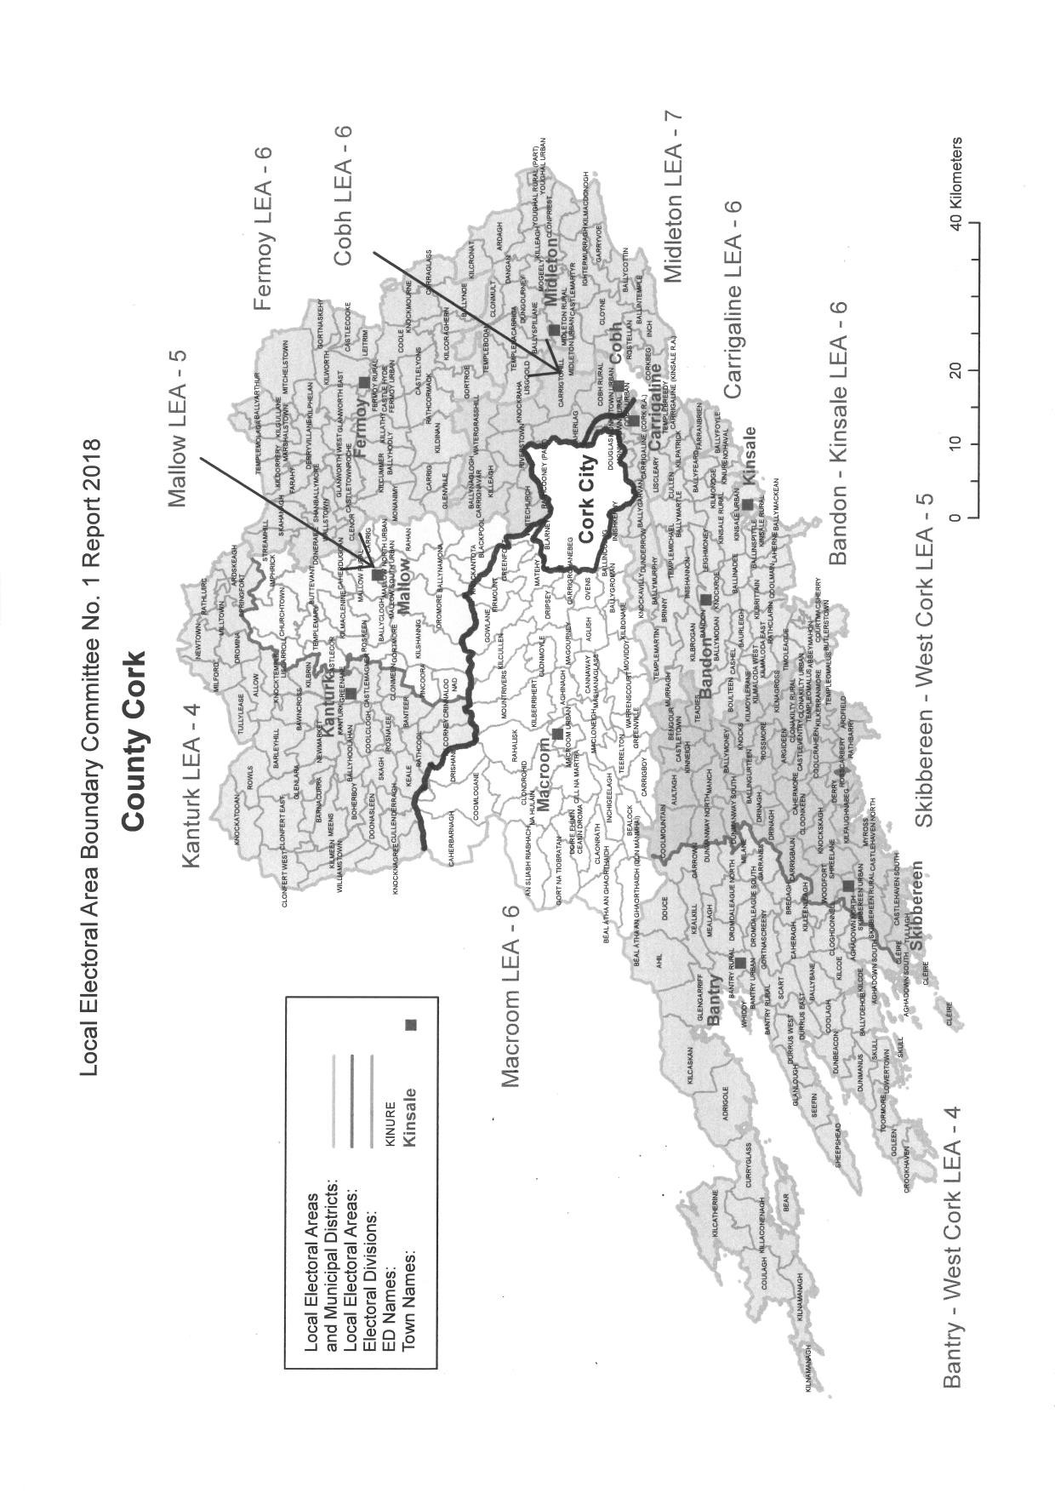

Figure 5. Proposed Dáil constituencies in Co. Cork. Map source: LEA Boundary Committee No. 1.
Proposed Dáil constituencies in Dublin City:

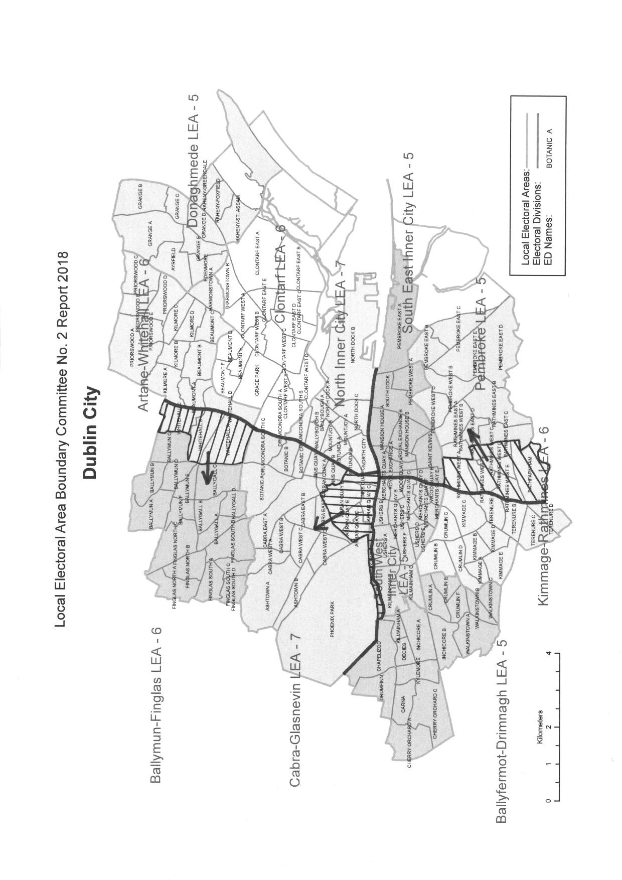

Figure 6. Proposed Dáil constituencies in Dublin City. Map source: LEA Boundary Committee No. 2.
Proposed Dáil constituencies in South Dublin:

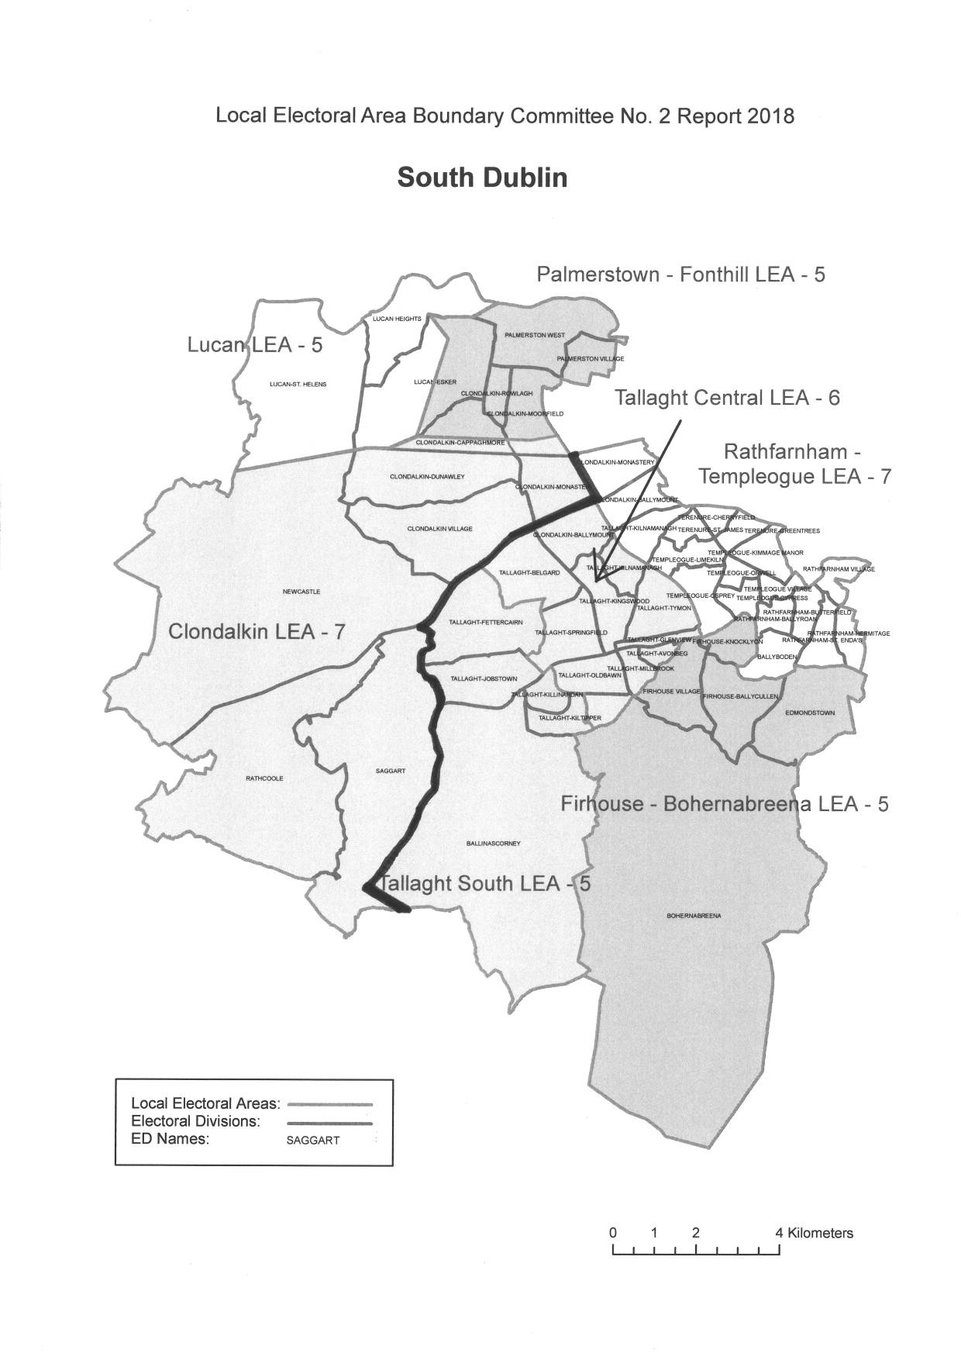

Figure 7. Proposed Dáil constituencies in South Dublin. Map source: LEA Boundary Committee No. 2.
Proposed Dáil constituencies in Fingal:

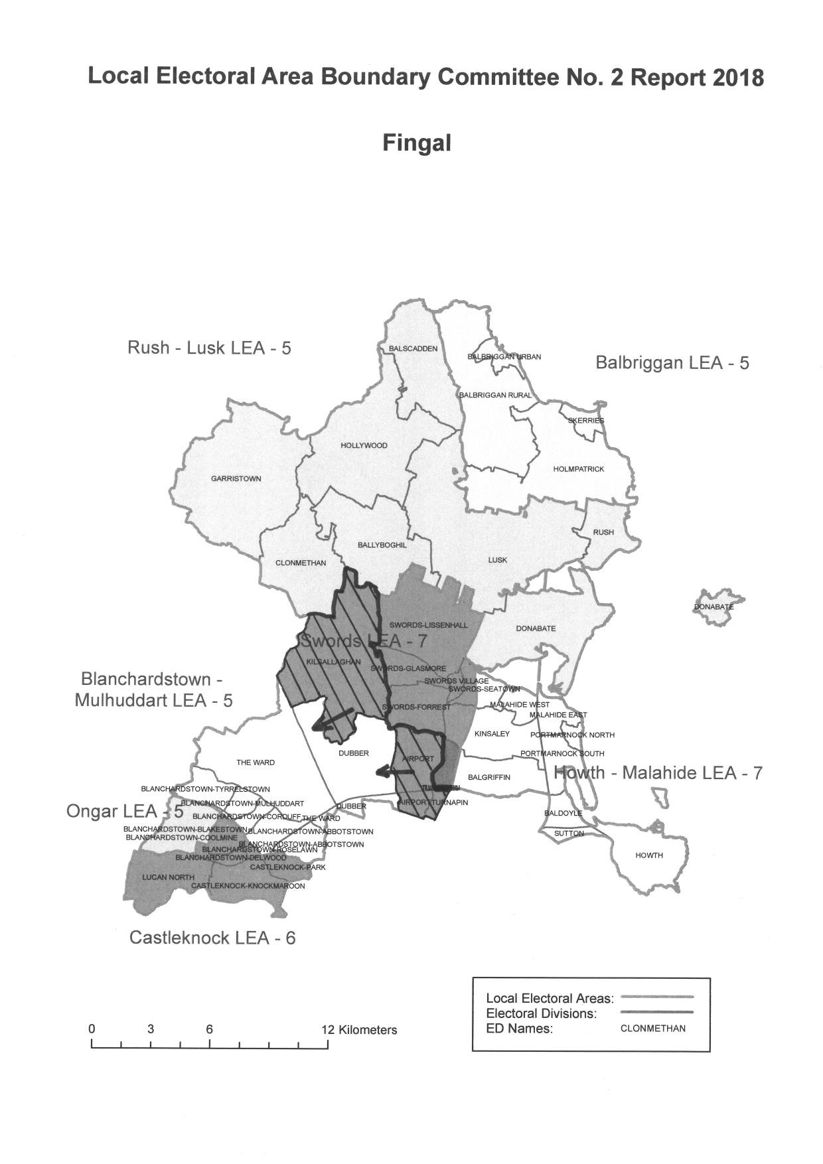

Figure 8. Proposed Dáil constituencies in Fingal. Map source: LEA Boundary Committee No. 2.
Proposed Dáil constituencies in Dún Laoghaire-Rathdown:

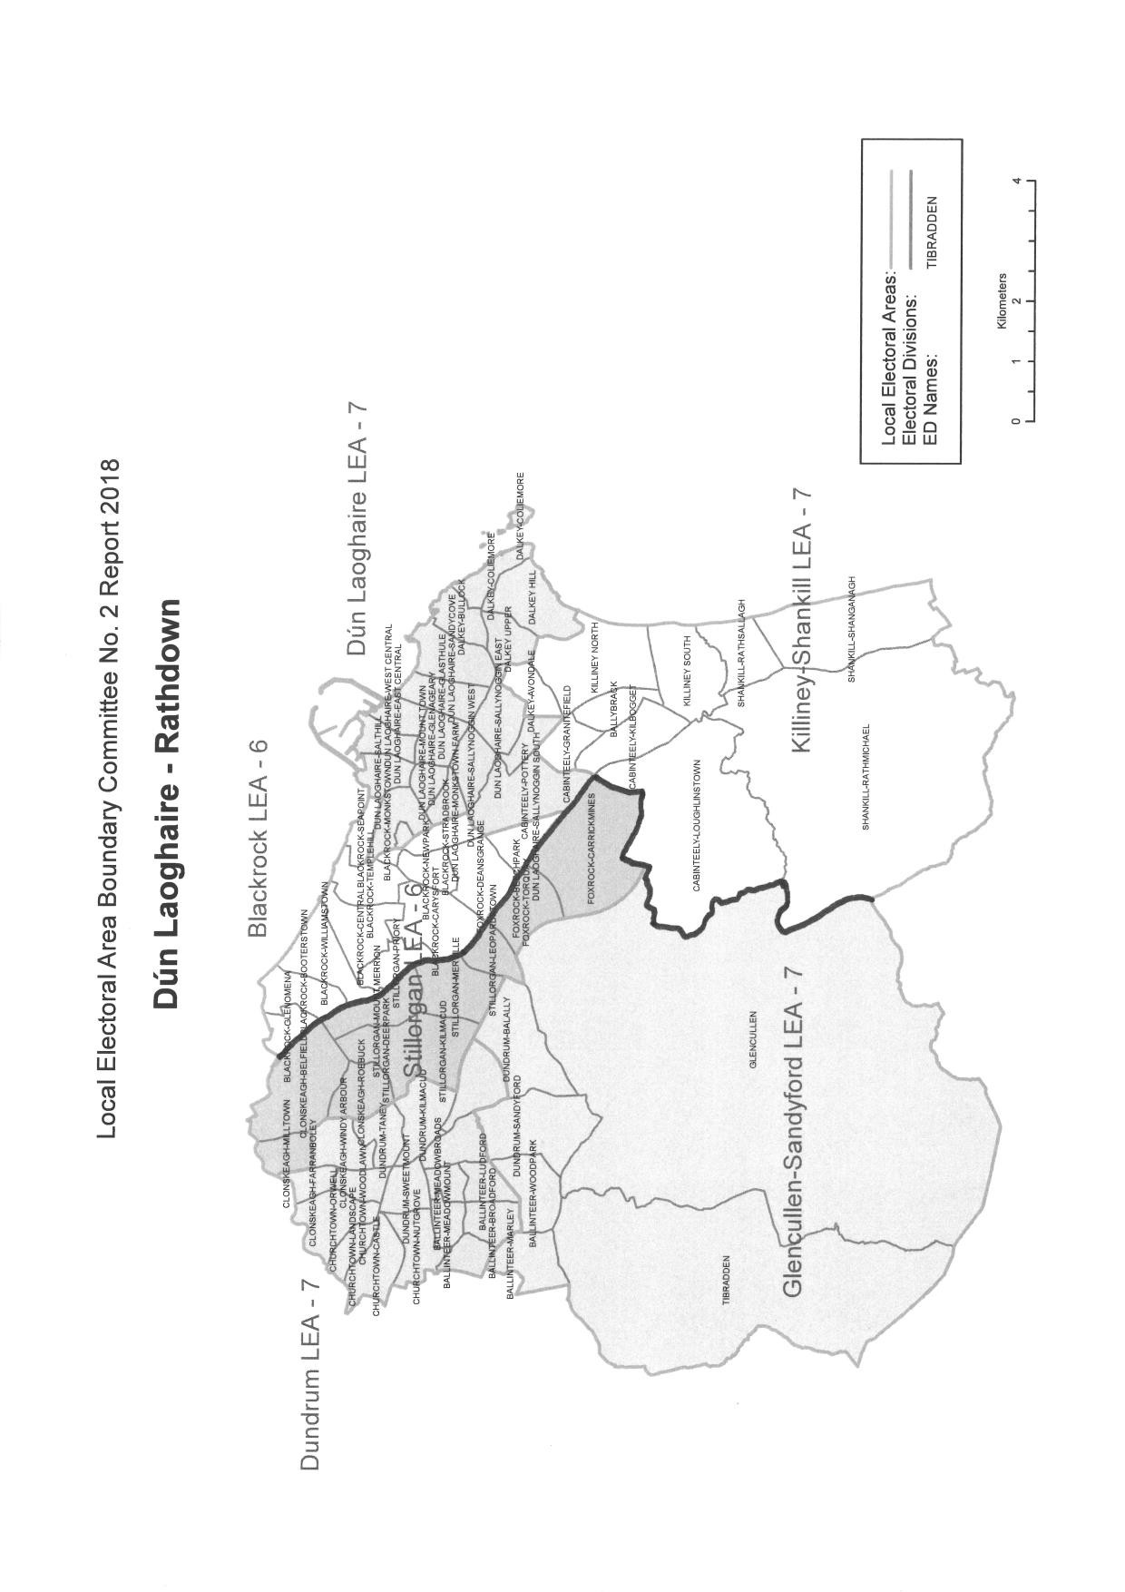

Figure 9. Proposed Dáil constituencies in DLR. Map source: LEA Boundary Committee No. 2.
Proposed Dáil constituencies in Co. Galway:

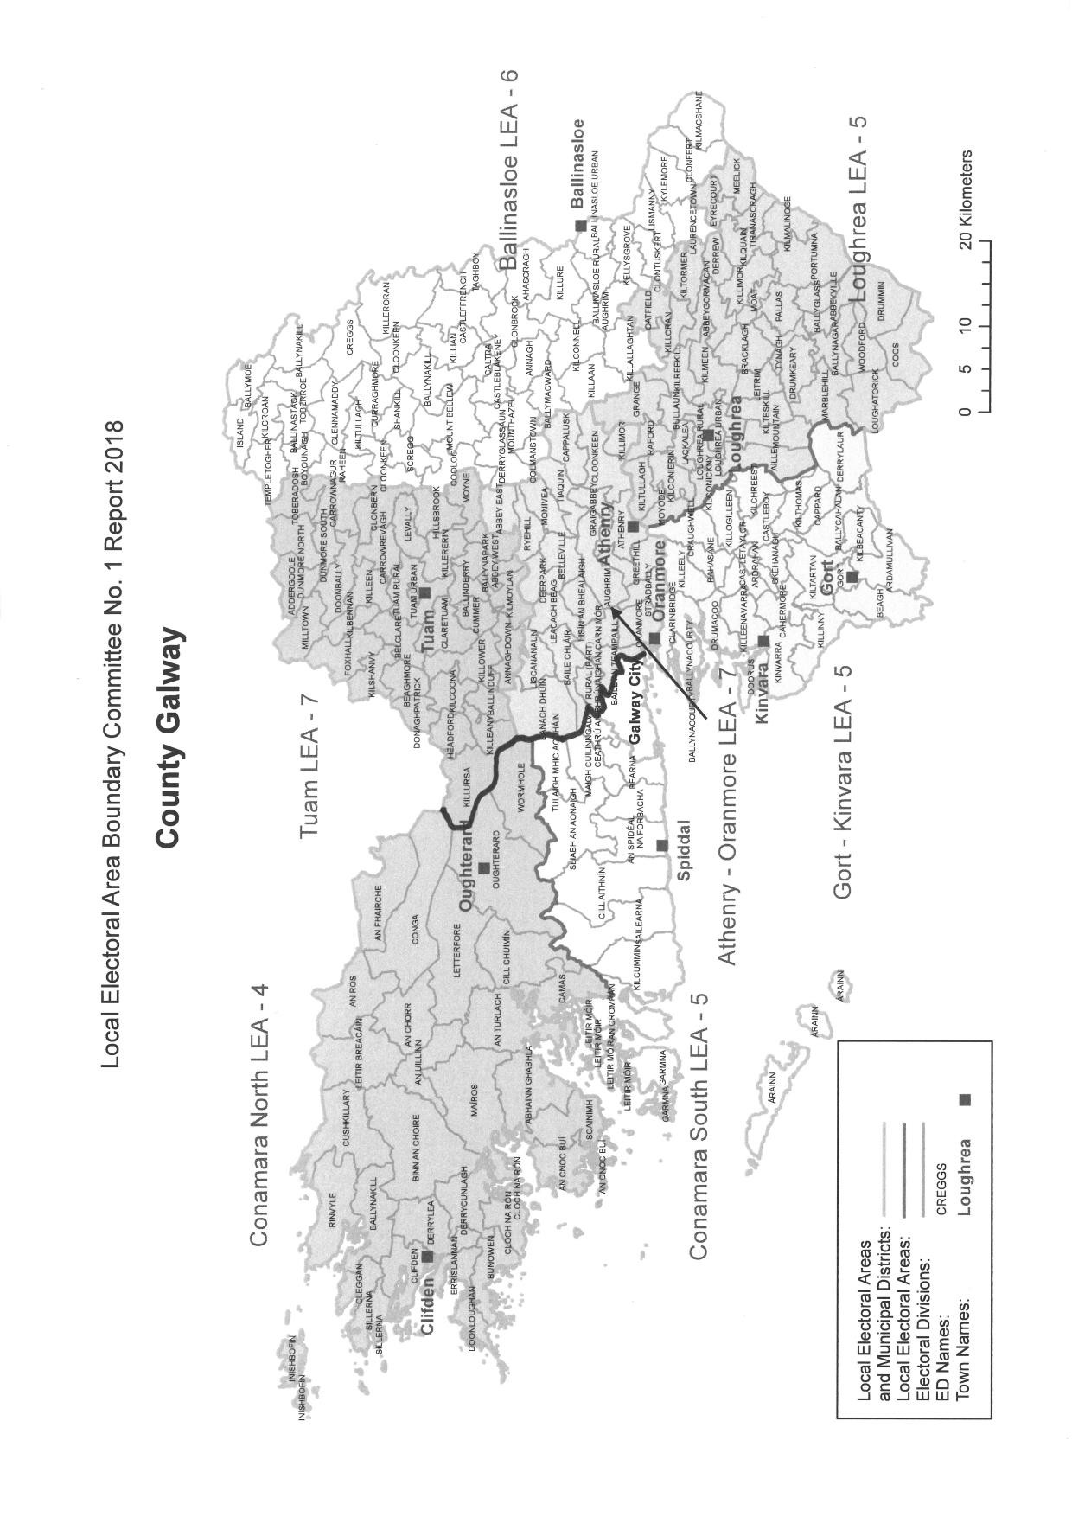

Figure 10. Proposed Dáil constituencies in Co. Galway. Map source: LEA Boundary Committee No. 1.
Proposed Dáil constituencies in Co. Kildare:

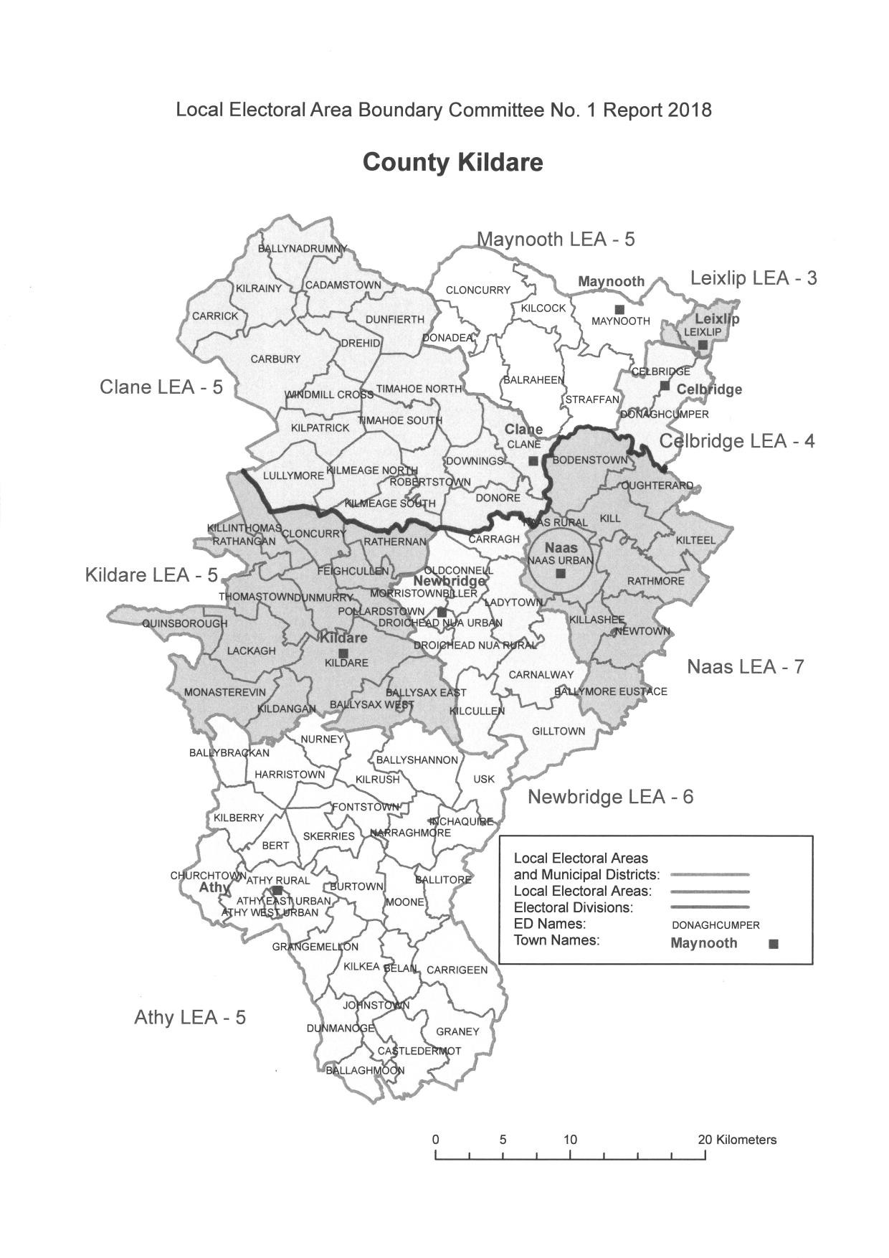

Figure 11. Proposed Dáil constituencies in Co. Kildare. Map source: LEA Boundary Committee No. 1.

40

