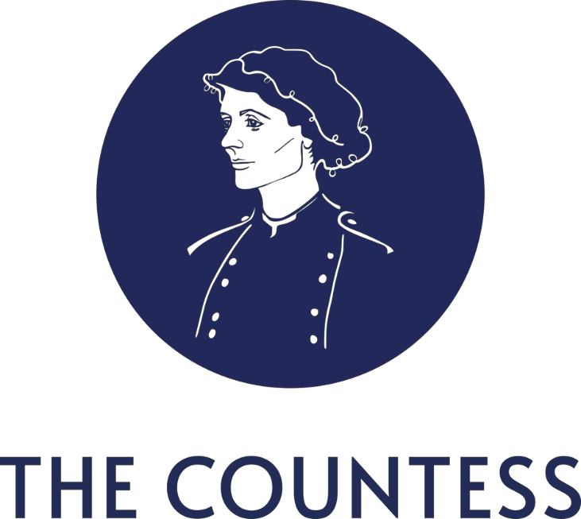

General Observations on the Electoral Commission’s Draft Research Programme

2024 - 2026

Submitted by The Countess CLG

About The Countess CLG

The Countess CLG1 is a legally registered Irish civil society organisation that campaigns to highlight the impact of gender self-identification as permitted by the Gender Recognition Act, 2015 on the rights of women and girls in Ireland. We have a broad interest in women’s rights and child safeguarding. Since being established in 2019 we have promoted constructive, respectful, and rights- focused dialogue on this issue. We wish to see a balanced approach to gender recognition that will:
•Vindicate the rights of women.
• Achieve best practice in safeguarding for children and young people.
• Defend the hard-won rights of same-sex attracted people.
• Ensure those with gender-questioning identities are treated equally to all others in society.

At our core is the belief that by virtue of our common humanity, all groups in society must be afforded the ability to live with dignity, respect, and safety.

General Observations on the Electoral Commission’s Draft Research Programme

The Electoral Commission has a mandate to protect and promote democracy and to act as a trusted source for advice and expertise regarding electoral events. The Commission has a responsibility to protect the democratic process through education and public engagement and to enable people to fully participate in democracy and electoral matters. The Countess CLG welcomes the Commission’s

1 The Countess - Advocating for Women and Girls in Ireland
‘focus on groups who have in the past been under-reached or marginalised from political and democratic processes2’.

Protecting Ireland’s democracy and electoral events from disinformation and misinformation.

In its capacity as a member of the National Counter Disinformation Strategy working group. the Commission has a central role to play in ensuring people have access to trustworthy and reliable information. In this capacity the Commission has an obligation to promote diversity and plurality of information and access to high quality ethical journalism3.

The NCDS working group will rely on input from a variety of listed stakeholders including the Institute for Strategic Dialogue. The ISD sits on two NCDS sub-committees. It is a reasonable assumption that the research and analysis produced by the ISD will be relied upon by the Electoral Commission and Government to formulate policy and practices to counter online threats to democracy.

We are concerned that by advocating for the rights of women to single sex spaces and sport a person or group may be classified as being part of the mis- and disinformation ecosystem.

The ISD has been granted a powerful position within the NCDS as an arbiter of what qualifies as
mis/disinformation.

The role of civil society organisations in promoting democracy.

One group of individuals currently under-served and marginalised by the democratic process are those who hold gender critical beliefs. Gender-critical beliefs are quite ordinary beliefs about the two sexes. If you believe that people are born male or female and grow up to be men or women and that laws, rules and policies that reflect this remain important, then you are “gender-critical”. This is sometimes summarised as saying sex is binary, immutable and important. People who are gender- critical do not believe that “trans women are women” or that “trans men are men”. This does not mean they want to harm people who identify as transgender5.

We trust that the Commission will be mindful of
these and any calls for disenfranchisement and will address them vigorously.

2 The Electoral Commission. Whatwe do .
3 National Counter Disinformation Strategy Group Scoping Paper 2023

5 A definintion of Gender Critical Beliefs.
Civil society organisations have a moral and legal obligation not to engage in the dissemination of misinformation or disinformation.

We trust that all misinformation and disinformation, regardless of where it emanates from, will be challenged by the Electoral Commission.

For more information about the information contained in this submission, please contact:

Sandra Adams, Schools and Safeguarding Lead, The Countess CLG Email:
The Countess CLG consents to the publication of this document by the Electoral Commission. January 23rd, 2024

4

5

6

7

8

