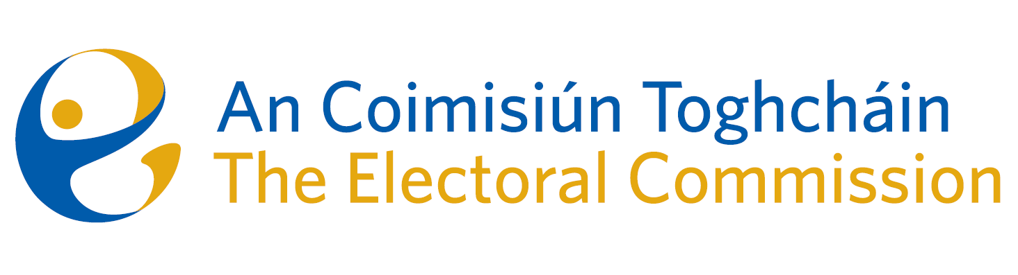
Agenda
Meeting #10/24 8.00am 6th August 2024 (1.5 hour)
Via Zoom
- Conflicts of Interest

For Discussion
- Appeal against National Party registration decision
  - Brief discussion on advice received and circulated 31st July.
  - Decision on appeal
  - Discussion on reasons for decision

