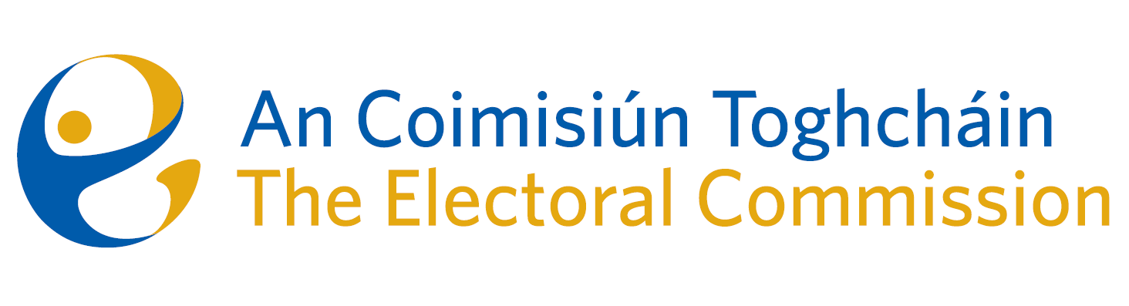
Agenda
Meeting #11/24 10.00am 12th September 2024 (2.5 hours)
Venue – ACT Boardroom – Dublin Castle

- Minutes of previous meeting (2 Mins)
- Conflicts of Interest
For Discussion
- General Election – campaign planning (20 mins – no paper)
- Draft Roadmap to a Public Engagement and Education Plan (30 mins,
Tim Carey)
- June Election results – NEDS data (25 mins – no paper)
- Corporate Dashboard Update – Budget and HR matters (25 mins Helen Codd, Emer Grenville)
For Decision
- Appeal against National Party Registration decision* (15 mins)
For information/noting
Commission L&D – Institute of Directors Cyber Security Fundamentals (for Directors) commencing on 15th October.
- AOB
- Date of next meeting 17th October 2024
*As registrar of Political Parties, the Chief Executive will absent himself from this agenda item

