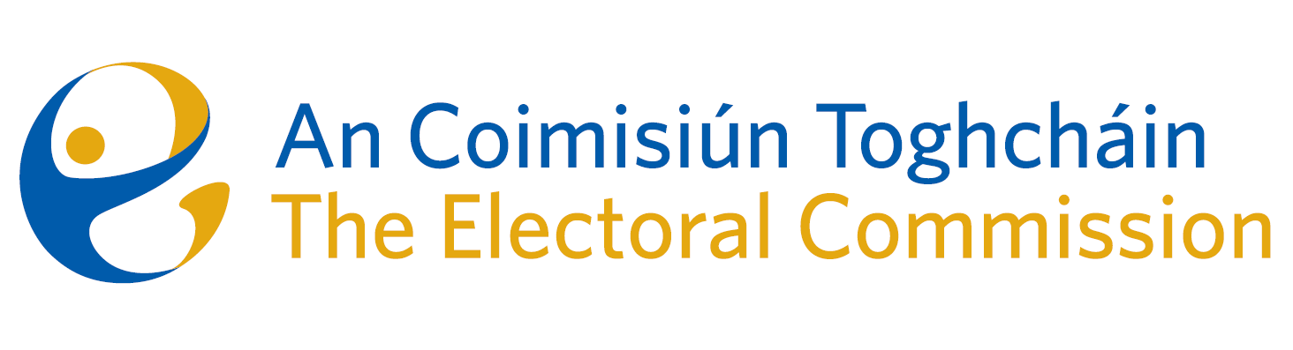
Agenda
Meeting #8/24, 10.00am 11th July 2024 (2.5 hours)
Venue – ACT Boardroom – Dublin Castle

- Minutes of previous meeting (2 Mins)
- Conflicts of Interest
For Discussion
- Review of June ’24 Local & European Elections (Chief Executive, 20 mins)
- Research Programme launch (Mary Clare O’Sullivan, 5 mins)
For Approval
- March PEER Report (Eunice Delaney, 15 mins)
6. March Referendum Report (Tim Carey, 5 mins)
- Budget estimates 2025 (Karen Kehily, 15 mins)
- Recommendation for appointment of two additional Commission Members (Chairperson and Chief Executive, 15 mins)
For Decision
- Risk Management Policy – Risk appetite (Karen Kehily, 10 mins)

For information/noting
- Note of Self Evaluation Working group
- Corporate Governance Framework
- AOB
- Date of next meeting 12th September 2024
- Appeal against National Party registration decision*

* The Chief Executive will absent himself for this agenda item

