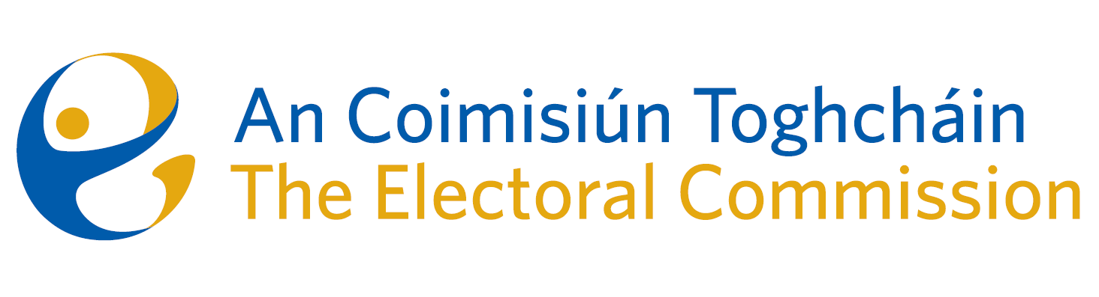
Agenda
Meeting #9/24 8.00am 24th July 2024 (1 hour)
via Zoom

- Conflicts of Interest

For Discussion
- Appeal against National Party registration decision

