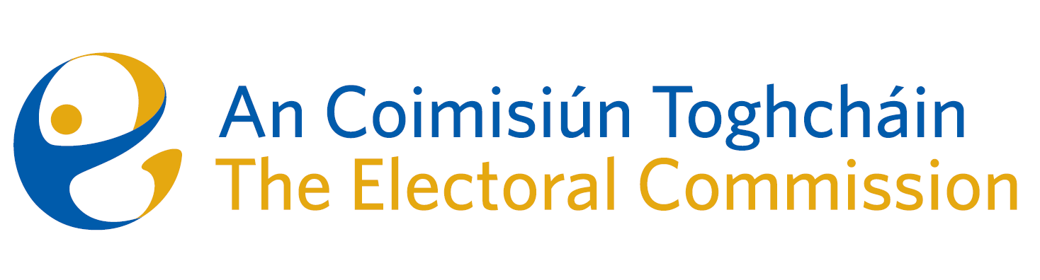
Meeting #10/24 of An Coimisiún Toghcháin (ACT), The Electoral Commission.

Held via Zoom 8.00am – 6th August 2024

In attendance:
Justice Marie Baker (Chairperson), Maura Quinn (MQ), Alex Attwood (AA), John Curran (JC), Ger Deering (GD), Caroline Fennell (CF).

An Coimisiún Executive: Karen Kehily (KK)

------------------------------------
- Welcome

The Chairperson welcomed members.

- Conflict of Interest

None declared

- Appeal against National Party registration decision

Commission members continued their consideration of the appeal and the meeting was adjourned for further discussion.

- AOB
None

_________________
Ms. Justice Marie Baker (signed)
Chairperson

