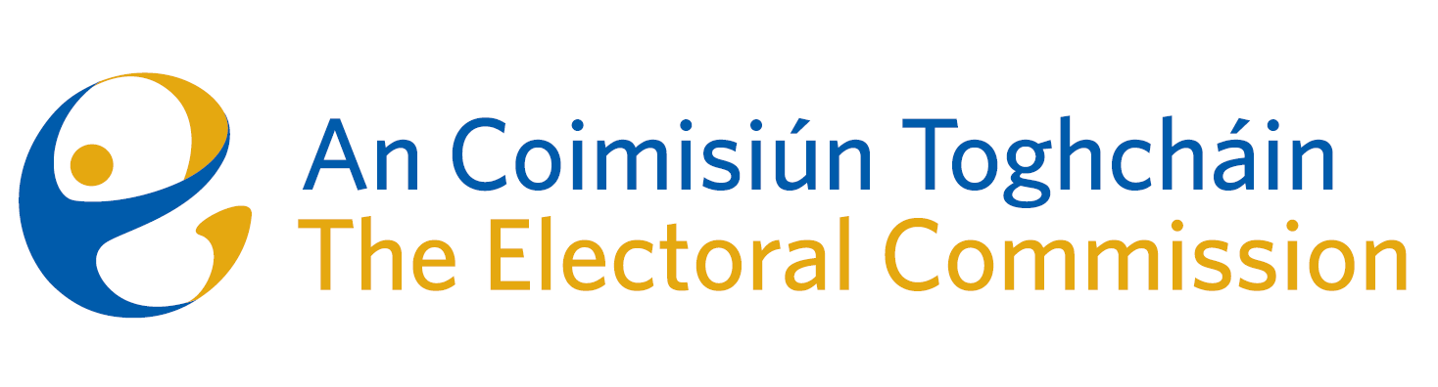
Meeting #09/24 of An Coimisiún Toghcháin (ACT), The Electoral Commission.

Held via Zoom 8.00am – Wednesday 24th July 2024

In attendance:
Justice Marie Baker (Chairperson), Maura Quinn (MQ), Alex Attwood (AA), John Curran (JC), Ger Deering (GD), Caroline Fennell (CF).

An Coimisiún Executive: Karen Kehily (KK)

------------------------------------
- Welcome

The Chairperson welcomed members.

- Conflict of Interest

A member of the Commission stated that in his former role as Registrar of Political Parties he registered the National Party on the Register of Political Parties. While it is believed that there is no conflict, it was agreed that the opportunity arises for a perceived conflict of interest and was recused from this meeting.

- Appeal against National Party registration decision

Commission members considered an appeal received on 30th April 2024 against the National Party registration decision. It was decided that a further meeting would be required and the meeting was adjourned.

- AOB
None

_________________
Ms. Justice Marie Baker (signed)
Chairperson

