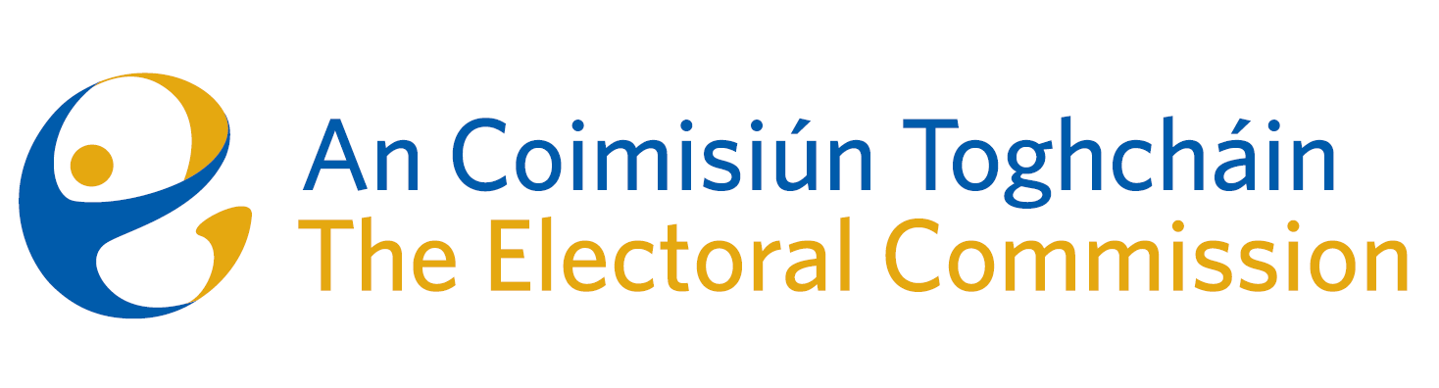
Meeting of An Coimisiún Toghcháin, The Electoral Commission.

ACT Boardroom, Dublin Castle| 10.00am | 12 September 2024

In attendance:
Justice Marie Baker (Chairperson), Alex Attwood* (AA), John Curran (JC), Ger Deering (GD), Caroline Fennell (CF)*, Peter Finnegan (PF) and Maura Quinn (MQ)

*Alex Attwood and Caroline Fennell attended the meeting remotely

Executive:
Art O’Leary (AOL), Mary Clare O’Sullivan (MCOS), Karen Kehily (KK), Tim Carey (TC)

Brian Dawson – Item 3, Sarah Keaveney and Séamus Byrne – Item 4, Dr Adam Whittle and Catherine Lynch – Item 5, Helen Codd and Emer Grenville – Item 6, Muireann Ní Thuairisg, (secretariat)
------------------------------------

- Welcome and Draft Minutes

The Chairperson welcomed members. The draft minutes from the meeting held on 11 July 2024 were approved.

- Conflict of Interest

Prior to the meeting, the Chief Executive notified the Commission members of a conflict of interest and it was agreed the Chief Executive would recuse himself from the discussion regarding agenda item number 7 – Appeal against The National Party.

- General Election – Campaign Planning

The Commission were updated on the planning underway in advance of the next General Election. While a General Election is yet to be called, members were informed that preparations are underway to roll out a public awareness campaign on the importance of registering to vote, how to vote and spoilt votes.

- Draft Roadmap to a Public Engagement and Education Plan

The Commission were briefed on the draft Public Engagement and Education Plan which sets out the proposed approach to the development of a multi-year education and engagement plan with three phases:
Phase I – Information and Stakeholder Engagement
Phase III - Meeting of Public Engagement & Education Forum
Phase II – Establishment of Working Groups
Commission members were invited to send any comments or feedback regarding the plan including and in particular the proposed membership of the Working Groups.
- June Election Results – NEDS data
The Commission were briefed on the National Education Democracy Study. A presentation on the data included themes such as;
- Voter Decisions & Motivations
- Knowledge & Trust
- Voting Experience
- Voter Registration
- Voters with Disabilities

- Corporate Dashboard - | HR and Finance Updates
Members were provided with an update on expenditure from January to August. The next Audit and Risk Committee meeting will take place on 16 September 2024.
Members also received an update on recruitment - there were 34 Full Time Equivalents (FTEs) currently in place with that number anticipated to increase to 40 by the end of 2024.
- Appeal against The National Party registration decision

The Chief Executive recused himself from the meeting.

The Commission decided to dismiss the appeal by James Reynolds under S.51 of the Electoral Reform Act 2022.

- Any Other Business
Date of next meeting – 17 October 2024.

_________________
Ms. Justice Marie Baker (signed)
Chairperson

