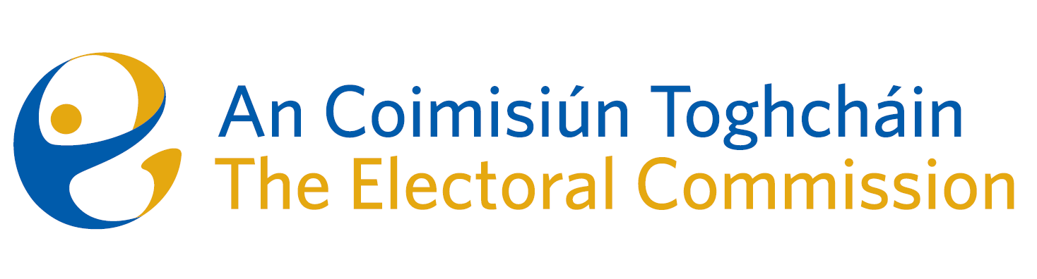
Meeting of An Coimisiún Toghcháin (ACT), The Electoral Commission.

Held in the ACT Boardroom, Dublin Castle, 10.00am – 11th July 2024

In attendance:
Justice Marie Baker (Chairperson), Maura Quinn (MQ), Alex Attwood* (AA), John Curran (JC), Ger Deering (GD), Caroline Fennell (CF) and Peter Finnegan (PF).

An Coimisiún Executive: Art O’Leary* (AOL), Mary Clare O’Sullivan (MCOS), Karen Kehily (KK), Tim Carey (TC), Eunice Delaney (ED – items 3 and 5), and Andrea Jones (secretariat)

*Alex Attwood and Art O’Leary attended the meeting remotely

------------------------------------
- Welcome

The Chairperson welcomed members.
The minutes from previous meeting were approved.

- Conflict of Interest

Prior to the discussion of agenda item number twelve, the Chief Executive notified the Chair and the Commission members of a conflict of interest. The Commission members acknowledged the conflict of interest and the Chief Executive recused himself from the discussion.

- Review of June ’24 Local and European Elections

The Commission were updated on the key findings observed by Electoral Commission staff during visits to 98 polling stations on European and Local Election polling day, 7th June 2024. These findings will form part of the June’24 post electoral event review (PEER) report, which will be published in quarter four of this year. In advance of the draft report publication and the possibility of a further electoral event later this year, the Commission have agreed to write to the Minister for Housing, Planning, Local Government and Heritage to highlight the preliminary findings of the review, along with the recurring findings identified from the March ’24 post electoral event review (PEER) report, to assist the Minister in planning and addressing voter concerns in advance of the next electoral event.

- Launch of Research Programme 2024-2026
The Commission were briefed on the launch of the ACT Research Programme 2024-2026, which took place on Wednesday 10th July at the Royal Irish Academy, Dawson Street.
The programme document sets out the vision and values underpinning An Coimisiún’s approach to its research and proposed suggested thematic strands to structure the research programme.
- March ’24 PEER Report
The Commission were provided with a copy of a draft March ’24 post electoral event review (PEER) report for consideration. The report will shortly be approved by the Commission and published in the coming weeks, in advance of being laid before the Houses of the Oireachtas before 8th September 2024.
- March ’24 Referendum Report
The Commission approved the March ’24 Referendum Report, which sets out the role and Referendum campaign of An Coimisiún Toghcháin for the proposed thirty-ninth amendment of the Constitution (The Family) Bill 2023, and the fortieth amendment of the Constitution (Care) Bill 2023. This report will be published on Monday 15th July.
- Budget Estimates 2025
In advance of Budget Day 2025 which will be held on 1st October 2024, the Commission discussed An Coimisiún Toghcháin submission of the ACT 2025 Budget estimate to the Department of Housing Local Government and Heritage. This submission will be collated as part of the Housing Vote Group submission to the Department of Public Expenditure, NDP Delivery and Reform.

- Recommendation for appointment of two additional Commission Members
The composition and skillset of the current Commission members were discussed by the Commission, along with the possibility of increasing membership by an additional two members, as allowed for in The Electoral Reform Act.

- Risk Management Policy – Risk appetite

The Risk Management Policy and recommendations on risk appetite was presented to the Commission for a formal decision. The Commission discussed and recommended review at regular intervals, as higher levels of Risk may be required during specific times/events.

- Noted by the Commission
- Note of Self Evaluation Working Group
- Corporate Governance Framework

- AOB
Legislation briefing on Parts 4 & 5 of the Electoral Reform Act.

- Appeal against National Party registration decision

Commission members considered an appeal received on 30th April 2024 against the National Party registration decision. This matter will be further considered by the Commission in the coming weeks.

Date of next meeting – 12th September 2024

_________________
Ms. Justice Marie Baker (signed)
Chairperson

