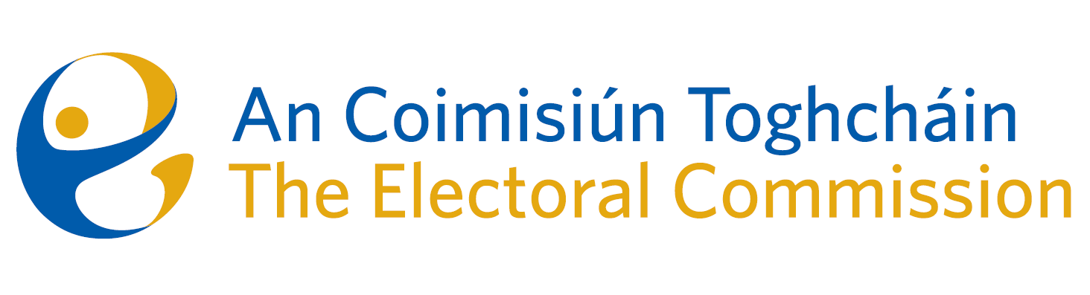
Agenda
Meeting #12/24 8am 17th October 2024 (2 hours)
Venue – ACT Boardroom – Dublin Castle

- Minutes of previous meeting (2 mins)
- Conflicts of Interest
For Discussion
- Amendment of Part 5 of the Electoral Reform Act (relating to mis/disinformation) – briefing from McCann Fitzgerald on the issues associated with new proposals (30 mins – papers attached)
- General Election – campaign planning (chief executive, 20 mins)
- Estimates 2025 (K Kehily, 15 mins)

For information/noting
- Research Update from the RAG
- Minutes of ARC Meeting – 11 June 2024
- Meeting Report of ARC Meeting – 16 September 2024
- Freedom of Information – DPENDR Central Policy Unit Guidance 24
- AOB
- Date of next meeting 14th November 2024
- 2025 Meeting Dates

