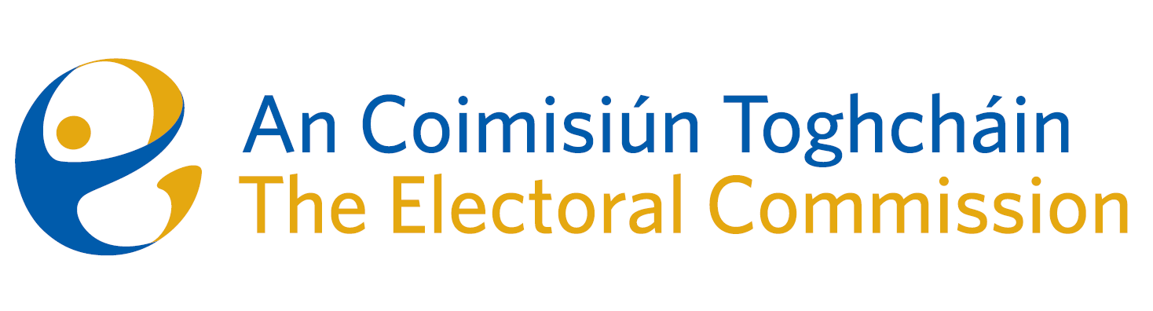
Meeting of An Coimisiún Toghcháin, The Electoral Commission.

ACT Boardroom, Dublin Castle| 8.00am | 17 October 2024

Attendance

An Coimisiún:
Justice Marie Baker (Chairperson), Alex Attwood (AA), John Curran (JC), Ger Deering (GD), Caroline Fennell (CF)*, Peter Finnegan (PF) and Maura Quinn (MQ)

* Caroline Fennell attended the meeting remotely

Executive:
Art O’Leary (AOL), Mary Clare O’Sullivan (MCOS), Karen Kehily (KK), Tim Carey (TC) Sean Garvey (SG), Eunice Delaney (ED) – Item 3 and Andrea Jones, (secretariat)

Adam Finlay (McCann Fitzgerald Solicitors) - Item 3
------------------------------------

- Welcome and Draft Minutes

The Chairperson welcomed members. The draft minutes from the meeting held on 12 September 2024 were approved.

- Conflict of Interest

No conflicts of interest were declared.

- Amendment of Part 5 of the Electoral Reform Act

The Commission were briefed on the proposed amendments to Part 5 of the Electoral Reform Act 2022 (the “2022 Act”), as set out in the version of General Scheme of the Electoral Reform (Amendment) Bill 2024 (the “General Scheme”). The General Scheme was submitted to the European Commission for consideration, and the comments and views of An Coimisiún on the proposed wording have been forwarded to the Department of Housing, Local Government and Heritage for consideration.

- General Election – Campaign Planning

The Commission were updated on the planning underway in advance of the next General Election. While a General Election has yet to be called, there is increased speculation that a General Election will take place in November 2024. For this reason and the tight turnaround for registering to vote, members were informed that preparations have already commenced, with plans in place to roll out a multi-phase public awareness campaign on all available media platforms to include;

- Voter Registration (how to register and deadline to register to vote)
- How to Vote
- How not to spoil a vote

- Estimates 2025

A financial overview of ACT estimates for Budget 2025 was provided to the Commission, along with an update on the progression of workforce planning in 2024, and a forecast for 2025.

- For information/noting
The below was noted by the Commission:
- Verbal Research Update from the Research Advisory Group. (The Commission were advised that a draft of the June PEER report is to be circulated in the coming days for comments, in order for the report to be finalised prior to the next meeting.)

- Minutes of Audit and Risk Committee Meeting – 11 June 2024
- Meeting Report of Audit and Risk Meeting – 16 September 2024
- Freedom of Information – Department of Public Expenditure, NDP Delivery and Reform Central Policy Unit Guidance 24

- Any Other Business
Meeting dates for Commission during 2025

Date of next meeting – 14 November 2024.

_________________
Ms. Justice Marie Baker (signed)
Chairperson

