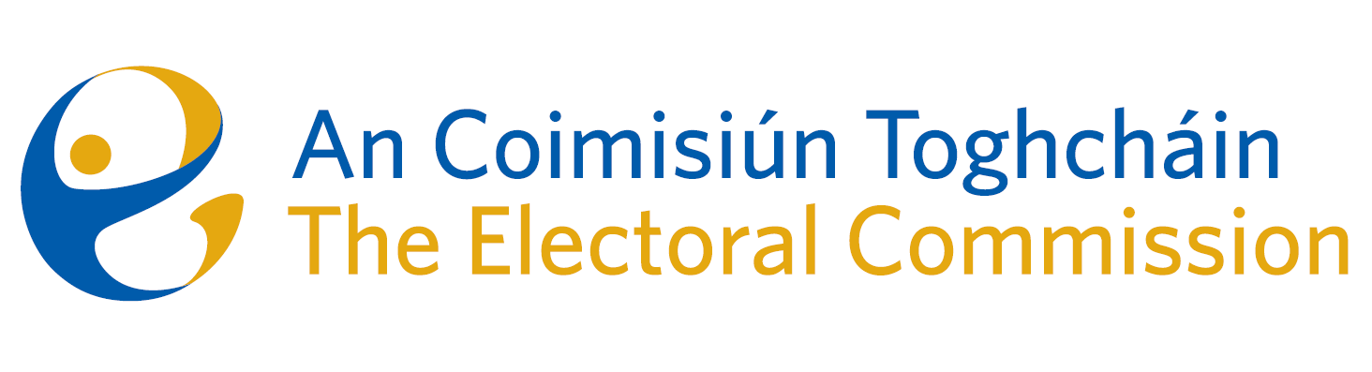
Agenda
Meeting #13/24 8.00am 14th November 2024 (2 hours)
Venue – ACT Boardroom – Dublin Castle

- Minutes of previous meeting (2 Mins)
- Conflicts of Interest
For Discussion
- General Election Campaign: Brian Dawson (15 mins)
- Briefing on Electoral Register Oversight Report: Tim Carey (20 mins)
- Update on parts 4 and 5 and the role of Coimisiún na Meán – AOL (10 mins)
For information/noting
- Post Electoral Event Review
  - - Approach to General Election PEER: Eunice Delaney & Anthony Trindle presentation (15 mins)
  - - June PEER: noting of final text & publication date (5 mins)
- Research Update from RAG – Mary Clare O’Sullivan (10 mins)
- Update on interviews for in-house lawyer – AOL (5 mins)
- Report ACT visit to India – document for noting.
- AOB
- Date of next meeting 12th December 2024
11. FileCloud Tutorial – 20 mins (Attendance is recommended if you have elected to receive meeting papers via a board portal).

