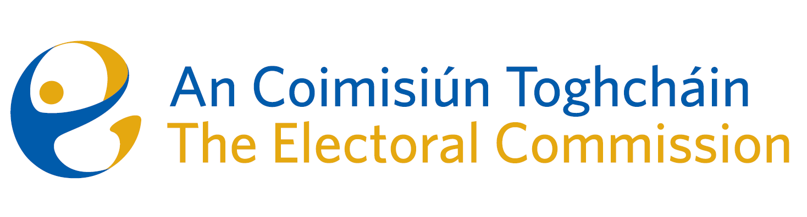
Meeting of An Coimisiún Toghcháin, The Electoral Commission.

ACT Boardroom, Dublin Castle| 8.00am | 14 November 2024

Attendance

An Coimisiún:
Justice Marie Baker (Chairperson), Alex Attwood* (AA), John Curran (JC), Ger Deering (GD), Caroline Fennell (CF), Peter Finnegan (PF) and Maura Quinn (MQ)

* Alex Attwood attended the meeting remotely

Executive:
Art O’Leary (AOL), Mary Clare O’Sullivan (MCOS), Karen Kehily (KK), Tim Carey (TC) Sean Garvey (SG), Brian Dawson (BD) – item 3, Eunice Delaney (ED) – item 6, Anthony Trindle – item 6, Hugh Burgess – item 6 and Andrea Jones, (secretariat)

------------------------------------

- Welcome and Draft Minutes

The Chairperson welcomed members.

The minutes from the previous meeting were approved.

- Conflict of Interest

No conflicts of interest were declared.

- General Election Campaign

The Commission were updated on the public information campaign for the General Election, which will be held on Friday 29 November.
The Commission were briefed on the three phase approach to the information campaign, target objectives of each phase, and the media and promotional events, both planned and already achieved, for this campaign.
The campaign includes a number of national radio, TV and podcasts, local community and Irish language radio, events in partnerships with targeted groups, and educational videos and content available through social media platforms and the official Electoral Commission website.

The Commission discussed the fundamental priority of the on line security and integrity of the Commission, and agreed a further discussion.

- Briefing on Electoral Register Oversight Report

The Commission were briefed on the development of the first electoral register oversight report.
The Commission has an oversight role in relation to the Electoral Register, and as such will propose to publish an annual report setting out their assessment of the status and functioning of the electoral register, and any recommendations the Commission considers necessary to maintain and enhance the integrity of the electoral register and the registration process.

The draft report will be further developed in the coming weeks, and reviewed by the Commission at the December meeting.

- Update on Parts 4 & 5 of the Electoral Reform Act 2022

The Commission were updated on the legislative progress for the enactment of part 4 and part 5 of the Electoral Reform Act 2022.

Once commenced the legislation will set out the responsibility of the Commission to ensure that political advertising on social media and other digital platforms is fully transparent and clearly identified (part 4), and to monitor, investigate, identify and combat mis-information, dis-information and inauthentic behaviour (part 5).

- Approach to General Election Post Electoral Event Review (PEER) and June PEER Report
The Commission were briefed on the advanced planning for the General Election PEER, which will take place on election day, 29 November. The polling stations identified for the PEER were selected from data sourced from previous reviews conducted in March and June 2024, and engagement with specific community groups and services. These factors include previous voter turnout, disability challenges, under resourced communities, geographic demographics and representations made by the general public.

The Commission were also updated on the June PEER Report and noted the final Report will be published on 6 December, in line with statutory requirements.

- Research update from the Research Advisory Group

The Chairperson of the Research Advisory Group updated the Commission on the progress to date and projected timelines of current research projects. The Commission welcomed the progress and discussed priority planning for research projects not yet commenced. This will be brought to the Research Advisory Group when it meets again in December.

- Legal Recruitment Update

The Commission were updated on the progress of the recruitment campaign to appoint a Head of legal at Principal Officer level.

- The below was noted by the Commission:

A report by the embassy of Ireland New Delhi, on the visit from the Chairperson and Chief Executive of the Electoral Commission to the Election Commission of India, between 21 – 26 October 2024.

- Any Other Business

Seanad Election date – 28 January 2025
Date of next meeting – 12 December 2024.

_________________
Ms. Justice Marie Baker (signed)
Chairperson

