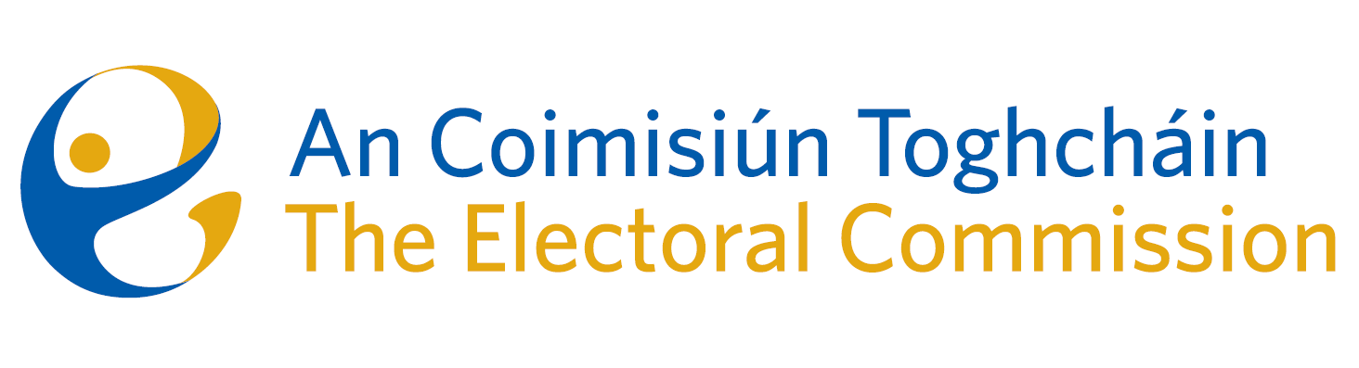
Agenda
Meeting #14/24 10.00am 12th December 2024 (2 hours)
Venue – ACT Boardroom – Dublin Castle
- Minutes of previous meeting (2 Mins)
- Conflicts of Interest
For Discussion
- General Election Campaign (Brian Dawson – 45 mins)
- Discussion on Electoral Register (Chair – 10 mins)
- Electoral Register Oversight Report (Tim Carey - 45 mins)
- Discussion on conflict issue between research that might recommend a constitutional change and providing independent advice on referendums. (Chair - 15 mins).
For information/noting
- Statutory Report to Oireachtas on the Research Programme (6-month update)
- Financial position forecast 2024
- ARC Annual Report 2024
- ARC December meeting report
- ARC Meeting Minutes 16 September 2024
- AOB
- Date of next meeting: 13 February 2025

