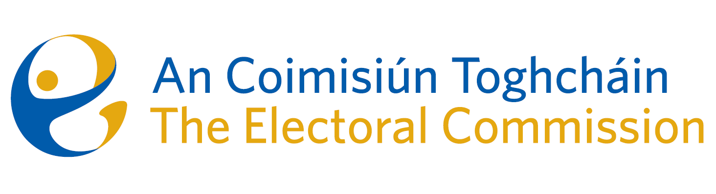
Agenda
Meeting #01/25 8.00am 6 February 2025 (1.5 hours)
Teams Meeting

For Discussion
- Discussion on the decision letter from the OIC, in relation to the FOI request that relates to the 2023 Constituency Review and the Dáil constituency of Cork East

Date of next meeting: 13 February 2025

