FURTHER CONSIDERATION OF CONSTITUENCIES

INTRODUCTION

This paper has been prepared for the information and consideration of the Electoral Commission. It provides reflections on the reasoning behind the preferences for certain options and also some potential alternative approaches in particular cases.

It follows on from discussions at the 11th Meeting of the Electoral Commission held on 6 July 2023.

NORTH WEST

Fixing the Donegal breach

- Donegal current variance +6.63 (174);
- Fixing the Donegal County Breach by returning the 9 EDs (9,331) from Sligo-Leitrim gives Donegal a +12.97% variance with a population of 166,321;
- Then the Sligo-Leitrim Variance would become -3.70% – without the north Roscommon transfer;
- With the Roscommon North transfer 8,523 and the 9,331 transfer to Donegal the Sligo-Leitrim variance becomes -10.93.
- Therefore, the Roscommon breach cannot be fixed.
- The large breach in County Galway with the Roscommon-Galway constituency needs to remain. The Roscommon variance remains +4.36%.
- The second additional seat to the region cannot go to Galway East as at least 12,000 of population is needed to bring the 4-seat variance above -8%.
- If Galway East is left with 3 seats, then the variance is +9.83 and therefore further transfers become necessary: Either to the Galway West or Mayo constituencies.
- It would make sense for the Galway East population to transfer to Galway West as its variance is +1.01% after the transfer to Mayo. Transferring approx.5,000 from Galway East to Galway West reduces the Galway East variances to +4.16% and increase the Galway West variances to +4.41%.
- The Mayo Constituency can receive an additional seat and have its boundary breach removed with the Galway West constituency.
- But, the 2nd additional seat for the region still needs to go somewhere. The only feasible option at this point is to give it to Donegal, which could split into two 3-seat constituencies. 166,321/2= 83,160. In this scenario, each 3 seat Donegal Constituency would have a -5% variance.

In summary:
If the breach in Donegal was to be fixed:
- One of the two seats must go to Donegal due to the +12.97% variance;
- The second of the 2 seats must go to Mayo due to the 11.52% variance;
- Therefore, there is no seat available to go to Galway East which has the next highest variance of +9.83% and which is therefore the logical place in which to add one of the two seats;
Therefore: Removing the Donegal breach does not allow for fixing the Roscommon County breach or reducing the Galway County breach.

NORTH EAST

All constituencies are aligned with county boundaries except for the electoral division of St. Mary’s

- The electoral division of St. Mary’s is located in the County of Meath.
- It is also located in the immediate southern environs and suburbs of the City of Drogheda.
- St. Mary’s population is 16,348.
- It represents about half a seat, and would seem well placed to remain in the constituency of Louth, from a geographical and community point of view.
- The electoral division to its south, Julianstown, Pop. 11,474, in the County of Meath, is transferred to Meath East in the preferred option.

SOUTH WEST

Kerry Split
- Kerry has a current variance of +5.45%
- Splitting Kerry into two 3-seat constituencies would necessitate a large transfer of population from Limerick County
- Limerick County has a current variance of +1.29%
- The transfer required for Kerry would greatly reduce the Limerick County variance.
- The minus variances that would result from adding a seat to Kerry, across the two potential constituencies of Kerry along with Limerick County and Limerick City, would not be sustainable without further transfers in from other adjoining counties.

SOUTH EAST

Reconsideration of the transfer of Urlingford and its hinterland from Carlow-Kilkenny to Tipperary North

The current position is as follows:
- The Carlow-Kilkenny constituency has a population of 165,616 and a variance of +12.49%;
- The Tipperary constituency has a population of 162,987 and a variance of +10.70%;
- The Waterford constituency has a population of 127,065 and a variance +7.90%;
- One seat needs to be added between those three constituencies.

As it stands, the preferred Option 6 proposes the following:
- Dividing Tipperary up into Tipperary North and Tipperary South, two 3-seat constituencies, thereby adding the seat;
- Transferring 6,379 of population from the electoral division of Urlingford and the surrounding hinterland from Carlow-Kilkenny into Tipperary North; This brings the variance of Carlow-Kilkenny down to +8.16%;
- Leaving the constituency of Waterford unchanged;
- Transferring 4,674 of population from the electoral division of Birdhill and two adjacent electoral divisions from Limerick City to Tipperary North.

If the Urlingford transfer is not made:
- Then a similar or greater population must still be transferred out of Carlow-Kilkenny. The only other possibility is to transfer population out to Waterford.
- Since Waterford already has a high variance then this means it must get the seat;
- If Waterford gets the seat, then Tipperary cannot get it; therefore, Tipperary cannot be split and it must remain a 5-seat constituency;
- However, the Tipperary variance with 5 seats is too high, so it must lose population, and since it cannot go to Carlow-Kilkenny, it must go to Waterford, where it is needed to fix up the variance;
- Therefore, Carrick-on-Suir and its hinterland must be transferred to Waterford.

In relation to the transfer from Carlow-Kilkenny to Waterford, the electoral divisions of Dunkitt (988), Kilculliheen (5,755) and Rathpatrick (1,130) have a total population of 7,873. They are all very close to the City, lying within about 7 kilometres, and are thus well within its hinterland.

Carrick-on-Suir and its hinterland contains the electoral divisions of Carrickbeg Urban (1,594); Carrick-on-Suir Urban (4,444); Carrick-on-Suir Rural (526); Newtown (406) Kilmurry (353) and Kilsheelan (1,478) with a total population of 8,801.

With these transfers the variances would be as follows:

Carlow-Kilkenny +7.14%
Tipperary +7.90%
Waterford -2.36%

Summary:
Existing preferred Option 6:
- Retain the Urlingford transfer;
- Tipperary is split 3 and 3;
- Waterford remains as a 4-seat constituency;
- There is a breach in County Kilkenny,
- No breach in Tipperary
- No breach in Waterford;
- The constituency seats are in the configuration 5 – 4 – 3 – 3;

Potential further option outlined above:
- Urlingford not transferred;
- Tipperary remains as a 5-seat constituency;
- Transfer Carrick-on-Suir to Waterford;
- Transfer three electoral divisions from Carlow-Kilkenny to Waterford;
- Waterford constituency becomes a 5-seater;
- There is a breach in County Kilkenny;
- There is a breach in County Tipperary,
- No breach in Waterford;
- The constituency seats are in the configuration 5 – 5 – 5.

If Urlingford is not transferred to Tipperary North, then Carrick-on-Suir must be transferred to Waterford.

CORK

Additional Seat to Cork East

- An additional Seat was considered to be given to the Cork East constituency. If the transfers of Ballincollig to Cork North-Central and the transfer of the Bishopstown EDS to Cork South Central happen then giving the seat to Cork East instead of Cork North Central would incur a large transfer of population from Cork North Central to Cork East.
- A transfer could be made from Cork North-West to Cork East but then the ED of Ballincollig would need to remain in Cork North-West and transfers from Cork South-West to Cork North-West would also become necessary.
- 1 seat must go to Cork South-Central.

DUBLIN NORTH

Dublin Bay North as a 5-seat constituency

Breakdown of preferred Option 5 – EC 8.1
Dublin North Region Constituencies | 2022 Population | Seats earned | Seats | Population per TD | % Variance
Dublin Bay North | 121,055 | 4.11 | 4 | 30,264 | +2.78
Dublin Central | 139,440 | 4.74 | 5 | 27,888 | -5.29
Dublin Fingal West | 87,684 | 2.98 | 3 | 29,228 | -0.74
Dublin North-West | 84,597 | 2.87 | 3 | 28,199 | -4.23
Dublin West | 121,463 | 4.12 | 4 | 30,366 | +3.12
Dublin Fingal East | 120,071 | 4.08 | 4 | 30,018 | +1.94
 | 674,310 | 22.90 | 23 | 29,318 | -0.43

The below alterations are based on changes to Option 5 - EC 8.1

- 5 seat Dublin Bay North- with no transfers has a variance of +5.29%
- Transferring the Howth, Sutton and Baldoyle EDs (22,248 Total Pop.) to the 4-seat Fingal East reduces the 5-seat Dublin Bay North variance to -9.62%
- Not transferring the Howth, Sutton and Baldoyle EDs (22,248 Tot pop) to the new 4-seat Fingal East constituency gives Fingal East a variance of -16.95% so there is not enough population for a 4 seat constituency.
- Making the Fingal East constituency a 3 seater gives it a variance of +10.74% so population need to be transferred out.
- Transferring Balgriffin (ED 5,536 pop) (highlighted in Blue below) to Dublin Bay North would reduce the 3-seat Fingal East variance +4.47%. This would further extend the Fingal County breach.

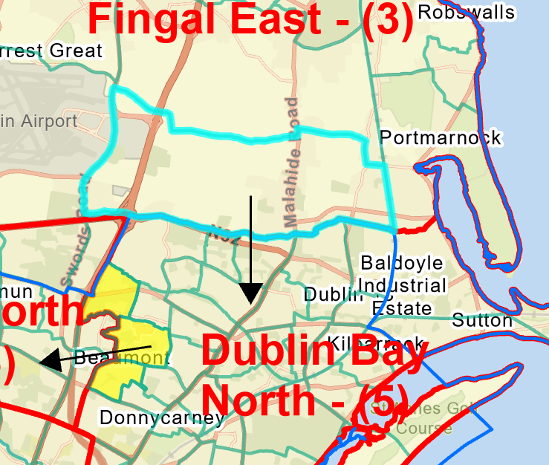 Balgriffin ED

- The Dublin Bay North variance would become +9.65%.
- This would allow for the same transfers proposed of 12,062 pop from Dublin Bay North to Dublin North-West (in yellow). After this transfer the 5-seat Dublin Bay North variance becomes +1.09%.
- The reduction of Fingal East from a 4-seat to a 3-seat constituency means the additional seat needs to go somewhere else in the region.
- The additional seat can go to the Dublin West constituency giving it a variance of -6.45%;
- Retaining 4-seat Dublin Central constituency with no transfers will leave it with a variance of +4.57%.

Keeping Dublin Bay North as a 5 seat extends the breach into Fingal County.
An important consequence of a 5-seat Dublin Bay North is that the seat distribution becomes 5, 5, 4, 3, 3, 3, since the 4-seat proposed Fingal East constituency is reduced to a 3 seat.

The 2nd seat to the region can be given to Dublin West if the two Ashtown EDS and Phoenix Park ED are not transferred.

Further consideration for the transfer of the two Ashtown EDS and Phoenix Park ED can be examined with the historical breakdown of these EDs below;

Ashtown and Phoenix Park EDs Historical Perspective
- The Ashtown and Phoenix Park EDs were in the Dublin West area from 1980 to 1990;
- Then they were part of the Dublin Central constituency from 1990 to 2012;
- They were transferred to Dublin West in 2012 and have remained in Dublin West since then.

In summary, the Ashtown and Phoenix Park EDs have been associated with the Dublin West or similar constituency for 22 out of the last 43 years, and Dublin Central for 21 of those years.

DUBLIN SOUTH

General comments made

- It was noted that some of the Stillorgan area electoral divisions have been transferred between Dublin Rathdown and Dun Laoghaire constituencies a number of times in the past. This does not give rise to any concerns.
- The extra seat going to Dublin Rathdown allows for there to be no breaches of the county boundary.
- Similarly, the other seat going to Dublin Mid-West fits with the population increases in that part of the region, and allows for the constituency boundaries to also be contiguous with the South Dublin County and Dublin City boundaries.

