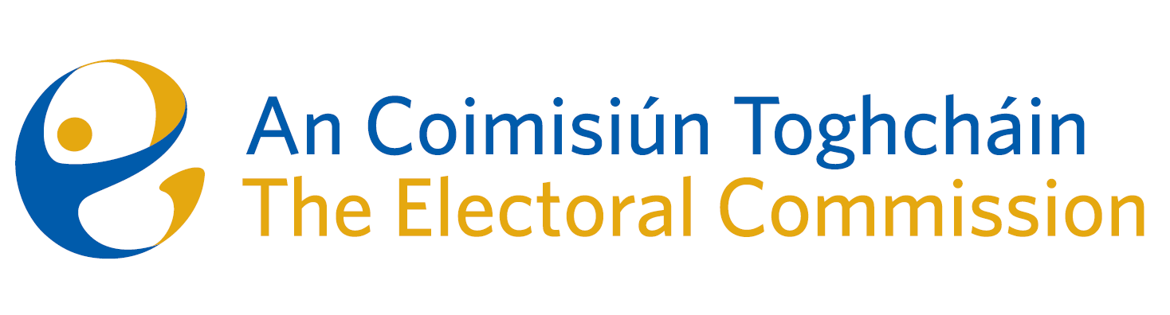
Minutes
Meeting of An Coimisiún Toghcháin, The Electoral Commission.

ACT Boardroom, Dublin Castle| 10.00am | 12 December 2024

Attendance
An Coimisiún:
Justice Marie Baker (Chairperson), Alex Attwood (AA), John Curran (JC), Ger Deering (GD), Caroline Fennell (CF), and Maura Quinn* (MQ)

Apologies – Peter Finnegan

* Maura Quinn attended the meeting remotely

Executive:
Art O’Leary (AOL), Mary Clare O’Sullivan (MCOS), Karen Kehily (KK), Tim Carey (TC) Sean Garvey (SG), Brian Dawson (BD) – item 3, Aoife O’Sullivan (AOS) – item 4 & 5, and Andrea Jones, (secretariat)
------------------------------------

- Welcome and Draft Minutes
The Chairperson welcomed members and the minutes of the previous meeting were approved as amended.

- Conflict of Interest
No conflicts of interest were declared.

- General Election Campaign
The Commission were updated on the public information campaign for the General Election, which was held on Friday 29 November.

The Commission were briefed on the three phase approach to the information campaign, the target objectives of each phase, and the media and promotional events delivered during the campaign.

The campaign included a number of national radio, TV and podcasts, local community and Irish language radio, partnerships with targeted groups, and educational videos and content available through social media platforms and the official Electoral Commission website.
- Discussion on Electoral Register
As part of the statutory oversight role in relation to the accuracy and completeness of the Electoral Register, the Commission members discussed a number of issues for inclusion in their first report on the register, expected to be published in Q1, 2025.

- Research Programme
The Commission discussed a number of priority items on the research programme and the possible overlap with other Commission functions and responsibilities.

- For information/noting
The Commission noted the following items;
- Statutory Report to Oireachtas on the Research Programme (6-month update)
- Financial position forecast 2024
- ARC Annual Report 2024
- ARC December meeting report
- ARC Meeting Minutes 16 September 2024

- Any Other Business
- The Commission were briefed on the progress of the recruitment campaign to appoint a Head of Legal at Principal Officer level;
- Seanad Election date – 28 January 2025. ACT website to be updated to include links to Seanad Election university websites; and
- Date of next meeting – 13 February 2025.

_________________
Ms. Justice Marie Baker (signed)
Chairperson

