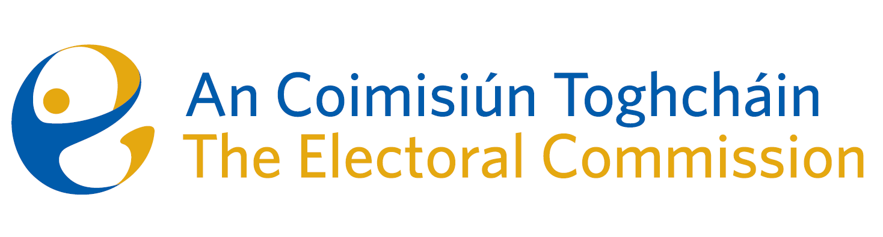

Minutes
Meeting of An Coimisiún Toghcháin, The Electoral Commission.

Teams meeting, 8.00am –6 February 2025
Attendance

An Coimisiún:
Justice Marie Baker (Chairperson), Alex Attwood (AA), John Curran (JC), Peter Finnegan (PF), Caroline Fennell (CF), and Maura Quinn (MQ)
Recused:
Ger Deering (GD)
Executive:
Art O’Leary (AOL), Mary Clare O’Sullivan (MCOS), Karen Kehily (KK), Tim Carey (TC), Diane Duggan (DD)
------------------------------------
- Welcome

The Chairperson welcomed members.

- Conflict of Interest

A member of the Commission was recused from this meeting due to a perceived conflict of interest with their current role. This was agreed by the Chairperson and the remaining members, and the member was recused from this meeting.

- Discussion on the OIC decision, in relation to the FOI request that relates to the 2023 Constituency Review and the Dáil constituency of Cork East
Commission members considered the decision letter received from the Office of the Information Commissioner (OIC) on 22 January 2025, relating to a review on the decision of An Coimisiún Toghcháin (ACT) to refuse access to records relating to Cork East constituency review deliberations. The Commission members decided not to appeal the OIC decision to the High Court.

_________________
Ms. Justice Marie Baker (signed)
Chairperson

