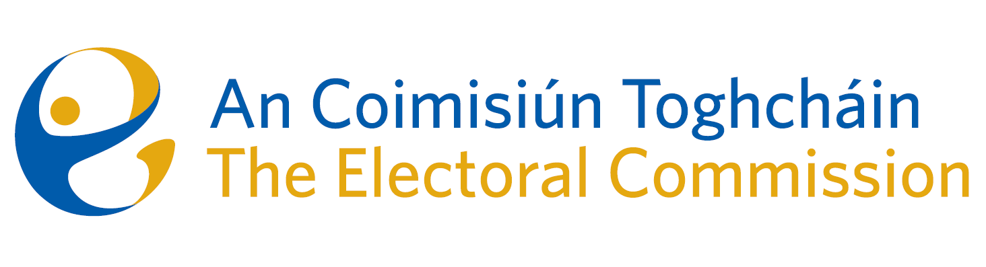
Agenda
Meeting #02/25 8.00am 13 February 2025 (3 hours)
Venue – ACT Boardroom – Dublin Castle

- Minutes of previous meeting (2 Mins)
- Conflicts of Interest

For Discussion
- Release of constituency review records (45 mins)
- Record keeping practices (Chair 10 mins)
- Update on Electoral Register Oversight Report (Tim Carey 45 mins)
- Postal Voting (from December meeting) (Mary Clare 20 mins)
- Update on Parts 4 & 5 of the Electoral Reform Act (Sean Garvey 25 mins)
- Risk Management and Risk Register (Karen Kehily 15 mins)
- Annual Commission Terms of Reference Review (Karen Kehily 5 mins)

For information
- Research Ethics & Integrity Policy
- 2024 Corporate Update
- Education Programme update
- Conflict of Interest Declaration 2024 (circulated Thursday 6th Feb 2025)
- Note on ACT Chairperson and ARC Chairperson meeting 30/01/2025.

- AOB
- Date of next meeting: 10 April 2025

