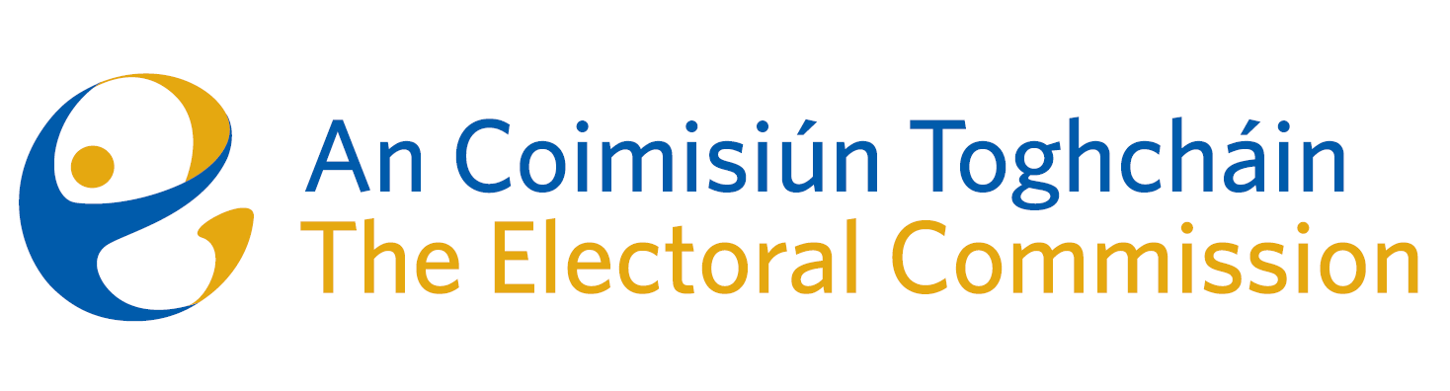
Minutes
Meeting of An Coimisiún Toghcháin, The Electoral Commission.

ACT Boardroom, Dublin Castle| 8.00am | 13 February 2025

Attendance
An Coimisiún:
Justice Marie Baker (Chairperson), Alex Attwood (AA)*, John Curran (JC), Ger Deering (GD), Caroline Fennell (CF), Maura Quinn (MQ) and Peter Finnegan (PF)

* Alex Attwood attended the meeting remotely

Executive:
Art O’Leary (AOL), Mary Clare O’Sullivan (MCOS), Karen Kehily (KK), Tim Carey (TC) Sean Garvey (SG), Diane Duggan (DD), Brian Dawson (BD) – item 3, Eunice Delaney (ED) – item 6, and Andrea Jones, (secretariat)
------------------------------------

- Welcome and Draft Minutes
The Chairperson welcomed members and the minutes of the previous meetings were approved as amended.

- Conflict of Interest
No conflicts of interest were declared.

- Release of 2023 Constituency Review records
The Commission agreed to release all of the working papers of the Commission for the 2023 Constituency Review. The records will be available on the Electoral Commission website in the coming weeks.

- Records Retention Practises
The Commission discussed current practises for retaining records. Record management will be added to the agenda for discussion at the next Commission meeting.

- Update on Electoral Register Oversight Report
As part of the statutory oversight role in relation to the accuracy and completeness of the Electoral Register, the Commission members discussed a number of matters for inclusion in the first report on the register, expected to be published in April 2025.

- Postal Voting
The Commission discussed the system of postal voting and possible interim measures of a practical nature in advance of the planned review of postal voting to be conducted as part of the Research Programme.

- Amendment of Part 4 of the Electoral Reform Act
The Commission were briefed on the proposed legislative amendments to Part 4 (regulation of online political advertising) of the Electoral Reform Act 2022. This will be reviewed by the Commission when a draft of the legislation is received from the Department of Housing, Local Government and Heritage, in advance of the adoption of EU regulation on 10 October 2025.
- Risk Management and Risk Register
An overview of risk management controls and the risk register were presented to the Commission. The Commission welcomed that a Risk Advisory Audit was part of the Internal Audit Programme for 2025.

- Commission Terms of Reference Review

As provided for in the Corporate Governance Standard for the Civil Service, the Commission should review and update its Terms of Reference on an annual basis. This review is currently underway and will be discussed further at the next Commission meeting.

- For information/noting

The Commission noted the following items;

- Research Ethics and Integrity Policy
- 2024 Corporate Update
- Education Programme Update
- Conflict of Interest Declaration 2024
- Note of ACT Chairperson and ARC Chairperson meeting January 2025

- Any Other Business

Date of next meeting – 10 April 2025

_________________
Ms. Justice Marie Baker (signed)
Chairperson

