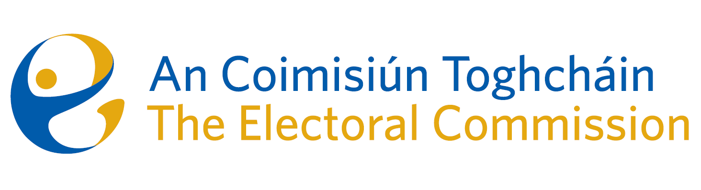
Agenda
Meeting #03/25 8.00am 10 April 2025 (3 hours)
Venue – ACT Boardroom – Dublin Castle

- Minutes of previous meeting (2 Mins)
- Conflicts of Interest

For Discussion
- Appeal (30 mins)
- Governance matters (Karen Kehily - 30 mins)
  - Commission Self-Evaluation Report
  - Audit & Risk Meeting Report 10 March 2025(Executive to join the meeting)
    - Annual Review of the ARC Terms of Reference
    - Internal Audit recommendations
  - Corporate Dashboard Q1 2025
  - Final Terms of Reference – for approval
  - Creative Agency and Media Buying contract approval
- General Election November 2024 PEER (Mary Clare O’Sullivan, Eunice Delaney - 30 mins)
- Ballot Research Paper (Mary Clare O’Sullivan, Catherine Lynch - 30 mins)
- Election Observation Opportunities – (Tim Carey - 10 mins)
  - Albania - 11 May
  - Moldova - 11 July
  - Local elections Georgia - October
  - North Macedonia (tbc)
  - Possibility of election in Serbia
- IT Security update (Luke Davis 15 mins)

For information
- AOB
- Date of next meeting: 10 July 2025

