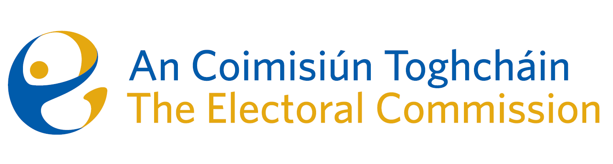
Minutes
Meeting of An Coimisiún Toghcháin, The Electoral Commission.

ACT Boardroom, Dublin Castle| 8.00am | 10 April 2025

Attendance
An Coimisiún:
Justice Marie Baker (Chairperson), Alex Attwood (AA), John Curran (JC), Ger Deering (GD), Caroline Fennell* (CF), Maura Quinn (MQ) and Peter Finnegan (PF)

* Caroline Fennell attended the meeting remotely

Executive:
From item 4b - Art O’Leary (AOL), Mary Clare O’Sullivan (MCOS), Sean Garvey (SG), and Diane Duggan (DD).
Karen Kehily (KK), Helen Codd (HC) – item 4, Eunice Delaney (ED) – item 5, Catherine Lynch (CL) – item 6 and Andrea Jones, (Secretariat)
------------------------------------

- Welcome and Draft Minutes
The Chairperson welcomed members, and the minutes of the previous meeting were approved.

- Conflict of Interest
Prior to the meeting, Peter Finnegan notified the Chair and the members of a perceived conflict of interest. It was agreed by the Commission member that they were satisfied there was no conflict, however in the interest of the discussion, the Commission member would recuse himself from agenda item number 3.

- Appeal from the decision of the Registrar of political parties
Commission members considered an appeal received on 11th March 2025 against a decision of the Registrar of Political parties. It was decided that a further meeting would be required, following further consideration.

- Governance Matters

  - Commission Self-Evaluation Report
The Corporate Governance Standard for the Civil Service states that the Commission should arrange a periodic self-review/assessment to measure delivery, performance and effectiveness against its Terms of Reference. Consideration was given to the Commission members responses to the self-assessment questionnaire, which was provided to members in March. The Commission identified key areas for further development, which will be implemented in due course.

b. Audit & Risk Meeting Report
(i) Annual review of ARC Terms of Reference
The Commission members were provided with a copy of the ARC Terms of Reference, which was reviewed and approved by the ARC at their meeting on 10 March 2025. No objections were noted, and the document was approved by the Commission.

(ii) Internal Audit Recommendations
The Commission were provided with the ACT 2024 internal audit report, which was carried out by Forvis Mazars. The report provided the assurance to the Commission on the system of internal controls within ACT, and that the findings identified by the audit provider have been accepted and addressed.

c. Corporate Dashboard Q1 2025
An overview of the corporate dashboard for Q1 2025 were presented to the Commission, to include an update on the strategic priorities, details of the contracts register and upcoming procurement requirements, the financial position as of end Q1 2025 and the HR update.

d. ACT Terms of Reference
The annual review of the ACT Terms of Reference will be further considered at a later meeting.

e. Creative Agency and Media Buying – Contract approval

The Commission reviewed and approved the procurement process for the procurement of creative agency services, and the procurement process of a media buying service.

- Draft General Election PEER Report
The Commission were updated on the progress of the General Election PEER Report, which took place 29 November 2024. A draft of the report will be sent to Commission members in the coming days for review, in advance of its publication on 29 May 2025.

- Ballot Paper Address Research
Commission members discussed the ballot paper address research, a draft of which will be sent to Commission members for review in the coming weeks.

- Election observation opportunities
The Commission were asked to consider and provide an expression of interest for international election observation opportunities which will take place in the coming months.

- Any Other Business

ACT Civil Service Excellence Award nomination (media campaign for electoral events) 29 May 2025

Events to conduct public engagement campaign on registering to vote.

Launch of Electoral Register Report

Date of next meeting – 5 June 2025

