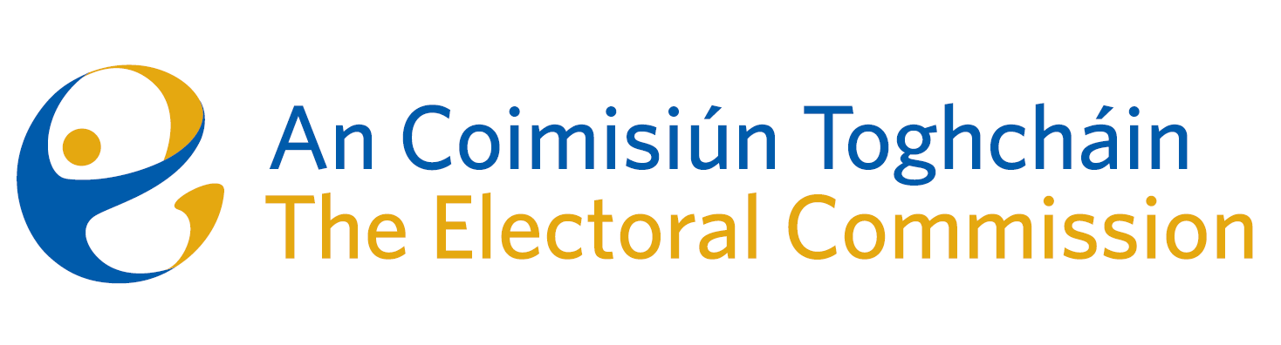
Minutes
Meeting of An Coimisiún Toghcháin, The Electoral Commission.

Remotely via Microsoft Teams| 8.00am | 2 May 2025

Attendance
An Coimisiún:
Justice Marie Baker (Chairperson), Alex Attwood (AA), John Curran (JC), Ger Deering (GD), Caroline Fennell (CF) and Maura Quinn (MQ)

Executive:
Karen Kehily (KK)
------------------------------------

- Welcome and Draft Minutes
The Chairperson welcomed members.

- Conflict of Interest
As recorded on the minutes of the meeting of 10th April 2025, Peter Finnegan notified the Chair and the members of a perceived conflict of interest. It was agreed by the Commission member that they were satisfied there was no conflict, however in the interest of the discussion, the Commission member would recuse himself from this matter.

- Appeal from the decision of the Registrar of political parties
Commission members further considered the appeal received on 11th March 2025 against a decision of the Registrar of Political parties. It was decided that a further meeting would be required.

- Any Other Business
Date of next meeting – 5 June 2025

