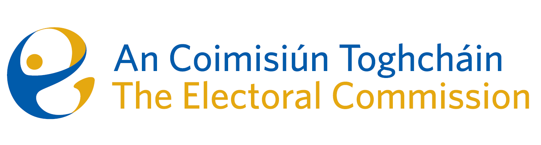
Minutes

Meeting of An Coimisiún Toghcháin, The Electoral Commission.

ACT Boardroom, Dublin Castle| 8.00am | 5 June 2025

Attendance
An Coimisiún:
Justice Marie Baker (Chairperson), Alex Attwood (AA), Ger Deering (GD), Caroline Fennell* (CF) and Maura Quinn (MQ)

* Caroline Fennell attended the meeting remotely

Apologies
Peter Finnegan (PF), John Curran (JC)

Executive:
Art O’Leary (AOL) - Items 1-8
Diane Duggan (DD), Sean Garvey (SG), Karen Kehily (KK), Kieran Lenihan, Mary Clare O’Sullivan (MCOS) and Muireann Ní Thuairisg, (Secretariat) - Items 1 – 7 -
Luke Davis- Item 1
Catherine Lynch (CL) and Anthony Trindle- Item 5
Sarah Keaveney - Item 6
------------------------------------

- Welcome and Draft Minutes
The Chairperson welcomed members, and the draft minutes of the meetings held on 10 April and 2 May were approved.

- Conflict of Interest
There were no conflicts of interest.

- ICT Overview

Members were given an overview of An Coimisiún’s ICT environment, including the role of An Coimisiún’s service provider Office of the Government Chief Information Officer (OGCIO), security, infrastructure, website management and printer management.

- Review of 1997 Act

Members discussed the review of the Electoral Act 1997 in respect of powers that are currently administered by the Standards in Public Office Commission.

It was agreed to further discuss the matter at the meeting in September.

- Ballot Paper Design Research Paper

Members discussed the research paper, ‘Ballot Paper Design: Address of Candidates on the Ballot Paper’. Members agreed to include a separate document “Commission Recommendations” also for publication alongside the research paper and to use this model going forward. The separate document will be circulated in advance of the next Commission meeting for agreement
It was noted the Seanad Peer will be published in the coming weeks.

- Summary of Education Consultation submissions

Members were given an overview of the submissions received on the Education and Public Engagement Strategy - 441 in total. The next steps will be to use the information from the public consultation to inform initial discussions with the four working groups representing the areas of focus – formal education, adult & community education, groups experiencing barriers and large-scale public engagement. Each group will hold four meetings, following which a draft strategy and implementation plan will be drafted leading to a second round of public consultation.

- Governance

- Final Terms of Reference

The draft final terms of reference were approved.

- Division of Responsibilities

Following a discussion on the document on the division of responsibilities, it was agreed to table the matter for discussion at the next meeting.

- Long Term Resourcing

The Commission met in closed session to discuss long term resourcing, including recruitment preparation in progress to recruit additional Commission members.

- Appeal

Commission members considered an appeal against a decision of the Registrar of Political parties. It was decided that a further meeting would be required, following further consideration.

