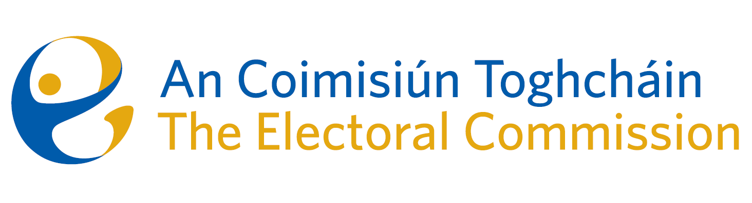
Draft Agenda
Meeting #04/25 8.00am 10 July 2025 (2.5 hours)
Venue – ACT Boardroom – Dublin Castle

- Minutes of previous meeting (2 Mins)
- Conflicts of Interest

For Discussion
- Governance matters (Karen Kehily - 30 mins)
  - Audit & Risk Meeting Report 9 June 2025 - for information
    - Risk Report and Risk Register
  - Corporate Dashboard Q2 2025 (including contracts register) – for information
  - Estimates 2026 – for discussion
- Presidential Campaign focus (Media plan – for information, Brian Dawson and update on Listening project – Séan Garvey – 30 mins).
- Research (Mary-Clare O’Sullivan – 30 mins)
  - Research Progress update to Oireachtas – for information
  - Recommendations on Ballot Paper Design - for agreement
  - Reducing Voting Age proposal – for agreement
  - Postal and Advance voting research update - for information
  - PEER follow-up: Postal Voting Certification, proposals from DHLGH – for information (Art O’Leary - 15 mins)
- Succession planning – for discussion (Chairperson – 15 mins)

For information
- AOB
- Date of next meeting: 11 September 2025

