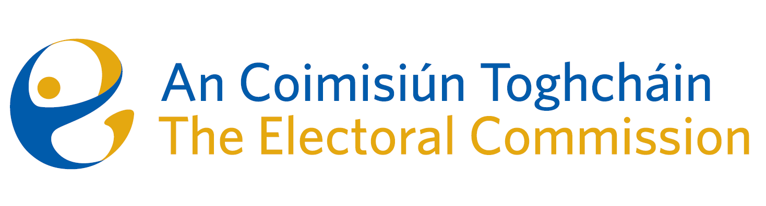
Minutes

Meeting of An Coimisiún Toghcháin

ACT Boardroom, Dublin Castle| 8.00am – 11:00am| 10 July 2025

Attendance
An Coimisiún:
The Honourable Ms. Justice Marie Baker (Chairperson), Alex Attwood (AA), John Curran (JC), Ger Deering (GD), Prof Caroline Fennell* (CF) and Maura Quinn (MQ)

Apologies
Peter Finnegan (PF)

Executive:
Art O’Leary (AOL) - Items 1-7
Diane Duggan (DD), Sean Garvey (SG), Karen Kehily (KK), Kieran Lenihan, Dr Mary-Clare O’Sullivan (MCOS) and Muireann Ní Thuairisg, (Secretariat) - Items 1 – 7
Brian Dawson (BD) – Item 4
Catherine Lynch (CL) -Item 5 (b)
------------------------------------

- Welcome and Draft Minutes
The Chairperson welcomed members, and the draft minutes of the meetings held on 5 June 2025 and 27 June 2025 were approved subject to one minor amendment.

- Conflict of Interest
There were no conflicts of interest.

- Governance

- Audit and Risk Meeting Report, 9 June 2025
- Risk Report and Risk Register

Members noted the report of the Audit and Risk meeting which took place on 9 June 2025.

Members held a discussion on the Risk Register and Risk Management report and suggested some textual changes to the risk register items. Members also noted the progress on the internal audit programme.

- Corporate Dashboard

Members were updated on finance, human resources, procurement and strategic priorities.

- Estimates 2026

The draft estimates figures for 2026 were approved.

- Presidential Campaign focus

- Media Plan

The Presidential Election Media Buying Plan was presented to members, the aim of which is to build voter registrations and updates with a particular interest on younger voters.

- Update on Listening Project

Members were updated on the development of a listening project in the context of the Presidential election. The procurement process is nearing completion.

- Research

- Research Progress Update to Oireachtas
An Coimisiún’s second progress update on its Research Programme 2024 – 2026 was sent to the Joint Oireachtas Committee on Housing, Local Government and Heritage on 9 July 2025.

- Recommendations on Ballot Paper Design
Following discussion, members agreed that the research paper would be re-visited and brought back for discussion at the next meeting.

- Reducing Voting Age Proposal

Members agreed to revise the reducing the voting age proposal. A revised paper will be circulated following the meeting.

- Postal and Advance voting research

AOL updated members on some initial engagement with International IDEA regarding the planned research on potential extension of Postal and Advance Voting provisions.

- PEER follow-up: Postal Voting Certification, proposals from DHLGH – for information

AOL updated members on the proposals from the Department of Housing, Local Government and Heritage. The senior management team met with the Franchise section at their quarterly meeting on 9 July 2025 where the proposals were discussed.

- Succession Planning
A memorandum on succession planning was discussed and the matter will be tabled for discussion at the Commission meeting in December.

- AOB

An Coimisiún has been invited by the Joint Committee on Disability Matters meeting of the Committee to discuss participation in political and public life on 16 July 2025.

