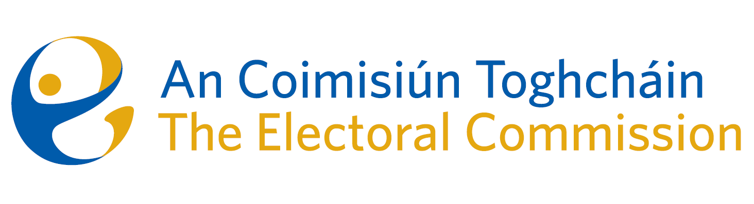
Agenda
10:00am | 18 August 2025 | MS Teams Meeting

- Welcome
- Conflict of Interest
- Appeal from the decision of the Registrar of political parties
- AOB

