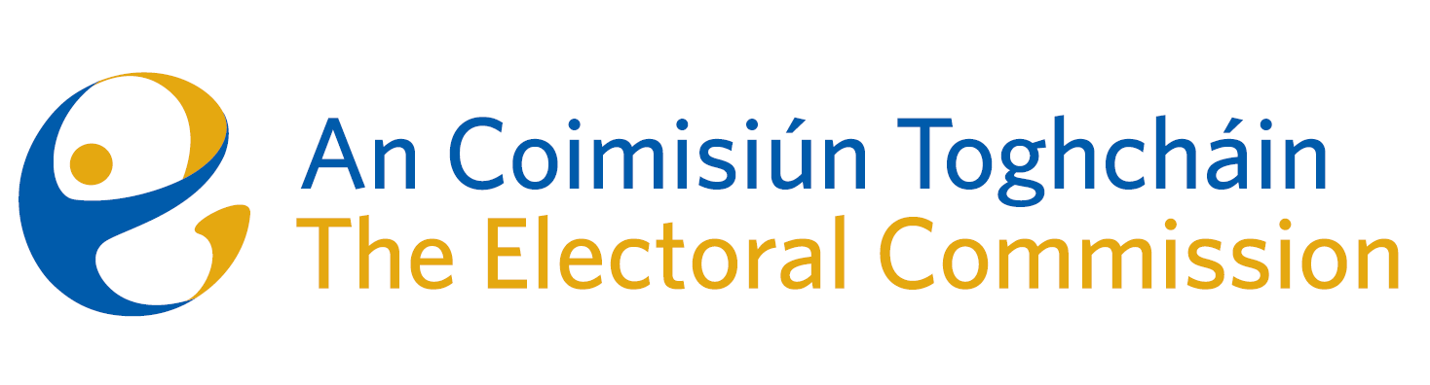
Minutes

Meeting of An Coimisiún Toghcháin

ACT Boardroom, Dublin Castle| 8.00am – 11:30am| 11 September 2025

Attendance
An Coimisiún:
The Honourable Ms. Justice Marie Baker (Chairperson), Alex Attwood (AA), John Curran (JC), Ger Deering (GD), Prof Caroline Fennell (CF) Peter Finnegan (PF)and Maura Quinn (MQ)

Executive:
Art O’Leary (AOL), Diane Duggan (DD), Karen Kehily (KK), Kieran Lenihan, Dr Mary-Clare O’Sullivan (MCOS) and Muireann Ní Thuairisg, (Secretariat), Brian Dawson (BD), Catherine Lynch (CL)
------------------------------------

- Draft Minutes

The draft minutes of the meeting held on 10 July 2025 were approved.

- Conflict of Interest

There were no conflicts of interest.

- Presidential Election Campaign

Members received a briefing on the presidential election media plan based on voter engagement which includes visits to third level campuses and schools, the National Ploughing Championships, street canvasses and engagement with schools and underrepresented communities. New innovations will also be introduced as part of the campaign with the additional element of English and Irish language content producers.

Members were also briefed on ACT’s presence at Electric Picnic, including social media metrics and highlights from the campaign.

- Recommendations on Ballot Paper Design

A summary document was circulated to commission members with a view to assisting them come to a decision regarding their Recommendations paper on Ballot Paper Addresses. Members agreed on an approach for their recommendation paper. The final revised recommendations paper reflecting what was agreed will be circulated again to members for their review before it is submitted to the Minister for Housing, Local Government and Heritage for his consideration and that of the Government.

- Local Government Task Force

The Local Government Task Force has requested An Coimisiún to engage in their targeted stakeholder consultation process. Members discussed a draft paper setting out the issues which come within the scope of the An Coimisiún’s functions. A response will be prepared for the Task Force, incorporating members’ comments and recommendations and submitted to the Task Force.

- Political Advertising

Members discussed the implementation of the new EU regulations on the transparency and targeting of political advertising and the plans put in place by the Executive to manage this process.

The related delegation order from An Coimisiún Commission to the Executive was approved and a sub-committee will be formed in accordance with Section 15 of the Electoral Reform Act 2022.

- Propose new Chair of Audit and Risk Committee

Due to the retirement of the Chairperson of the Audit and Risk Committee, nomination for a new Chair was put forward and approved by the members.

- Any Other Business

It was noted members are welcome to participate in the Post-Electoral Events Review planned for the presidential election.

- Appeal

The appeal was considered. The Commission came to a consensus decision on the appeal and agreed that the decision and its reasons will be circulated to the parties by Friday 19th September 2025.

