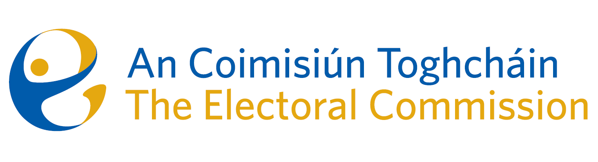
Agenda
Meeting #10/25 8.00am 9 October 2025 (2 hours)
Venue – ACT Boardroom – Dublin Castle

- Minutes of previous meeting (2 Mins)
- Conflicts of Interest

For Discussion
- Quarterly Corporate Update (30 Mins)
  - Corporate Dashboard Q3 2025 (Karen Kehily)
  - Risk Management Report (Helen Codd)
  - Meeting Report – Audit and Risk Committee Meeting, 8 September
  - Proposed Dates for 2026*
- Update on Political Advertising – Diane Duggan / Séan Garvey (15 Mins)
- Presidential Election Update – Brian Dawson (15 Mins)
- Moldova Trip update – Kieran Lenihan and Alex Attwood (15 Mins)
- Research Update – Dr Mary-Clare O’Sullivan (15 Mins)
- AOB

For information
Date of next meeting: 11 December 2025
Proposed 2026 Meeting Dates

