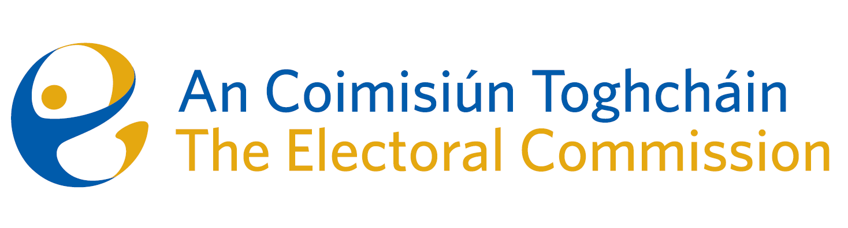
Minutes

Meeting of An Coimisiún Toghcháin

ACT Boardroom, Dublin Castle| 8.00am – 11:00am| 9 October 2025

Attendance
An Coimisiún:
The Honourable Ms. Justice Marie Baker (Chairperson), Alex Attwood (AA), John Curran (JC), Ger Deering (GD), Prof Caroline Fennell (CF) Peter Finnegan (PF)and Maura Quinn (MQ)

Executive:
Art O’Leary (AOL), Diane Duggan (DD), Karen Kehily (KK), Kieran Lenihan, Dr Mary-Clare O’Sullivan (MCOS) and Muireann Ní Thuairisg, (Secretariat), Nick Callan (NC), Brian Dawson (BD)
------------------------------------

- Draft Minutes

The draft minutes of the meeting held on 11 September 2025 were approved, subject to one minor amendment.

- Conflict of Interest

There were no conflicts of interest.

- Quarterly Corporate Update

  - Corporate Dashboard

An overview of the corporate dashboard for Quarter 3 2025 were presented to the Commission, to include an update on finance, strategic priorities, procurement and human resources.

  - Risk Management Report and Risk Register

The Commission were provided with a Risk Management Report and an update on the risk register.

  - Meeting Report – Audit and Risk Committee Meeting, 8 September

Members noted the report of the Audit and Risk meeting which took place on 8 September 2025.

  - Proposed Dates for 2026

The proposed dates for 2026 Commission meetings were approved - 12 February 2026; 19 March 2026; 16 April 2026; 21 May 2026; 18 June 2026; 17 September 2026; 15 October 2026; 10 December 2026.

- Update on Political Advertising

Members discussed the implementation of the new EU regulations on the transparency and targeting of political advertising and the plans put in place by the Executive to manage this process.

The political advertising guidelines to be published shortly by the EU Commission will be circulated to members.

Once the Statutory Instrument implementing the EU Regulation in Irish law is signed by the Minister, An Coimisiún will officially be the National Contact Point for Ireland and a competent authority for the purposes of EU Regulation 2024/900.

Members agreed to publish Ireland’s election dates on the EU portal for election dates and register of legal representatives.

An update will be provided at the next meeting on 11 December 2025.

- Presidential Election Campaign

Members received a briefing on the presidential election media plan based on voter engagement which includes a programme of partnership-based visits, Shelton Abbey Prison, webinars with Down Syndrome Ireland, Dublin Adult Learning Centre (DALC) students and tutors, Rehab Ireland and the National Adult Literacy Agency (NALA).

Members were briefed on a number of early presidential campaign outcomes such as an increase in new registrations and updates to existing registrations since the start of the campaign, a summary of national and regional broadcast interviews and education and voter awareness.

- Moldova Trip update

AA and KL briefed members on their participation in an OSCE/ODIHR Election Observation Mission (EOM) to observe the parliamentary elections held in the Republic of Moldova on 28 September 2025. NC also visited Moldova at the invitation of the Central Electoral Commission of the Republic of Moldova who organised a program for the international visitors from Electoral Management Bodies.

- Research Update

Dr Mary-Clare O’Sullivan gave an update on the work of the research team, a copy of which will be circulated to members.

The Commission’s Recommendations paper on ballot paper address will be circulated to members for final observations before publication shortly after the presidential election.

- Any Other Business

There was no further business.

