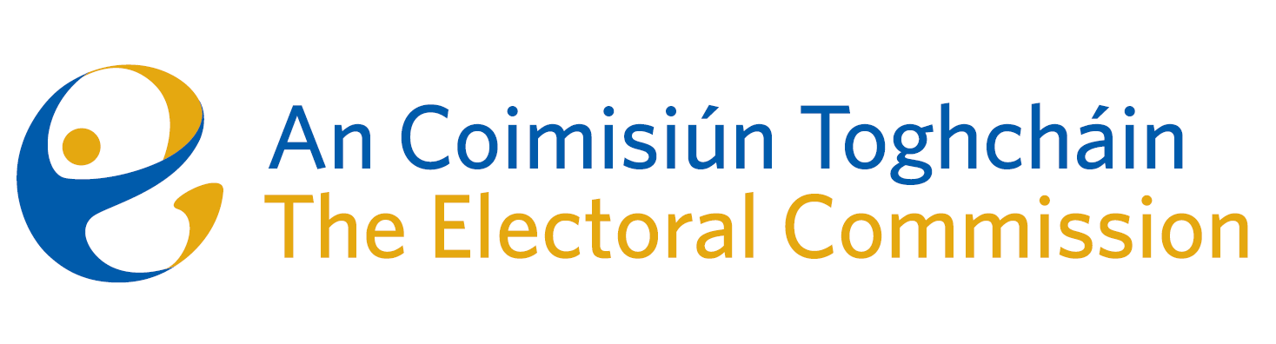
Draft Minutes

Meeting of An Coimisiún Toghcháin

9.00am – 12:00pm | 11 December 2025 | Dublin Castle

Attendance
An Coimisiún:
The Honourable Ms. Justice Marie Baker (Chairperson), Alex Attwood (AA), John Curran (JC), Ger Deering (GD), Prof Caroline Fennell (CF) and Maura Quinn (MQ)

Executive:
Art O’Leary (AOL), Diane Duggan (DD), Seán Garvey (SG), Karen Kehily (KK), Kieran Lenihan, Dr Mary-Clare O’Sullivan (MCOS), Muireann Ní Thuairisg, (Secretariat), Brian Dawson (BD)
------------------------------------

  - Draft Minutes

The draft minutes of the meeting held on 9 October 2025 were approved.

  - Conflict of Interest

There were no conflicts of interest.

2. Succession Planning

Commission members met in closed session with the Chief Executive and Head of Corporate Services to discuss succession planning. Consideration was given to the establishment of committees of the Commission.

3. Draft Research Progress Update to Oireachtas

MCOS gave an update on the work of the research team.

The third progress update on An Coimisiún’s Research Programme 2024 – 2026 was circulated to members in advance of the meeting and will be sent to the Joint Committee on Housing, Local Government and Housing in early January 2026.

4. Review of Presidential Campaign

Members received a briefing on the presidential election campaign delivery which took place from 28 August to 24 October 2025.

During the campaign period, key updates were provided across registration, turnout, communications, and public engagement. A total of 60,733 new voter applications and 30,424 update applications were received, while voter turnout increased by 1.93% compared to 2018, representing 164,098 additional voters. The advertising campaign delivered strong performance across social media platforms, with significant impressions recorded and notable impact achieved through the use of content creators, who drove reach and engagement among non-followers. Public engagement activity was substantial, with An Coimisiún staff responding to 700 public questions and queries. The initiative to bring voters’ voices to the fore helped showcase real voter experiences in the final days leading up to polling day. Website analytics showed 189,986 views between 28 August and 25 October. The campaign continued to prioritise accessible, informative, and authentic information. Additionally, the PEER team conducted visits to 100 polling stations and 11 count centres, contributing valuable observations to the overall process.

5. (a) Risk Policy and Risk Appetite Review

An Coimisiún were provided with a Risk Policy and Risk Appetite Review, and no changes were made.

5. (b) Risk Management Report and Risk Register

An Coimisiún examined the Risk Management Report and the updates to the mitigating actions on the risk register.

5. (c). Meeting Report – Audit and Risk Committee Meeting, 8 December

Members noted the report of the Audit and Risk meeting which took place on 8 December 2025.

6. Corporate Dashboard and Financial Position 2025

An Coimisiún examined the corporate dashboard for Quarter 4 2025, including a financial forecast for 2025, an update on strategic priorities, procurement and human resources.

7. Delegation Order – Transparency and Targeting of Political Advertising - A resolution to appoint an authorised officer

It was agreed that An Coimisiún Toghcháin, in exercise of its powers and functions
pursuant to the European Union (Political Advertising) Regulations 2025 (S.I. No. 474 of
2025), and in particular pursuant to Regulation 8(1)— (2) thereof, has appointed Seán Garvey,
Head of Supervision and Enforcement to be an authorised officer.

A warrant of appointment was signed by the Chairperson and Chief Executive.

8. Review of the 1997 Act

Members discussed a paper circulated in advance of the meeting on the Electoral Act 1997 - Review of political financing regime in Ireland.

A paper will be prepared reflecting comments from members regarding a roadmap, timeframe and structure, after which the matter will be discussed at the next meeting.

- Any Other Business

There was no further business.

