Election posters in Ireland:
Practices, attitudes and impacts

Dawn Wheatley, Saoirse McGarrigle and Eoin O’Malley

June 2026




Contents

Plain Language Executive Summary 2
1. Introduction 4
2. Regulations for posters and political advertising 6
2.1 Rules of political advertising and poster use in Ireland 7
2.2 International models of poster use 11
3. Understanding the role and impact of posters 17
3.1 Posters as communication tools 17
3.2 Mobilisation and turnout 22
3.3 Environmental impact 26
4. Data collection & methods 27
5. Findings 32
5.1 Number of posters in use and amount spent 32
5.2 General attitudes to posters 33
5.3 Posters as a mobilising and engagement device? 36
5.4 Environmental impact 53
5.5 Potential changes to poster rules 67
6. Conclusion and formal considerations for the Electoral Commission 75
Bibliography 81
About the authors 85

All images used in this report are either taken by the report authors, received from others with re-use permission, credited accordingly, or obtained and used via a Creative Commons license.

Plain Language Executive Summary

For hundreds of years, posters have been an important part of politics, dating back to the period around the French Revolution, functioning – alongside print media – as the main vehicle for political messaging in a pre-radio, pre-television and pre-internet era. It was in the 20th century where posters – which had typically featured longer text content – started to focus on more visual images that governments or political parties wanted to use to attract the public, particularly during election periods.

In Ireland, posters are widespread in public spaces during election campaigns, and Ireland is one of the places in the world where they are most used. In earlier generations, they tended to feature more issue-based messaging and perhaps target opposition parties. Today, we see parties and candidates put up posters that mainly just feature the face and name of the candidate or party leader, though in referendums, policy messages and framings are more common.

This report draws on a variety of methods to help with the Electoral Commission’s aims to deepen our understanding of the role of posters, how they affect political engagement, and their environmental impact. We used data gathered from the Commission’s public consultation, two sets of opinion poll questions related to public attitudes towards posters, four focus groups with 38 participants, 26 interviews with those involved in politics, and data relating to expenditure on posters in the 2024 general election. We also commissioned a life-cycle assessment to quantify some of the environmental impact of poster use in an election, and also consider it relative to digital campaigning. The main findings from the report are:

- Posters provide a public service in alerting citizens that an election is on: 59 per cent said seeing posters had a role in their awareness of the 2025 presidential election, and this was confirmed in political interviews and focus groups with the public. In an age when fewer people engage with the same media as each other – whether newspapers, live radio or TV – posters offer a common mechanism that people cannot avoid. When an election is on in Ireland, everyone knows it is taking place. We suggest that posters work through incidental exposure, where people unknowingly and subconsciously learn about candidates and elections without directly seeking out the information.

- However, Irish people do not like election posters and many object to their widespread use. Generally, they see them as a waste of resources – financial and environmental – and that they are ugly without providing any obvious benefits. Our polling shows that a clear majority would like to see them banned outright. Much of that opposition is based on the significant environmental cost of posters, which we outline here. We have estimated that approximately 280,000 posters were produced for the 2024 general election. These accounted for almost one-third of all election expenses logged with the Standards in Public Office. We compare this environmental cost to other activities and events, finding that the total carbon cost of posters in a general election is the equivalent of a full commercial plane making two return flights from Dublin to New York. We also highlight some of the environmental costs associated with digital content.

- The precise role that posters play varies depending on the type of election. Many participants felt they were not that important in presidential elections, especially when there was a small number of candidates. There was wider recognition for their use in local elections where there are more candidates, often not well known to the public. Similarly, in general elections, posters are seen to have some value in helping the public learn about who is running in their constituencies. In referendums, posters may simplify complex issues by those using posters to ‘interpret’ the vote into more straightforward slogans and potentially relatable talking points.

- Candidates report that posters are very important as a cheap way to get noticed and taken seriously by the public. In our interviews, many established elected representatives acknowledge that they themselves no longer need posters and that it would be better for them if they were restricted or even banned. However, new or challenger candidates say that they need posters to break into politics, and many established politicians acknowledged this importance in terms of fairness for newcomers.

- In our polling, despite the generally negative attitude towards posters, many voters acknowledge that posters provide a service, in that they allow the voter to know who their candidates are, can put a face to them, and find out what party (if any) they belong to. For example, 36 per cent of poll respondents said posters help with learning the names and faces of candidates. This comes through in interviews with candidates, who report that once posters go up, people tend to recognise the candidates, and that this facilitates a connection between voter and representative.

- Alternatives to Ireland’s poster system are mentioned in this report, both in the context of international comparisons (such as designated poster zones), changes to rules (such as limiting the number/location) and digital alternatives. The final chapter of the report outlines a list of potential changes – and associated considerations – on which the Electoral Commission may reflect.

Finally, it is worth noting that the research took place against the backdrop of the 2025 presidential election in Ireland. The campaigning dynamics of a presidential election differ greatly to those in local/general elections and referendums given the widespread, national-level media coverage each candidate receives, meaning posters have less of a role in candidate recognition. The relatively low number of candidates in 2025 was also unusual. Furthermore, the research came after a period of heightened electoral activity in 2024 (general election, local elections, European elections and referendums) which meant the public had more exposure to posters in the 18 months prior to this research than may typically be the case. This may have shaped the findings in terms of both heightened positive and negative attitudes.

1. Introduction

Political posters are a staple of political communications, especially during electoral events in democracies. Ireland is no different. However, there has been little change to regulations or formal reflection and evaluation on posters’ contemporary role, particularly against the landscape of digital and social media. Furthermore, though election posters feature in virtually all democratic elections, there is very little academic work on how they are used or their impact. Most studies treat election posters as artworks and analyse the imagery to analyse parties, candidates or the politics of the country at a particular time. The research presented here considers the extent to which posters remain an important communicative device in Irish elections and reflects on their relevance and sustainability as a campaigning and communicative device.

An Coimisiún Toghcháin/The Electoral Commission outlined the following terms of reference for this research, citing its aim to:

(i) Deepen our understanding of the role of posters as a political communication tool in election campaigns in Ireland and elsewhere compared to other modes of political communication and engagement both traditional and online;
(ii) Deepen our understanding of how posters impact political engagement and electoral awareness among the electorate, including amongst people who may be marginalised from the political process;
(iii) Deepen our understanding of the environmental impacts of posters (including any impacts on road or pedestrian safety);
(iv) Draw on the evidence from (i) to (iii) above to evaluate the two policy options below with a view to potentially informing recommendations to be made by An Coimisiún Toghcháin to Government:
(a) Leave the legislation and other provisions on posters as it is (no policy change)
(b) Revise policy/regulations around posters (and within this option identify available policy sub options with reference to any international best practice)
(v) Any recommendations made under (iv) should be informed by
- An Coimisiún’s mandate to increase political participation and democratic engagement;
- Ireland’s environmental and climate action objectives;
- Any potentially relevant existing or emerging legislation such as the new EU regulations on political advertising;
- Any potential impacts on road or pedestrian safety;
- Consideration of enforcement costs and clear identification of enforcement roles and responsibilities.
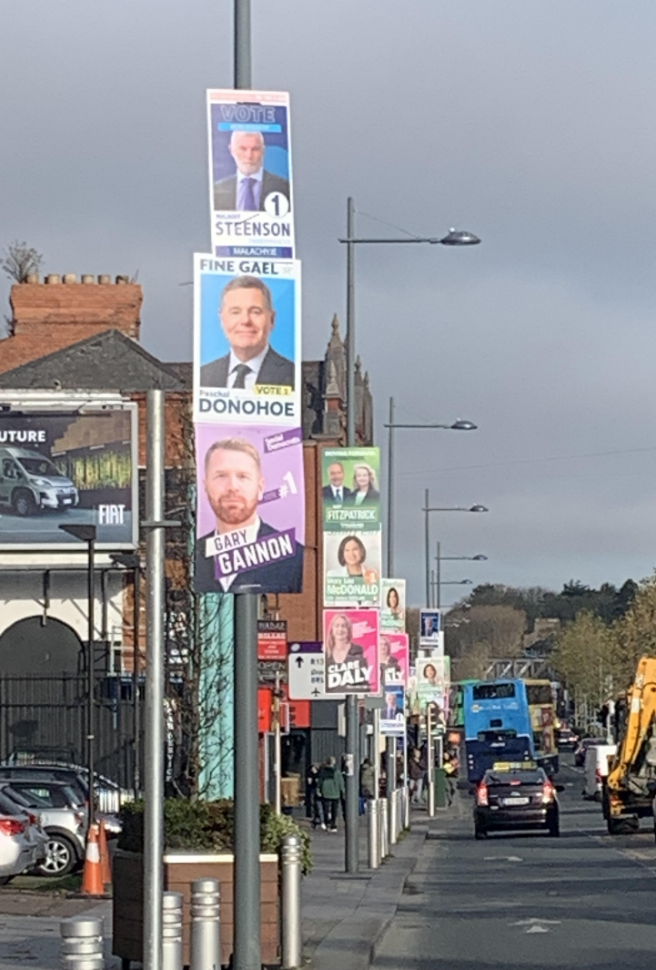
The research draws on a variety of methods, quantitative and qualitative, including polling, focus groups, and interviews with election candidates and party organisers. It also draws on administrative data in the shape of Standards in Public Office (SIPO) returns, and an environmental life-cycle assessment. It will show Irish people’s attitudes towards election posters, how posters are used by Irish parties and election candidates, and draw inferences about the impacts posters have as communicative devices, such as connecting citizens and candidates, and alerting citizens to the proximity of an electoral event. We also estimate the environmental impact of posters.

The research begins in Chapter 2, by laying out the current rules regarding political advertising in Ireland, and specifically the regulations on poster use. There is a discussion of new rules and practices of election campaigning in the context of social media use and the bans on political advertising. In Chapter 3, we then consider what is known about the three areas of interest to the Electoral Commission: posters as communications tools, mobilisation tools, and their environmental impact.
Figure 1: Election posters are ubiquitous in Irish elections, making it difficult to avoid knowing that there is an election on.

In Chapter 4, we outline the various methods employed. Chapter 5 presents our results from the research and, in Chapter 6, we consider potential recommendations, providing context for the Commission’s consideration.

2. Regulations for posters and political advertising
Political campaigning tends to be quite heavily regulated in democracies across the world. Different countries adopt different rules related to campaigning in their political systems, including campaign finance, the use of posters, and advertising. Often these emanate from the political culture, which may then be formalised legally, or at times political rules will be effectively set by the courts, which might declare some forms of campaigning contrary to the constitution; for instance, in the McKenna judgement, using public funds to campaign for a particular referendum outcome was outlawed. The media are constrained in the amount of time they can give to various groups, and in referendum coverage in Ireland, both sides of the debate are expected to get roughly equal amounts of time, and this is formalised in broadcasting in particular. Campaign spending is limited in many countries, including Ireland. In some places there are restrictions on the hours that campaigning may take place. Campaign cars with loudhailers are allowed in the United Kingdom but not seen in the United States. Many countries, such as Canada, Greece, Mexico, Norway and Poland, ban the publication of opinion polls in one form or another before polling. Political advertising on new media tends to be more heavily regulated than older forms of campaigning, such as door-to-door canvassing, holding public meetings or hanging posters. Although social media, the newest of the new media, was until recently subject to almost no regulation.

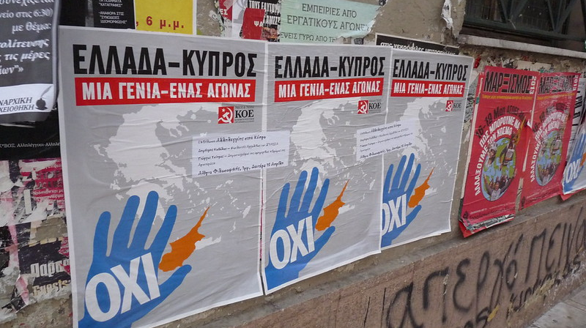
The perceived need for regulation may have been the result of excesses in campaigning. For instance, in Greece in 1981 there were ‘poster wars’ that meant that “much of urban and rural Greece was covered with posters, banners and painted slogans, with rival bands of poster stickers fighting (sometimes literally) not only to display the posters of their own party but also cover up those of their rivals” (Clogg 1987: 89).
Figure 2: Political posters in Greece tend to be glued on top of each other.
Source: stanjourdan/CC BY-SA 2.0

Something similar happened in Poland’s first post-communist democratic elections where “posters were distributed everywhere, and by night [posters] were often destroyed [or] removed” (Dobek-Ostrowska 2017: 261). In Japan, elections are sometimes described as a sensory overload (Lewis & Masshardt 2002: 373): “From the din of the circling campaign cars and the physical and verbal bombardment in front of the train station to the colourful posters that magically sprout from nowhere to cover everything in sight, one would have to try very hard to forget that an election is occurring.” This is despite there being strict rules on the number and sizes of posters permitted. In many other countries, there are virtually no national rules on the use and placement of election posters – leaving it entirely to local authorities to regulate. Other models of international poster use are further explored in Section 2.2.

In what follows, we look at some of the regulations on political advertising in Ireland, focusing especially on those related to posters.

2.1 Rules of political advertising and poster use in Ireland

Posters
The regulation of election posters in Ireland is governed by national legislation. This rests primarily with the Department of Housing, Local Government and Heritage. Posters are exempt from planning and development regulations under Class 14 of the “Exempted Development – Advertisements” in Part 2 of the Planning and Development Regulations, 2001.

The legislation governing the placement of posters at election time is the Litter Pollution Act 1997, as amended by the Electoral (Amendment)(No.2) Act 2009. The erection of posters is only permitted from the date the order is made by the Minister appointing the polling day or 30 days prior to the date of the poll, whichever is the shorter period. Posters must be removed within seven days of the polling day. Posters displayed outside the permitted period can be removed by the local authority and are subject to a €150 on-the-spot fine per poster. On polling day, posters cannot be displayed within 50 metres of a polling station.

Local authorities do not have election poster-specific bye-laws, but councils enforce the national rules. The Electoral Commission does not have responsibility for electoral policy or legislation. All posters must display the name and address of the printer and publisher. For Dáil elections, this requirement is set out in the Electoral Act 1992; for referendums, in the Referendum Act 1994, for local elections, in the Local Elections Regulations 1995; and for European Parliament elections, in the European Parliament Elections Act 1997. Omitting this information is an offence. Similarly, the Road Traffic Acts require that drivers have clear lines of sight, which affects where posters can be placed. Posters must not be put on road signs, at junctions or on roundabouts if they create safety risks. Under the Road Traffic Act 1961, it is an offence to erect any sign that blocks a traffic sign.

While local authorities are responsible for enforcing the national legislation, they also issue practical guidelines to ensure that posters are not a hazard to the public. These guidelines are usually published on the council websites. For public safety, posters should be placed at least
2.3 metres above footpaths, cycle lanes, or other pedestrian areas. They should not be put on lampposts with overhead wires, traffic signal poles, bridges, overpasses, pedestrian bridges, or roadside barriers. Posters must not block road signs or traffic signals and should be securely fastened with cable ties or similar materials, which must be removed when the posters are taken down.

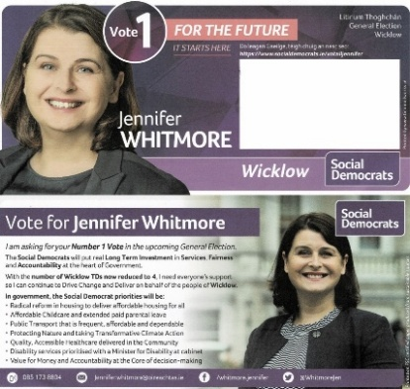
Litir um thoghchán
The litir um thoghchán (election letter) is a free election service provided by An Post. It allows all election candidates “to send one addressed mail item to every registered voter in their constituency at no cost. This service offers a direct and efficient way to distribute election literature and campaign information during elections”. For party candidates, these are typically co-ordinated by party headquarters. As it is linked to individual voters, each household may receive multiple copies of each candidate’s letter depending on the number of voters registered at the address.
Figure 3: Example of a litir um thoghchán from 2024 (Irish Election Literature).

Wider political advertising (TV/radio/party-political broadcasts)
In Ireland, the Broadcasting Act (2009) prohibits television and radio political advertising, and this was amended by, and expanded on, in the 2022 Online Safety and Media Regulation Act which states: “A broadcaster shall not broadcast, and a relevant media service provider shall not make available in a catalogue of the relevant service, an advertisement which is directed towards a political end or has any relation to an industrial dispute.” This applies to political parties, candidates and lobby groups or charities that are promoting issues that are deemed to be “directed towards a political end”. Party-political programmes, better known as party-political broadcasts, are permitted during election campaigns under the 2009 and 2022 Acts. A party-political programme is a scheduled and uninterrupted slot on television or radio that enables parties to present their policies directly to the public. These slots are typically one minute of television and 30 seconds of radio per party. There is no obligation for broadcasters to use these, but if they do, they must ensure that they treat each party equally/proportionally. So, RTÉ, which provides this service, limits its broadcasts to registered political parties that received more than 2 per cent of the first-preference vote in the previous election and has at least one TD. No payment is made for the broadcast of party-political programmes, thereby ensuring they are not classified as advertisements.

Political advertising in print
In Ireland, political advertising is allowed in print media but is subject to regulatory oversight. As a result of the new EU Regulation 2024/900, advertisers are now obliged to specify that the advertisement in question is a political advertisement, who paid for the advertisement, and how much was paid. Section 140 of the Electoral Act 1992 (as amended) states: “Every notice, bill, poster or similar document having reference to a Dáil election or distributed for the purpose of furthering the candidature of any candidate at a Dáil election shall bear upon its face the name and address of the printer and of the publisher thereof.” Furthermore, in October 2025, Ireland implemented Regulation (EU) 2024/900, known as the Transparency of Political Advertising Regulation. This applies to both print and online media and is further discussed below.

EU political advertising and transparency regulations
Aside from Irish legislation governing physical election posters, digital political advertising is now subject to EU-wide regulation. Regulation (EU) 2024/ 900 of the European Parliament and Council on the transparency and targeting of political advertising came into effect on 10 October 2025. In Ireland, an initial grace period until 31 October 2025 was applied, meaning that political advertising during the most recent presidential election (24 October 2025) was not subject to the new rules.

The regulation aims to enhance transparency by enabling the public to identify political advertisements, understand who is responsible for them and determine whether they have been targeted. Under the new rules, political advertisements must include a transparency label and an easily retrievable transparency notice, clearly identifying the advertisement as political. They must also contain key information, including the sponsor, the relevant election or referendum, amounts paid, and any targeting techniques used.

Targeted political advertising online is permitted only under strict conditions. Personal data must be collected directly from the data subject and may be used for political advertising only with explicit and separate consent. Special categories of personal data, such as data revealing racial or ethnic origin or political opinions, may not be used for profiling. The regulation also seeks to protect the integrity of elections and referendums by reducing the risk of information manipulation and foreign interference. To support this objective, it prohibits the provision of political advertising services to third-country sponsors in the three months preceding an election or referendum.

The Electoral Commission has provided information about the implementation of the new rules on its website (https://www.electoralcommission.ie/regulation-of-political-advertising/). It states that the Commission is the regulator, including for the new EU rules on transparency, for political advertising in:
- Newspapers (online and offline)
- Posters, flyers and leaflets
- Public spaces such as billboards, bus shelters and banners
- All websites except: any platforms, broadcast media, social media or search engines (for these, Coimisiún na Meán is the regulator)

Response to EU rules: Meta’s ban on political advertising
The rules intended to improve transparency around online advertisements sparked a wave of criticism from some stakeholders. Reacting to the Transparency and Targeting of Political Advertising Regulation, Google and Meta announced in 2024 that they would stop political advertising on their platforms in the European Union. This ban came into effect in October 2025. Google and Meta (which owns Instagram, Facebook, Threads, and WhatsApp) cited significant new operational challenges and legal uncertainties for political advertisers and platforms under the new rules. This raised concerns that the removal of regulated political advertisements might unintentionally redirect political communication to platforms with less oversight, such as unmoderated social media posts. Politicians across Europe have voiced concerns that this shift could make it harder to monitor and address misinformation. Banning political ads might also “favour those whose speech is already highly amplified” either in mainstream media or through social media algorithms (Who Targets Me 2025).

2.2 International models of poster use
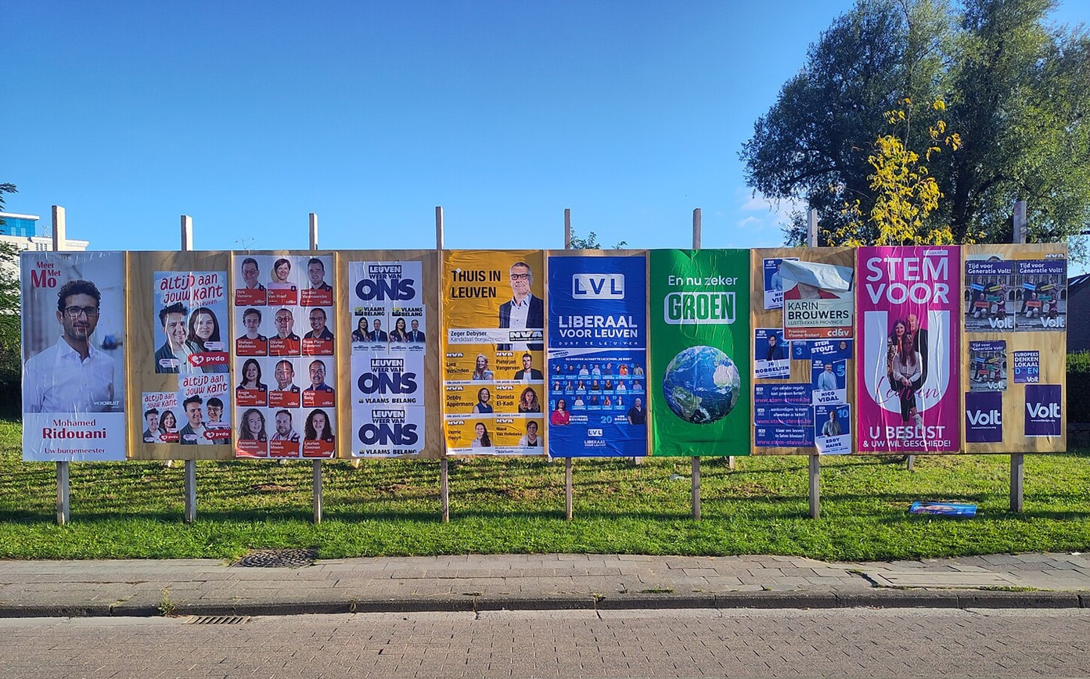
Figure 4: Election posters on temporary public boards in Belgium.

In nearly every democratic country in the world, some form of election posters are an important medium to communicate with the public. Because they are low-cost, low-tech and relatively inescapable, with an emphasis on the visual, they represent a method of communication that is accessible to nearly all. They can reach more voters than many other forms of mass communication. In some countries, such as France, Germany and Belgium, posters constitute as much as 20 per cent of a campaign budget (Dumitrescu 2009) and this is higher in Ireland, as discussed later in Section 5.1. Rules will also take account of prevailing weather in a country, and so bans on certain materials might make sense where the weather allows other campaign materials to last the duration of the campaign. Below we identify four general models of regulation of posters.

Model A: Flexible public display
In countries such as Ireland, Denmark, Germany, the United Kingdom, the United States, Australia and Canada, candidates are generally free to display election posters in public areas, provided they do not pose a risk to public safety; however, there may be local/federal bye-laws with stricter rules in place. Unlike systems with designated poster zones, local authorities in these countries typically do not allocate fixed spaces, leaving candidates and parties responsible for the placement of their posters. Posters are permitted only during the official campaign period and must be removed promptly after the election, with fines imposed for noncompliance. Additional rules govern how close posters can be to polling stations to maintain a neutral voting environment, and safety guidelines ensure that posters do not obstruct roads, footpaths or cycle lanes, nor interfere with traffic lights, road signs or public utilities such as electricity poles. While national legislation sets the overall framework, enforcement is carried out by local authorities, who may remove unsafe posters or issue fines for violations. In countries with relatively unrestricted display rules, election posters are usually allowed on private property with the consent of the property owner. A prominent example is the lawn sign in the United States, where national law regulates transparency and spending on election posters, but placement rules are set by individual states and can vary widely, including restrictions near polling stations.
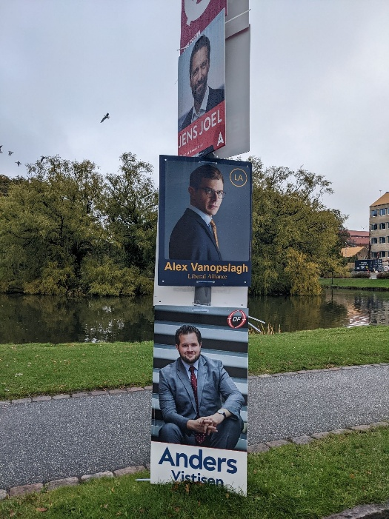
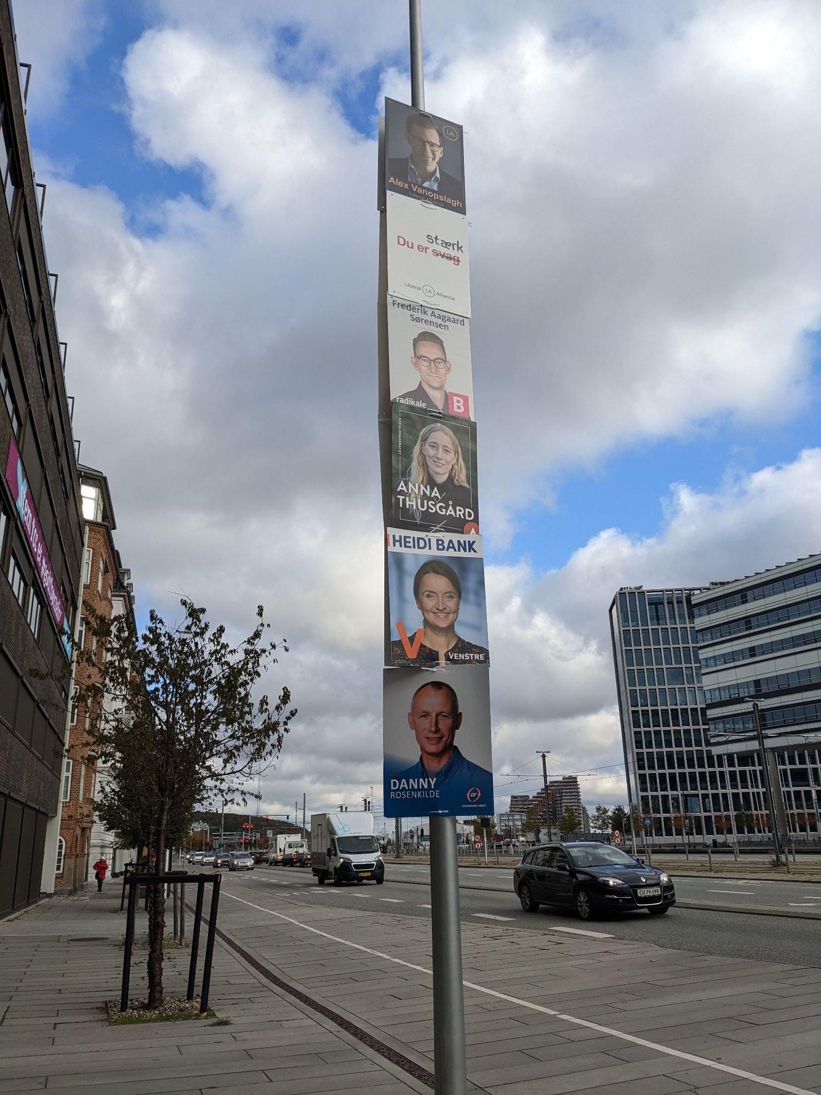
Figures 5 and 6: Election posters in Aarhus, Denmark, in 2022. Denmark operates a similar regime to Ireland where posters are allowed on lampposts.
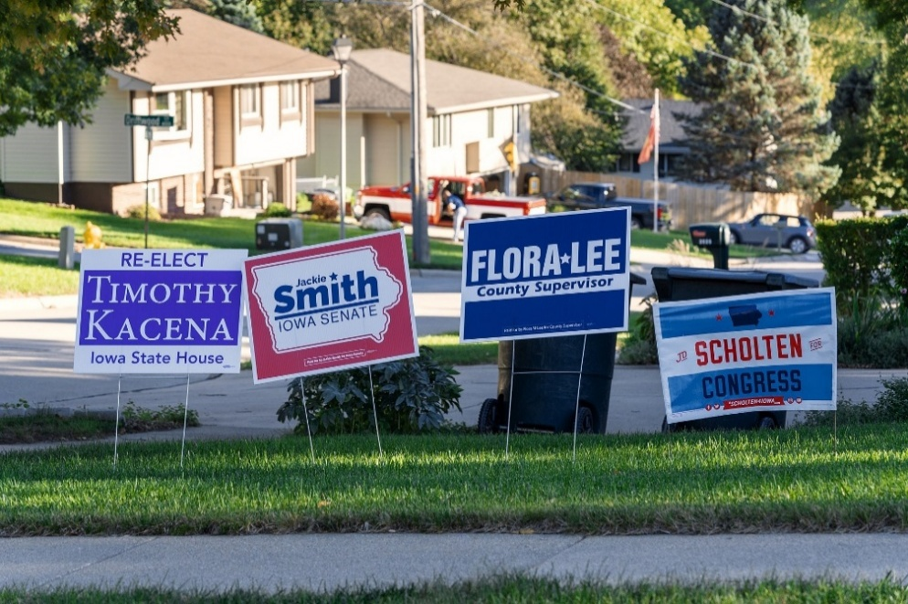
Figure 7: Political Lawn Signs in Sioux City, United States. Lawn signs are an important part of US elections, with the signs used to build name recognition but are also a signal of electoral strength. (Tony Webster, CC).

Model B: Designated areas with equal space per candidate
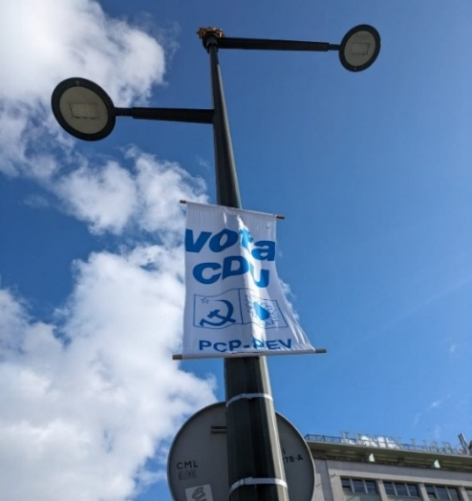
Some countries establish designated poster zones in each electoral area. Local authorities erect an official board for candidates to display their posters. In countries such as France, Netherlands, Portugal and Japan, space on these boards is allocated equally to each candidate or party to ensure fairness. In France, candidates are only permitted to display posters on these official boards temporarily installed by the electoral authorities at the start of the campaign, which is typically two to three weeks before the first round of voting. The French Electoral Code prohibits poster display elsewhere, including on private property. In practice, posters are often stuck to street furniture such as postboxes.

In Portugal, there is also one space per candidate on official boards. However, the Portuguese law does not completely ban posters outside these zones. Colourful fabric posters and murals are common, but there are restrictions on display locations, such as national monuments and religious buildings. With the owner’s permission, posters may also be displayed on private property. The Japanese system of allocating equal space to each candidate came under scrutiny in 2024 during the Tokyo gubernatorial election, when a group exploited the system by nominating several candidates simply to monopolise advertising space on these boards, as opposed to genuinely seeking election.
Figure 8: A fabric poster for the Coligação Democrática Unitária (Unitary Democratic Coalition) in Lisbon, Portugal, in 2024. Portugal permits posters outside its designated poster zones.
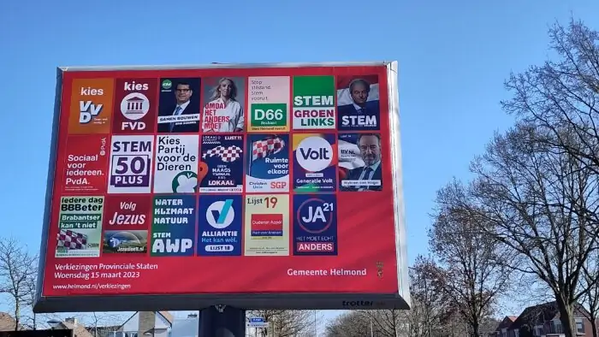
Figure 9: In the Netherlands temporary election boards, known as trotters, are placed around a town, with each party getting to display their poster (Jeanette Hendriks, CC).

Model C: Designated areas with proportional allocation
A variation on the designated zones model allocates space on official boards to political parties proportionally based on previous electoral performance. This approach is used in countries such as Spain, Italy, Greece and Switzerland. In Spain (see Figures 10 and 11), city councils provide free designated spaces according to prior election results, while parties may also use paid outdoor advertising in authorised locations subject to spending limits. Italy and Greece similarly restrict posters to official boards, with space distributed according to party size or historical support. In Switzerland, allocation is typically proportional to party strength, though local rules vary between municipalities. In all these countries, posters may be displayed on private property with the owner’s consent and in accordance with local regulations, and enforcement is the responsibility of local authorities.
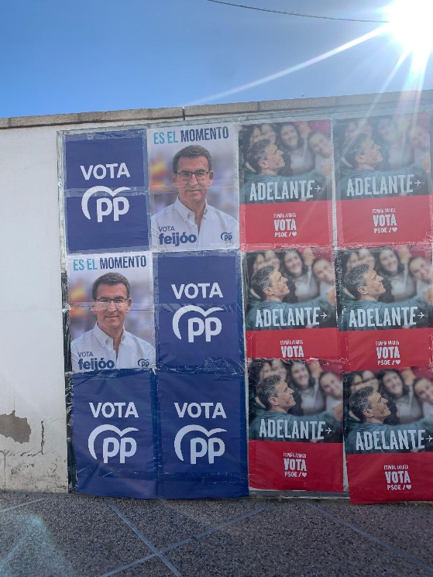
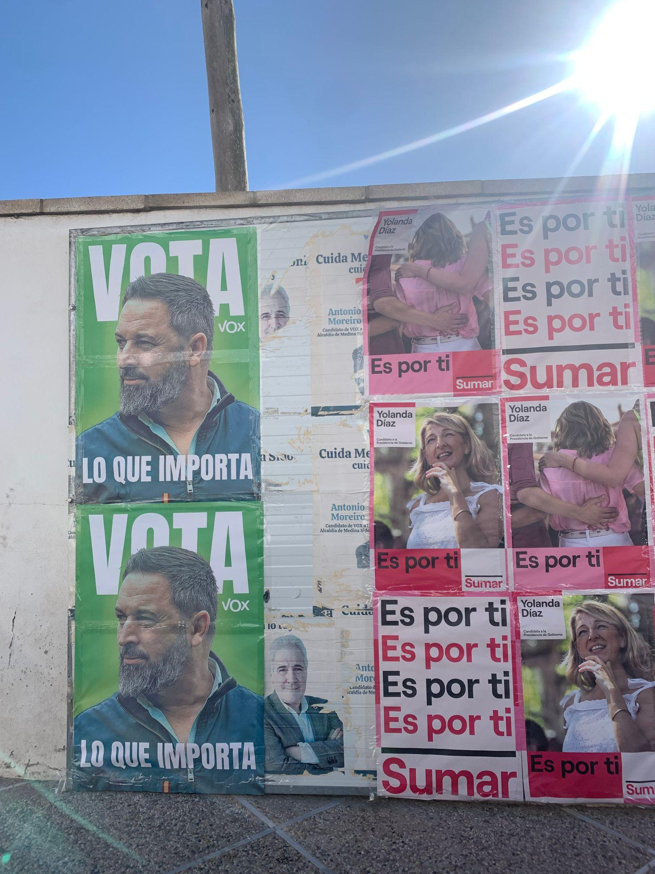
Figures 10 and 11: Election posters in Cádiz, Spain (2023). Poster space in Spain is allocated on the basis of past performance and usually placed in a specific part of the city or town, often out of the way.

Model D: Complete poster bans
Bans on election posters are extremely rare but we present two examples here from quite different contexts. In Bangladesh, a 2025 law introduced a total prohibition on posters, including on private property. It is important to note the current political landscape in Bangladesh, which is quite distinct from the more settled European political context: Bangladesh had an interim government in place following an uprising in July 2024, with concerns around violence, political pluralism and civic freedoms ongoing. A member of the Bangladeshi Electoral Commission suggested that four concerns – environmental, indecent campaigning practices, unregulated expenses, and violence triggered by poster disputes – were the basis for the ban.

Billboards and banners remain permitted under controlled conditions. Campaigns are very heavily regulated, with rules about the types of poses that candidates can use in their campaign photos. There is a limit on the number of microphones at public meetings, which must be approved by authorities. There are rules around what can be said, with ‘inflammatory statements’ outlawed as ‘misinformation’. Violations can result in fines or even disqualification from the election. Enforcement is strict, reflecting the authorities’ commitment to the new regulations. And while it is illegal to print in colour or put posters of any kind on trees, lampposts, electricity or telephone poles, banners can be used which are festooned across the streets (CN News, 2026). The visual impact of the new laws may not have had the expected effect as banners are still everywhere (see Figure 12). Some critics have suggested that it may disproportionately affect smaller/challenger parties that rely on posters to reach voters, and so might be designed to assist government parties.

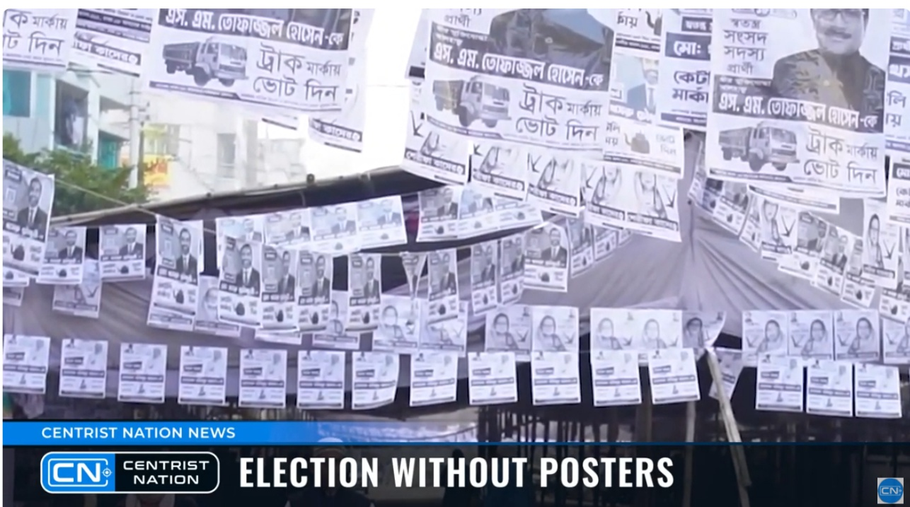

Figure 12: A screenshot from a Bangladeshi TV news report about posters during the recent Bangladeshi election. Though posters are banned, banners are festooned across streets.
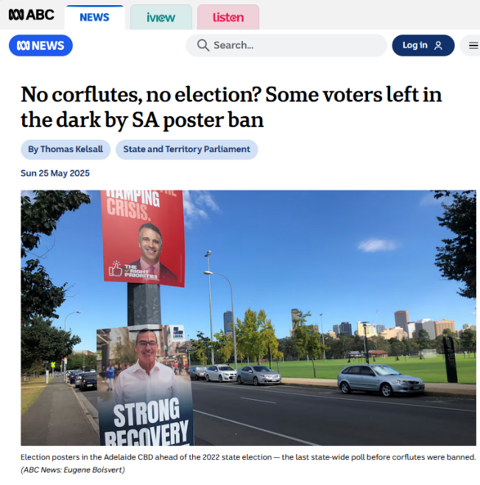
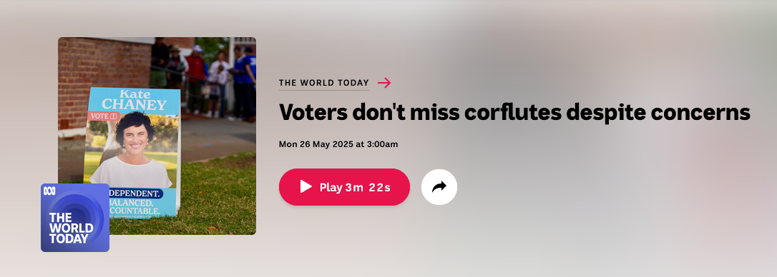
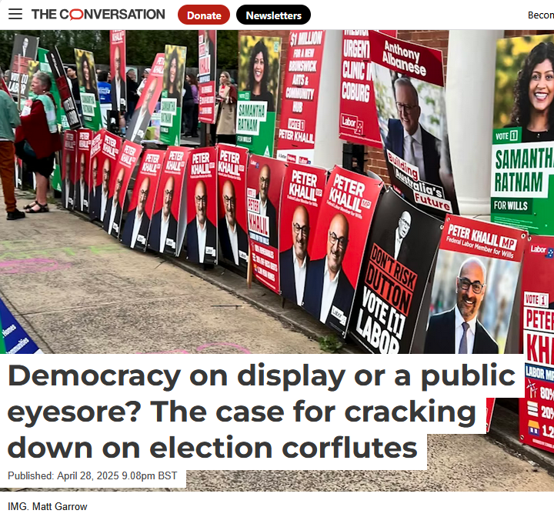
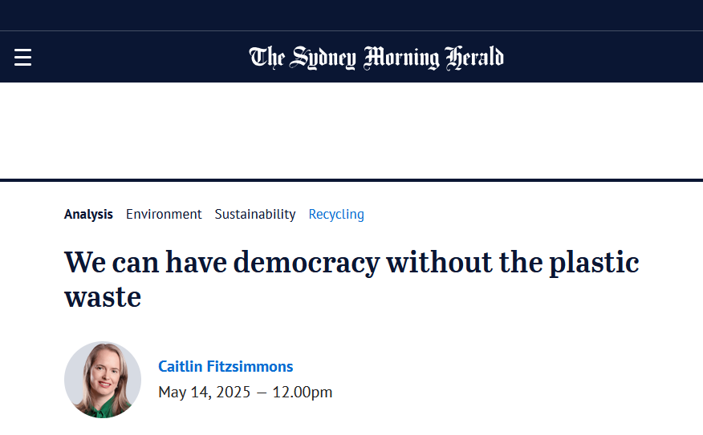
Figure 13: Examples of some of the media commentary regarding the ‘corflute’ ban in South Australia, praising the environment benefits while raising concerns around voter engagement.

In Australia, the federal state of South Australia introduced a 2024 ban on ‘corflutes’, akin to corriboard posters, in public spaces (they are still permitted on private land). The ban was introduced on environmental grounds to reduce plastic waste and reduce visual pollution. It provides an interesting case study as the Electoral Commission of South Australia (ECSA) has since listed the poster ban as one of the main issues it faces: in an advertising tender for the 2026 elections, ECSA states "[The ban] does pose some challenges for ECSA, as the posters had previously helped raise awareness of the elections and their candidates.” It references a survey following a regional bye-election which found that “the recent ban on posters significantly impacted electors’ awareness", with 24 per cent of voters and 37 per cent of non-voters reporting they felt less aware of the election because of the ban. The bye-election was the first election in the state since the poster ban was introduced; there has since been federal elections in 2025 which led to media commentary on the poster ban (see Figure 13), but it should be noted that turnout in the 2025 federal election was unaffected compared to the previous 2022 elections, though this is in the context of compulsory voting.

3. Understanding the role and impact of posters
Political posters perform a number of functions in political communications. As a cheap and easy-to-adopt format, they were for a long time the most common form of visual communication in elections. They have the advantage that they are difficult to avoid: you do not choose to see a poster. With technological changes, posters might be reduced in importance, but there is no sign yet that they are being employed less in election campaigns. Posters are, however, also being circulated via social media, not just in the physical printed form. In this section, we go through what we know of the use and effect of posters on the criteria the Electoral Commission set (as outlined in the Introduction). We present it around three sections: (i) understanding the role of posters as communication tools, (ii) their impact on political engagement, and, more briefly (iii) their environmental impact.

3.1 Posters as communication tools
Political posters are a form of promotion for an ideology, political party, individual candidate or referendum/election outcome. Holtz-Bacha and Johansson (2013: 3) outline the history of posters across art, culture and commerce, dating back to the 15th century, but declare that “political posters made their entrance with the revolutions”, such as the French Revolution in the late 1700s. It was then technological developments – particularly lithographic flat printing – in the late 19th century which enabled “fast and inexpensive” large poster production. The outbreak of World
War I saw posters become an even more important political tool in mass persuasion in terms of military recruitment and notions around national identity and wider propaganda (Seidman 2008). Understanding the media environment in the early half of the 21st century is crucial in understanding why posters often had more text and messaging at the time as, alongside the newspaper press, there were few other mass communication sources of information about political and social events. However, with the advent of radio (in the 1920s) and television (in the late 1940s-1960s), more effective methods evolved to promote political messaging, and while posters remained important, it was primarily as a specific election tool (Holtz-Bacha & Johansson 2013).

Dumitrescu (2009: 9) defines an election poster as “any static visual electoral material designed for posting in public (or private, but publicly observable) spaces for a longer period of time”, but deliberately resists parameters on content or messaging, saying that such decisions are in themselves a political statement. When comparing historical and contemporary posters, one stark observation is the change in design and the amount of text/information featured on posters, and also the tone, which was historically more critical of opponents. While political advertising more broadly can be divided into three categories – (i) attack (make case against opponent); (ii) advocacy (make case for the candidate/party) and (iii) contrast (make case for candidate/party and against opponent) (Campbell & Jamieson 2006) – the majority of contemporary Irish election posters fall into the second category, focused on advocacy for a particular candidate or party. Referendum posters are more likely to feature negative messaging, but modern election posters are primarily about promotion and building name/party recognition, and this is not unique to Ireland. There is some suggestion, however, that online poster-style advertising is taking on a more negative tone towards opponents, such as Stefan and Venema’s (2020) comparative research on German political advertising.

In his study of the increasing ‘professionalisation’ of Dutch election posters between 1946-2006, Vliegenthart (2012) notes as an increased use of party logo, increasing prominence of the party leader, and a decreasing focus on ideology. This toning down of ideology and messaging is commonplace across Europe, and particularly stark shifts are evident in post-communist countries like Slovenia (Dezelan & Maksuti 2012). In the German context, Schott & Wolf (2012) suggest that reducing policy or ideological messaging is a wasted opportunity and urge candidates and parties to take more of a risk with policy statements on posters, such as specifics about already successful projects or demands for future legislation. But it is noted by Holtz-Bacha and Lessinger (2017: 183) that “Posters are a must in German election campaigns … a party foregoing posters is not present in the campaign.” Nevertheless, in an Irish context, repetition of faces and names – rather than policy information or criticism of opponents – is the norm. There is research deconstructing Irish election poster content for symbolism and meaning (e.g. Martínez Lirola 2023), but semiotic analysis and strategic decision-making around content are beyond the remit of this project.
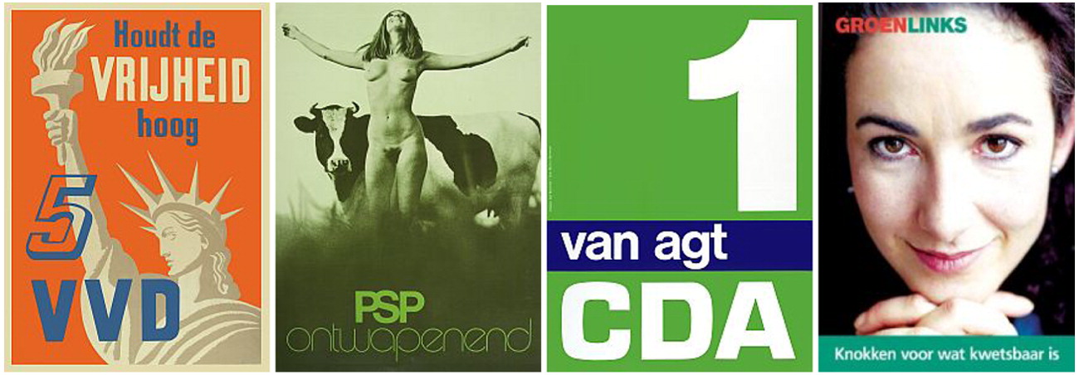
Figure 14: The evolution of posters in the Netherlands. Some can be very simple, others are designed to shock (Documentation Centre Dutch Political Parties, University of Groningen).

More broadly, research about poster engagement and effectiveness is limited: it is difficult to measure the effect of posters – or any single political communication method – because of the complex factors shaping voter behaviour and attitudes (discussed more extensively in the following Section 3.2 on mobilisation and turnout). Ultimately, “political images, party identification or the salience of certain issues are often developed over a long period of time, whereas political communication is almost always a short-term process” (van den Bulck 1993). However, there can also be longer-term, ‘sleeper’ effects with political advertising that extend beyond the election period, which are often overlooked (Gotlieb et al. 2015).

During an election campaign, it is clear that election agents are effectively advertising a product in the form of candidates or parties which has led to comparisons to material product promotions: “Both candidates and manufacturers want to reach the target audience in a cost-effective manner”, wanting to create name recognition, brand association, and short slogans (Campbell & Jamieson, 2006: 284-86). A political campaign’s use of media is “more short-lived and intense” than a product campaign (ibid.) yet, as articulated by Jacques Seguela – who worked on François Mitterand’s presidential campaign in France in 1988 – there is often “no significant difference between advertising for a soap powder, an automobile, or a president of the Republic” (in Seidman 2008: 121). The role of posters in such campaigns is the central consideration here, and repetition is a defining trait of the election poster model of communication. Dumitrescu (2009) interviewed party strategists in France and Belgium: many highlighted the importance of this repetition and recurring images throughout an electoral area. One said: “One [candidate] poster serves no purpose, but seeing the same poster 100, 200 times, over two weeks, that is good ... One must have a lot of posters and be present in the territory for poster campaigns to give results” (Dumitrescu 2009: 57). Dumitrescu (2012) also gathered survey data from party members in France and Belgium, concluding that posters are mainly used to signal the strength of a party’s campaign. Furthermore, often bigger parties use them to signal power, and smaller parties use them to try to expand their voter base by providing additional information, she found.

Beyond the effect of repetition and brand awareness which is central to any advertising campaign, there are three other crucial points to note regarding how elections posters function as a communication and political advertising device: (i) They cannot be turned off like other media where candidates and parties feature (e.g., an election debate on radio); (ii) They cannot be discarded like other election material (e.g., posted leaflets); (iii) They are exposed to voters who may not actively seek them out and are difficult to avoid in everyday life.

A useful way of conceptualising these points is the idea of political posters as a form of incidental exposure: “Exposure to political information that individuals did not intend to be exposed to” (Nanz & Matthes 2022: 347). Posters specifically align with what is considered first-level incidental exposure, the brief scanning of incidentally encountered political information (rather than second-level exposure, which they pay more attention to as it may be particularly detailed or helpful to them). Incidental exposure is also tied to ideas of passive learning: there is no intention to obtain new political information, but also no resistance to learning, so people may absorb knowledge which can leave “memory traces” (Nanz & Matthes 2022: 349). Furthermore, Nanz and Matthes note how incidental exposure “may not only increase political participation by providing individuals with (factual) knowledge, it may also foster political discussion and expression, which in turn, drives political participation” (2022: 350). Of course, none of this is to suggest that posters have the same effect on everyone or have the effect that the politician/party hopes; such a ‘propaganda’/direct effects model of communication is outdated. Instead, audiences – voters, in this context – decode advertising messages in different ways, often in ways not intended by the producer who may have attempted to encode particular meaning into the posters. Ultimately, the psychological, social and cultural contexts in which the public are situated shape their reception of advertising (Aitken, Gray & Lawson 2008).

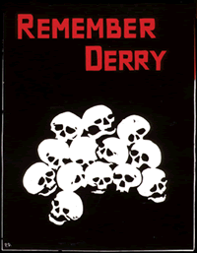
Poster use in Ireland
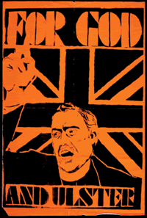
As posters became widespread as political messaging tools at the turn of the 20th century, the significant political activity in Ireland was also evident through public artworks, with history textbooks punctuated with examples of poster images and newspaper cartoons of Ireland, Home Rule and the war of independence, often defined by overtly critical commentary of social issues and opponents. Furthermore, in an Irish context, it is worth noting the continued importance of posters in political activism, particularly the contentious history of Northern Ireland: for example, the Linen Hall in Belfast houses its ‘Divided Society’ collection of more than 800 political posters (Figures 15 and 16), and notes about the collection and the social significance of posters:

“These posters give real insight – they are the physical remnants of the times in which they were collected and serve as historical documents that help us to better understand those times; conveying the messages of the moment, stirring emotions, encouraging reflection or in many cases promoting action.”

The National Library of Ireland (NLI) has 314 items in its “political posters” ephemera collection, focused on material since the 1970s, while a search of its catalogue for “political posters” produces older material back to the 1920s. Elsewhere, the Irish Election Literature website (on Facebook as Irish Political Ephemera) is another source of election literature – leaflets, posters – mostly since the 1980s.
Figures 15 and 16: Some posters from the Linen Hall Library collection.
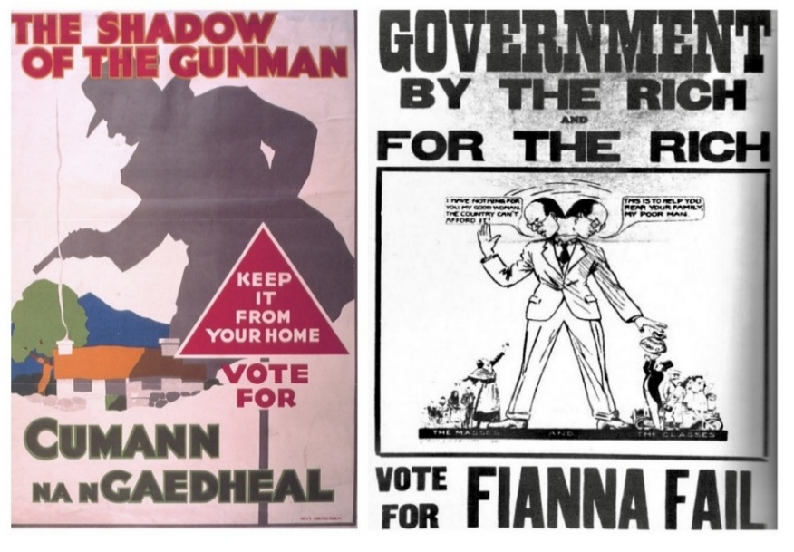
Figures 17 and 18: Posters in the 1932 Irish general election (NLI).
The limitations on political advertising on television and radio in Ireland (Rafter 2011) mean that physical, in-person methods such as posters, leaflets, and door-to-door canvassing have historically been relied on to connect with voters. For example, in the 2002 Irish general election, more than half of respondents encountered canvassers at their door, while 83 per cent of voters looked at candidates’ posters, compared to only 4 per cent attending public meetings; 68 per cent read election leaflets,
52 per cent looked at advertisements for parties/candidates in the newspapers, and 5 per cent saw information about parties and candidates online (Marsh 2004: 252).
Family and Care referendums,
March 2024 (NEDS poll)
Almost one in four (23%) respondents said posters were a source of information during the campaign. This
compared with:
- TV/ radio: 83%
- Newspapers/news websites: 69%
- Electoral Commission information, e.g. booklets, website: 67%
- Social media: 50%
- Online videos/forums: 41%
- Messaging apps: 27%

Of course, the information landscape has evolved over the past two decades, and social media is now an important tool for the majority of candidates and parties. However, it does not necessarily replace traditional methods (see Figure 19), particularly given widespread mistrust in online sources. Recent polling from the National Election and Democracy Study (NEDS) found posters had lower reported use, but higher trust, than many online sources (see panels).
Local/European elections, June 2025 (NEDS poll)
When asked about trust in information sources, 11% of respondents had high trust in posters. This was higher than online videos (7%) and social media (7%), but lower than RTÉ (35%), newspapers (25%), other TV/radio (25%), information directly from parties/candidates (22%) and online-only news sites (14%).

Most respondents (56%) had medium trust in posters, while 30% had low trust. That compares with 51% who have low trust in information on messaging apps, 44% who had low trust in online forums, 48% who have low trust in social media, and 44% who have low trust in online videos.

Finally, 6% of respondents said they “often” use posters as an information source.

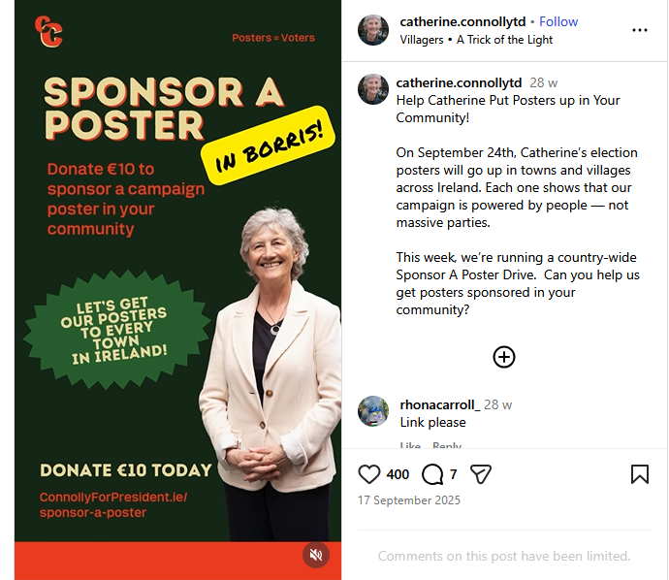
Figure 19: An Instagram post by Catherine Connolly’s campaign team during the 2025 Irish presidential election, reflecting a goal to get posters across all towns in Ireland. This highlights the continued investment in posters as a campaign and election tool.

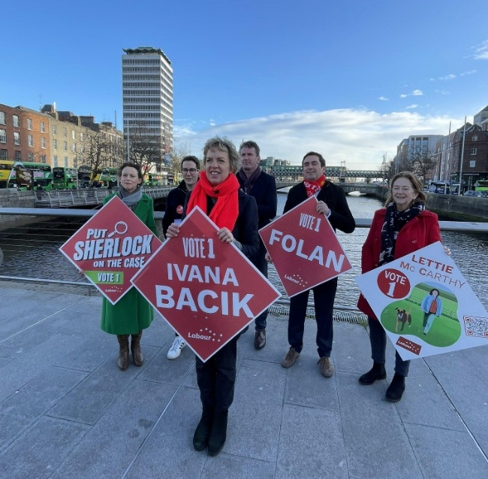
3.2 Mobilisation and turnout
Though historically political posters were ways to convey arguments, and to some extent they still do in referendums, mostly election posters do two things. One is to mobilise voters to vote for particular candidates and parties by raising awareness of those candidates and parties (brand awareness). The second effect is a by-product, which is to raise awareness of the fact that there is an electoral event taking place at all. Though there is very little academic work on the impact of posters, many political scientists would agree with Holtz-Bacha and Lessinger (2017: 183) that, as in Germany, “posters are directed towards the voters to remind them of the election being close and to present them with the choice of parties and candidates”.
Figure 20: Politicians often use poster launches as a photo/ press opportunity. Here Labour leader Ivana Bacik presents the diamond posters in 2024.

Most research tends to be from the US and looks at the impact of advertising there, which tends to be on broadcast media. It has been found that the saturation effects on advertising on mobilisation tend to flatten out after a certain point – ever more advertising delivers diminishing returns (Lipsitz & Padilla 2024; Juárez-Gámiz 2025). Other studies use posters as campaign instruments but do not study the effects of the poster per se, for instance, Gattermann and Marquart (2020) use posters to test the level of personalised and opposed-to party-based campaigning. As we will show, election posters are regarded as important elements of the Irish electoral campaign. Estimating the electoral impact of posters on vote share would be very difficult and well beyond the scope of this report, but suffice to say they are regarded by candidates as important, and though we also struggle to estimate the effect of brand advertising on sales, those meta analyses that exist do show a positive effect on sales from advertising (Sethuraman et al. 2011). While we cannot be certain, all else being equal, it is likely that posters do positively impact on vote share.

Estimating the effect of posters on turnout is also difficult. There is a large academic literature on voting turnout, mainly attempting to explain variation in turnout over time, across space (why those in some constituencies or countries are more likely to vote), across electoral events (why turnout at some types of elections is higher than others) and across groups of citizens (why are some groups less likely to vote than others). The results of one very large experimental study (Aggarwal et al. 2023) on the impact of a digital advertising campaign to increase turnout “indicate that differential mobilisation effects of even large digital advertising campaigns in presidential elections are likely to be modest”.

The jury is out as to what causes variation in turnout, but the level of voting is influenced by the level of mobilisation at election time, that is, campaign activity. So, voting tends to be higher where elections are close, which is related to there being more campaign activity. There is evidence that voters who are canvassed are more likely to vote (Gerber & Green 2000). Those more aware of an election are more likely to engage in electoral activities such as voting. Elections with a lot of electoral activity, canvassing, media debates, posters, etc. seem more salient, and that salience will increase the likelihood that people talk about elections within their social networks, which in turn increases the likelihood to vote.

So, though we often think of voting as an individual activity, and as such, a calculation made at the individual level, Rolfe (2012) argues persuasively that the decision to vote is in fact a result of this social context. While it is not novel to argue that voters are socialised into voting, she argues that the decision is influenced by the social context: if our social network (family, friends, colleagues) votes, then we are more likely to vote. It is not through ‘peer pressure’ or overt attempts at persuasion. Basically, we follow the social group norms through the ‘slow drip’ of everyday life. Rolfe (2012: 17) underlines that it is not necessarily about individuals within the network: “Social network differences are not reducible to differences in the individuals in those networks.”

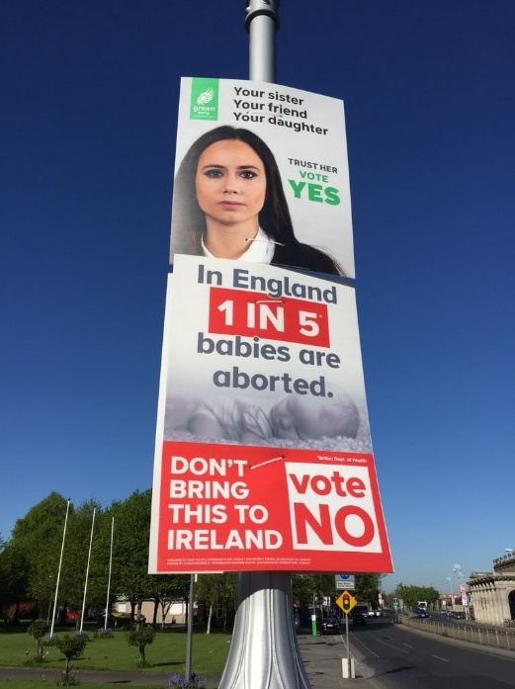
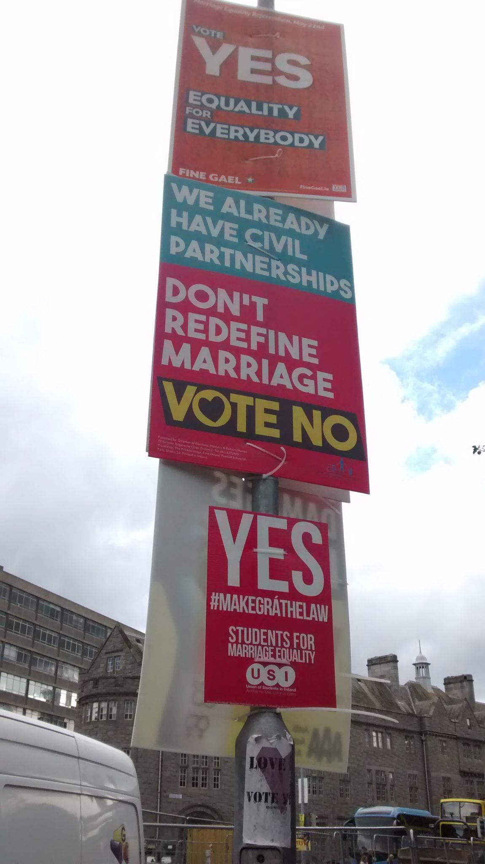
The effects of mobilisation by parties and candidates may not be uniform across social or demographic groups. For instance, turnout might be lower, as is frequently reported, among young people. This may be in part because younger people are less engaged with traditional media that might alert them to electoral events.

However, interestingly, this is not uniformly the case. Turnout in some electoral events might be more likely to elicit interest among young people. One estimate of turnout among young women in the 2018 abortion referendum was much increased on voting in the 2016 general election, and that the normal age gap in turnout was considerably closed (Cunn-ingham et al. 2025).
Figures 21 and 22: Examples of posters from two Irish referendums, the 2015 same-sex marriage referendum and the 2018 repeal of the Eighth Amendment abortion referendum.

One particular group to get attention for apparent low turnout is younger working-class voters: it is assumed that turnout is lower in this group. It is more difficult than one might expect to get accurate turnout data about different demographic groups. Because the marked register does not have demographic information, we cannot derive much meaning from it. Survey evidence is also questionable because social desirability bias means many more people claim to have voted than actually have. There is often an assumption that young voters are disinterested in politics, but this does not appear to bear out empirically. For instance, the recent NEDS data on the presidential election shows that young people were as likely to claim to follow the election closely as any other cohort, up to those aged 55+ years (after that, there was an increase with age in likelihood to follow elections closely). Table 1 suggests that young people are as interested in politics as any other age group under the age of 55.

FOLLOWING THE CAMPAIGN | Aged 20-24 | Aged 30-34 | Aged 40-44 | Aged 50-54
Not or not very closely | 41.4% | 41.2% | 47.1% | 39.2%
Fairly or very closely | 58.1% | 55.1% | 51.8% | 59.3%

Table 1: How closely did you follow the election campaign (by age, selected groups). These are weighted percentages. Don’t knows and Prefer not to answers are not reported.

We can also look at this by sex, where men are slightly more likely to follow a campaign closely than women (66.9 to 60.2 per cent). Those who have one or more parent born outside the state are much less likely to have followed the campaign closely (50.4 per cent to 67.3 per cent). The same is true of those born in Ireland compared to those born in a country other than Ireland or the UK (65.9 per cent of those born in Ireland followed the campaign closely or fairly closely compared with 45.4 per cent who were born outside Ireland or the UK). The relationship with education is there, but not strong; those with higher levels of education are slightly more likely to report having followed the campaign closely (68 per cent for those with bachelor’s degrees but 60 per cent for those who did not complete secondary education). The same is true of household income: there are no large differences in self-reported interest in the campaign based on income levels.

However, if they are not socialised into voting or if politics and voting is not part of everyday life, then turnout is likely to be lower. If voting is not a norm in their areas, then voting is likely to be lower. If they do not know people who vote, then voting is likely to be lower. We should take these factors into account when considering any changes to policy related to electoral posters (or indeed any other policy changes aimed at boosting turnout). As we will see in this report, posters have an impact on mobilisation and crucially socialise the idea of the election in their areas. Particularly when younger voters are removed from traditional media, analogue reminders of electoral events might be crucial.

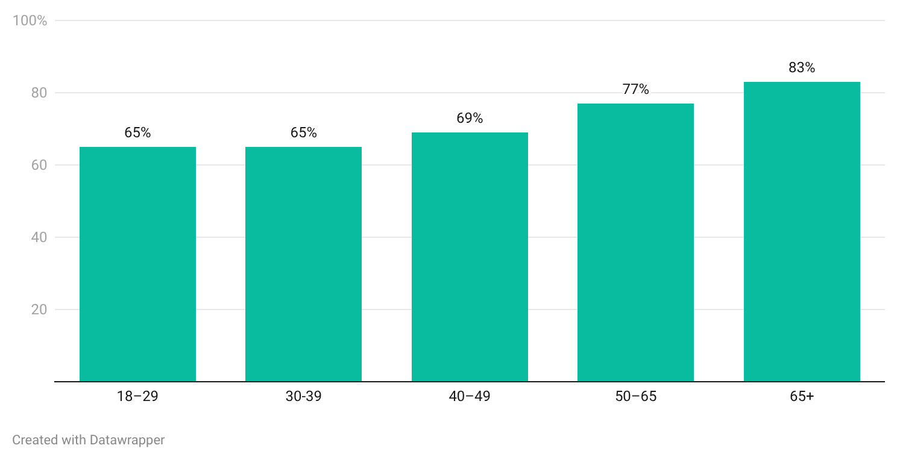
Voter turnout by age

Figure 23: Self-reported turnout at the 2025 presidential election by age, based on data from the National Election and Democracy Study.

In fact, the issue of low youth voting may not be as critical as is sometimes argued. In the 2025 presidential election – the election on which we base our polling – age was not a significant variable in explaining turnout. Figure 23 shows the self-reported turnout for the 2025 presidential election. The estimates are much higher than actual turnout, partly because of social desirability bias (people don't like to admit that they did not vote) and also because the type of person who agrees to do a long survey on politics is more likely to have actually voted. So, the level of reported turnout is of less interest than the variation we can observe between age cohorts.

Aside from age, other factors such as ideology were much more important: those with conservative views were much less likely to vote compared to those with socially liberal views. That might be a result of the unusual array of candidates on offer in that election rather than reflective of a general pattern. But there is still much to learn about who votes and who does not.

3.3 Environmental impact
What are posters
made from?
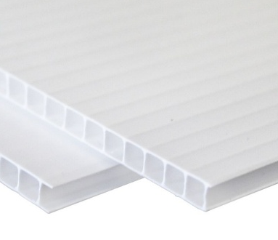

Typical election posters in Ireland are made from corriboard, also known as Correx (a brand name), corrugated plastic, or fluted polypropylene. It is like a plastic version of the corrugated cardboard used for larger cardboard boxes, with an inner, hollow structure sandwiched between two flat outer layers.

The corriboard itself is lightweight, waterproof and relatively cheap to produce from a material called polypropylene, a type of plastic widely used in things like yoghurt pots and bottle caps. Corriboard is typically 3-5mm thick and can be easily cut with utility knives or have holes punched in it without damaging its structure (necessary for inserting cable ties for posters). Technically, corriboard/ polypropylene is fully recyclable (depending on facilities), and is generally easier to recycle than PVC, polystyrene or mixed plastics such as crisp packets.

Most cable ties are made from polyamide (usually Nylon 6.6). They are harder to recycle than corriboard and not as widely accepted in recycling facilities.

Election campaigns undoubtedly have an environmental impact. Elections are associated with more printed material, increased activity on social media, and travel associated with campaigning. There are no high-quality studies that measure ‘election pollution’, though one study in India sets out the potential for different environmental effects of elections there (Padhan & Goswami 2025). Another study on Morocco (Hajri & Daife 2023) shows that leaflets cause a high degree of litter pollution (although it should be noted that other forms of litter make Morocco an already highly littered country). That study urges a move to online campaigning, but does not consider the less visible environmental impact of such campaigns. A study of public attitudes to election materials and their environmental impact in a region in Iraq shows a strong preference to restrict the use of physical election materials (Hassan & Salahaddin 2025), and we might expect that these preferences are not unique to that particular region. Seo (2025) highlights election posters’ impacts in terms of microplastics, and suggests that more “integrated approaches”, such as sustainable material innovation, community-based recycling, and digital campaigning, could reduce the environmental footprint of political campaigns.

Steiner et al. (2024) note how corriboard/polypropylene in the form of used election posters “demonstrate considerable potential for recycling, although the implementation of specific eco-design strategies remains a future objective”, noting how stages such as washing are key. Elsewhere, Aran (2024) positions election posters as part of wider election-related plastic waste, and references other elements such as plastic tamper-proof envelopes, plastic pens, and plastic ballot boxes. He explains how “campaign materials like banners or posters cause a lot of pollution to the environment when there are no effective waste management action plans or regulation of material type/grammage” (2014: 12). He suggests electoral management bodies and political parties could take the lead in overseeing waste reduction and recycling, and further consideration could be given to implementing more environmentally friendly options. We deal with this in greater detail later in Section 5.4.5.

4. Data collection & methods
This research report relies on a range of data from a variety of sources to help us respond to the key points raised in the terms of reference, with the Electoral Commission seeking to:

(i) Deepen our understanding of the role of posters as a political communication tool in election campaigns in Ireland and elsewhere compared to other modes of political communication and engagement both traditional and online;
(ii) Deepen our understanding of how posters impact political engagement and electoral awareness among the electorate, including amongst people who may be marginalised from the political process;
(iii) Deepen our understanding of the environmental impacts of posters (including any impacts on road or pedestrian safety).

Table 2 summarises the data sources used in this report. The purpose of employing a variety of different data sources is that each one has its own uses and drawbacks; this section briefly outlines the reasons for choosing each and its potential limitations. It also sets out how each data collection method was conducted. Before each method is outlined, we present some important context for the period of this study. Ethics approval for the focus groups and interviews was granted by DCU’s Faculty of Humanities and Social Science Research Ethics Committee.

Data source | Description
Public consultation submissions | Review of 1,104 submissions to public consultation in 2025 (undertaken by the Electoral Commission rather than the report authors).
Polling | Polling from two sources:  - The National Election and Democracy Study (NEDS) poll during/following the 2026 presidential election.  - An omnibus poll carried out by Ireland Thinks in October 2025.
Focus groups | Four focus groups held in Co. Louth, Co. Kerry, and Dublin (x2) with 38 participants.
Political stakeholder interviews | Interviews with 26 political stakeholders, including current/former politicians, candidates and party representatives.
Life-cycle assessment | Consultancy with Dr. John Gallagher, associate professor in Environmental Systems Modelling at Trinity College Dublin, to determine the environmental impact of posters in a campaign.
Administrative data | Data from the Standards in Public Office (SIPO) regarding campaign expenditure in the 2024 general election.

Table 2: The data sources used in this report.

4.1 Political context in Ireland in late 2025
This research was undertaken during the 2025 Irish presidential election, therefore relying on it as the main electoral event that would have been on people’s minds when thinking about the issue of election posters. Presidential elections are atypical of Irish elections in that the whole state is a single constituency (although we often report results in referendums and presidential elections at the constituency level, the counting just takes place at these levels for administrative ease). Furthermore, because national media cover the election at the national constituency level, candidates have less reliance on posters. Indeed, in 2011, one candidate made a virtue of necessity by claiming he was not using posters. Whether the reason was due to resources (financial or manpower) or a deliberate strategy, this did not stop him from being the frontrunner until very late in the campaign. As such, we recognise that posters should have less of an impact in presidential elections (O’Malley 2012).

The 2025 presidential election was also unusual in that there were only three candidates: the successful independent Catherine Connolly, who had cross-party support from left-wing parties, Fine Gael’s Heather Humphreys, and Fianna Fáil’s Jim Gavin who dropped out mid-campaign. It was an election where there was great enthusiasm for the left-wing candidate, but much less enthusiasm for the candidates of the parties of the centre. Because for many participants in polling and focus groups, the questions are asked in the context of a presidential election, we recognise the research might underestimate the wider role of posters. Also, in referendums, posters tend to perform a distinct function, which is message-based rather than delivering face and name recognition, so had the research taken place during a referendum, some responses would have been different. However, it may also be the case that due to there being fewer posters than during other electoral events, negative responses or potential inconveniences may also be underestimated. Ultimately, respondents may not be as exposed to them in daily life and, consequently, may not be as mobilised or feel as strongly in favour or against them.

4.2 Public consultation
The Electoral Commission undertook a public consultation on the value of election posters at the start of this research process: it was open for submissions between 27 March – 9 May 2025. Public consultations purport to get a sense of the view of key stakeholders and interested parties. However, the data that emerges from a public consultation is subject to a response or selection bias as the sorts of people or groups who respond to public consultations may be very interested in the topic, usually reflected in strong opinions. Because of this response bias, we cannot expect to see that these will be wholly representative of public opinion, but they can provide a sense of the arguments for or against the topic under consultation. In this case of posters, we do get to see the formal positions of some groups, such as Tidy Towns committees, political parties or advocacy groups. We use some of the institutional submissions later in this report, and they also provided useful talking points for the interviews. However, a comprehensive or systematic analysis of the submissions in terms of themes and topics raised is beyond the scope of this report. We understand The Electoral Commission may later publish more detailed summary findings of the 1,104 submissions.

4.3 Polling
Can we always trust people’s
responses to polls?
In a study by Cialdini (2005), researchers approached people who passed a busker. Some had given money, others did not. The respondents did not know it, but they were subject to an experiment, where in some cases they witnessed someone (part of the research team) just before them giving money or not. The difference in donations was stark. Those who witnessed others donate were eight times more likely to donate. However, when they were interviewed on why they chose to donate, the reasons had almost nothing to do with them having witnessed someone else donating. People gave largely rational and plausible answers, but these had almost nothing to do with what the experiment revealed. As such, we need to be sceptical of data that asks people directly why they act in the way that they do.
Surveys and polling are mainstays of the study of electoral behaviour. We often ask people how they behaved, and then seek to find patterns in the data that might link those behaviours with some other characteristics. The large number of respondents in a survey gives us confidence that the data are representative of the universe of possible respondents whose behaviour we are interested in studying or understanding. We ask respondents why they behave the way they do, for instance, asking them whether they voted for a local candidate, for a government or a party. The problem with such an approach is that people often do not know why they behave as they do, but will give plausible rationales for their behaviour (see panel).

Nevertheless, polling remains an important tool to provide insight into public sentiment, and we use data from two sources. One source is questions in the National Election and Democracy Survey (NEDS) panel, surveys carried out online during and after the 2025 presidential election. This panel has 1,583 respondents and there are questions relevant to posters and campaign awareness in waves 1 and 3. The other data come from an omnibus poll by Ireland Thinks during the same election. It is an online poll using a panel of 1,382 respondents.

4.4 Focus groups
One of the limits of polling is that you get little opportunity to explore ideas in more depth. Also, it is difficult to see how others’ ideas and opinions might influence people. A focus group involves the gathering of a group of people who are asked about their attitudes toward a person, party, policy, product or idea. They allow us to expand on or explore ideas that emerge in polling or some other forum, such as the public consultations. Focus groups are typically semi-structured, guided by a facilitator following a general question guide, but who has the flexibility to adapt questions as the discussion progresses and depending on the perspectives in the room.

Focus groups are ultimately valuable for gathering qualitative, in-depth insights into people’s attitudes, opinions, and behaviours through moderated, interactive discussions with small, targeted groups. They are highly useful for exploring the ‘why’ behind decisions, testing new ideas, understanding user experiences, evaluating programmes, services, or policies to see how to improve them. The group dynamic allows for a richer exchange of ideas and deeper exploration of topics than individual interviews, and moderators can observe body language and facial expressions for additional insights. Respondents tend to feel comfortable talking among others, rather than the more formal one-on-one structured interview.
We recruited the members of the focus groups informally, starting with local contacts and snowballing from there. We told participants that the focus group was on political communication, and we discussed other forms of communication during election campaigns rather than just focusing on posters. We ran four focus groups from September to November. The first was a pilot using students from Dublin City University, followed by one in a rural area (Killorglin, Co. Kerry), a large town (Drogheda, Co. Louth) and in Dublin city (Drumcondra). The focus groups had a mix of people; they were not expected to be ‘representative’ in demographics, but Table 3 provides the sex and age breakdown. Indeed, the homogeneity – people from a particular area – gives weight to them representing opinion in that area. They took a little over an hour each, with about eight people for each group. Respondents were paid a €50 voucher for their time and travel costs and offered refreshments at the venue.

 | Teens | 20s | 30s | 40s | 50s | 60s | 70s | 80s | TOTAL
Female | 0 | 5 | 5 | 3 | 6 | 3 | 1 | 1 | 24
Male | 3 | 2 | 1 | 1 | 3 | 2 | 1 | 1 | 14
Total | 3 | 7 | 6 | 4 | 8 | 6 | 2 | 2 | 38

Table 3: The demographic breakdown of the focus group participants across all four focus groups.

4.5 Interviews
Those who use posters – primarily candidates – will have an alternative and important perspective. As those at the frontline of democratic politics, they might have a better understanding of the dynamics of election campaigns. In-depth interviews allow us to explore ideas and policies in more detail with these politicians. They are more flexible and more private than focus groups, usually allowing one to concentrate on those factors that the respondents think most salient regarding their use of posters and other campaign materials and tactics.

We sought a mix of political candidates, both electorally successful and unsuccessful, from around the country, as the aim was to gain a sense of the perspectives of politicians at each stage of their careers. Some were experienced incumbents, others were first-time candidates. Some were sitting TDs, others were councillors, or neither. We interviewed candidates for council and Dáil elections in both rural and urban constituencies, and from a mixture of parties. A small number of political party staff were also interviewed. A sex and party breakdown is provided in Table 4, but their identities are anonymised for the report.

Interviews lasted from 20 minutes to more than two hours, either by phone, face-to-face or via Zoom. The focus of these interviews was to establish the extent to which candidates used posters and any other campaign approaches, such as advertising in local press or on social media. We asked them how important they thought posters were to modern campaigns and what regulatory changes they would recommend.

Political Party | Male | Female | Total
Aontú | 1 | 0 | 1
Fianna Fáil | 3 | 1 | 4
Fine Gael | 4 | 3 | 7
Green Party | 2 | 0 | 2
Independent | 2 | 0 | 2
Labour Party | 1 | 2 | 3
Social Democrats | 2 | 1 | 3
Sinn Féin | 1 | 2 | 3
People Before Profit | 1 | 0 | 1
TOTAL | 17 | 9 | 26

Table 4: Demographic and party breakdown of political interviewees.

4.6 Administrative data
All candidates are required to provide returns to the Standards in Public Office (SIPO) after their elections outlining their spending and making claims that their spending did not breach regulatory limits. These claims are publicly available some months after an election. We can use these returns to both cross-check for validity the claims made by interviewees and draw more general conclusions on the extent of spending on various materials in election campaigns, including on posters. For this report, we used the SIPO returns for the 2024 general election.

4.7 Life-cycle assessment
To try to understand some of the environmental impact of poster use, we engaged Dr. John Gallagher, an associate professor in Environmental Systems Modelling at Trinity College Dublin to conduct a life cycle assessment (LCA). The LCA was performed in accordance with the 14000 family of International Standards (Environmental management – Life cycle assessment), specifically ISO 14040 (principles and framework) and ISO 14044 (requirements and guidelines) standards (ISO, 2006a,b), to ensure methodological consistency and transparency.

We provided Dr. Gallagher with an estimate of the number of posters used for a general election (280,000 – see Section 5.1) and information on the materials, and he produced data regarding their environmental impact, which we use in Section 5.3.5.

5. Findings

5.1 Number of posters in use and amount spent
We used two methods to estimate the number of posters used in Irish election campaigns, drawing on the 2024 General Election as a case study. We made the first estimate on the basis of interviews with candidates, poster printers and secondary sources, and extrapolated the numbers for the population of candidates. This was done by breaking down the 685 candidates who ran in the 2024 general election into three distinct party groups to reflect the potential party resources available:
- The 233 candidates from Fianna Fáil, Fine Gael and Sinn Féin using 700 posters each (=163,100)
- The 186 candidates from Aontú, PBP-Solidarity, Green Party, Labour and Social Democrats using 400 posters each (=74,400)
- The 171 candidates who ran as independents and the 95 candidates who ran with smaller parties/groups using 125 posters each (=33,250)

From this, we estimated that c.271,000 posters were used in the 2024 election, but this figure can only ever be an approximation given the many variables at play in terms of constituency size, number of running mates, incumbency status, resources, etc.

We then did a second calculation based on campaign expenditure: Standards in Public Office (SIPO) returns after the 2024 Irish general election were used here to again estimate the number of new posters in the election. According to this data, spending on posters varied greatly between many candidates reporting zero spending on posters to one who spent almost €28,000 on posters. If we include the candidate spending on posters, party spending on candidate posters and party spending on posters, the total is €2,797,104 spent on posters. If we assume that each large poster and two cable ties cost €10 (assuming the cost of erecting the poster is covered by volunteer labour), this amounts to approximately 280,000 posters. This does not include posters that have been reused from other elections, just new spending. This amounts to an average of 408 (new) posters per candidate in the 2024 Irish general election. We use the larger figure – 280,000 – from the SIPO returns in our later calculations.
€2.8m
The amount spent by candidates on posters during the general election in 2024

About €9.2 million was spent by parties and candidates during the election, so the almost €2.8 million spent on posters represents nearly a third (30.5%) of the total spend. As well as being the most visible indicator of the election, posters are the single most significant feature of an Irish general election in terms of spending (other advertising is next at €2.38 million).

5.2 General attitudes to posters

5.2.1 Electoral Commission public consultation
A total of 1,104 submissions were made to the Electoral Commission as part of its electoral postering consultation, which ran from 27 March – 9 May 2025. While the majority were personal submissions from members of the public, 58 organisations also responded.

Figure 24 presents the breakdown of sentiments expressed in the submissions to the public consultation. Analysis of the submissions found that 807 (74%) expressed a negative view of election posters. Within this group, 411 submissions were categorised as strongly negative, indicating clear opposition to the use of posters during election campaigns.

A further 226 submissions (20%) were categorised as mixed, identifying both advantages and disadvantages but no clear preference. Table 5 gives a snapshot of some extracts from submissions which were categorised under the positive/mixed/negative categories. Overall, the submissions indicate a predominance of negative views, alongside evidence that some respondents are open to regulatory change or alternative approaches.

A systematic analysis of the submissions, in terms of specific issues raised, was not carried out for this report, the remainder of which relies on the polling, focus group and interview data. However, as provisional analysis of the submissions helped inform our questions for these later data collection methods, there is overlap in themes with the public consultation submissions.

Sentiment of public consultation: 1,104 submissions
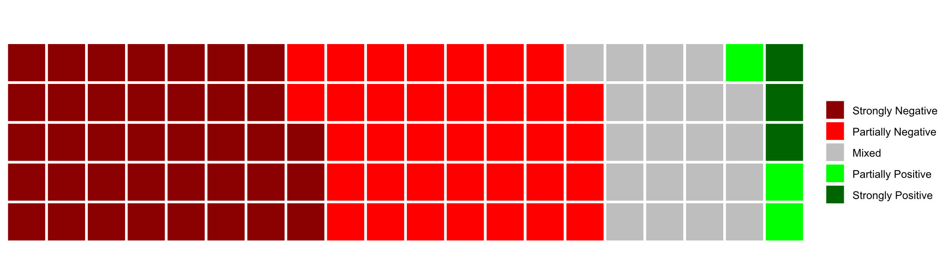

Figure 24: A summary of the positive/negative/mixed tone of the public consultation submissions.

Examples of public consultation submissions

Positive | Mixed | Negative
“They’re great for public awareness and play an important role in informing people that an election is happening and who the candidates are in their constituency. Unlike social media, TV, or radio ads, which can be easily missed, manipulated, or even polarising, posters are static, visible in everyday public spaces, and generally straightforward. They help bring politics into the public eye in a way that’s hard to ignore or distort.” (M, 18-24, Meath)  “Posters add to the atmosphere of elections. There is too much apathy towards politics and politicians. There is too much canvassing on social media, it only adds to negativity.” (W, 65+, Clare)  “They make the election very visible throughout the community. You don’t need to buy a newspaper, own a television or a smartphone to be aware that an election is taking place. They are a visual information source and legible to people with limited literacy and English language skills. They emphasise the communal and unique nature of the electoral process - taking up space in the ‘commons’, on our streets.” (W, 35-44, Cork)  “As someone in my 20s I find posters helpful to quickly see who to vote for judging one image, and if interested researching the candidate.”  (W, 25-34, Dublin)  “Posters provide a relatively low-cost method to promote a candidate and their widespread use is a visual alert to there being an election or referendum on. It creates an atmosphere where even people with a low level of interest in politics will be made aware that something is going on. They are conversation starters. Having been involved in many campaigns some for candidates with small budgets, I have seen how a few thousand spent on posters can make a difference. They, along with leaflets, are a simple way of spreading the message and are far preferable to TV or radio ads which they have in other countries. (M, 55-64, Dublin) | “It gives the electorate notice the election is taking place in a tangible way. It makes the election a reality and promotes engagement with candidates. … Litter is the main problem and obscuring signage and traffic views.” (M, 55-64, Dublin)  “[They provide] a face to the name. Local politics is strong in rural communities. … [but] the waste left behind long after each election is evident. Cable ties left on poles everywhere. Also finding them strewn in ditches months later after a winter storm season.”  (M, 45-54, Cork)  “In more rural areas, you may not know who is running and smaller or newer candidate don’t get the same exposure as more established people … [but] it’s extremely unfair that established politicians can have massive signage on main roads as well as two or three posters at round-abouts for example when: A) Those just starting out may not have that level of marketing funds, and B) It’s a total eyesore and distraction for drivers. To add, no politician should be allowed to litter roundabouts with posters – it is a mess.” (W, 35-44, Limerick)  “They are particularly helpful for those running for election for the first or second time and for non-incumbents, to remind voters there are other candidates in the race apart from incumbents, who tend to be known by the electorate already. … they are expensive, and not good for the environment, and the money and time planning and putting them up could be put to better use, for example: meeting voters, town halls, preparing and doing radio interviews etc.”  (M, 45-54, Tipperary) | “They are a complete waste of materials, cause obstructions / distractions and look terrible. In this day and age of social media there is no need for any election posters anywhere.” (W, 65+, Waterford)  “They are nothing more than litter. They distract drivers and block road user visibility. They do nothing to communicate anything meaningful about the character, policies or views of the candidate. There is no positive, voter-oriented reason to have them. At best they are just vanity.”  (M, Dublin, 35-44)  “They look terrible. Are distraction for drivers. Are often vandalised.  The cable ties are often left behind on poles or cut and strewn on the ground. Excessive use of short term corriboard. Wasteful.” (W, 35-44, Kildare)  “Waste of taxpayers’ money but even worse is the environmental impact of producing the posters and disposing of them after the elections. Many end up on the street or in waterways causing damage to flora and fauna.”  (M, 45-54, Dublin)  “They don’t have any effect on my voting preferences, and they’re unsightly / oppressive. They’re also a waste of cardboard and environmentally unfriendly. I just think there’s too many and they are ugly.” (W, 18-24, Dublin)  “This is 20th century technology that has no place in modern Ireland. Posters are eyesores, foisted upon us without consent and environmentally damaging.” (M, 55-64, Galway)  “They are very unsightly, you know who you are going to vote for and a poster isn’t going to change your mind. They are also a hazard especially when placed on electricity poles, and when the block you view when driving like at roundabouts.” (W, 35-44, Roscommon)

Table 5: Some extracts from the public consultation submissions (W = woman, M = man).

5.2.2 Polling: General sentiments
As highlighted in the public consultation submissions, it is clear that the Irish population, on the whole, does not like election posters. In the omnibus poll, we asked a random sample of respondents to say what they thought of posters in three words (in reality, people gave many more than three words). We manually coded these responses as negative, neutral or positive. In total 68 per cent of respondents gave negative responses, 18 per cent were neutral, and just 14 per cent were positive towards election posters. This negative response aligns with the responses from the public consultation, which were overwhelmingly negative, and from the NEDS data where an open-ended question about posters was also asked.

There was some variation on sex, with women much more hostile to posters (75 per cent were negative compared to 61 per cent of men). There was a strong age cohort effect, with the under 35s much less negative about posters. Just under 50 per cent gave negative responses in this younger group, whereas each of the other age groups was c. 70+ per cent negative. Perhaps unsurprisingly, those interested in politics are more positive about posters than those who are less interested in politics.
75%
of women were negative in their thoughts on posters, compared with 61% of men

The negative comments on posters were often about the visual impact (people regard them as ugly), their financial impact (people say they are a waste of money), or their environmental impact (they do not like the plastic use). Those who are more positive about election posters cite things such as it reminds some voters that there is an election on, or who the candidates in their area are: this is explored in more depth in the following section 5.3.

Many of the people claimed that “posters don’t have any impact on me” (a neutral statement), but is it true? Few of us think we are persuaded by advertising, yet private companies are hardly engaged in advertising because they wish to fund media. Many of the effects of advertising might be subconscious (Heath 2012). So, although people might not think they are influenced by election posters, they may be influential in a number of ways.

In the following sections, we are going to explore some of the issues that emerged both in the public consultation and the representative polls of the general public. To explore them in more detail we also rely on the data from focus groups and interviews with politicians.

5.3 Posters as a mobilising and engagement device?
The following sections consider the extent to which posters function as a mobilising device in Irish elections from both a political stakeholder and voter/public perspective. It is structured around six sections: awareness of elections, candidate familiarity, role for first-time candidates, posters as accessible information sources, vandalism, and gender-specific issues, with each section drawing on extracts from the different data sources. The section concludes with a novel polling question designed for this research regarding how well people recall posters they have seen, based on the 2025 presidential election candidates’ posters.

5.3.1. Awareness of election

Polling
One argument for posters is that they make people aware of elections. Because they are ubiquitous and hard to miss in Ireland, it will be difficult for the public to avoid knowing that there is an electoral event taking place. We asked respondents how they became aware of the presidential election in late 2025, allowing them to select as many ways as they wished. We can see in Figure 25 that the most common response was broadcast media. The next most common is posters, with almost 60 per cent citing them. Interestingly, the response for posters is higher than social media (50.6 per cent).

Poll question: In what ways did you become aware of the presidential election?
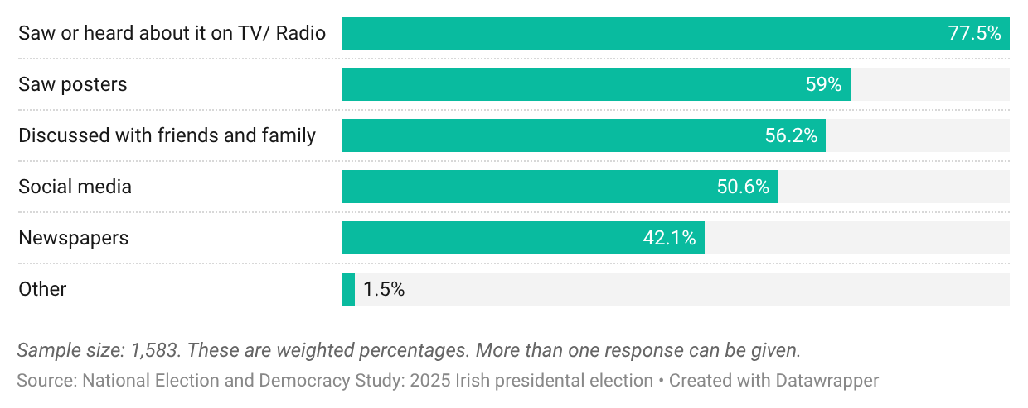
Figure 25: The poll results about how voters become aware of the presidential election

Focus groups
Though most people are negative about election posters, we considered that it may be the case that posters provide a service that they do not realise unless prompted, particularly around awareness that an election is happening. A common perspective emerged across the focus groups that election posters play a role in both raising awareness of elections and reminding citizens to vote. There was a shared understanding that posters act as visual cues that inform voters that polling day is approaching: “When you see the posters, it doesn’t really matter who you’re looking at; what matters is that they keep voting on your mind. Because of posters, you never forget election days.”

However, while participants generally agreed with this point, varying opinions emerged on the topic of who is most impacted by election posters. It was widely acknowledged that posters significantly influence individuals who are less engaged with digital media, such as those who do not access social media platforms or view news content on their mobile devices. This participant, aged in his 80s, noted: “Posters are very convenient for people who aren’t into social media. That’s where they come in.” Some younger participants also felt this accommodation for older voters is important for inclusivity in the run-up to elections, but said they themselves would not need posters to know that an election is coming or to remind them to vote. This participant, aged 30s, explained: “We’d know about an election anyway. It’s everywhere. It’s on the radio, TV and Facebook, so we know an election is on.”

Nevertheless, some participants noted that even if they consumed traditional and online media, they still gained knowledge from the presence of election posters: “When you see them, you know something’s happening.” Others noted the particular reminder about going to vote: “I like them [posters] up. They remind me of the people. I’d miss them if they weren’t there. It informs me and triggers something in my brain.” Another echoed this sentiment: “One good thing is it reminds you to vote. I’ve been busy, haven’t watched much TV, very little snippets on the radio, sometimes I miss the news, so I don’t get it [news about the election coming]. So, the posters remind me that voting is coming up. It’s kind of the unavoidable factor.” This “unavoidable factor” cropped up on multiple occasions. Some participants alluded to the fact that while you can choose to scroll past an article about an election or switch to another station when a politician is on air, a person cannot avoid seeing a poster on a lamppost.

Yet some participants resisted the idea that they might impact turnout. One stated that “posters don’t push you to vote”, while others suggested the lack of information on posters is a missed opportunity to inform voters of basic details ahead of polling day: “There’s no information on them. It’s just a picture. Sometimes the date isn’t even on it.” This observation was repeatedly remarked upon, with another participant stating: “Posters don’t carry the policy of the party or anything on the person ... It’s just a catchphrase, maybe.”

Despite this criticism, other participants acknowledged that posters could serve as catalysts for further engagement. One suggested that even posters with just a name and party can prompt the public to ask more questions about a forthcoming election: “I do think posters act as a notification that an election is happening … lots [of people] don’t read the media at all. When they see posters, that probably is the catalyst to go Google ‘what’s this poster about?’ or ‘who is this fella?’ So, posters might push them to learn more.”

Political interviews
Among the political interviewees, there was a consensus that election posters play a key role in mobilising voters: politicians consistently described election posters as crucial signals that alert the public to an imminent election. This TD illustrated that point: “When the posters go up, it shows that the election is on. That is fundamental.” This sentiment was echoed at local authority level, with a county councillor also stating: “Most people don’t realise that an election is happening until they see posters. That’s really when they start thinking about it.”

Politicians highlighted posters’ capacity to engage with people who otherwise might not know that an election campaign is underway, a point identified by interviewees across the country. A female councillor in a densely populated urban electoral area said: “I do think there’s a lot of people who wouldn’t even know there was an election if there weren’t posters up.” Similarly, a female TD from a smaller, more rural constituency expressed the same view: “It is incredible for many people to imagine, but some people don’t actually realise that an election is about to happen until the posters go up. They’re not tuned into it in the same way that many of us are, so I think that a lot of people don’t engage in political discourse until they see the posters going up.”
“We’d probably be more likely to put more posters, rather than less,
in areas that have traditionally got low turnouts”
Some politicians considered posters a crucial way to engage with people who feel disconnected from the political system. One female councillor in a socio-economically disadvantaged electoral area said that posters go beyond promoting a candidate, they have the effect of reminding the community that every vote matters: “There’s so many people that feel disenfranchised and they are disenfranchised, but trying to get across to them that the only way things are going to change is if you get out there and have your voice heard, you know, the same as everybody else.” She stressed the importance of outreach in low-turnout areas: “We’d probably be more likely to put more posters, rather than less, in areas that have traditionally got low turnouts.”

Those most strongly in favour of election posters described them as crucial to the democratic process. A former minister of state said: “What’s the price of democracy? We live in a time where democracy is under more threat than probably since the 1930s. Posters are part of the democratic process – they help inform voters.” Meanwhile, a councillor said that posters bridge the gap between politicians and the people they represent: “They enable people to approach you, because they recognise your face. So, in a way, they facilitate democracy – that connection between the citizens and the politicians, you know?”

Many of the interviewees who expressed particular interest in this potential link between the use of election posters and democracy referred to the need to even the playing field between incumbents and new entrants to the political system. Their argument was rooted in the understanding that election posters are the best way of affording new candidates’ visibility whereas incumbents have the advantage of having built a profile due to the exposure during their previous term/terms. A party official said: “I’ll die on this hill … the risk to democracy and to having new and different candidates is greater. For a new entrant into a political system, posters are absolutely crucial and I can’t overstate how crucial they are.” This point was also argued by elected representatives such as this TD: “A poster ban would be devastating to the democratic process. A poster ban would be a way of building a wall around the political system and stopping new entrants coming in.” Another echoed this: “I actually think if there was a ban on posters, I think that would be quite anti-democratic. I think having a system whereby [newcomers to politics] couldn’t relatively cheaply get their face up in front of the constituents, I think that would really undermine democracy.” This is further discussed in Section 5.3.3.

5.3.2 Candidate familiarity

Polling
We asked respondents about what election posters help them with, suggesting six potential uses, and a “none of these” option. As shown in Figure 26 below, a plurality said there were no uses, but this was a minority. The most common use was that posters help learn the names and faces of candidates, which more than one in three respondents agreed with (36 per cent). Almost 28 per cent say that posters help them discover which candidates are local to them, which might be even more important in local elections. These estimates might, therefore, have been higher had the fieldwork taken place during a different election, not the presidential election.

Poll question: What do posters help with?
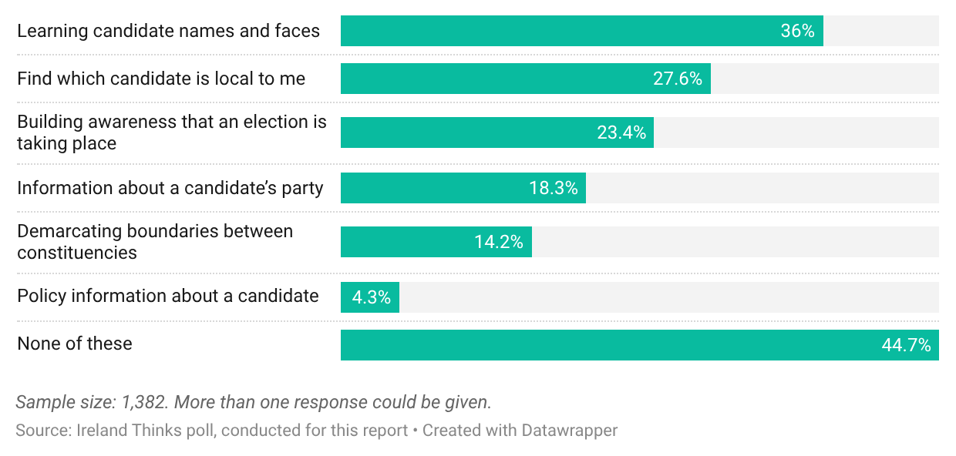
Figure 26: Polling about what posters are useful for.

When we break these results down by age, we can see that more than 50 per cent of 18-34-year-olds say they use posters to learn about candidates’ names and faces, whereas just
26 per cent of this age group found no uses for posters. This contrasted with the oldest cohort, aged 65+, of whom just 26 per cent used them to learn candidates’ names and faces. For
self-described social class, those who say they are middle class are more likely to say they
“use” posters than those who identify as working class (62 per cent of middle-class respondents compared to 48.5 per cent of working class). There is no substantive difference between men and women.

Focus groups
Focus group discussions consistently indicated that election posters play a substantial role in enhancing public awareness of the candidates running in their constituency by facilitating visual recognition through sustained visibility and repeated exposure. A candidate’s photograph on a poster, which is typically the same as the one that will appear beside their name on the ballot, was described as the most effective tool for increasing visibility, illustrated by this participant: “I think that the object of the exercise, you know, for putting up posters is about recognition – getting to know somebody, especially somebody that’s only probably entering into politics, who’s not one of the part of the main party, so it’s a big advantage for them. The other thing is that when you get your photograph up on a poster, it’s there. You could be there for a couple of weeks.”

Candidates and parties typically rush to erect posters as soon as permitted, not just to ensure prime locations, but also to maximise the period that they are on display. Some participants drew attention to the impact of repeated exposure to election posters during their daily routine: “The more impressions you see of a person, the more you’re thinking of that person, whereas somebody who doesn’t have posters, they’re not in your mind. So, they’re kind of at a disadvantage." Similarly, this participant suggested that frequent exposure to election posters had the impact of “subliminal messaging”, commenting that: “Psychologists say it, that the more visually you see something, the greater the impact it has. I actually agree with that. It’s really right. It’s visual, visual, visual.”
“The more impressions you see of a person the more you’re thinking of that person, whereas somebody who doesn’t have posters they’re not in your mind. So, they’re kind of at a disadvantage”

Discussion about the effect that election posters had prompted varying opinions. This participant agreed that the presence of posters on her daily commute had a profound impact on her ability to recognise a candidate on polling day: “It [a poster] informs me. It sticks something in my brain, and it might trigger something. And I think that’s what the intention is.” This participant felt that viewing posters might have an impact on her, but she was uncertain to what degree she was influenced by posters: “It’s the recognition. I think if you’re driving along, and you see a politician, he/she is in your mind. Maybe it does have an effect, but we don’t realise that.”

Others were conscious of posters in their constituencies but resisted the idea that they shape their voting behaviour (“The name and face don’t do much for me”). A female participant echoed this: “Posters are just a background, a face, a name and a party – not enough to go on.”
One clear theme emerged with widespread agreement: the inclusion of party logos and the colours typically associated with that party was broadly considered a form of ‘brand recognition’, with one saying: “The colours help you to recognise which party someone’s associated with.” The use of colour was also an effective means of catching a person’s attention (“I do find some posters can be more catchy because of the colour”).

There was a shared understanding that election posters are less important in a referendum or presidential election. One participant said: “I actually don’t see the value of them, and even in the presidential [election], I think it’s very clear who the candidates are. I don’t think any posters are really that necessary, not for me anyway, but I still would not like to see them banned.”

Collectively, participants agreed that posters are most beneficial in a local election. This participant explained why she felt that the more candidates involved in an election, the more important posters are: “They’d be good for local elections if you don’t know who’s running because there’s loads [of candidates]. … I don’t like the posters, but I was learning a lot from [them], like who was running. On my way into work, I would see all of them three times, so I would have known everyone in the local election then.”

Interviews
Building candidate name and face recognition was among the most common arguments in favour of posters arising in the political interviews. As one senior party official said: “I am firmly in the camp of the most important thing in politics is name and face recognition. [And] the most beneficial aspect of poster use in Irish politics is name and face recognition.” Given that Irish ballot papers display a photograph of each candidate alongside their name, interviewees argued that posters serve to reinforce recognition when voters reach the polling booth. An overwhelming majority of both male and female politicians, as well as political officials, described posters as an effective mechanism for increasing visibility. As this female councillor noted: “Even though they are a nightmare and the most difficult aspect of a campaign, they are the best way to get a candidate’s name out there. They make voters aware of the candidate and give the candidate face recognition that is essential in elections where your face is on the ballot.”
“I think the posters at least get your face up there. They’re a pain in the backside. They’re the worst part of campaigning, but they’re essential”

Although politicians frequently expressed frustration with the inconvenience and logistical challenges, time, expense and planning around posters, this sense of exasperation was typically accompanied by a clear and pragmatic defence of their continued use as a necessary component of a viable campaign strategy. This TD articulated his mixed feelings about posters, which was common: “I think the posters at least get your face up there. They’re a pain in the backside. They’re the worst part of campaigning, but they’re essential.” Ultimately, the perceived benefits, particularly in generating name and face recognition, were seen to outweigh the drawbacks.

While no interviewee suggested that posters could replace in-person canvassing, many maintained that posters facilitate engagement by familiarising voters with candidates in advance of direct contact. Several interviewees described tangible benefits following the erection of posters. A female TD representing a geographically large constituency reported: “The difference was phenomenal, I would say, five or six days after the posters went up. When I was knocking on the doors, people were saying ‘Hello, [first name]’. Rather than before that, some of them honestly didn’t know that I was in the election.” Suggesting that this is not unique to rural constituencies, a Dublin-based TD also observed: “Because of the number of posters, people recognised me when I called to doors or was at a meeting – they felt freer to come up to me. It sort of enables connections between representatives and constituents.” Similarly, a local election candidate reported a similar experience: “Posters work. Sure, people complain about them, especially if you’re on a pole next to their house, but people recognise you. I always get people saying, ‘I know you’, and coming up to me. It makes it much easier to connect with people. They feel like they know you.” These accounts suggest that posters are viewed not as a substitute for in-person canvassing, but as a means to facilitate better engagement.

Posters were also described as a symbolic statement of a candidate’s seriousness and commitment. A male TD elected in his first general election reflected on this dual purpose: “As a first-time candidate in the constituency, I needed them for face and name recognition. The posters were also an indicator of the seriousness of my campaign.” In the same vein, this politician noted that people often judge how committed a candidate is based on whether they choose to use posters during their campaign. He described running a poster-free campaign as a “risk” for a newcomer: “Quite simply, there is a risk if you are a new candidate and you have very few posters or no posters, that you’ll be seen as not taking it seriously … But that risk becomes less and less as you become more known, or as you become an incumbent.” This account suggests that posters serve both as a visibility tool and as a signal to voters that they are credible and engaged candidates.

Candidates representing rural and geographically expansive constituencies stressed the particular importance of posters in areas where door-to-door canvassing is more logistically challenging. One TD from the west of Ireland stated: “Posters are a way for people to see who is running. Especially in rural areas, people might not know the candidates unless they see their faces on the posters … In a rural constituency that’s nearly 100 miles long – you just can’t have enough [posters]. Posters, especially the big ones, still matter.” Similarly, a county councillor in a rural part of the southeast remarked: “I think the posters give me facial recognition in some of the parts that I might not be able to get to.” Politicians from urban areas acknowledged that canvassing was more efficient in densely populated areas where canvassers can reach a large number of houses on foot and noted that posters further enable meaningful interaction with constituents. This Dublin city councillor insisted that for her “canvassing is key”, but she was also “very much in favour of posters”. She explained that “with canvassing, it makes it easier to get a response if they know who you are – if they recognise you”. While canvassing was her priority in the last local election, she still used up to 2,000 posters as a means of facilitating better engagement on the doorsteps.

5.3.3 Political perspective: Importance for first-time candidates and independents

Interviews
A particularly strong theme to emerge from the interviews concerned the importance of posters for first-time candidates and the potential consequences of banning them. Across party lines and geographic contexts, participants emphasised that posters are vital for newcomers to build name and face recognition. Many interviewees articulated a clear differentiation between the requirements of incumbents and political newcomers, noting that posters are particularly significant for individuals who are campaigning for election for the first time. A senior party official reflected on patterns she had observed across decades of campaigning and multiple election cycles. She argued that posters even the playing field for candidates without established public profiles: “First-time candidates benefit the most from using posters. Incumbents already have name recognition and may not rely as heavily on posters.”
“I don’t think as
a new candidate,
I could have managed without posters. Seriously, I think that
they were very helpful to me”
This perspective was reinforced by the experience of a female TD elected for the first time she contested a general election. She emphasised that posters played a fundamental role in making her known to voters: “I don’t think as a new candidate, I could have managed without posters. Seriously, I think that they were very helpful to me.” Similarly, a TD from a smaller party highlighted the value of posters in providing newcomers with a platform to compete in a political environment often dominated by established figures. Reflecting on the barriers faced by candidates without the organisational resources of larger parties, he stated: “For a new entrant into a political system, posters are absolutely crucial and I can’t overstate how crucial they are.”

On the opposite end of the spectrum, long-serving incumbents acknowledged that they would be less reliant on posters in future elections. A TD with more than three decades of experience commented: “I’m a known face in my constituency. There’s less of a need for posters in my case. But I do think it could be a disadvantage for first-time candidates who don’t have that same recognition. There’s no doubt about that.” Another TD recognised the gap between a newcomer and an incumbent in terms of candidate familiarity: “I already have name and face recognition; it’s harder for new candidates to break in without that visual exposure.”

Even for those who have been politically active for years, posters can be particularly important when a councillor steps up to contest a general election for the first time. While they may be very well known in their immediate vicinity, they are essentially newcomers in other parts of the constituency where they previously would not have had a presence. This TD illustrated his own experience: “They’re necessary and they’re particularly necessary for someone trying to make a breakthrough. Facial recognition is hugely, hugely important. That’s probably the number one thing in politics. If you’re unknown, you’re already losing. So, I would have needed them hugely when I was trying to break through as a councillor into national politics.”
The independent politicians interviewed were unequivocal in their insistence that they needed posters to raise their public profile. Without the backing of a “party machine”, these independents insisted that they relied on the visibility that posters provide to communicate with voters. This independent councillor spent the majority of his campaign budget on posters, insisting: “Posters are the only way for independents to get their name out there. We don’t have the party machine behind us.” He pointed out that independent candidates consistently face a significant disadvantage compared to major parties, which often have extensive local networks and branches that help promote their candidates. The independent councillor added: “Large political parties and organisations usually have a Cumann in every town and village, making it much easier for them to raise awareness of their candidates.”

5.3.4 Posters as an inclusive, accessible form of information

Public consultation
Different groups of people learn about politics and elections through different channels. Some of the group submissions to the Electoral Commission’s public consultation are worth highlighting here as they suggest posters have a role in informing some more traditionally marginalised voter groups.

Down Syndrome Ireland: This submission highlighted how people with Down Syndrome are “generally visual learners”. Therefore, posters can be an aid to recognising candidates that voters will see on ballot papers. This is particularly important because people with Down Syndrome tend not to access information in the same way as the general population, such as through television/radio debates, newspapers, and digital media. However, Down Syndrome Ireland also stated that a large number of posters in one area “might cause sensory overload or confusion, especially for someone with processing difficulties”. Beyond the impact of poster content and placement, the organisation identified the negative environmental impact and driver safety issues connected to posters. This issue is discussed further in Section 5.4/5.4.4.

National Adult Literacy Agency: This submission stated that election posters are important for its students. Posters help people with literacy needs to recognise candidates. The agency reports that it polled its student subcommittee and found that members feel that posters help them to access key information surrounding elections and who is running in their area. While some stated that they were “very helpful,” others described them as “quite helpful”, but nobody said that they were “not helpful at all”. Based on this feedback, the agency does not advocate for significantly stricter regulations or a ban on the use of posters. Notwithstanding this, the National Adult Literacy Agency identified the scope for improvements to existing methods. One recommendation made by the agency is for plain language to be adopted for the written content on posters.

Dublin Adult Learning Centre: The Dublin Adult Learning Centre stated that posters signal that an election is happening. This is particularly important for those who are otherwise disengaged with the political system. Posters showing photos of the candidates can assist a voter with reading difficulties who might not be able to identify the names written on the ballot. The Dublin Adult Learning Centre also advocated for the creation of a designated poster zone, as opposed to displaying them on every lamppost (see Section 5.5.3).

Focus groups and interviews: Posters as a talking point with children
Several focus group participants highlighted that children and teenagers pay attention to election posters, suggesting posters contribute to an early awareness of democracy and the electoral process. A woman in one of the focus groups said: “I have a 13-year-old granddaughter and somebody asked her about the election or who would she vote for, or was she aware of the presidential election. And she laughed and said ‘how could I not be when they’re on every pole?’” Another participant also highlighted this early exposure: “I hate the environmental aspect of posters, but I do think they’re necessary for say younger people who wouldn’t be into politics that much to see faces and then maybe identify somebody that they know around town.” During the interviews, one party official explicitly connected posters to sparking children’s early political interest: “People will tell me their children got interested in politics when posters go up”, while a councillor said that during the most recent campaign, he was surprised by how many children noticed his posters. He reported that they appeared to pay close attention to the names on posters: “Kids in the primary school were saying that their parents should vote for me because they liked my name.” Another councillor emphasised that when children notice posters, they often raise the topic at home leading to family conversations about the electoral process: “Kids are engaged. You talk to voters and they say their kids saw you.”
“People will tell me their children got interested in politics when posters go up”

5.3.5 Vandalism

Focus groups
Although an unintended consequence of posters, defacement may still indicate some level of political engagement (Philipps 2015), albeit from a more negative perspective. Participants across all focus groups were able to recall incidents of poster vandalism in their area, and while there was uniformity in terms of an awareness that posters are defaced, the participants’ interpretations of it varied greatly. Many female participants, in particular, expressed sympathy for the candidates whose posters had been defaced, particularly when it involved altering the candidate’s image (“I think I feel embarrassed for the person’s poster that it is. It’s like they are taking the mick out of them. [The culprit] might dislike them, but don’t vandalise their posters”). Older participants demonstrated a more cynical view, with some suggesting that even the most disturbing defacement of posters can lead to a positive outcome for the candidate: this participant, aged 50s, said: “If it’s very bad, they get on the radio, so they can talk about the vandalism of their posters, so then they get extra exposure with it.” Male participants frequently expressed their amusement at some of the vandalism they had witnessed; one suggested that poster vandalism adds entertainment to a campaign: “I think it can be very amusing, too, when you see the defacements of the posters. Like, some of them are very clever.”
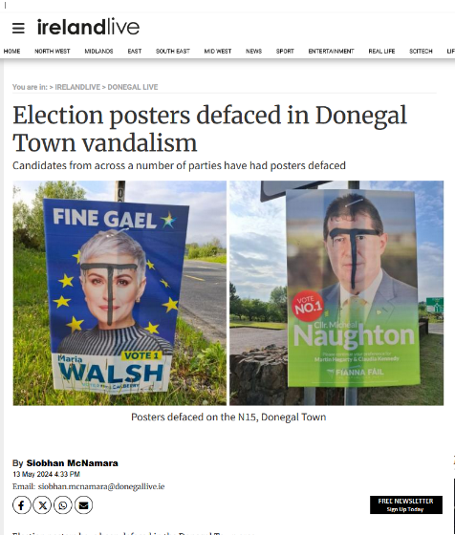
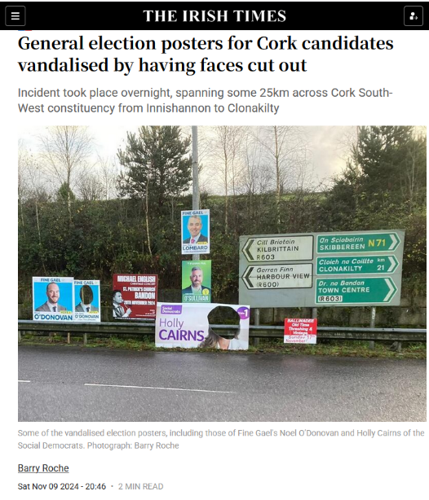
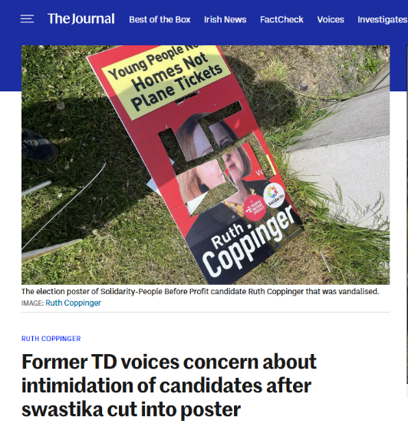
Figure 27: Examples of news reports relating to vandalism of election posters. Some focus group participants felt that politicians benefit from the media coverage they get if posters are damaged.

When the vandalism was considered to be light-hearted, it was frequently considered to be beneficial to the candidate. Participants suggested that it made that candidate more memorable and would “stick in a voter’s mind”. This participant articulated this point with an example that he can recall: “During the last general election, you know the kind of the eyes on a spring? Someone had done that to one of the candidates and like the eyes kind of just go in and out, and obviously it’s a Godsend to whoever the politician is because everybody looks at it.”

Other participants described the defacement of posters as a way to express dissatisfaction with a candidate. This participant group recounted how vandalism can be an effective form of protest, recounting one particular case from the last local election: “You know, there's a far-right candidate, right? And on his posters, they were defaced with Hitler, and people had written really what they thought about him. It was sort of, very contrary to what he was trying to portray, it was working against him. It was actually very negative.”

Interviews
Poster vandalism was widely reported among the political interviewees, but interpretations of its significance varied considerably. While some politicians treated it as an inevitable or even advantageous feature of campaigning, others described emotional distress and embarrassment. Clear differences also emerged along gender lines. For experienced male politicians, vandalism was something to be expected. A male former Minister of State described it as a “part of every campaign”. Recalling one incident, he explained: “Someone stuck plastic googly eyes on one of my posters. I used to drive by and laugh at it. It was hilarious. We kept the poster, actually, it’s in the shed, and my kids love it.” Even when vandalism took a more hostile form, it was sometimes reframed strategically. The same former minister of state observed: “Sometimes, if it’s nasty, you even get a bit of public sympathy from it.” A similar tone was evident in the account of a male county councillor who reported having a swastika spray painted over one of his posters: “I just pull down the poster, put up a new one, and just took it on the chin.” He dismissed the idea of reporting the incident to An Garda Síochána, suggesting that taking the time out from canvassing to make a statement at his local garda station would have had a more damaging effect on his campaign.

Female candidates were more likely to describe vandalism in personal and emotional terms. All of those who reported being distressed by poster defacement during the interviews were women, though not all women were distressed by it. One female TD reflected: “Some of them were taken down. I suppose the hardest part was seeing some of my posters trampled on the ground or driven over.” She explained that it was particularly upsetting for her daughters to witness this, underscoring how the impact extended beyond the candidate herself and into family life. A female county councillor described entering the campaign “kind of expecting” vandalism yet still experiencing humiliation when it occurred: “I was a bit embarrassed, I was like, ‘Oh my God, get that down.’” These accounts suggest that poster defacement may carry symbolic significance, particularly for female candidates who feel more exposed or scrutinised.

Even male politicians who had not personally experienced vandalism acknowledged the unfairness of targeted acts, particularly when directed at female candidates. One male councillor expressed strong condemnation: “I’ve seen this done and it’s not right and it’s not fair, because I think anyone who puts their name in a ballot paper are very brave people and they do it with the best of intentions to serve their community.”

Two politicians from ethnic minority backgrounds reported that they had not been subjected to racially motivated vandalism of their posters, frequently insisting that they experienced more discrimination online. One black politician stated that he had experienced “minor” non-malicious vandalism, which he described as “humorous doodles”, but no hate speech or serious defacement. He suggested that those who intend to spread racism tend to do so online rather than through physical interference with posters in public spaces.

5.2.6 Gender-specific issues

Interviews
As well as the vandalism outlined above, interviews with political stakeholders identified a number of challenges related to the use of election posters that are gender specific (participants in the focus groups did not demonstrate any awareness of a disparity between the experience of men and women in political campaigns).

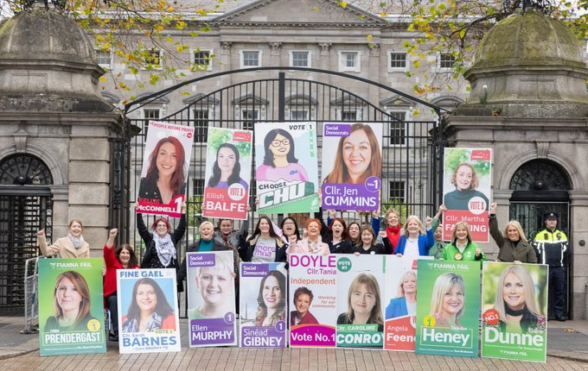
Firstly, logistical challenges associated with postering were frequently reported by female politicians. Interviewees described asking male relatives or friends to help with the physical work of erecting and removing posters. One female TD recalled how she had relied on her husband to organise postering because she could not scale a ladder to attach or remove posters herself: “My husband took charge of postering. While driving around the town, he would pay close attention to what lampposts were most suitable for posters. He had friends through GAA circles. They helped with erecting posters.” One party official observed that over the course of her decades-long career in national politics that election posters present a distinctive challenge for female candidates irrespective of age or geography. In her experience, male candidates often find it easier to co-ordinate a poster plan, drawing on established networks through community organisations such as the GAA. These networks frequently include male friends with access to practical resources such as vans and ladders, making the logistical demands of postering more manageable. By contrast, she noted that female friends usually support in other ways: “They might offer to make sandwiches or babysit while they go canvassing, but other women won’t offer to put up posters for a friend.”
Figure 28: Some of the women running in the 2024 general election. Source: Women for Election.

Female politicians frequently referenced concerns for safety in relation to postering. A TD recounted a particular incident where two women were physically attacked while erecting a poster on her behalf: “I think [being a woman] makes you a target when you’re doing it… I think if it had been two men, they’d have been less likely to be a target.” The incident was reported to An Garda Síochána, but she was unsure if it would result in charges/conviction. Another female TD reported seeking assistance from male relatives and friends. She acknowledged the considerable efforts they made to support her, in particular, climbing ladders on rural roads at night. In response, she felt a sense of responsibility for their safety. She recounted encouraging them to wear high visibility vests but noted that since she was asking a favour, she could not mandate the use of safety measures.

Other interviewees said that they felt that women faced more physical scrutiny for their appearance. This female county councillor pointed to how women face greater criticism based on how they look and dress: “It’d be especially bad for young women. People talk about them, and women are more likely to be seen than men.” Echoing this sentiment, a female TD, in her 30s, described agonising over her choice of outfit ahead of a photo shoot for her posters. She reported feeling more comfortable in bright colours but felt that constituents expected her to present herself “conservatively” if she was to be considered to be “taking it seriously”. She felt that appearing youthful is not always beneficial, and it can cause some voters to question her credibility and readiness for a role in politics. Conversely, this female councillor, in her 60s, expressed her concern about appearing older and how that might impact her future use of election posters: “I’ve thought about whether people would still recognise me if I let my hair go grey – because image is part of it. I mean, if I change my look – say, I go grey – I might need to get new [posters].” When asked about the challenges they encountered with posters, no male interviewee referred to issues around their image. This male TD suggested that men are less concerned about their appearance in election posters: “It doesn’t bother me. Men don’t put as much thought into it. A white shirt, blue shirt, dull tie – that’s about it.”

Finally, name recognition was also an issue for female candidates because many women choose to change their surname after marriage, potentially making them less identifiable to constituents. A female county councillor highlighted this issue, noting that while a woman may still be known locally by their maiden name, but will appear on posters/ballots as their married surname: “It’s a real thing, and especially for women. I remember canvassing with a woman whose married name was different from her family name. She had to explain at every door, ‘I’m X and Y’s daughter’, because no one knew her by her married name. That made a huge difference.”

5.3.7 Who takes notice of posters?
Though many people claim that posters have no impact on them, we have seen above that people also acknowledge that they have some use for them. So, while it may be true that people do not consciously engage with posters, it is likely that they still take some kind of notice, even subconsciously. One way of measuring whether posters enter voters’ minds is the ability to recall. In a classic paper, Standing (1973) found that people are capable of identifying an image they had seen before, even among thousands of novel images they had not. Most people tend not to know what will make a memorable image (Rust and Mehrpour 2020), and equally, they might not be able to recognise memorability in election posters.

For instance, a person’s ability to recognise or remember a poster might indicate that they are aware of those posters, even those who say they do not follow elections or who claim that posters have no impact on them. We asked respondents to identify the actual poster a candidate used compared to one we created. Ours were distinct enough so as not to be an attempt to trick the respondents, but professional enough so as not to make the exercise too easy: they are shown in Figure 29.
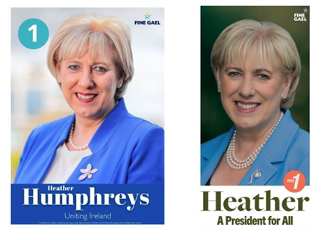
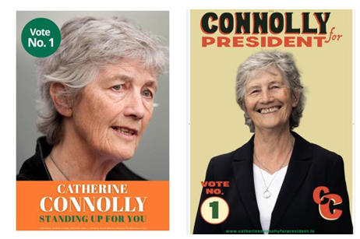

Figure 29: Mocked-up and real posters for the presidential election candidates 2025. The real poster is the second one in each case.

The results of the poster recall question are shown in Figure 30. For Catherine Connolly, 70 per cent of respondents chose the real poster, and it rose to 74.6 per cent for Heather Humphreys. With Jim Gavin, the results were quite different: just over two-fifths (40.7 per cent) of respondents could correctly identify his posters, over a quarter chose the wrong poster, and a third said they did not know. The results for Jim Gavin’s poster are not surprising, but reassuring. Because Gavin stopped campaigning midway through the campaign period, his posters were less common than for the other two candidates. This provides a validity test for the results of the survey. The much lower recall for his posters shows that this is a valid measure of people’s memory.

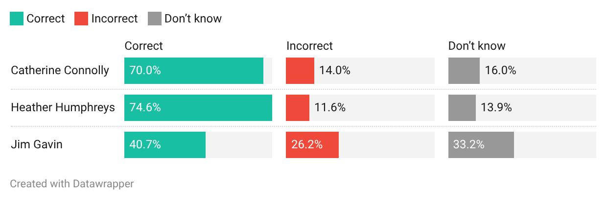
Poll question: Can you identify the poster you have seen for each candidate?

Figure 30: The results for the recall question on the three candidates’ real and mocked-up posters.
Table 6 below shows the results of a question in which we analyse these results controlling for certain features of the respondents. Do we see that those marginalised or hard-to-reach voters are ‘reached’ by posters? Table 6 compares people’s ability to recognise the correct election poster with reported interest in the presidential campaign. Again, those who followed the election closely were much more likely to correctly identify posters, though even those who claimed not to follow the campaign could correctly identify the posters of the two candidates who campaigned fully. This suggests that even low-attention voters are noticing posters.

 | Not closely | Not very closely | Fairly closely | Very closely | Total
Catherine Connolly
Correct | 52.3% | 65.3% | 72.7% | 81.9% | 70.0%
Incorrect | 15.1% | 15.1% | 14.0% | 12.2% | 14.0%
Don’t know | 32.6% | 19.7% | 13.3% | 5.9% | 16.0%
Heather Humphreys
Correct | 54.7% | 74.2% | 77.0% | 81.9% | 74.6%
Incorrect | 16.8% | 6.8% | 12.9% | 13.4% | 11.6%
Don’t know | 28.5% | 19.0% | 10.1% | 4.7% | 13.9%
Jim Gavin
Correct | 24.8% | 38.3% | 44.4% | 44.3% | 40.7%
Incorrect | 35.8% | 24.7% | 24.2% | 29.7% | 26.2%
Don’t know | 39.4% | 37.0% | 31.4% | 26.0% | 33.2%

Table 6: The ability to identify posters by self-declared interest in campaign, based on how closely they said they followed the campaign. These are weighted percentages, totalling 100 in each column. Subject to rounding errors. Respondents who answered ‘don’t know’ or ‘prefer not to say’ to the question on following the campaign are excluded because of their very low numbers.

We also asked respondents questions on the role of the president and used this measure of understanding of the role alongside the results of the poster question, as shown in Table 7. These questions about the role were not that easy. Even for those who got none correct, respondents who answered (i.e. did not say ‘don’t know’) were four times more likely to correctly identify a poster than not. Including don’t knows, there was a better than 50:50 chance of getting it right. Those who got just two correct were much more likely to identify the posters of Catherine Connolly and Heather Humphreys than get it wrong or refuse to answer – almost 70 per cent in the case of Heather Humphreys.

What these data show is that even if they do not think so, voters – even ones who are less engaged with politics – observe and remember posters, which goes some way to supporting politicians’ decisions to spend quite a lot of effort and resources on them.

 | Limited understanding | Moderate understanding | Good understanding | Total
Catherine Connolly
Correct | 57.7% | 67.4% | 76.4% | 70.0%
Incorrect | 13.8% | 15.7% | 11.9% | 14.0%
Don’t know | 28.5% | 16.9% | 11.8% | 16.0%
Heather Humphreys
Correct | 62.3% | 74.1% | 78.2% | 74.6%
Incorrect | 13.0% | 11.1% | 11.7% | 11.6%
Don’t know | 24.7% | 14.7% | 10.1% | 13.9%
Jim Gavin
Correct | 30.4% | 41.4% | 42.4% | 40.7%
Incorrect | 24.6% | 24.8% | 28.2% | 26.2%
Don’t know | 45.0% | 33.7% | 29.4% | 33.2%

Table 7: Ability to identify posters by self-declared understanding of the role of the president. These are weighted percentages, totalling 100 in each column. Subject to rounding errors.

5.4 Environmental impact

5.4.1 Perception of environmental impact

Focus groups
As noted in Section 5.2, environmental concerns were frequently raised in the public consultation and open polling questions, and the issues were further explored in the focus groups. There was a shared view among the focus groups that election posters have a negative environmental impact with the excess plastic produced being the central concern (“Visually, it’s so overstimulating, but the environmental impact and the plastic – it’s just such a waste.”) Other participants acknowledged the plastic used but framed it as relatively insignificant when compared to larger-scale industrial plastic consumption: “The plastic itself, I think there’s a lot worse going on with bigger corporations and what they’d be getting up to.” A similar comparison emerged in discussions of carbon emissions, where it was suggested by some participants that the emissions associated with posters were minor when set against larger contributors. This participant felt that, for example, air travel should be a bigger concern for the public than election posters: “I’m not sure about the plastic, but I’d say relative to other carbon emissions, like take a flight to China or something and I’m sure the emissions on that relative to this plastic are much worse.” Participants who displayed a particular interest in climate change cautioned against evaluating environmental impact solely by the volume of plastic waste, arguing that this narrow understanding overlooked the broader resource implications of election campaigning. As this participant explained: “It’s the whole operation – the vans driving around, cable ties on the ground, time and money – it’s an awful lot of waste of resources.”
“It’s the whole operation – the vans driving around, cable ties on the ground, time and money – it’s an awful lot of waste of resources”

From this perspective, posters were understood as part of a wider system of consumption and emissions rather than an isolated environmental issue. Some participants were equally critical of leaflets coming into their letterboxes: “It annoys me because there’s four of us in the house and four of us will get one. It’s the one house, so there’s no need to be sending each one individually.” While many people felt strongly about the environmental impact of posters, it is worth noting that a small number of participants expressed ambivalence. This was identified more in rural areas as opposed to focus groups in urban locations. When asked if they had ever considered the environmental implications of election posters, one participant in Co. Kerry responded: “I’ve never thought about it. Never dawned on me. I just say, ‘Thank God that’s gone.’ I presume they take them back; they go into a shed and wait for another election.”

Interviews
Political stakeholders across all parties and ideological positions demonstrated an awareness of the environmental impact of election posters. No interviewee attempted to downplay concerns surrounding the level of plastic waste arising from the production and discarding of election posters. Instead, they moved to justify their continued use. This councillor campaigned on an environmental platform and admitted the drawbacks of producing plastic posters: “Look, it’s not great, it’s really not great,” but he defended their use, describing them as a “small sacrifice in terms of what I can do for the environment having been elected”. Another TD insisted that she was concerned by the environmental implications but argued that “the downside to not having them is just so great from an electoral perspective”. Echoing this, a councillor stated unequivocally that he had “no concerns around the environmental impact”, insisting that posters are “an important part of the electoral process”.

Similarly, a party official stated that he has seen countless candidates who aspire to run poster-free campaigns, but seasoned political campaigners understand that posters are a “necessary evil”. He remarked: “There’s always someone who says they want to run without posters, but every party quickly shuts that down. The reality is, if you want to get elected, you need posters, despite their environmental cost. It’s a necessary evil.” Another councillor acknowledged how “it’s not good for the climate, it’s not good for the environment”, before adding that he still bought posters. He said that he felt he had no choice, or he would have been defeated by his rivals who were more visible. However, his concerns around plastic waste prompted him to display just 100 posters in the last local election, whereas his rivals had up to 2,000 posters each throughout the electoral area. Other public representatives argued the need for a balanced approach. One councillor accepted the need for election posters but insisted that the problem is when candidates poster to the extreme: “If there’s one on every lamppost in the town, that’s a bit excessive and you do have to think about the environment.”

Newcomers to politics expressed their surprise when they realised the quantity of posters involved in any given campaign. This councillor, who ran for the first time and was elected in the 2024 local election, said that in the heat of the campaign, he had not been focused on environmental considerations: “Honestly, it was the last thing on my mind.” It was only after the election, when his posters were taken down and brought together in one pile, that he realised the scale of the plastic waste generated by his own campaign. Although the majority of interviewees raised concerns about the environmental effects of posters, a few politicians questioned the criticism levelled at candidates who use election posters. This councillor was dismissive of those who criticised election posters on environmental grounds: “I think the people that talk about the environmental impact that posters have are a little bit OTT now. The same people that talk about the environmental impact on them, they’ve no problem going out buying goods that come in cardboard boxes.”

5.4.2 Plastic composition and material

Focus Groups
Participants across all focus groups demonstrated an understanding of the composition of election posters and that they are constructed from plastic. There was a consensus that the use of plastic is inevitable because of its durability and the harsh Irish weather, particularly in the winter months. Nevertheless, some recalled posters from other materials, as illustrated by this participant: “I remember Jack Lynch posters – they were cardboard. My father still has loads of old Fianna Fáil posters. Some of them have fallen apart, but most are still solid after 20 or 30 years.” Some felt there should be an onus on politicians to review existing materials (“Parties should be encouraged to find biodegradable solutions and there are solutions out there.”)

While there was consensus that politicians were somewhat restrained by the materials available to them for the production of election posters, participants insisted that there was more that candidates and parties could do to manage how single-use cable ties are disposed of. Participants understood that it was possible to reuse election posters, but demonstrated uncertainty around the potential to reuse cable ties. Another participant recounted one particular incident in a busy urban street when she witnessed campaigners dispose of cable ties in a general waste bin, as opposed to recycling them with other plastics. She said: “I saw party workers taking posters down – putting all the plastic ties straight into a rubbish bin. I pulled him up on it.”
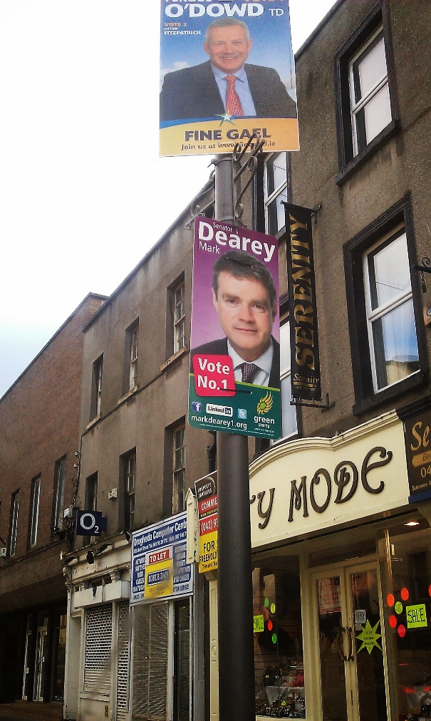
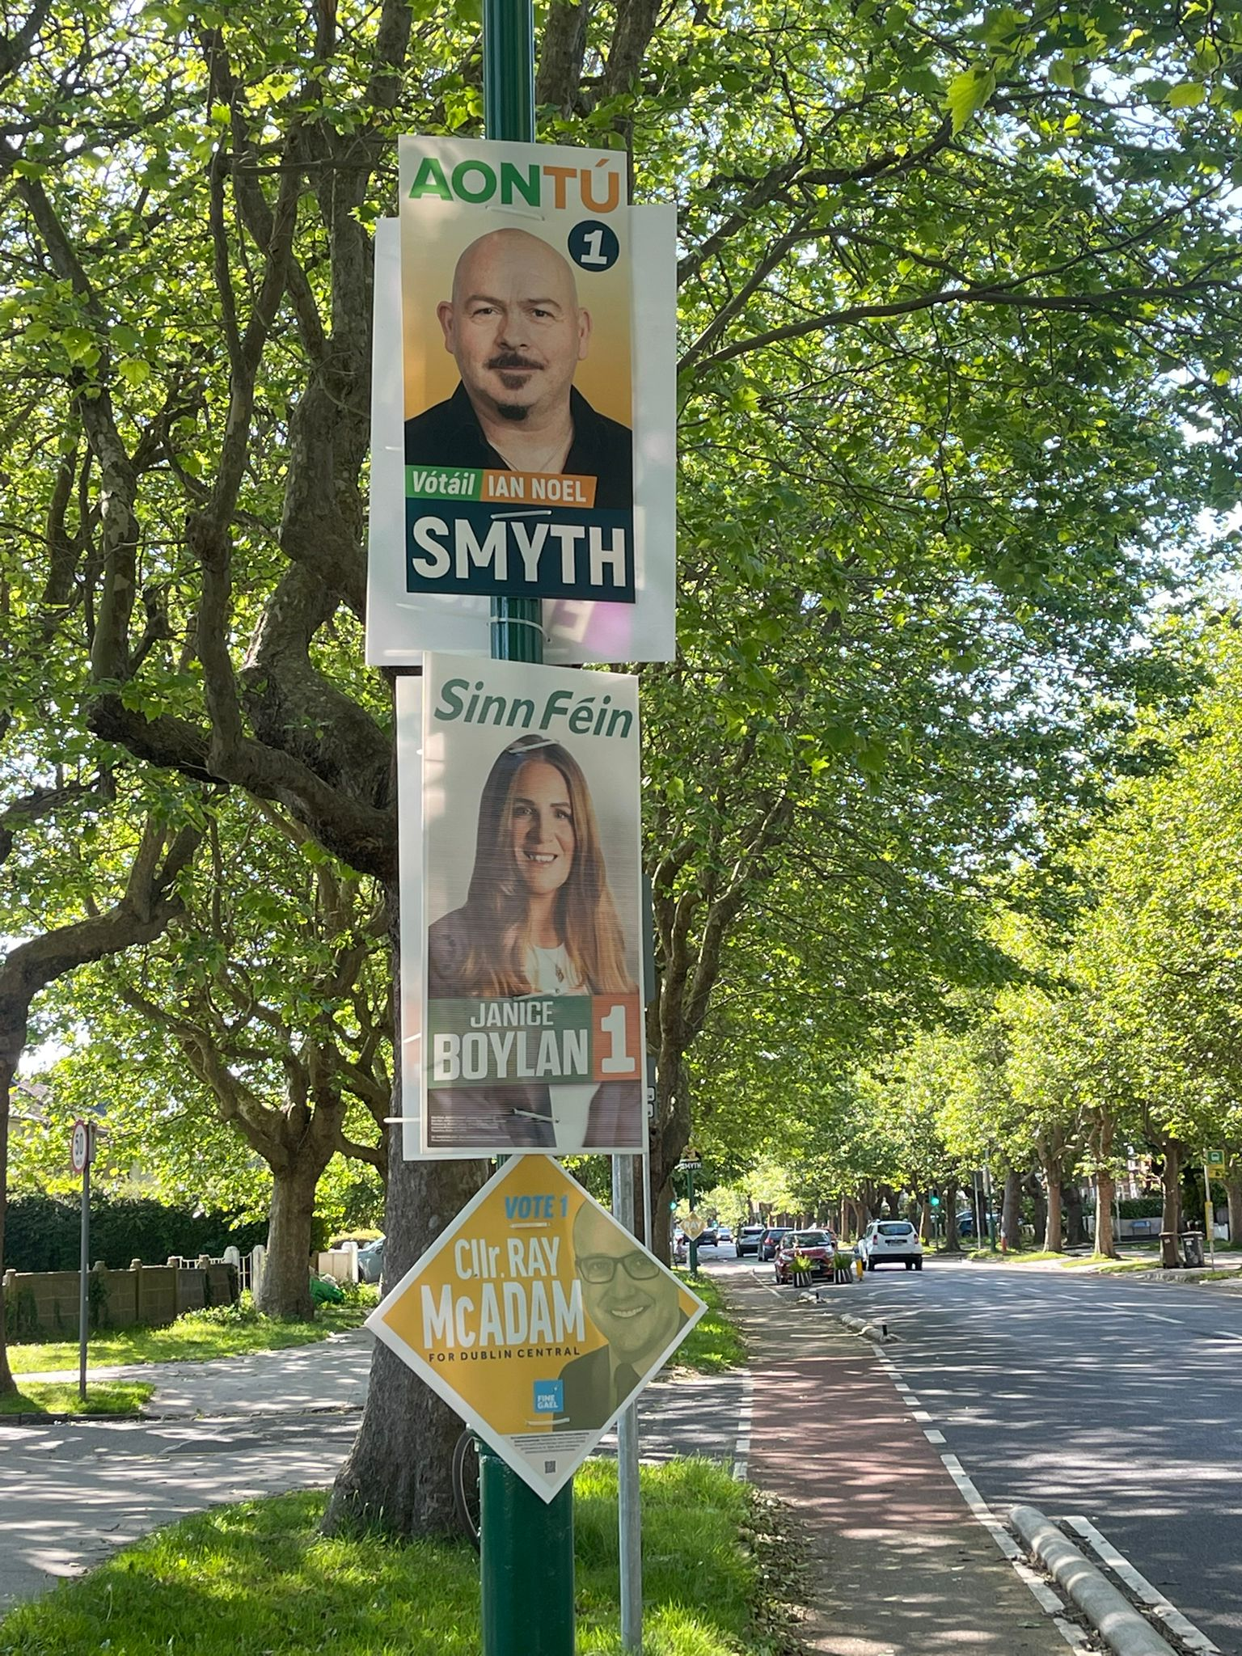
Figure 31: Examples of some different shapes of posters, such as the traditional full-width poster
(O’Dowd, left, in Louth in 2011) and the narrower posters which use around one-third less plastic (Dearey, left, and Smyth and Boylan, right, in the 2026 Dublin Central bye-election). Candidates also sometimes use diamond posters, such as McAdam’s, right, to complement their larger posters.

Interviews
In the interviews, politicians highlighted concerns around the biodegradability of the materials used and many expressed dissatisfaction with the corrugated plastic/corriboard. This councillor outlined the conflict between biodegradability and durability: “You see election posters sitting in ditches, and that’s not a good thing. The corriboard itself obviously has to withstand the Irish weather. But how biodegradable it is – or isn’t – I honestly don’t know. Could we use better materials? Maybe.” The interviews revealed a general willingness to consider greener alternatives for election posters. However, this openness was consistently outweighed by a strong preference for corriboard, which was described as the most durable and practical material available. Some interviewees recounted previous attempts to adopt biodegradable materials and the challenges encountered. One party official insisted that the more eco-friendly posters have not withstood the Irish climate and recounted the experience of using eco-friendly card-based posters for a candidate in the 2020 election: “We would have trialled environmental material. They never work. Oh, it was just a nightmare.”

The durability of the material used in election posters was a greater concern for politicians in the northwest, as opposed to interviewees in any other region. One councillor in Donegal reported that he lost between 20 and 30 posters during the last local election as a result of high winds: “A few were never found … usually, someone would ring me and say, ‘There are two of your posters in a field’ and I’d go collect them.” He insisted that trialling the use of cardboard posters in a region that experiences such harsh weather would be unrealistic. While many politicians have considered alternatives to corriboard, all eventually returned to it. This politician discussed the use of alternatives such as plywood or cloth-based posters, but noted that corriboard remained the preferred option due to its durability and practicality: “Corriboard is just a very good material. It withstands wind pretty well, withstands rain, it’s durable, it’s lightweight. It’s by no means perfect, but it’s the least bad option we’ve come across so far.”
“Corriboard is
just a very good material. It withstands wind pretty well, withstands rain,
it’s durable, it’s lightweight”

This has led to a situation where, despite many politicians expressing concern around its use, demand for corriboard posters outstrips demand for biodegradable alternatives. As a result, many suppliers are only providing corriboard posters, meaning that even when a politician wants to use an alternative material, it might not be possible. One councillor explained that she felt she had “no choice” but to purchase corriboard posters because the local supplier could not offer a more environmentally friendly alternative. She said that she still feels regret over this decision “and it still doesn’t sit right with me”.

While the lack of biodegradable materials was a source of dismay for some politicians, cable ties caused frustration for some interviewees. Many suggested that the waste created by the plastic fasteners used to secure the posters to poles has long been overlooked. One councillor said: “The biggest issue is the cable ties. You still see them on poles years later. They don’t move. They’re stuck tight. Most parties will take down their posters, but the cable ties stay.” There was a consensus that while most candidates adhere to the rules in relation to postering, cable ties are frequently discarded by some on the footpath or roadside after they are cut to remove the poster. This TD suggested that tackling this issue required stricter enforcement of anti-littering legislation: “It’s not just the posters themselves that are a concern from an environmental point of view. It’s also the cable ties used to attach them to poles. It’s concerning to see cable ties still left on poles after elections. Because honestly, if your cable tie is left behind, I think you should be fined for littering. They should be removed, simple as that.” That TD insisted that this is not a new issue and has been a problem in his constituency, a large town, for years. New policy could help address this, he argued: “At one point, I even suggested introducing identifiable cable ties – ones that could be traced back to a party or candidate. So, if there were a way to code cable ties – maybe through colour-coding or some other traceable mechanism – that would allow them to be linked back to individual candidates or parties, I think that’s something worth considering. The cable ties really are a problem.”

However, one former TD from an urban area resisted any suggestion that he or his team – or any other candidate in his constituency – left cable ties on the lampposts; he pointed out that volunteers are very aware of how much the public hate it and so are mindful of taking them all down and bagging them separately. He added that the manner in which posters are cut down – by snipping the ties – means the ties typically fall down with the posters: “It’s actually harder to cut a poster down without cutting them. The common perception makes no sense. Left behind cable ties are clearly the remnants of posters that have broken in storms or been torn down through vandalism.”

Most interviewees adopted a system whereby they would “pre-thread” posters to make attaching them to the poles faster when they get to the location. They then used a clippers-type tool to snip the cable ties to free the poster. While this was the system adopted by most interviewees, one TD insisted that cable ties can be reused: “We take down the tie wraps as well, and actually, believe it or not – and this wouldn’t be widescale – but in my own office, we reused tie wraps. It is quite awkward to do, but if you do it right, you can take it down and reuse it again in the future.”

5.4.3 Reuse of election posters

Focus groups
Focus group participants generally agreed that reusing election posters represents a more environmentally sustainable alternative to discarding posters after each election. Participants frequently referenced specific candidates and parties in their areas that used the same posters in multiple campaigns. Some participants also questioned whether the decision to reuse posters was rooted in environmental concern or financially motivated. As one said, “It does save them the cost of buying new ones, so maybe it’s not just about saving the planet.”

While participants broadly supported the reuse of election posters on environmental grounds, participants identified clear limits to a poster’s lifespan. It was commonly understood that posters are reused for a finite number of campaigns before becoming too worn or outdated. One participant explained: “If you look at the posters that come out of each election, they usually don’t last any more than two elections. That’s the only issue.” This view was reinforced by another participant’s observations from the 2024 general election, where he recalled seeing posters reused from the previous campaign but not from earlier ones: “You’d know the poster style they used for that election and the one before that. A lot of them were used again, but posters going back as far as 2016 were gone.” Together, these observations suggested a shared understanding that posters typically remain usable for two elections but are not fit for purpose over longer timeframes.
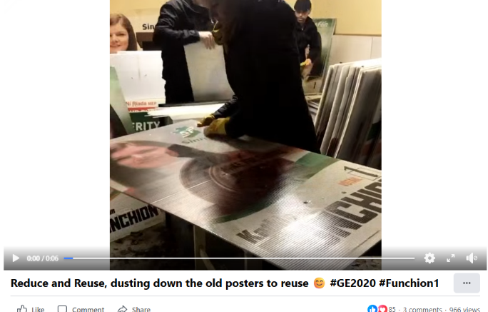
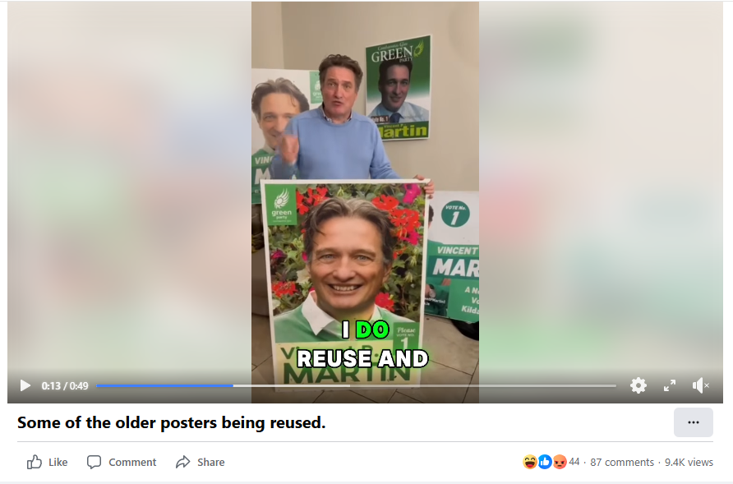
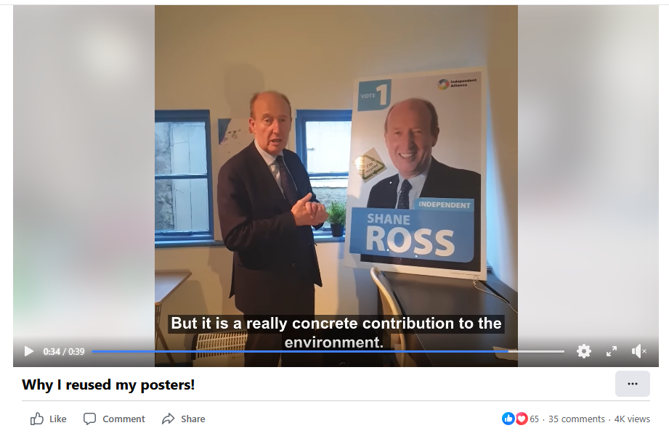
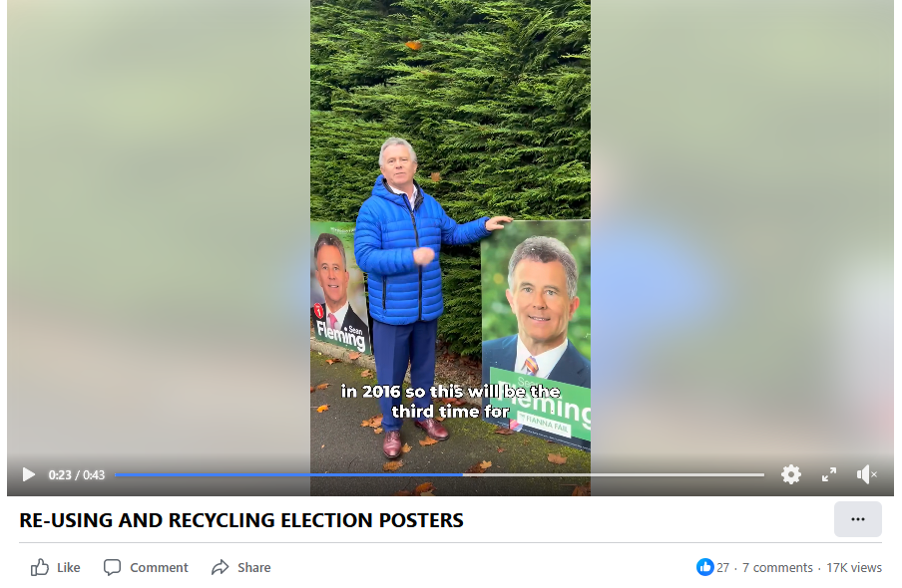
Figure 32: Facebook posts from politicians – Seán Fleming, Shane Ross, Kathleen Funchion and Vincent P. Martin – during the 2020 and 2024 general election campaigns, highlighting their reuse of older posters.

The most significant point of contention was the use of outdated photos on posters. Participants frequently criticised this practice, arguing that it can be misleading and does not accurately represent the candidate’s current appearance. While recycling posters was widely viewed as a positive step, using old images was seen as potentially opening candidates to critique. One participant articulated this tension clearly, stating: “This raises another issue: if a candidate is reusing posters – which we might see as positive – but their photograph appears different, does that open them up to ridicule or criticism? For instance, is it problematic if someone uses a photo that’s a decade old? Could this influence your opinion of them, even though they’re being environmentally responsible by recycling, but are relying on how they looked ten years ago?”

Most agreed that reusing a poster is not only acceptable but also encouraged. However, they also felt that a photo should not be reused if it is over ten years old. As one participant said: “Five or ten years is fine. But there’s one poster and every time I see it, I’m like, ‘you do not look like that anymore, now come on’.” Another participant felt that some images were far too old to accurately portray the candidate, remarking: “Some of them must have used their graduation photo. They look about 20 years younger on the poster.” Participants warned that when the image no longer resembled the candidate, it can damage their campaign, as noted by this participant: “You see the poster and then you see them at the door, and you wouldn’t know it was the same person.” This criticism was not gendered: participants suggested that both male and female candidates from all political backgrounds reuse photos that are no longer an accurate representation, as reported by this participant: “They all do it, not just the women. The men are just as bad for using old photos.”

Participants were largely unfamiliar with the concept of ‘re-skinning’ posters, whereby existing posters are updated with a new printed layer. However, some recalled seeing posters altered through more improvised methods, particularly the use of stickers. As one participant commented: “Some of them just stick a new sticker on the old one and hope nobody notices.” While such practices were often interpreted as environmentally motivated, they were also criticised for appearing unprofessional. This sentiment was reflected in comments such as: “You can always tell when they’ve reused the poster from the last election – the date is scratched out or covered over”; “It’s better than throwing them out, I suppose, but it still looks a bit cheap”; “I’ve seen posters where you can see the old campaign underneath the new details.”

Interviews
Interviewees consistently argued that reusing election posters significantly offsets their negative environmental impact. One TD maintained that reuse is already widespread, stating: “If people are reusing posters, there’s a significantly smaller environmental impact. At least 80% of posters that are used in any given election will be used in the next election.” While the precise scale of reuse is difficult to verify, these interviews indicated a general willingness among politicians to reuse posters for at least two elections, after which many opted to repurpose or recycle them and buy new posters. Several interviewees illustrated this approach through personal experience. One councillor explained that he first ran in 2019 and reused the same posters when re-elected in 2024 but did not intend to use them again in a third campaign. Reflecting on this decision, he said: “If I was to use the same photograph as my 2019 election for my 2029 election campaign, it probably wouldn’t look much like me.” Rather than discarding the posters, he stored them in his garden shed and repurposed them for practical uses, including bedding for a hen house and raising flower beds. He also acknowledged that such storage and reuse practices were more feasible for rural politicians with access to sheds or land than for urban candidates living in apartments. Some interviewees expressed a willingness to reuse posters over longer periods. One TD reported having used the same posters across four elections over the past decade and planned to continue doing so in future campaigns.

Younger candidates, in particular, demonstrated greater familiarity with and openness to re-skinning posters. One first-time county councillor explained that he planned to adopt this approach in future elections, noting: “Re-skinning costs around €4–€6 per poster, vs. €10–€14 for new ones. It’s a hell of a lot cheaper and the party supports it. They are environmentally conscious.”

Party-level strategies also emerged as facilitating the reuse of posters. One party official explained that in recent years, larger parties have deliberately standardised poster designs to enable minor updates between elections: “We have used a similar kind of design deliberately over the last couple of years, so that they can put a white sticker at the bottom, and the only thing that needs to get amended is the running mate, for example.”

All interviewees, whether they intended to reuse posters or not, expressed a willingness to repurpose the posters where possible as opposed to sending them to landfill. Politicians outlined numerous ways that they have repurposed posters to date, often shaped by geographic context. Rural TDs and councillors reported donating posters for use in cattle sheds and hen houses, while urban politicians more commonly donated them to animal charities, particularly dog shelters. Others described using old posters in community gardening initiatives or donating them to primary schools for art projects.

One former politician highlighted what he described as an “ad-hoc” approach to the provision of recycling facilities for old and unwanted posters and wished there was a more centralised, “official” way to dispose of/recycle posters. He suggested that local authorities have a role to play in improving this: “I think there probably should be a little bit more effort put into liaising between the council and recycling companies, in terms of ensuring that adequate facilities are available and they dispose of posters in a kind of safe and regularised way. Because that doesn’t really happen, and it’s all a little bit ad hoc and all depending on the goodwill of the private sector in many cases. That isn’t great.”

5.4.4 Wider environmental concerns

Public Consultation: Tidy Towns
A large number of submissions – 28 – were made through the public consultation process on behalf of Tidy Towns groups nationwide (nine of which came from groups based in Co. Louth). These voluntary organisations voiced strong opposition to the current use of election posters with concerns about plastic waste emerging as a consistent theme. Baldoyle Tidy Towns characterised posters as “extremely wasteful in terms of plastic and cable ties”, a sentiment echoed by others, including Roscommon Tidy Towns, which noted: “Posters are usually made from corrugated plastic which has a lifespan of up to 400 years.” Similarly, Loughrea Tidy Towns stated: “Posters are not biodegradable; they constitute unnecessary plastic.”

A significant number of these submissions drew particular attention to the use of plastic cable ties. Cherrywood Tidy Towns documented how its volunteers have been left to remove discarded cable ties: “As a clean-up group so many times we had to pick up cable ties after posters been removed, after windy day pulling those posters from hedges and ditches, they are made of plastic so nothing environmentally friendly about the posters.” Other submissions reported frustration that posters damage the aesthetic of towns and villages that these volunteers work to preserve. This is demonstrated by this excerpt from Westport Tidy Towns: “Election posters can also be visually unsightly, detracting from the natural beauty of our communities and undermining the tireless efforts of local volunteers and organisations who work year-round to protect and enhance our environment.” Another issue raised, articulated here by Knockbridge Tidy Towns/Stephenstown Pond Trust Ltd, was a frustration that politicians were seemingly not listening to locals – or at least those locals involved in Tidy Towns: “Despite repeated public requests over the years to stop putting them up, candidates continue to ignore this feedback. That sends a clear message they’re not listening. Choosing to start a campaign by disregarding constituents shows a lack of respect and awareness.”

Focus groups: Safety concerns
There was a shared understanding among focus group participants that parties and candidates intentionally place posters in areas with the greatest volume of traffic to maximise visibility. Busy junctions, crossroads, and areas where vehicles regularly stop were described as the most popular locations, because they offer repeated and prolonged visibility to motorists and pedestrians alike. This participant articulated this perception of strategic placement, observing: “At junctions, you have to remember that most of the politicians want them where people stop in traffic. Of course it’s the prime spot, you know.” Participants repeatedly emphasised that these same high-traffic locations can create safety concerns. Posters positioned at junctions and crossroads were described as obstructing drivers’ vision. One participant explained the impact that posters have on her driving: “They are blocking the view. You’re coming out much further onto the road than you should be because you can’t see if someone is coming.”
“They are blocking the view. You’re coming out much further onto the road than you should be because you can’t see if someone is coming”

A number of participants specifically pointed out that posters hung too low are a notable concern. This driver outlined their concerns: “I don’t like them because going out the road you have quite a few poles and half the time you can’t see what’s coming. Some of them are down to eye level. They’re a danger.” Another participant noted that posters are not always deliberately positioned too low but can become problematic when they shift or fall from their original placement: “It’s when they block traffic lights or fall down that you notice.”

These comments prompted suggestions that candidates and political parties should take greater responsibility for monitoring and maintaining posters after they have been erected to ensure they do not create safety hazards. Some participants suggested that there needs to be increased surveillance on the part of the local authority and stricter enforcement of penalties for those who do not adhere to the guidelines. This participant offered a solution: “Maybe if there was a number you could call in the council if there is a sign that’s obstructing pedestrians or vehicles safety?”

Participants demonstrated uncertainty around the existing regulations in terms of where posters are permitted to be displayed. One participant proposed “no posters allowed on road signs”, but this rule technically already exists. Another participant, who demonstrated an understanding of the existing rules, proposed a regulated buffer zone: “I think within a certain distance of a junction there should be a prescribed distance, and that would kind of keep everybody in line with each other.”

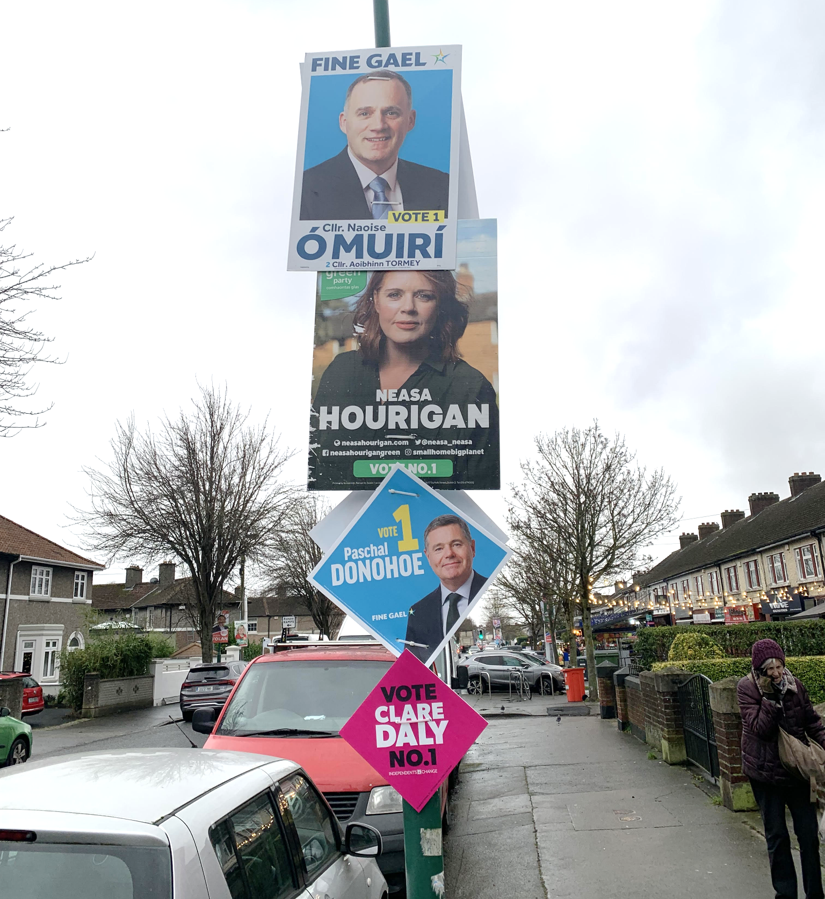
Figure 33: Election posters often show the demarcation between constituencies. Here there are posters of candidates from two constituencies on a road that divides Dublin Central and Dublin Bay North. However, this can lead to some boundary roads getting targeted by two pools of candidates.

In addition to blocked visibility, participants raised concerns about distraction, particularly where posters were clustered together or placed at eye level. This participant described the impact of a heavily postered junction: “If you are at that junction, you’ll see that they’ve plastered the billboards there on the railing and it’s actually really distracting – it is. There’s that many they’re literally all on top of each other.” This was echoed by another person: “It’s ridiculous when you literally have ten faces in front of you. Getting distracted and that kind of thing is not OK.”

Among those who raised concerns about road safety, there was a consensus that the problem becomes particularly acute in the lead-up to local elections. Participants suggested that this was because local elections typically involve a larger number of candidates than other electoral events, resulting in a noticeable surge in poster numbers. This increase in volume was seen as directly intensifying the impact on road safety, with more posters competing for space at already busy junctions and roadside locations. This participant illustrated this point: “For local elections, they are too overpowering with their posters. If you’re trying to come out onto the main road and there’s posters, it was so hard because the fencing was just plastered. It was just too much. It’s way too much. Way too many posters.”

Interviews: Road safety
The focus group contributions show that participants were largely concerned about election posters and the implications they have for road safety. However, interviews with political stakeholders revealed that politicians did not demonstrate the same concern for potential road safety issues. Politicians did not raise the topic of road safety voluntarily: when prompted to discuss this aspect of public concern around election posters, all interviewees pointed to the implications for the electoral process of reducing or eliminating posters in public spaces.

A limited group of respondents recognised that displaced posters may present road safety risks. While candidates may initially position posters securely, external factors such as weather or interference can result in them becoming hazards. One councillor explained that his postering strategy focused on maximising visibility in high-traffic areas: “I’d pick out key junctions and entrance points to towns, good visibility spots.” Another councillor described how posters can also be deliberately interfered with. Even when fitted securely, he noted that they may be pulled down and repositioned in dangerous locations to generate negative attention. Recounting his experience during the most recent local election, he stated: “One large poster was tampered with and moved into the road, creating a hazard.” These accounts suggest that the maintenance and security of posters present additional challenges that can have unintended consequences for road safety.

Public Consultation: Physical risks
Some submissions to the public consultation process also highlighted the physical risks related to posters and other negative consequences associated with their erection in public spaces. These included:

Irish Non-Neurotypical Disabled Persons Organisation: It reported that there have been a substantial number of injuries associated with election posters. Detached retinas were the leading injury, while others suffered serious cuts and bruises. It suggested that one measure to tackle the potential dangers associated with posters is the creation of designated areas in central locations for candidates to display their posters. The organisation also argued that the “practice of having numerous posters for the same candidate along barriers or a stretch of road needs to stop”.

Vision Ireland: It called for the establishment of designated poster zones. It suggested that local authorities would have responsibility for allocating equal spaces to each candidate and posters would be displayed on billboards in central locations. Vision Ireland was critical of the current situation. It stated that posters are “a real danger” to its service users. The submission stated that although most councils require posters to be at least 2.3 or 2.5 meters above ground, candidates often disregard these guidelines. Vision Ireland described how “the sharp corners and edges of posters can cause cuts or lacerations to the face, with protruding cable ties also presenting an issue”.

Voice of Vision: Also advocating on behalf of those who are blind or partially sighted, Voice of Vision Impairment submitted that its members were endangered by low-hanging posters. It reported that a member of the organisation had sustained a long-term brain injury after colliding with a low-hanging poster in 2014, which also led to the loss of the remainder of his sight.

5.4.5 Life-cycle assessment
As noted in the previous section, one of the main objections to electoral posters is on environmental grounds. Up to and including the 1980s posters were typically made of cardboard, but may not have lasted the duration of the campaign, being subject to rain and wind. One can think of a number of ways in which election posters have an environmental impact. First, the amount of plastic used and the carbon impact of that. There is also the visual impact of posters, which many people, particularly those in Tidy Towns groups, object to. Finally, there is the impact on groups that might be negatively impacted by electoral posters; for instance, posters might be a hazard for the visually impaired or may cause traffic accidents if posters are misplaced, as highlighted earlier.

In the opinion polls of the majority who said why they did not like posters nearly always made reference to some environmental aspect of posters: that they are ugly, that they are wasteful of resources (financial or material) or that they represent some form of hazard. Politically, those who are most vocally opposed to the use of posters base their views on environmental grounds. In some countries, such as Mexico, there are regulations about the type of material that can be used in the manufacture of election posters to ensure that they are recyclable (Juárez Gámiz 2017: 254).
168tonnes
The estimated weight of plastic used for c. 280,000 posters in the 2024 general election in Ireland
If we estimate that approximately 280,000 posters were produced for the 2024 Irish general election (see Section 5.1) then the total amount of plastic used for the posters was about 168,000kg or 168 tonnes. Though many of these posters will be reused, either as posters or in other ways, much of this will end up as waste. Dr. John Gallagher, an associate professor in Environmental Systems Modelling at Trinity College Dublin conducted a life cycle assessment (LCA) and assisted in the production of this section.

We evaluate the impacts of a complete national inventory of corriboard polypropylene (PP) posters, including printing and cable ties. The functional unit considered in this study was 1,000 large (printed) posters (with a pair of cable ties). In this study, we are assuming all virgin materials with no reuse of posters, and this represents a worst case. We considered several indicators for environmental impact, such as water and energy resources needed to produce posters. In both cases, these are significant. So, for instance, the water that goes into the manufacture and sourcing of material for 280,000 posters equates to just over 197,000 m³ eq. of water, that is approximately 0.7m³ of water for every poster printed. The energy output in the entire manufacturing process for 280,000 posters is 15.3m megajoules including cable ties and printing.

The main analysis we do is of the carbon emissions used in the manufacturing of the posters, however. These are not the only sources of pollution. Posters may break down and cause pollution in the water course, or if burned may cause air pollution. However, they also may be recycled fully, which would significantly reduce (though not negate) the impact of posters on the environment. Our main metric of analysis is kg CO₂ eq., where 1,000 posters (including cable ties) causes 2,354kg CO₂. With 280,000 new posters used at the last general election, we estimate that this caused 669,120kg CO₂ eq., or just over 2kg of CO₂ eq. in emissions per poster.
2024 general election poster use: carbon emission equivalents


About 1.3 million takeaway coffees


Just over six million small plastic bottles

Approx. 185 cars on Irish roads for a year, with each car driving 15,000km

A full commercial plane making
two return flights from Dublin to New York

That number does not mean much to most people, so a comparison is needed. This is the equivalent of about 1.3 million takeaway coffees, on some estimates, half of the amount of coffee drunk in Ireland in one day. Alternatively, it is equivalent to just over six million small plastic bottles. In terms of transport, the production of the total campaign was the equivalent of 185 cars on Irish roads for a full 12 months, with each car driving an estimated 15,000km, with each 1,000 posters equating to one car on the road for an estimated eight months. The impact of the total poster campaign could offset about 812 Dublin to New York passenger flights, with just under three passengers flying to New York being the equivalent of each 1,000 posters. The carbon output of the 2024 election posters was approximately the carbon equivalent of a full commercial plane making two return flights from Dublin to New York.

We can also compare the electrical or oil heating demands of a domestic home to the impact of the total poster campaign. It is the equivalent of oil heating for more than 18,760 homes on a winter night (6 hours or 14 litres of oil) or providing electricity for a complete year (4,200 kWh @ 0.255 g CO₂ eq.) to over 616 homes. Breaking that down to per 1,000 posters, the equivalent would heat 52 homes for a winter night or provide electricity to 2.2 homes for a year.

The 168 tonnes of plastic waste produced by posters in elections may seem high, but it needs to be compared to other events. For instance, some estimates of the Electric Picnic music festival previously put waste at more than 400 tonnes (Friends of the Earth 2017) and while there are increased efforts to reduce the amount of unrecycled waste, posters might be considered easier to recycle than the varied, dirty waste at a music festival.

Environmental impact of digital content
Obviously, electoral events cause more pollution than just posters. They involve quite a bit of transport, leaflets are produced etc. We also need to consider the environmental impact of other forms of political communication, e.g. reading newspapers online or in print imposes environmental costs as well. For instance, it was estimated that a single tweet (short social media post) or page view generates between 0.02 g and 0.026g of CO₂ eq. Any estimates will have large confidence intervals, especially given the variation in how the energy is generated, but recent work has shown that social media is heavily polluting (Batmunkh 2022; Istrate et al. 2024).

So, if we see tweets or posts generate 10 million impressions, this may cause 260kg of CO₂ eq – though 10 million impressions may seem like a lot. As a point of comparison, one election-related post by the Fianna Fáil leader on X during the Ireland v. New Zealand rugby match received 276,000 impressions. It is likely that posts on other social media platforms such as TikTok cause a greater environmental impact as they tend to be video content. Another X post by RTÉ News showing a well-known incident involving a party leader’s encounter with a member of the public in a supermarket ahead of the 2024 general election was viewed 3.6 million times on that platform. Because this is 45 seconds of video, the environmental impact increases significantly. Allowing for some reasonable assumptions, and depending on using Carbon Trust estimates or lower International Energy Agency estimates, this is roughly 2 tonnes CO₂ eq, equivalent to driving a light car for 8,000-10,000km (approx. 5,000-6,000 miles) or 5-6 short-haul flights. The majority of these emissions come from the electricity used by data centres to process, transfer, and deliver data, and it may be higher, especially if they rely on fossil-fuel-powered grids.

Any estimates will be imprecise, but another example might further demonstrate the significant environmental effect of social media. During the 2024 Irish general election, there were ten million interactions with the c. 17,000 posts on X (Twitter) regarding immigration (Culloty et al. 2025: 144). There is a good chance that platforms inflate the number of impressions to attract advertising, but the number of impressions will be a multiple of the interactions, perhaps 200 times. If, to be very conservative in our estimate, we assume that X doubles the number of interactions, and we halve the possible conversion rate from interactions to impressions, ten million interactions might be the equivalent of half a billion impressions, which if it includes some video and visual content might cause as much as 250 tonnes of CO2 eq. or roughly 120 round-trips to New York from Dublin.

So, allowing for crude estimates based on conservative assumptions, the environmental impact of one topic being discussed on one platform during the Irish 2024 general election campaign might be the equivalent of the carbon impact of one-third of the posters in an Irish election campaign. Even if this conservative estimate is an overestimate, we can see that the environmental impact of posters, while far from negligible, might be small compared to the impact of the online campaign and discussion.

Road safety impact
Another environmental impact that the Commission referred to in the terms of reference was the impact on road and pedestrian safety. We contacted two insurance companies to see if there is an uptick in the month during election campaigns compared to similar months in non-election years. While they were reluctant to release data for reasons of commercial sensitivity, in both cases, they dismissed the idea that election posters are in any way associated with accident claims. They ruled election posters out as an issue for road safety.

Pedestrians, however, might be affected by falling posters due to high winds. In one public consultation submission, a claim was made that one person was seriously injured by a misplaced poster. We also consulted with a disability activist, who dismissed the idea that election posters are a serious problem for disabled people in comparison to other issues that affect that group. Politicians also report that they are increasingly conscious that posters must be placed correctly and secured and will remove damaged or fallen posters, if only to avoid public criticism, which tends to be strong from some quarters.

5.5 Potential changes to poster rules
This research sought to consider what alternative regulations could be in place regarding poster use, as well as exploring the different channels of communication for election communication which may function as replacements for traditional physical posters.

Polling
Survey respondents were asked about four specific potential changes to the current poster regulations. Overall, as shown in Figure 34 below, almost two-thirds of respondents (64.9 per cent) favoured an outright ban on political/election posters, while one in five (20.7 per cent) opposed such a ban. Two potential limits were more popular: limiting the location where posters can be erected was supported by 80.1 per cent, while limiting the number of posters per candidate was supported by 75.4 per cent. A lower proportion, just over half (53.2 per cent) supported a limit on the size of posters, with a quarter (25 per cent) being indifferent to this particular size suggestion. In the limited space of a survey, it is not possible to explore in depth what may be meant by “limit location”, which was the most popular of the suggested alternatives, but some of this was expanded on in the focus groups and interviews as discussed below. Although much more informal than the polling, almost a third (31 per cent) of the focus group participants supported a complete ban on posters (most popular in the rural focus group in Kerry covering villages/ small towns), while one in five (21 per cent) opposed a ban – similar to the poll. Almost half (48 per cent) of focus group participants favoured keeping posters, but introducing new regulations or caps.

Poll question: Would you be in favour, against, or neutral on each of the following potential changes to rules around the use of election posters?
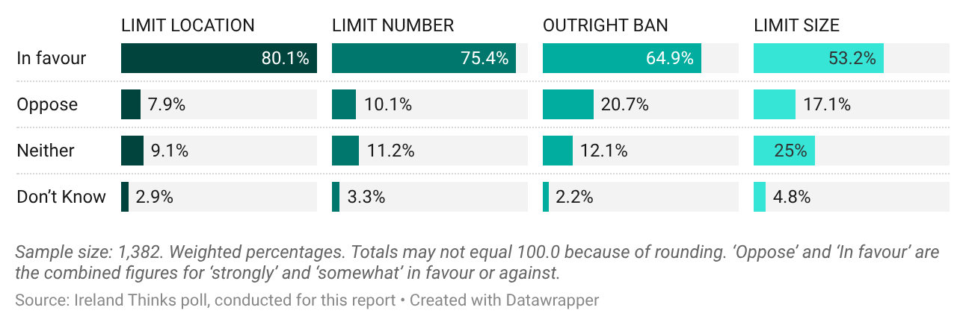

Figure 34: Public attitudes to various potential changes to the regulation of posters.

5.5.1 Ban

Focus groups
Some focus group participants suggested a total ban made sense as there was simply no need for this form of election advertising in the age of social media and mobile communication and “you’d need to live under a stone” not to know an election was taking place: “They serve no purpose except the politician’s ego. Maybe 30–40 years ago, they reminded people an election was on. Some people don’t read a newspaper, but now everyone has a phone.” Other arguments in favour of a ban related to environmental concerns and the ideas around waste, as outlined earlier in Section 5.4. However, some were concerned that banning posters could marginalise certain voters from the democratic process, as one said: “The only reason that I’m thinking ‘No’ to an outright ban, is just because, I don’t want to think that anybody would be excluded. For instance, elderly people that aren’t on digital media … [you] can’t assume that everybody has the same access, you know?” Digital alternatives are further explored in Section 5.5.4.

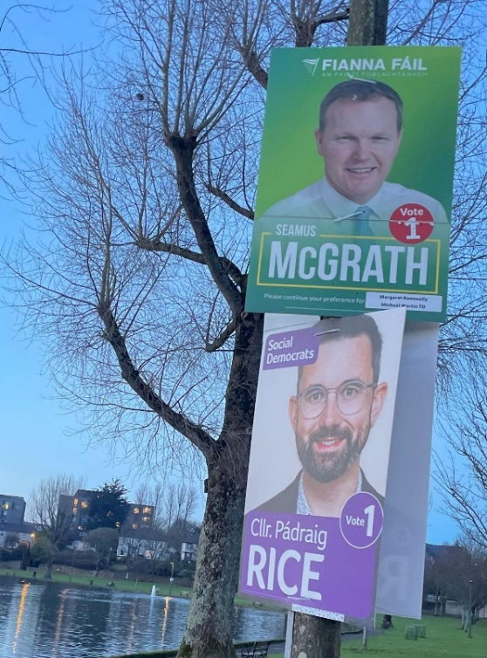
Interviews
Political stakeholders are overwhelmingly opposed to a poster ban, citing its unfairness for new candidates and approx. 90 per cent of interviewees would not support a blanket ban on posters. Among the minority of interviewees in favour of stopping poster use altogether, all were already established politicians – and admitted that they would probably be against a ban if still in the early stages of their political career. One councillor from the Midlands said: “A poster ban wouldn’t really bother me, because then it’s a level playing pitch for everybody. But I suppose if I was going for my first election, I’d like to get my face and name out there.”

There was a shared understanding among the politicians that are opposed to banning posters that they believe it would harm democracy. This theme was repeated throughout the interviews, with strong emphasis on the democratic value of posters for visibility and participation, as is illustrated by these remarks from a TD from a small party, also referenced earlier in the report: “Poster bans are a disaster for new parties. A poster ban would be devastating to the democratic process. It would be a way of building a wall around the political system and stopping new entrants coming in.” This sentiment was echoed by a new female TD: “I would not like to see them banned outright. It creates a huge advantage to an incumbent. New candidates need the opportunity.” Others argued that a poster ban would disproportionately impact independent candidates, with this independent county councillor explaining their worry: “My concern would be that it would give the government an unfair advantage over the independents and everyone else.”
Figure 35: Posters in the Cork South Central constituency in 2024.

5.5.2 Limit numbers

Focus groups
There was overwhelming support for introducing a cap or limit on the number of election posters permitted per candidate: this consensus is one of the most robust and consistent findings across all the focus groups, and aligns with the survey results presented above.

Many focus group participants argued that limiting the number of posters could help level the playing field between candidates. They expressed concern that the current system advantages those with greater financial resources, allowing them to dominate public space. One participant described the current system as “unfair” and advocated for a poster limit: “There should be a cap on the number of posters that are put up. Because I think there are too many of the ones that can afford to put them up, and not enough from the poor old candidates that can’t afford them.” Others supported a cap on environmental grounds, suggesting it would reduce plastic waste, as discussed previously (Section 5.4). As one participant stated: “Everybody should be allocated a number [of posters], and they shouldn’t be able to exceed it. I think it should be really reduced, right down.”

Some participants suggested that one potential method to determine how a cap would be decided would be to base it on geography to curtail the high concentration of posters in congested urban areas, particularly cities: “Maybe a limit could be decided based on a geographical factor, so a certain number of posters per square kilometre.” Although support for a cap was near-unanimous, many participants acknowledged practical challenges in implementing such a measure. In particular, concerns were raised about how local authorities would count the posters. Ultimately, while participants strongly favoured the principle of a cap, many felt that it would be very difficult to enforce. Some proposed revising SIPO’s expense reimbursement rules, including limiting the number of posters eligible for reimbursement. This participant argued this could be one way to motivate all parties and candidates to adhere to a poster limit: “I think you could reduce the leaflets and the posters by saying each party would have a cap of say 50 or 100 posters and they would only get their expenses back for 50 posters.”
“Maybe a limit could be decided based on a geographical factor, so a certain number of posters per square kilometre”

Notwithstanding this, a small number of participants insisted that a poster cap was viable, but only if substantial fines were imposed for non-compliance. This participant asserted that imposing substantial financial penalties would encourage candidates and parties to comply with the regulations: “A way of enforcing the cap would be to have a stringent fine, that if they overstep, and I am sure the parties will be checking on each other, but if they overstep they will be fined. They are meant to be fined if they go past the date to take them down. They just need to tighten the regulations.”

Interviews
The focus groups’ support for introducing a poster cap was not mirrored by the political interviewees. Their objections to a cap echoed many of the same concerns raised against an outright ban: politicians argued that restricting the number of posters they could display would undermine their campaign visibility and negatively impact the electoral process. A small number of interviewees demonstrated a willingness to adopt this model. One councillor detailed how they had previously called on the local authority to introduce a cap: “We definitely need to find some kind of compromise on these election posters. I was proposing to the council that all the candidates should be allowed to print the same number of posters.” The motion was defeated.

Separately, a small group of interviewees indicated that, in principle, they would support a cap rather than an outright ban, describing it as striking a balance between democratic engagement and environmental concerns: “I would support capping the number of posters... it gives people who aren’t incumbents a fairer shout. But also, for the people who are totally anti-poster would feel it’s a step in the right direction.” Nonetheless, among this limited group of politicians willing to observe a poster limit, it was recognised that enforcement could present significant challenges. While they supported the measure for reasons of fairness, they also noted the practical difficulties inherent in ensuring compliance. This TD’s comments demonstrate a willingness to adhere to a cap, but also acknowledge that challenges exist around feasibility and enforcement: “I would definitely like to see a conversation had about maybe a quota or a limit that every candidate has a limit. I think that that would make it very equitable, because as it stands at the moment, some candidates can spend, you know, multiple thousands of euros on postering … now, how you police that is a different thing, of course, but I think that that would be most equitable.”

5.5.3 Designated poster zones

Focus groups
The concept of designated poster zones elicited conflicting views: some participants raised the concept without being prompted, citing observations from visiting other European countries. This participant illustrated an understanding of how such zones operate: “People like the Swiss have a better way. They ban posters totally and each village or town has these mini billboards, and what they do is you go into each town from each angle so you come in each road whether it’s south, east or west and you will see the five or six posters.” Some participants suggested that a designated zone would eliminate the over-proliferation of election posters in towns and cities: “I’d rather see posters set up like this than walk down and see, like, three posters for one party, and then on the other side of the street, like, 15 posters for the same person. I’d rather see a mix of candidates in one place. Because if I was interested to see who was running in my area, I’d know where to look.” Another added that having them grouped together would be useful to “help you compare messaging and style”. Additionally, a positive raised was the potential for the designated poster zones to “even the playing field” as candidates would no longer require large financial resources to purchase posters. One said how, specifically for new independents, “this could be a really helpful way for them to break in”.

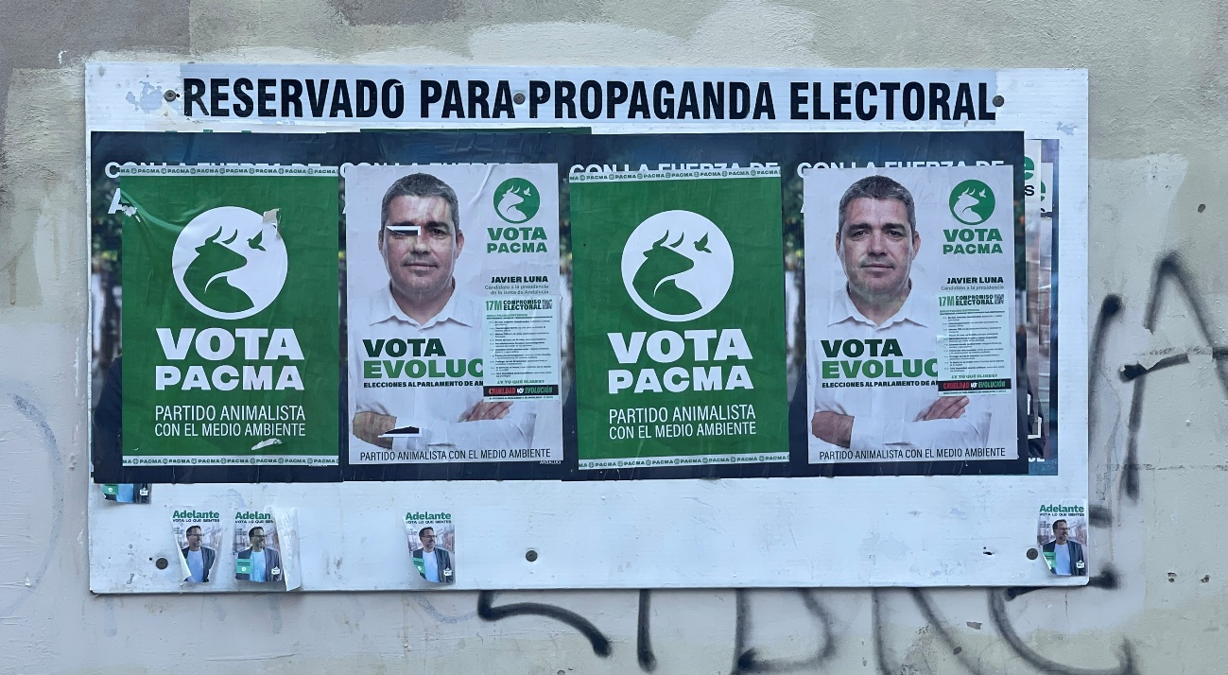
Figure 36: An example of a designated poster zone in Cádiz, Spain. The text at the top of the board states “reserved for electoral propaganda”.

Critics of the idea generally fell into two groups: some doubted its effectiveness because they believed people would not intentionally visit the billboard to look at their local candidates, while others thought it would fail since having all the posters together would be overwhelming. Moving all posters to one fixed location would mean fewer people see them by chance: “I don’t think people are going to go out of their way to look at it. Unless they’re really into politics. If you’re just a regular person walking down, you’re not going to be stopping and looking at it.” A further critique was that consolidating all candidates’ posters in a single area could be visually overwhelming and hinder a voter’s ability to effectively process the names and faces. As one participant observed: “It seems like it would be very cluttered, everyone on the one thing”, while another elaborated: “When you see it, it would be very busy, would you actually be looking at everybody? You’d probably just spot one candidate that you recognise and then walk on.”
“If you’re just a regular person walking down, you’re not going
to be stopping
and looking at it”

Interviews
Political stakeholders in Ireland were largely sceptical about the idea of introducing designated poster zones. Many interviewees showed a solid understanding of how such zones operate in other countries but expressed doubts about whether this approach would translate effectively to the Irish context. A political party official specifically highlighted that Ireland’s unique multi-seat; multi-candidate single-transferable vote (STV) system could make the implementation of designated zones problematic. Systems that work in other countries may not be directly applicable in Ireland, where the dynamics of local elections and constituency sizes vary greatly.

In addition to systemic concerns, some interviewees suggested designated zones might unintentionally reinforce existing inequalities as well-resourced candidates could still gain more visibility through advertising or networks, disadvantaging newcomers. One first-term councillor expressed scepticism about whether designated poster zones would create fairness: “I would question whether equal poster space truly levels the playing field, especially since newcomers often lack the infrastructure or support that established candidates have.”

Ultimately, those directly involved in politics are more eager to maintain the status quo regarding poster use, while the public would like to see changes. While there is public support for a total ban on posters, a stronger feeling that comes through is for some change to the current situation, perhaps through limits on location or numbers. However, questions arise regarding the enforcement of any changes, such as a limit on numbers. The designated poster zones sometimes seen in other countries would reduce the visibility of posters and would reduce the number of posters in use, but this may come at the expense of general awareness of candidates, and there was some scepticism regarding public engagement with these poster zones.

5.5.4 Digital alternatives to posters

Focus groups
Focus groups participants made some suggestions regarding digital posters to help combat the physical waste they associated with traditional posters. The environmental impact of digital campaigns was not discussed.

Digital advertising as a waste-reduction strategy: Young participants highlighted the potential for digital alternatives, suggesting that digital advertising could help reduce the waste and pollution associated with physical posters. Some participants advocated for financial inducements for candidates and parties to encourage them to spend more on digital advertisements and less on physical posters (“Maybe there is a way to incentivise more digital advertising than physical posters. That would be good for the environment”).

Digital billboards and public screens: Some participants suggested that political advertising should shift from physical posters to digital displays in public spaces. This would reduce environmental waste and visual clutter. Participants discussed the potential to use electronic screens at train stations, bus stops, or shopping centres that could rotate political advertisements. Similar to a traditional election poster, these digital advertisements would include candidates’ names, photos, party slogans, or campaign messages. It was suggested that these screens could be programmed to show each candidate equally, ensuring fairness and visibility for smaller parties. This young participant said: “You know those digital ads? Sometimes they’re on these big boards, like say you’re at a train station and they just automatically advertise different stuff. I’ve never seen parties advertised through those. Maybe they could, just to reduce the waste and stuff like that.”

Social media campaigns and short-form content: Participants emphasised the power of social media, especially TikTok and Instagram, for reaching younger voters. There was a shared view that short, engaging videos that are easy to consume and share are the most effective. Participants suggested that politicians could create more TikTok videos or Instagram reels explaining their policies, showing behind-the-scenes campaign moments, or even providing tutorials on how to vote. This participant explained more: “Nothing too excessively long and something engaging and different, not sitting in a room and talking about your policies, but just a way to make not light of it because it’s still politics but just try and draw them in through just being a bit light-hearted about stuff. Instagram and TikTok would be the main way to do that, I think.”

However, it is important to note that all the discussion of social media as an alternative was not necessarily positive. One rationale for the continued use of posters was to promote electoral fairness in a digital era. This participant expressed concern about the highly personalised content that she was consuming online and articulated her apprehension around how social media algorithms influence what material each user is exposed to. She said that while posters lead to the creation of plastic waste, this issue should be measured against the need to ensure that voters have equal access to political communications: “Because digital media is algorithm-based, so you’re only going to see more of what you’re looking for, right? Posters at least level the playing field. Environmentally, I think that they’re a disaster, visually too many, there seems to be no regulation around it. But the only thing is that at least it’s independent in nature so that everybody gets to see it, consume it.” Another spoke about their experience on social media during the presidential election, and an absence of political/election information: “Even though I’d be on Facebook or Instagram, I actually have not seen one thing about the election. I don’t know if it’s just my algorithm, but all that comes up for me is Trump!”
“Even though I’d be on Facebook or Instagram,
I actually have not seen one thing about the election. I don’t know
if it’s just my algorithm, but all that comes up
for me is Trump!”

Hybrid digital advertising and limited physical posters: While digital alternatives were seen as promising, participants recognised that not all demographics are equally engaged online and suggested a hybrid approach. This young person said: “Obviously, a lot of a certain demographic would be online and they would see the candidates advertising themselves online or through the media, but there are going to be a certain amount who don’t really engage with the digital world and how are they going to be able to see who’s running for them? So, I think it’s still important to kind of have their faces out there.” Young participants also suggested that QR codes could be printed on physical posters to link directly to digital content, such as candidate videos or policy summaries. Another explained how, in terms of “levelling the playing field” and making visibility easier for new candidates or those with fewer resources, the same imbalances will always apply: “The more money you have the more digital media you have, the more money you have, the more posters you buy. Be it online or offline, the deeper pockets get more reach either way. But I do think in general posters – resource-wise – there is a much better way of doing it.”

Digital campaigning for community engagement: Some contributors also discussed using digital platforms to mobilise young people for in-person events, such as community meetings, Q&A sessions with politicians, or campaign rallies. Participants discussed using social media to advertise local events, encourage voter registration, or organise meet-ups with candidates. They also spoke about creating online communities, primarily through WhatsApp channels or Facebook groups, for ongoing political discussion and engagement. This person explained how that could work: “If you use social media to advertise events and little meetings and stuff like that in communal spaces, I think that could be so effective for people to come on board and have like a direct line of communication.”

6. Conclusion and formal considerations for the Electoral Commission
Through the mixed methods in this research, we have identified the following conclusions:

- Most Irish people dislike election posters and would like to see their use significantly reduced. This was evident and consistent across the public consultation, the polling and the focus groups.

- In contrast, political stakeholders believe that posters remain a crucial component of the Irish democratic process: mainly by helping to establish name/face recognition for candidates and building awareness and engagement around an electoral event.

- Both the focus groups and political interviews noted that posters are valuable in familiarising new/challenger candidates with voters, and so might be thought an important aid to the democratic process.

- Most of the public’s objections to posters are on the basis that posters are a waste of resources and visually polluting. These significant costs were set out in this report, both financial and environmental, as well as highlighting the labour demands on candidates. Concerns about road safety were also highlighted.

- The environmental waste issue, particularly around corriboard/cable ties, was repeatedly mentioned by the public. Politicians generally accept that there is an environmental cost but justify their continued use of posters by arguing that they are essential for campaigning and connecting with the public. Even those politicians with serious environmental concerns feel they would be disadvantaged without posters so continue to use them.

- Another theme of the objections raised by the public was the feeling that posters serve no purpose. However, when we explore these ideas in focus groups and polling, people are more likely to acknowledge that there is some merit to posters, such as building awareness of electoral events. In polling, we also found that people find posters useful for learning about candidates and knowing an election is taking place. Nevertheless, the quantity, repetitive nature and positioning of posters are responsible for some of the negative feeling towards their use.

- Our polling also shows that posters are reaching low-interest potential voters. This indicates that they do have a reach that many other modes of communication – which can be more easily avoided – might not have with these groups.

- We present some potential alternatives to posters: both reference points in other countries, digital alternatives, and possible changes to the current Irish rules. These are more comprehensively outlined and synthesised in the final part of this chapter.
Before outlining a summary of potential changes for the Electoral Commission to consider, it is worth noting some additional points regarding the scope and context of the findings presented in this report. The following issues were not widely discussed in the focus groups, polling or interviews, but the authors believe they provide some additional context which is relevant to highlight when consideration is being given to attitudes and potential changes in contemporary political communication regulation, practices and attitudes.

Presidential election: The research undertaken for this report mainly took place in the context of the Irish presidential election in 2025. Presidential elections in Ireland are events that require fewer posters than others because candidates should already be well known to the public and because it is a single election (as opposed to the 43 separate elections in the Dáil Éireann election in November 2024), national media can give a great deal of attention to each candidate. The fact that there was only three candidates is also atypical. Ultimately, we cannot expect – nor would it be desirable – that elections do not impact people and thus impact, in various ways, the responses provided for this report. Election campaigns should prompt potential voters to think about politics, and people will be influenced – positively and negatively – by events around them at the time.

Electoral system: The candidate-centred nature of the Irish electoral system is not unique, but PR-STV has some particular traits, meaning candidates rely heavily on developing personal name and face recognition. This becomes important when newcomers are challenging incumbents, and even between running mates from the same party competing in a constituency. The PR-STV system in Ireland also means that election strategies – such as poster regulations – that are in place in other countries (even those using other types of proportional representation) may not operate in the same way or have the same role/effects as evident elsewhere.

Digital alternatives: Online and offline communication are not interchangeable formats and attention should be given to some of the wider reservations associated with social media. In this context of political communication/advertising, two elements are particularly relevant. Firstly, algorithmically promoted content, a trademark of social media users’ experiences, ensures that the content presented to users differs from person to person, removing any “common ground”. Distinct material is promoted on each individual user’s feed depending on demographics, hobbies, social values, etc. This is a fundamentally different mode of communication to analogue communication methods, and is one which thrives on social fragmentation. Secondly, the metrics of success and engagement associated with third-party platforms are distinct from traditional notions of voter engagement and mobilisation. What might be valuable user activity from the perspective of social media platforms likely differs from democratic norms. Furthermore, third-party companies can intermittently take policy decisions which will impact political discourse and political content online, both through algorithmic structures and formal rules as seen with the Meta ban on political advertising. Finally, there are still environmental costs associated with digital content: they are less visible/material than posters, and may not be directly comparable, but data and network infrastructures and electricity are not environmentally neutral and should not be presented as such.
Below, in Table 8, we outline potential alternatives/changes with some observations that the Commission may wish to consider.

Proposal | Description | Additional considerations
OVERALL USE
Total ban of posters in public spaces | Posters would no longer be permitted on public architecture like lampposts.  This would have the advantage of reducing plastic waste and would limit the visual presence of posters.  A ban would eliminate the carbon impact of the equivalent of 185 cars on the road for a year.  Instead, only digital campaign could be allowed with no physical material, like posters. Voters would rely on digital sources, likely social media, for much of their information on candidates. | Political advertising is already curtailed in Ireland with limits/bans on TV/radio advertising.  Posters are a relatively cheap form of advertising that allow candidates to become known in the public eye.  Digital billboards in public spaces – if relying on commercial advertising spaces (e.g. bus shelters) – is limited and costs could grow making it difficult for candidates with fewer resources to afford advertising space.  Reliance on social media leads to enhanced power in hands of third-party platforms. Furthermore, the content which voters see will vary hugely and depend on their algorithms. Also, digital content still comes with an environmental impact.
Cap on numbers  of posters per candidate | Limiting the number of posters allowed per candidate could be a way to reduce the number of posters produced. This would have the advantage of reducing plastic waste and would limit the visual presence of posters.  This change could stop bigger parties with more resources taking over public spaces with more posters. It may also reduce the physical labour demands on all candidates.  Each poster could be printed with a serial number/sticker to identify it. | The number of posters per candidate would need to be adapted for each constituency based on geographic size, number of seats, etc.  This proposal brings an administrative burden for candidates if required to log location/database of posters. There would also be an administrative burden for the councils or whichever body is required to enforce this rule.  There is the potential for fraudulent numbering systems. Related to this, the actual enforcement of this cap could be challenging.
Limit funding support for posters | The amount of election expenses reimbursement of election expenses could be reduced/capped for posters.  The aim could be to (indirectly) reduce the number of posters used, thus reducing the waste, visual impact and associated physical labour. | This could be a step towards reducing the amount of posters in circulation.  However, parties may try to cross-subsidise and so there might not be any material effect or guaranteed reduction in the number of posters.
Limit the time period during which posters are up | Posters could be used during a narrower window of time before an election, and/or must be removed within a shorter period.  This would reduce the duration of the visual impact. | Relatively tight regulations are already in place (i.e., from the issuance of the electoral order before election, and removed within 7 days).  This would not necessarily lead to any actual reduction in material produced as posters would likely still be put up all over constituencies, just for a shorter window.
Limit the electoral events for which posters can be used | This could reduce the number of posters produced and in use, thus reducing their overall environmental and visual impact.  It would mean making a decision to potentially exclude the use of posters during local, general, presidential elections or referendums. | This could have consequences for voter awareness and candidate/issue familiarity.  If any bans are introduced, posters for public meetings – which are also typically erected on corriboard posters – may be used by candidates to attempt to circumvent the rules.
Prevent localised poster bans | At present, some Tidy Towns committees impose informal “bans” on posters in certain areas. This might lead to “information deserts” or disadvantage new candidates. A regulation to disallow such bans would prevent these problems. | It is not clear that this is a real problem.  As the “bans” are in the form of a ‘gentleman’s agreement’ based on social pressure, it could be difficult  to enforce such a regulation.
LOCATIONS
Use designated poster zones/boards. | Posters would not be permitted on lampposts.  Posters might be in specific ‘civic’ areas at one/various points around urban areas.  Each candidate could be allocated equal space, randomly assigned, or space based on previous vote share.  This would have the advantage of reducing plastic waste and the visual impact of posters. It would also allow for direct comparisons between candidates in a constituency. | This approach relies on people going to the poster boards rather than the incidental exposure of lampposts/ roads. It is a different communicative process and does not have the same subconscious “memorable” effect on citizens as repeated exposure. This may be important for building awareness among non-politically engaged voters.  Candidates running in large rural areas would be relying on small sites in urban locations to build awareness of their candidacy.
Limit posters to selected roads | This might entail keeping posters to main roads only and banning them from smaller roads, housing estates, etc.  It would potentially be up to each local authority to designate which roads are permitted.  This could reduce the waste, visual impact and associated physical labour. | This would potentially have the advantage of reducing plastic waste and the visual impact of posters, but may intensify the effects in other areas where posters are allowed.  It ultimately might increase competition for space in approved areas.  Candidates from bigger parties may have the resources to take up these spaces, crowding out smaller candidates.
ENFORCEMENT
Designate powers to councils to make their own rules | Grant councils the power to set their own rules regarding poster use.  This could be similar to setting the rules around the property tax rate, which varies between councils.  This would potentially reduce waste and the visual impact of posters. | This would not bring any guaranteed change to current practices/regulations and the status quo may prevail. Conversely, there could be a race to ban posters in response to voters’ preferences, which might be detrimental to certain candidates and voters.  Candidates running in constituencies that cross council boundaries could have two sets of rules.
Change/increase fines | Councils could increase fines for posters placed in problematic locations or issue new rules about the positioning of posters.  This could help with public frustration around poster placement. | Fines are already quite high (€150 per poster).  Candidates are generally already trying to abide by regulations and state that failures are a result of oversights rather than laziness.
Review and improve enforcement of current laws | Many laws around the positioning of posters are already in place, such as height and distance from junctions.  Better enforcement of current laws may reduce public frustration with posters.  This could help with public frustration around poster placement. | If the current rules are not being comprehensively enforced, it may be difficult to find out the reasons why or what updates are needed. Councils may need to be consulted.
MATERIALS, DESIGN AND CONTENT
Use more sustainable materials | Ensure that candidates use alternative, non-plastic material.  E.g., cardboard, fabric, etc.  This would have the advantage of reducing plastic waste, and minimising the wider environmental impact such as microplastics.  Materials may be more easily recycled. | Corriboard/correx is durable and weatherproof meaning it lasts both  the duration of the election and between elections. Alternative materials might need regular replacement, be more likely to be damaged, or come down in bad weather. So, they might me more easily recycled but not be as easily reused.  Corriboard/correx can also now be “reskinned”, meaning the base material is retained and a new top layer of ink is printed on.  Enforcement around materials used would be challenging.
Limit the shape or size of posters | This might reduce the amount of waste if posters were made smaller.  Narrower posters (in terms of width dimensions) might be less likely to be damaged in storms so could be reused more. | Any regulation should not prevent existing posters from being reused, as this might lead to an increase in waste if old posters had to be disposed of.  If posters are standardised too much, people might become ‘blind’ to them, thus reducing their positive impacts.
Include more information about the election | This might include details like asking election candidates/ parties to give the date of the election on a poster.  Also include links (such as QR codes) to policy information/party manifesto/ further information about the candidate. This would ensure there is more information of use to voters included on posters, thus broadening their uses. | Some parties/ candidates already do this, so it would not be onerous.  Stickers could be used on posters to enable the reuse of old posters.  More text on posters leads to potentially more distractions for drivers. Other passers-by may not read much text on posters and instead absorb the name/face more.
EU transparency rules re: political advertising | Transparency information became an EU requirement in October 2025 (not fully in place for the 2025 presidential election) so the next elections – bye-elections in May 2026, and then local/European elections in 2029 – should have these rules observed by all candidates. | In recent years, posters have always had to feature the name/address of the election agent/publisher so candidates and parties will be familiar with some level of content requirements.  Clarity/guidance from the Electoral Commission may be needed on the practical requirements for posters. The Commission outlines the information (https://www.electoralcommission.ie/regulation-of-political-advertising/ ) but how this might align with, e.g. SIPO requirements (e.g., “who paid for the advertisement, and how much was paid”) and how this is practically enforced on posters may require clarity.
REMOVAL / DISPOSAL / RE-USE
Improve processes around poster disposal and recycling | Councils/the Electoral Commission could reach agreements with recycling/waste companies to accept posters. Information could be made available to candidates before election day. Gathering a centralised list of charities/community groups who have uses for old posters may also be valuable.  This would provide more structure/clarity on the reuse/disposal of poster material would help with recycling rates. | As it stands, acceptance of posters for disposal/recycling is done on a somewhat ad-hoc basis and varies between constituencies. It can be challenging for candidates to dispose of posters responsibly.  Any companies/organisations “endorsed” for taking posters would need to be vetted to ensure the used posters are being responsibly processed/used.
Support re-use of existing posters | Encourage candidates to re-use posters. This could be done with financial support for cleaning/storing posters, useful for those without access to storage space. This could further reduce the number of new posters being produced for each election.  If candidates/parties want the images changed on the posters, there is the possibility of “reskinning” them. | Most candidates are already reusing posters where possible given the costs associated with printing them and the efficiencies/savings with re-use.  Posters need to be in good condition to be reskinned so need to be made from high enough quality material to not be damaged by the end of the election.

Table 8: A summary of potential changes for the Electoral Commission to consider.

Bibliography
Aggarwal, M., et al. (2023). A two-million person, campaign-wide field experiment shows how digital advertising affects voter turnout. Nature Human Behaviour, 7(3): pp. 332-41.

Aitken, R., Gray, B. & Lawson, R. (2008). Advertising effectiveness from a consumer perspective. International Journal of Advertising, 27(2): pp.279-97.

Aran, B. (2024). Opportunities to reduce plastic pollution in elections: Policy brief for electoral management bodies and political parties. Westminster Foundation for Democracy. Available at: https://www.wfd.org/sites/default/files/2024-09/wfd_2024_opportunities_to_reduce_plastic_pollution_in_elections.pdf

Batmunkh, A. (2022). Carbon footprint of the most popular social media platforms. Sustainability, 14(4), 2195.

Campbell, K.K. & Jamieson, K.H. (2006). The interplay of influence: News, advertising, politics, and the internet. Public Relations Review, 32(1): pp.88-89.

Centrist Nation News. (2026). Election Without Posters: Bangladesh’s New Campaign Rules. 6 January 2026. https://www.youtube.com/watch?v=K_8HstpBTbI

Cialdini, R. (2005). Basic social influence is underestimated. Psychological Inquiry. 16: pp. 158-61. 10.1207/s15327965pli1604_03.

Clogg, R. (1987). Parties and Elections in Greece: The search for Legitimacy. Hurst.

Culloty, E., O’Connor, C. & Suiter, J. (2024). Digital Media Trends and Testing Regulatory Structures. In Gallagher, M. et al. How Ireland Voted 2024: The New Normal? Palgrave, pp. 139-58.

Cunningham, K., O’Malley, E., & Quinlan, S. (2025). Campaigns, Mobilisation, and Composition Effects in the 2018 Irish Abortion Referendum. Politics and Governance, 13, Article 9236.

Dezelan, T. & Maksuti, A., (2012). Slovenian election posters as a medium of political communication: An informative or persuasive campaign tool?. Communication, Politics & Culture, 45(1), pp.140-59.

Dumitrescu, D. (2009). Spatial visual communications in election campaigns: Political posters strategies in two democracies (Doctoral dissertation, The Ohio State University).

Dumitrescu, D. (2012). The importance of being present: Election posters as signals of electoral strength, evidence from France and Belgium. Party Politics, 18(6), pp.941-960.

Dumitrescu, D. (2010). Know Me, Love Me, Fear Me: The Anatomy of Candidate Poster Designs in the 2007 French Legislative Elections. Political Communication, 27(1): pp. 20-43.

Friends of the Earth. (2017). ‘Friends of the Earth appeal to Electric Picnic-goers to keep Stradbally clean and bring camping gear home’, https://www.friendsoftheearth.ie/news/EP2017/. 3 September 2017.

Gattermann, K., & Marquart, F. (2020). Do Spitzenkandidaten really make a difference? An experiment on the effectiveness of personalized European Parliament election campaigns. European Union Politics, 21(4): pp. 612-33.

Gerber, A. S., & Green, D. P. (2000). The effects of canvassing, telephone calls, and direct mail on voter turnout: A field experiment. American Political Science Review, 94(3): pp. 653-63.

Gotlieb, M.R. et al. (2017). Cumulative and long-term campaign advertising effects on trust and talk. International Journal of Public Opinion Research, 29(1): pp.1-22.

Greenwood-Hau, J. (2025). Capital, Privilege and Political Participation. Liverpool University Press.

Hajri, O., & Daife, Y. (2023). The environmental impact of using social networks in election campaigns. In E3S Web of Conferences (412). EDP Sciences.

Hassan, N. E., & Salahaddin, S. D. (2025). Election Campaigns and Visual Pollution: A Study of Public Spaces, Mental Well-Being, and Environmental Impact in Duhok Governorate, Kurdistan Region-Iraq. Goya Journal 18(10): pp. 17-27.

Holbein, J. B. & Hillygus, D. S. (2020). Making young voters: Converting civic attitudes into civic action. Cambridge University Press.

Holtz-Bacha, C. & Johansson, B. (2017). Posters: From announcements to campaign instruments. In Election Posters Around the Globe: Political Campaigning in the Public Space (pp. 1-12). Springer.

Holtz-Bacha, C., & Lessinger, E. M. (2017). Indispensable and very much alive: Posters in German election campaigns. In Election Posters Around the Globe: Political Campaigning in the Public Space (pp. 159-186). Springer.

ISO. (2006a) ISO 14044:2006, Environmental management—Life cycle assessment—Principles and framework. Geneva: ISO, 2006

ISO. (2006b) ISO 14044:2006, Environmental management—Life cycle assessment—Requirements and guidelines. Geneva: ISO, 2006.

Istrate, R. et al. (2024). The environmental sustainability of digital content consumption. Nature Communications 15, 3724

Juárez Gámiz, J. (2017). Electoral Posters in Mexico: From Monochromatic Iconography to Multicolor Saturation. In Election Posters Around the Globe: Political Campaigning in the Public Space, (pp. 239-258). Springer.

Juárez Gámiz, J. (2025). Campaign saturation. In Elgar Encyclopedia of Political Communication (pp. 161-165). Edward Elgar.

Kim, P. (1992). Does advertising work: A review of the evidence. Journal of Consumer Marketing, 9(4): pp. 5-21.

Lewis, J. & Masshardt, B.J. (2002). Election Posters in Japan. Japan Forum 14(3): pp. 373-404.

Lipsitz, K., & Padilla, J. (2024). The nonlinear effects of political advertising. Journal of Political Marketing, 23(2): pp. 192-205.

Marsh, M., (2004). None of that post-modern stuff around here: Grassroots campaigning in the 2002 Irish General Election. British Elections & Parties Review 14(1): pp. 245-267.

Martínez Lirola, M. (2023). A multimodal critical discourse analysis of a sample of posters used in the 2016 and 2020 election campaigns in Ireland. Estudios Irlandeses (18): pp. 37-53.

Matthes, J., Zoizner, A., Nanz, A., Hopmann, D. N., Theocharis, Y. & Noetzel, S. (2025). The Relationship Between Incidental News Exposure and Political Participation: A Cross-Country, Multilevel Analysis. Digital Journalism, 1–20.

Nanz, A. and Matthes, J., (2022). Democratic consequences of incidental exposure to political information: A meta-analysis. Journal of Communication, 72(3): pp. 345-73.

O’Malley, E. (2012). Explaining the 2011 Irish Presidential Election: Culture, Valence, Loyalty or Punishment? Irish Political Studies, 27(4): pp. 635–55.

Padhan, S., & Goswami, S. (2025). Election Fever and Environmental Fallout: An Ecological Perspective on Democratic Practices in India. GeoChronicle Panorama. Vol. 5 (1): pp. 4-16.

Panagopoulos, C., Green, D. P. & Moniz, P. (2025). Revisiting name recognition and candidate support: Experimental tests of the mere exposure hypothesis. Research & Politics, 12(4).

Philipps, A. (2015) ‘Defacing Election Posters: A Form of Political Culture Jamming?’, Popular Communication, 13(3), pp. 183–201. doi: 10.1080/15405702.2014.974759.

Prior M. (2018). Hooked: How Politics Captures People’s Interest. Cambridge University Press.

Rafter, K. (2011). Hear no evil—see no evil: Political advertising in Ireland. Journal of Public Affairs, 11(2): pp.93-99.

Rolfe, M. (2012). Voter turnout: A social theory of political participation. Cambridge University Press.

Rust, N. C. & Mehrpour, V. (2020). Understanding image memorability. Trends in cognitive sciences, 24(7), pp. 557-68

Schott, M., & Wolf, J. (2018). Election poster persuasion: Attitude formation in the void. Social Psychology, 49(1), 3–15.

Seidman, S.A. (2008). Posters, propaganda, and persuasion in election campaigns around the world and through history. Peter Lang.

Seo, J.H., 2025. Toward sustainable election campaigns: Addressing microplastic pollution from promotional materials. Science Progress, 108(4), p.00368504251397431.

Standing, L. (1973). Learning 10,000 pictures. The Quarterly Journal of Experimental Psychology, 25(2): pp. 207-22.

Steffan, D. & Venema, N. (2020). New medium, old strategies? Comparing online and traditional campaign posters for German Bundestag elections, 2013–2017. European Journal of Communication, 35(4): pp.370-88.

Steffan, D. (2025). Campaign posters. In Elgar Encyclopedia of Political Communication (pp. 148-151). Edward Elgar.

Steiner, P., Lasslop, N., Weller, F., Auer, M., Schmidt, J. and Woidasky, J., 2024. Kreislauffähigkeit von Kunststoff-Wahlplakaten (Recycling of plastic election posters). Österreichische Wasser-und Abfallwirtschaft, 76(9), pp.427-434.

Who Targets Me (2025). How (and why) to fix political ads in the EU. Full Disclosure. 1 August https://fulldisclosure.whotargets.me/p/how-and-why-to-fix-political-ads

Van den Bulck, J. (1993). Estimating the Success of Political Communication Strategies: The Case of Political Poster Impact in a Belgian Election. European Journal of Communication, 8(4): pp. 471-89.

Vliegenthart, R. (2012). The professionalization of political communication? A longitudinal analysis of Dutch election campaign posters. American Behavioural Scientist, 56(2): pp.135-50.

Acknowledgments
Sincere thanks to two reviewers, Conor Little of University of Limerick, and Heinz Brandenburg of University of Strathclyde, for comments on earlier versions of the research. Thanks to Mary Clare O’Sullivan and Adam Whittle of the Electoral Commission for their comments and guidance. Thanks also to Ciara O'Riordan in the Electoral Commission for her analysis of the public consultation submissions.

About the authors
Saoirse McGarrigle is a PhD candidate at the School of Law and Government, Dublin City University where she is working on the practice of public inquiries into sensitive topics, such as child sex abuse. She is also a freelance journalist with various national outlets, and was shortlisted for the Mary Raftery Prize, which recognises outstanding social affairs journalism produced in Ireland.

Eoin O’Malley is an associate professor of politics at the School of Law and Government, Dublin City University. His work is primarily on Irish politics and policy making. He is the author of Charlie vs Garret: the rivalry that shaped modern Ireland (Eriu 2025), and co-editor of How Ireland Voted 2024: The New Normal? (Palgrave 2025) and Handbook on Opposition Politics (Edward Elgar 2025) as well as many other books and research articles mainly on Irish politics.

Dawn Wheatley is an assistant professor at the School of Communications, Dublin City University where her research and teaching focus on journalism studies, with a particular interest in sources in the news. She is involved in various international projects, working on the Irish contribution to the international Worlds of Journalism study which surveys journalists, and co-ordinating the Irish data for the Global Media Monitoring Project which analyses the role of women in the news.

(McKenna v An Taoiseach (No. 2), 1995)
S.I. No. 600/2001 - Planning and Development Regulations, 2001 https://www.irishstatutebook.ie/eli/2001/si/600/made/en/print#part2
Litter Pollution Act, 1997. https://www.irishstatutebook.ie/eli/1997/act/12/enacted/en/html
Electoral (Amendment) (No. 2) Act 2009 https://www.irishstatutebook.ie/eli/2009/act/9/section/9/enacted/en/html
Section 140, Electoral (Amendment) (No. 2) Act 2009 https://www.irishstatutebook.ie/eli/1992/act/23/section/140/enacted/en/html#sec140
Section 6, Referendum Act, 1994 (which draws on the Electoral Act 1992) https://www.irishstatutebook.ie/eli/1994/act/12/enacted/en/print#sec6
S.I. No. 297/1995 - Local Elections Regulations, 1995. Article 101 https://www.irishstatutebook.ie/eli/1995/si/297/made/en/print#article101
European Parliament Elections Act, 1997. Section 109. https://www.irishstatutebook.ie/eli/1997/act/2/schedule/2/enacted/en/html#sched2
Section 95 (14), Road Traffic Act, 1961 https://www.irishstatutebook.ie/eli/1961/act/24/section/95/enacted/en/html#sec95
https://www.dublincity.ie/voting-and-elections/find-out-about-local-elections/election-postering
An Post: Litir um Thoghchán – Free Election Mail Service for Candidates. https://www.anpost.com/Commerce/Postal-Services/Litir-um-Thoghchan-Free-Postage-Scheme-for-General-Elections. See also Dáil Elections Free Postage Scheme, 1992 https://www.irishstatutebook.ie/eli/1992/si/338/made/en/print
Section 41, Broadcasting Act 2009. https://www.irishstatutebook.ie/eli/2009/act/18/enacted/en/print#sec41
Part 5, Section 46M(2), Online Safety and Media Regulation Act 2022. https://www.irishstatutebook.ie/eli/2022/act/41/section/10/enacted/en/html
Part 5, Section 46I and 46M(4), Online Safety and Media Regulation Act 2022. https://www.irishstatutebook.ie/eli/2022/act/41/section/10/enacted/en/htm l
Coimisiún na Meán (2025). Guidelines in Respect of Coverage of Elections
Section 140, Electoral (Amendment) (No. 2) Act 2009 https://www.irishstatutebook.ie/eli/1992/act/23/section/140/enacted/en/html#sec140
S.I. No. 474/2025 - European Union (Political Advertising) Regulations 2025 https://www.irishstatutebook.ie/eli/2025/si/474/made/en/print
Regulation (EU) 2024/900 of the European Parliament and of the Council of 13 March 2024 on the transparency and targeting of political advertising. https://eur-lex.europa.eu/eli/reg/2024/900/oj/eng
https://freedomhouse.org/country/bangladesh/freedom-world/2025
https://www.dhakatribune.com/bangladesh/385251/ec%E2%80%99s-poster-ban-hailed-as-step-towards-cleaner
https://www.abc.net.au/news/2025-05-26/some-voters-left-in-dark-by-sa-poster-ban/105329218
Available at https://www.ecsa.sa.gov.au/images/Research-icons/2024%20Dunstan%20BE%20Survey%20of%20Electors.pdf
Turnout is consistently high in Australia due to compulsory voting. It was 91.47 per cent in 2025 compared with 91.07 per cent in 2022.
Interviewees were based in 15 different counties.
Neutral might have been because they stated something factual or words that were not obviously making a judgement, or because they would say one word or phrase that was positive and one that was negative
The phrasing of the question was: “Posters are a major part of election campaigns in Ireland. Below are a series of posters for each of the candidates. Can you identify the poster you have seen for [candidate name]? Please select the one you think you have seen during the campaign.”

