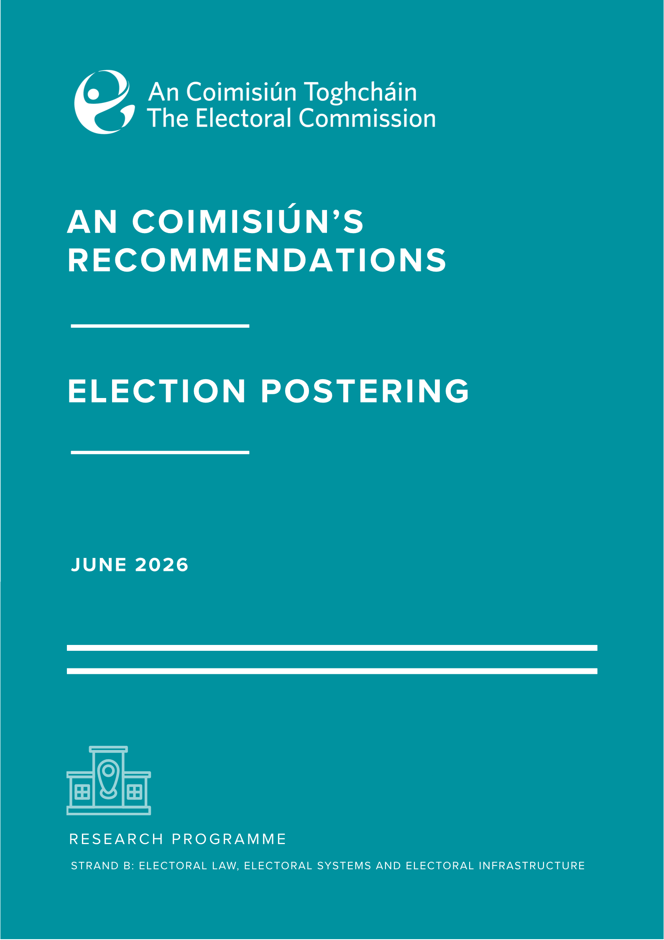

Contents
Summary 1
Background & Context 3
Strong evidential base 3
The deliberations and recommendations of An Coimisiún 4

Summary
Section 64 of the Electoral Reform Act 2022 provides that An Coimisiún Toghcháin (An Coimisiún) may commission or conduct research on electoral policy and procedure and may, arising from that research, make such recommendations to the Minister and the Government as it considers appropriate.
These recommendations are made under that statutory power in the light of the findings from independent research on election postering commissioned by An Coimisiún, and from the results of our own public consultation carried out over a period of six weeks in early 2025. The previous Minister for Housing, Local Government and Heritage and Minister of State for Heritage and Electoral Reform and Government had suggested postering as a research topic as had other contributors to the consultation process on our Research Programme.
The primary aims of the research were to:
- Deepen our understanding of the role of posters as a political communication tool in election campaigns in Ireland and elsewhere compared to other modes of political communication and engagement both traditional and online;
- Deepen our understanding of how posters impact political engagement and electoral awareness among the electorate, including amongst people who may be marginalised from the political process;
- Deepen our understanding of the environmental impacts of posters (including any impacts on road or pedestrian safety);
- Drawing on evidence gathered, evaluate potential policy options.
We believe the report that resulted from the independent research entitled ‘Election Posters in Ireland: practices, attitudes and impacts’ makes a valuable contribution in furthering our understanding of public engagement around elections. An Coimisiún welcomes the range of empirical data underpinning the analysis in the Report and the significant number of public submissions received. These were carefully considered and captured in a separate summary analysis published along with the main Report and with this analysis and recommendations. The international element was also informative and posters of various types and in various forms of display are in use in many countries.
The use of posters at election time is a multi-dimensional topic which undoubtedly generates strong public opinion.
The Electoral Reform Act 2022 confers a wide range of responsibilities on An Coimisiún which it has balanced carefully in coming to its recommendations. It is conscious of its mandate to consider and promote evidence-based electoral reforms, and to promote public understanding of electoral processes, and encourage greater engagement and participation in the State’s democratic life.
In the light of the results of our own deliberations and the analysis contained in the Research Report, An Coimisiún considers that election posters play an important part in public engagement with the electoral process in a number of respects. First, they inform the public that an election cycle has started. Second, they can have the effect of delineating the constituency boundaries, which may be important for newly arrived electors and when a boundary has been changed following a review. Third, they may help to identify the candidates, and a poster may be the primary means by which a new candidate or one who does not, for whatever reason, have a high public profile can become known. Fourth, the poster is public, in a way a social media post is not, and can engender conversation, including casual conversation, about a candidate, the issues or the election generally. Fifth, the poster can sometimes be effective and informative in a subliminal way, as is apparent from the fact that many persons who responded to the surveys had actually noticed the contents of a poster, or differences between posters, without being fully aware of the fact.
Many of the negative views on posters that were expressed through our consultation process and the data gathered through stakeholder engagement by the independent researchers related to environmental concerns. These are real and important but it seems to An Coimisiún that certain ameliorating practices could reduce the environmental impact. Further, we consider that many persons who responded had the incorrect view that the use of social media platforms was carbon and environmentally neutral or at least had not fully reflected on this aspect so that this factor may have influenced their preference for communication in that form.
Accordingly, An Coimisiún makes the following recommendations:
1. There should be clearer communication and more consistent and stringent enforcement of existing legislation and guidance governing election postering. In particular, the breaching of guidelines around placement should result in more consistent and timely enforcement action.
2. There should be clarity on who is responsible for enforcing and monitoring compliance with specific elements.
3. There should also be a specific national level communications campaign targeted at political stakeholders on the public safety hazards caused by inappropriate placement of posters.
- The permitted shape and size of posters should be limited to reduce the amount of waste and environmental damage they cause. This should be introduced on a phased and gradual approach to allow the reuse of existing poster stock.

- The Minister should request local authorities to put improved facilities and supports in place to encourage sustainable disposal and recycling of existing posters. This should provide more structure and clarity on arrangements to reuse or dispose of poster material thereby helping with recycling rates.

Background & Context
An Coimisiún published its first Research Programme in July 2024 after public consultation. Several submissions to the consultation process supported the inclusion of research on the use of election posters (including a joint submission by the then Minister of Housing, Local Government and Heritage and Minister of State for Heritage and Electoral Reform) and it was included as a priority topic.
Dr. Eoin O’Malley and Dr. Dawn Wheatley of Dublin City University were appointed to conduct the research after a competitive procurement process and in parallel a public consultation was launched with the resulting submissions analysed by our staff. The public consultation resulted in 1,104 submissions on the topic and these were carefully considered in coming to our recommendations.

Strong evidential base
An Coimisiún welcomes the breadth of data collected and analysed as part of the research. As well as the public consultation the research was based on data from questions in two nationally representative surveys; four focus groups held in Co. Louth, Co. Kerry and Dublin; interviews with twenty-six political stakeholders including current and former politicians, candidates and party representatives; an in-depth life cycle analysis of the environmental impacts of posters; an analysis of administrative data from the Standards in Public Office Commission (SIPO) regarding campaign expenditure in the 2024 General Election and an international comparison examining how elections posters are used and regulated. An Coimisiún considers that the range of data employed in the Research Report provides a strong and robust evidence base for our recommendations.

The deliberations and recommendations of An Coimisiún
Section 67 (1) of the Electoral Reform Act states "The Commission shall, through educational and information programmes promote public awareness of, and participation in, the State’s electoral and democratic processes and encourage the public to vote at electoral events." An Coimisiún has kept this educative function in mind when considering its recommendations.
It is evident from the research that posters have a positive public communication and engagement effect in informing the public that elections (or referendums) are imminent. They allow people to familiarise themselves with the candidates’ names and images that they will see on the ballot paper. Whilst individuals may not be immediately aware of the impact of posters, they do receive a significant amount of information from them by being exposed to their messages. This was evidenced in both the polling data, in which 59% of respondents said they became aware of the recent presidential election due to the presence of posters, and in the focus groups when participants discussed how posters provide visual cues that an election is approaching.
Additionally, the research has highlighted that posters can, and do, play a role in promoting political awareness and debate amongst children and teenagers. This suggests that posters contribute to an early awareness of democracy and the electoral process, which is significant given that international evidence suggest younger cohorts are least likely to engage in democratic processes.
An Coimisiún notes the widely held view from the political stakeholders consulted that an outright ban or any potential significant restrictions on the use of posters would have a detrimental impact on the ability of new candidates to get noticed. Approximately 90% of interviewees would not support a blanket ban on posters, citing unfairness on new candidates.
The research found that, irrespective of party lines and geographic context, interviewees emphasised the vital importance of posters for newcomers and their ability to build name and face recognition. The research highlights a clear difference between incumbents and political newcomers, finding that posters are a relatively low-cost and effective medium for first-time candidates to promote themselves and their policies within their constituency.
The importance of posters for candidates (both incumbents and newcomers) is also mirrored in the Report's polling data, where 36% of respondents indicated that posters help with learning the names and faces of candidates. Considering Ireland’s PR-STV electoral system, which allows the expression of multiple preferences, the importance of face and name recognition is heightened.
An Coimisiún is cognisant that different groups of people learn about politics and elections through different channels. An Coimisiún therefore welcomes the report's framing of posters as an inclusive and accessible form of information, especially for low information (less engaged) or marginalised voters as well as for voters with some forms of disability. Advocacy groups including Down Syndrome Ireland, the National Adult Literacy Agency and Dublin Adult Learning Centre provided submissions stating how posters have a positive role in informing their members and can be a helpful visual tool in aiding voters in recognising candidates on the ballot paper.
However, An Coimisiún also notes submissions from organisations including the Irish Non-Neurotypical Disabled Persons Organisation, the National Disability Authority, Vision Ireland and Voice of Vision Impairment who have observed that the placement of posters can at times be hazardous for their members and those they represent.
An Coimisiún was particularly concerned to learn of careless positioning of posters causing injury to passers-by, including a report of a person suffering permanent life-changing injury. The research suggests that awareness amongst political stakeholders of hazards and public safety risks that can be caused by posters is not adequate and a national information and communication campaign should be conducted to highlight and mitigate these risks.
An Coimisiún acknowledges that election campaigns undoubtedly have an environmental impact. Exploring the environmental impact of election posters was a key rationale for carrying out this research and was incorporated as a core element of the Terms of Reference (ToR) of the research.
Concerns regarding the environmental impact of posters were expressed in the public consultation process and were further explored in the focus groups. There was a shared view amongst the public that election posters have a negative environmental impact. Concerns around the durability of materials and lack of biodegradable alternatives were raised. Thirty-eight submissions from Tidy Town groups and residents’ associations were received as part of the public consultation process. These provided useful insights into how posters impact their work including the experience of their implementation of voluntary poster free zones.
As well as concerns about the posters themselves, many of those who participated in the research noted that the cable ties used to secure the posters add to the sustainability impact. This is particularly where they are left on poles or on the ground after the election campaign. Although there is no systematic data on the scale of this, An Coimisiún recognises these concerns.
The legislation governing the placement of posters at election time is the Litter Pollution Act 1997, as amended by the Electoral (Amendment) (No.2) Act 2009. The erection of posters is permitted only from the date the order is made by the Minister appointing the polling day or 30 days prior to the date of the poll, whichever is the shorter period. Posters must be removed within seven days of the polling day. Posters displayed outside the permitted period can be removed by the local authority and are subject to a €150 on-the-spot fine per poster. Certain provisions apply on polling day itself as set out in Section 147 of the Electoral Act 1992 (as amended by the section 33 of the Electoral (Amendment) Act 2001). These provide that on polling day, posters cannot be displayed within 50 metres of a polling station.
Section 25 of the Litter Pollution Act 1997 places the enforcement powers with the local authority. However, there are also references within the Act to Garda powers which allows both Gardaí and litter wardens to issue on the spot fines for littering. In this context it is important that there is clarity amongst all stakeholders as to where primary responsibility for enforcement regarding inappropriate poster placement or breach of rules lies.
While local authorities are responsible for enforcing the national legislation, they also often issue practical guidelines to ensure that posters are not a hazard to the public. These guidelines are usually published on the council websites. These provide that, for public safety, posters must be placed at least 2.3 metres above footpaths, cycle lanes, or other pedestrian areas. They should not be put on lampposts with overhead wires, traffic signal poles, bridges, overpasses, pedestrian bridges, or roadside barriers. Posters must not block road signs or traffic signals. They should be securely fastened with cable ties or similar materials.
An Coimisiún notes that, in accordance with the Litter Pollution Act 1997, cable ties are considered to be a part of the poster and should therefore be considered to be subject to the same timeline and placement regulations and guidelines. An Coimisiún recognises, however, that there are challenges in enforcement around timely and compliant removal of cable ties which are less easily seen, and harder to trace, and therefore more difficult to regulate than posters.
As well as considering stakeholder views and experience, to help capture more systematically the environmental impact of posters the researchers conducted a life cycle analysis of their environmental impact. This life cycle analysis provided an estimate of the cost of the 280,000 posters generated for the 2024 General Election campaign, equating these posters to 168 tonnes of plastic. To better contextualise this figure, this equates to approximately 1.3 million takeaway coffees - on some estimates, half of the amount of coffee drunk in Ireland in one day. The carbon impact was considered to equate to a full commercial plane making two return flights from Dublin to New York.
Stakeholders often suggest that, in the age of the internet and social media, election posters are outdated as a communication tool. In this context An Coimisiún was particularly interested in the data provided regarding the potential carbon footprint of social media and online communications regarding elections. The Research Report highlights that in an increasingly digital environment the generation and transmission of online posts, videos and other types of short form content utilises a significant amount of electricity. An Coimisiún notes conservative estimates from the researchers suggesting that the environmental impact of one topic being discussed on one platform during the Irish 2024 General Election campaign might be the equivalent of the carbon impact of one-third of the posters in an Irish election campaign.
An Coimisiún considers that this life cycle analysis and information regarding the environmental impact of online communications suggests that the carbon emissions resulting from the use of posters in an election campaign may not be as disproportionate as previously assumed when placed in the wider consumption environment. However, that is not to say that more cannot, and should not, be done to reduce the negative impacts of election posters on the environment.
There should be more high-profile communication at national level and stricter enforcement of existing rules around the placement of posters and cable ties, and of associated time limits. The analysis in the Research Report suggests there is also scope for increased supports for the disposal and recycling of posters to reduce waste and litter. An Coimisiún recommends that the Minister requires the local authorities to explore the provision of expanded facilities in this area.
In terms of other potential reforms explored in the research, it is clear that there are enforcement challenges in limiting the number of posters or their permitted locations. Another commonly cited reform - designated poster zones – is not regarded by us as appropriate, given the potential reduction of electoral awareness, and implementation challenges in the context of Ireland’s electoral system and varying constituency profiles. For example, it could be challenging to determine what would be considered adequate designated zones in larger rural constituencies compared to urban areas as well as accounting for the increased number of posters arising from the different local electoral areas in Local Elections.
However, an Coimisiún recommends that limiting the size of posters in a phased fashion should be considered. This would reduce the environmental costs of the material used and, could also reduce the likelihood of weather damage to posters by high winds, thereby increasing potential for reuse and reducing the possible hazards caused by displaced posters.
An Coimisiún is very aware of the growing influence that social media has in our day-to-day lives, and how the public receives information during election campaigns. The report includes a thorough examination of the role of social media, and it is immediately clear is that the notion that digital alternatives can replace posters is more nuanced and complex than initially thought.
As well as the environmental impacts of social media and online campaigning outlined earlier, An Coimisiún notes the report's detailed discussions on how, given that digital media is algorithm-based, everyone does not receive the same type of information, such that personalised information can limit the individual’s exposure to different candidates and issues. This in turn raises significant concerns about the transmission and availability of diverse information in an increasingly digital era and can potentially impede open and informed political debate.
We are therefore in agreement with the Report's findings that, from an information perspective, posters provide a level playing field insofar as everyone is exposed to the same posters within their own constituencies.
An Coimisiún Toghcháin would like to thank all those who contributed their time and expertise to the preparation of the Research Report being published today and to the associated consultation process. This includes the excellent research team from DCU, the advisory committee, the individuals, organisations and advocacy groups who submitted responses to the public consultation, all those who participated in the focus groups and national surveys, and the political stakeholders who participated in the interviews.
An Coimisiún believes the Research Report provides a robust and wide-ranging evidence base to inform debate and ministerial action on this topic. It is part of a growing suite of data and research An Coimisiún is committed to delivering in fulfilment of its research mandate under the Electoral Reform Act 2022.

