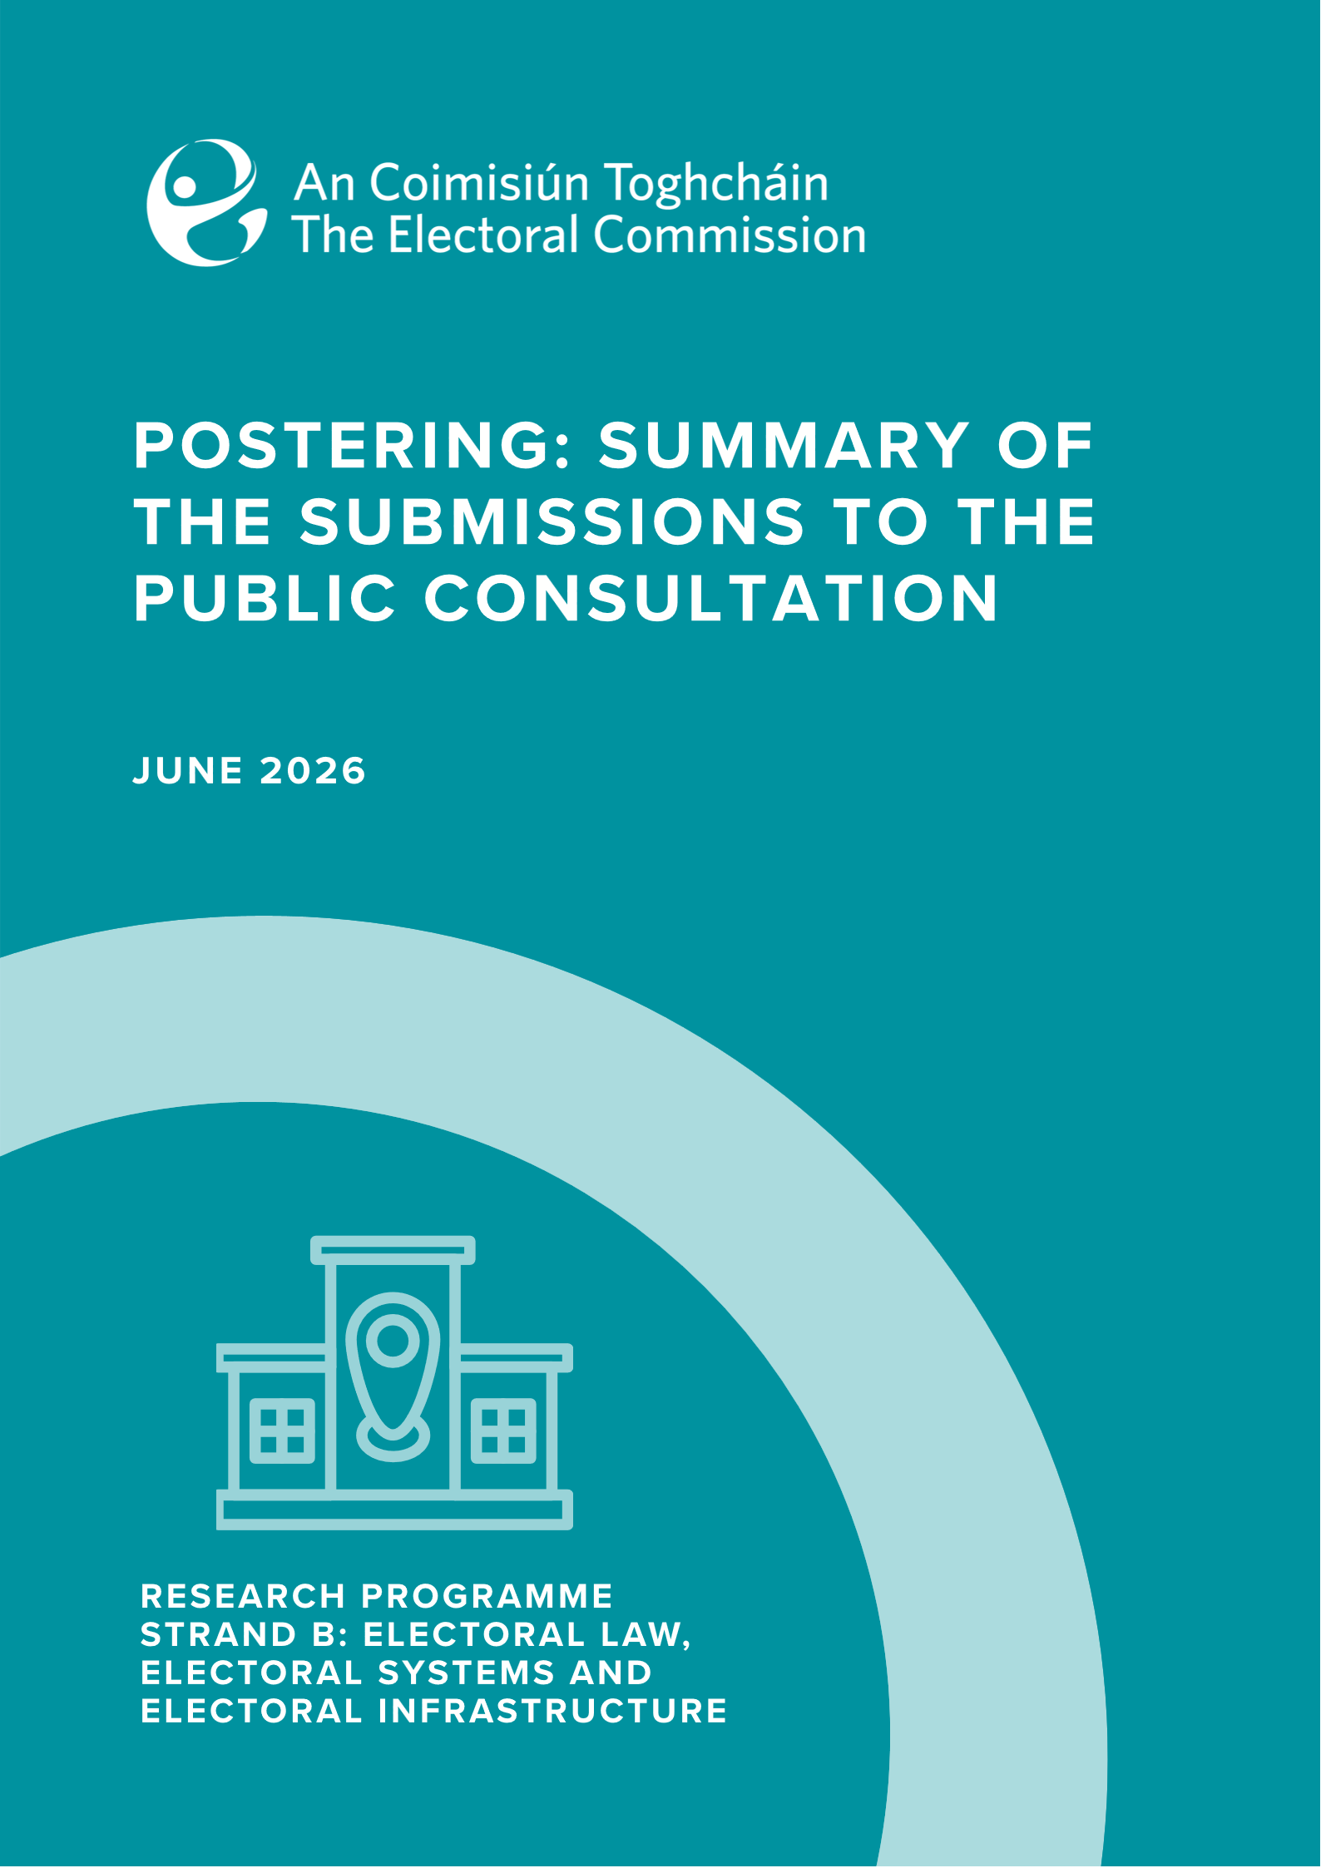

Contents
Introduction 1
Profile of Submissions 2
Individual Submissions 2
Organisational Submissions 2
Sentiment Analysis of Submissions 3
Thematic review 7
Environmental Impact 8
Placements of Posters: Hazard 10
Election Posters as an Information Tool 11
Importance for Groups who Rely on Visual Tools 14
Placement of Posters: Aesthetic Appeal 16
Regulations and Enforcement 17
Tidy Towns Poster Free Zones 19
Alternatives to Posters 20
Fairness/ Level the playing field 22
Tradition and Culture 25
Recommendations for changes to rules and regulations around posters 27
Do Nothing/Maintain the Current System 27
Enforcement 28
Improvements to Poster Design 29
Innovations in Materials and Circularity of Posters 29
Limiting Poster Numbers 30
Designated Area 30
Outright Ban 31
Conclusion 32
Appendix 1: Detailed Breakdown of Individual Submissions 33
Age Group 33
Gender 34
Region of Submission 35
County of Residence 36
Appendix 2: Public Consultation Paper 37
Introduction 37
Background 38
Appendix 3: List of Organisations 41
Appendix 4: Words Searched in Thematic Analysis 43
Appendix 5: Words Searched in Regulation Recommendations Analysis 44

Introduction
An Coimisiún Toghcháin (An Coimisiún), Ireland’s independent electoral commission, was established on 9 February 2023. An Coimisiún’s powers are set out in the Electoral Reform Act 2022. Section 64 of that Act provides that An Coimisiún may conduct or commission research on electoral policy and procedures. An Coimisiún may also make recommendations arising from this research to the Minister and Government.
An Coimisiún published its first Research Programme 2024-2026 in July 2024 after public consultation. This sets out An Coimisiún’s research priorities for the period to 2026, which include research into the use of election posters. Independent researchers (Dr. Eoin O’Malley and Dr. Dawn Wheatley) were commissioned to conduct this research, and a public consultation process was launched to ensure stakeholder views were considered as part of the analysis.
On 27 March 2025, An Coimisiún opened the public consultation for a period of six weeks until 9 May 2025. A number of late submissions were also accepted. Submissions could be made through an online submissions form, by email or by post. The consultation document (see Appendix 2) was made available in both Irish and English on An Coimisiún’s website and it was promoted through social and other media.
The consultation asked respondents the following four questions:
- Do you see any positive aspects/advantages to election posters? If yes, please explain.
- Do you see any negative aspects/disadvantages to election posters? If yes, please explain.
- Do you think Ireland’s rules and approach to election posters should change? If yes, please explain the changes you’d like to see and the reasons for this.
- Is there anything else you would like to say about the use of election posters in Ireland?
In total, An Coimisiún received 1,104 submissions which were made available to the researchers. This summary paper has been prepared by staff from An Coimisiún’s Research Team. All quotes appearing in this document are drawn directly from the text of the original submission.

Profile of Submissions

Individual Submissions
An Coimisiún received 1,046 submissions from individuals (more detailed profiles of submitters at Appendix 1) accounting for 95% of the total submissions received. Feedback from individuals varied significantly in length and depth – in particular a number of brief submissions provided primarily critical remarks about election posters, while others provided a more extensive and nuanced perspective on their use.
Political Postering Public Consultation Submissions
Submission Category | Number of Submissions
Group/Organisation Submission | 58
Individual Submission | 1,046
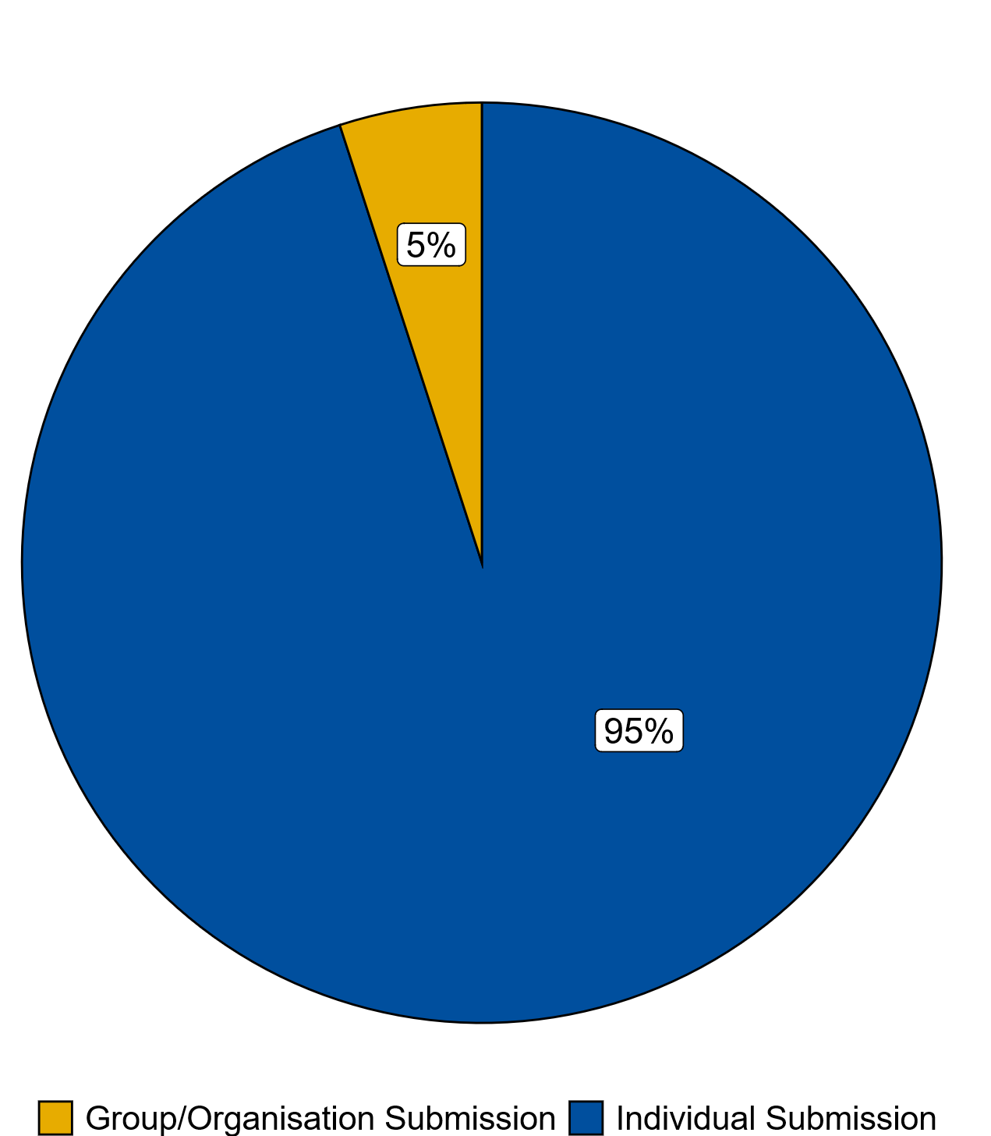

Organisational Submissions
58 of the submissions received were on behalf of organisations and groups, amounting to 5% of total submissions received. These organisations range from Political Parties, County and City Councils, Election Engagement Groups, Disability Groups, Education/Advocacy Bodies, Statutory Bodies and Tidy Towns/Residents’ Associations. A breakdown of the organisations can be seen below, with each square representing an organisational submission. A full list of all organisations that submitted can be found in Appendix 3.

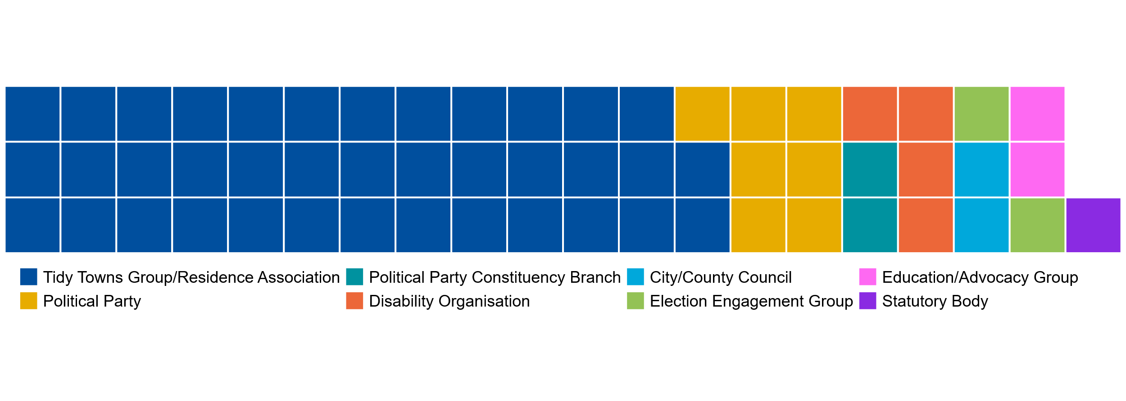
The organisational submissions were generally longer than the individual submissions and had a mixed view towards the use of election posters. The average individual submission word count was 144 words, while organisation/group submissions were longer on average at 260 words. Submissions from organisations ranged from one-line comments to 20-page response documents.

Sentiment Analysis of Submissions
- General Sentiment Analysis of Submissions
A general analysis of the sentiment of every submission was carried out. Each submission was read and assigned a category based on its contents. Submissions were categorised as either:
- Strongly Negative: submissions which did not see any advantages of posters or advocated for a total ban.
- Partially Negative: submissions that identified some advantages to posters, but considered the disadvantages greatly outweighed any merits.
- Mixed: submissions that expressed both negative and positive attitudes towards posters.
- Partially Positive: submissions that identified some disadvantages to posters but considered the advantages outweighed these disadvantages.
- Strongly Positive: submissions which did not see any serious disadvantages around posters and were content with existing postering practices in Ireland.
The graphic below presents a summary of the sentiment analysis. Each square in the chart below presents one percentage of total submissions. Of the 1,104 submissions a vast majority of these expressed a negative sentiment towards posters, with 807 submissions highlighted as either partially or strongly negative, equating to 74% of total submissions.
There were 226 submissions classified as mixed sentiment amounting to 20% of total submissions. Submissions with a positive sentiment towards posters were in the minority, with only 71 submissions highlighted as either partially or strongly positive, equating to 6% of total submissions.
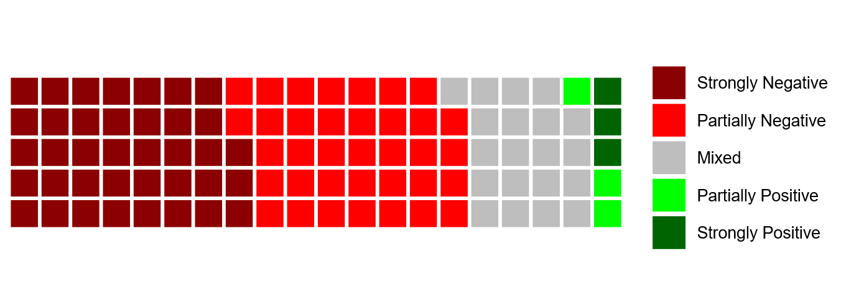
In terms of the submissions, it was observed that submissions which were the most negative towards posters tended to be shorter (and in some cases did not include much if any detail on reasoning) and many were received at an early stage in the consultation process.
- Sentiment, length and timing of submissions
The length of submissions varied with the maximum word count of submissions received 1,697 words and the minimum word count of a submission sitting at four words. The average length of all submissions was 150 words.
The average word count of each submission broken down by the five sentiment groups is presented in the graph below.
The mixed sentiment submissions were those with the largest word counts. Strongly negative submissions were seen to be those with the smallest word count on average with 87 words.
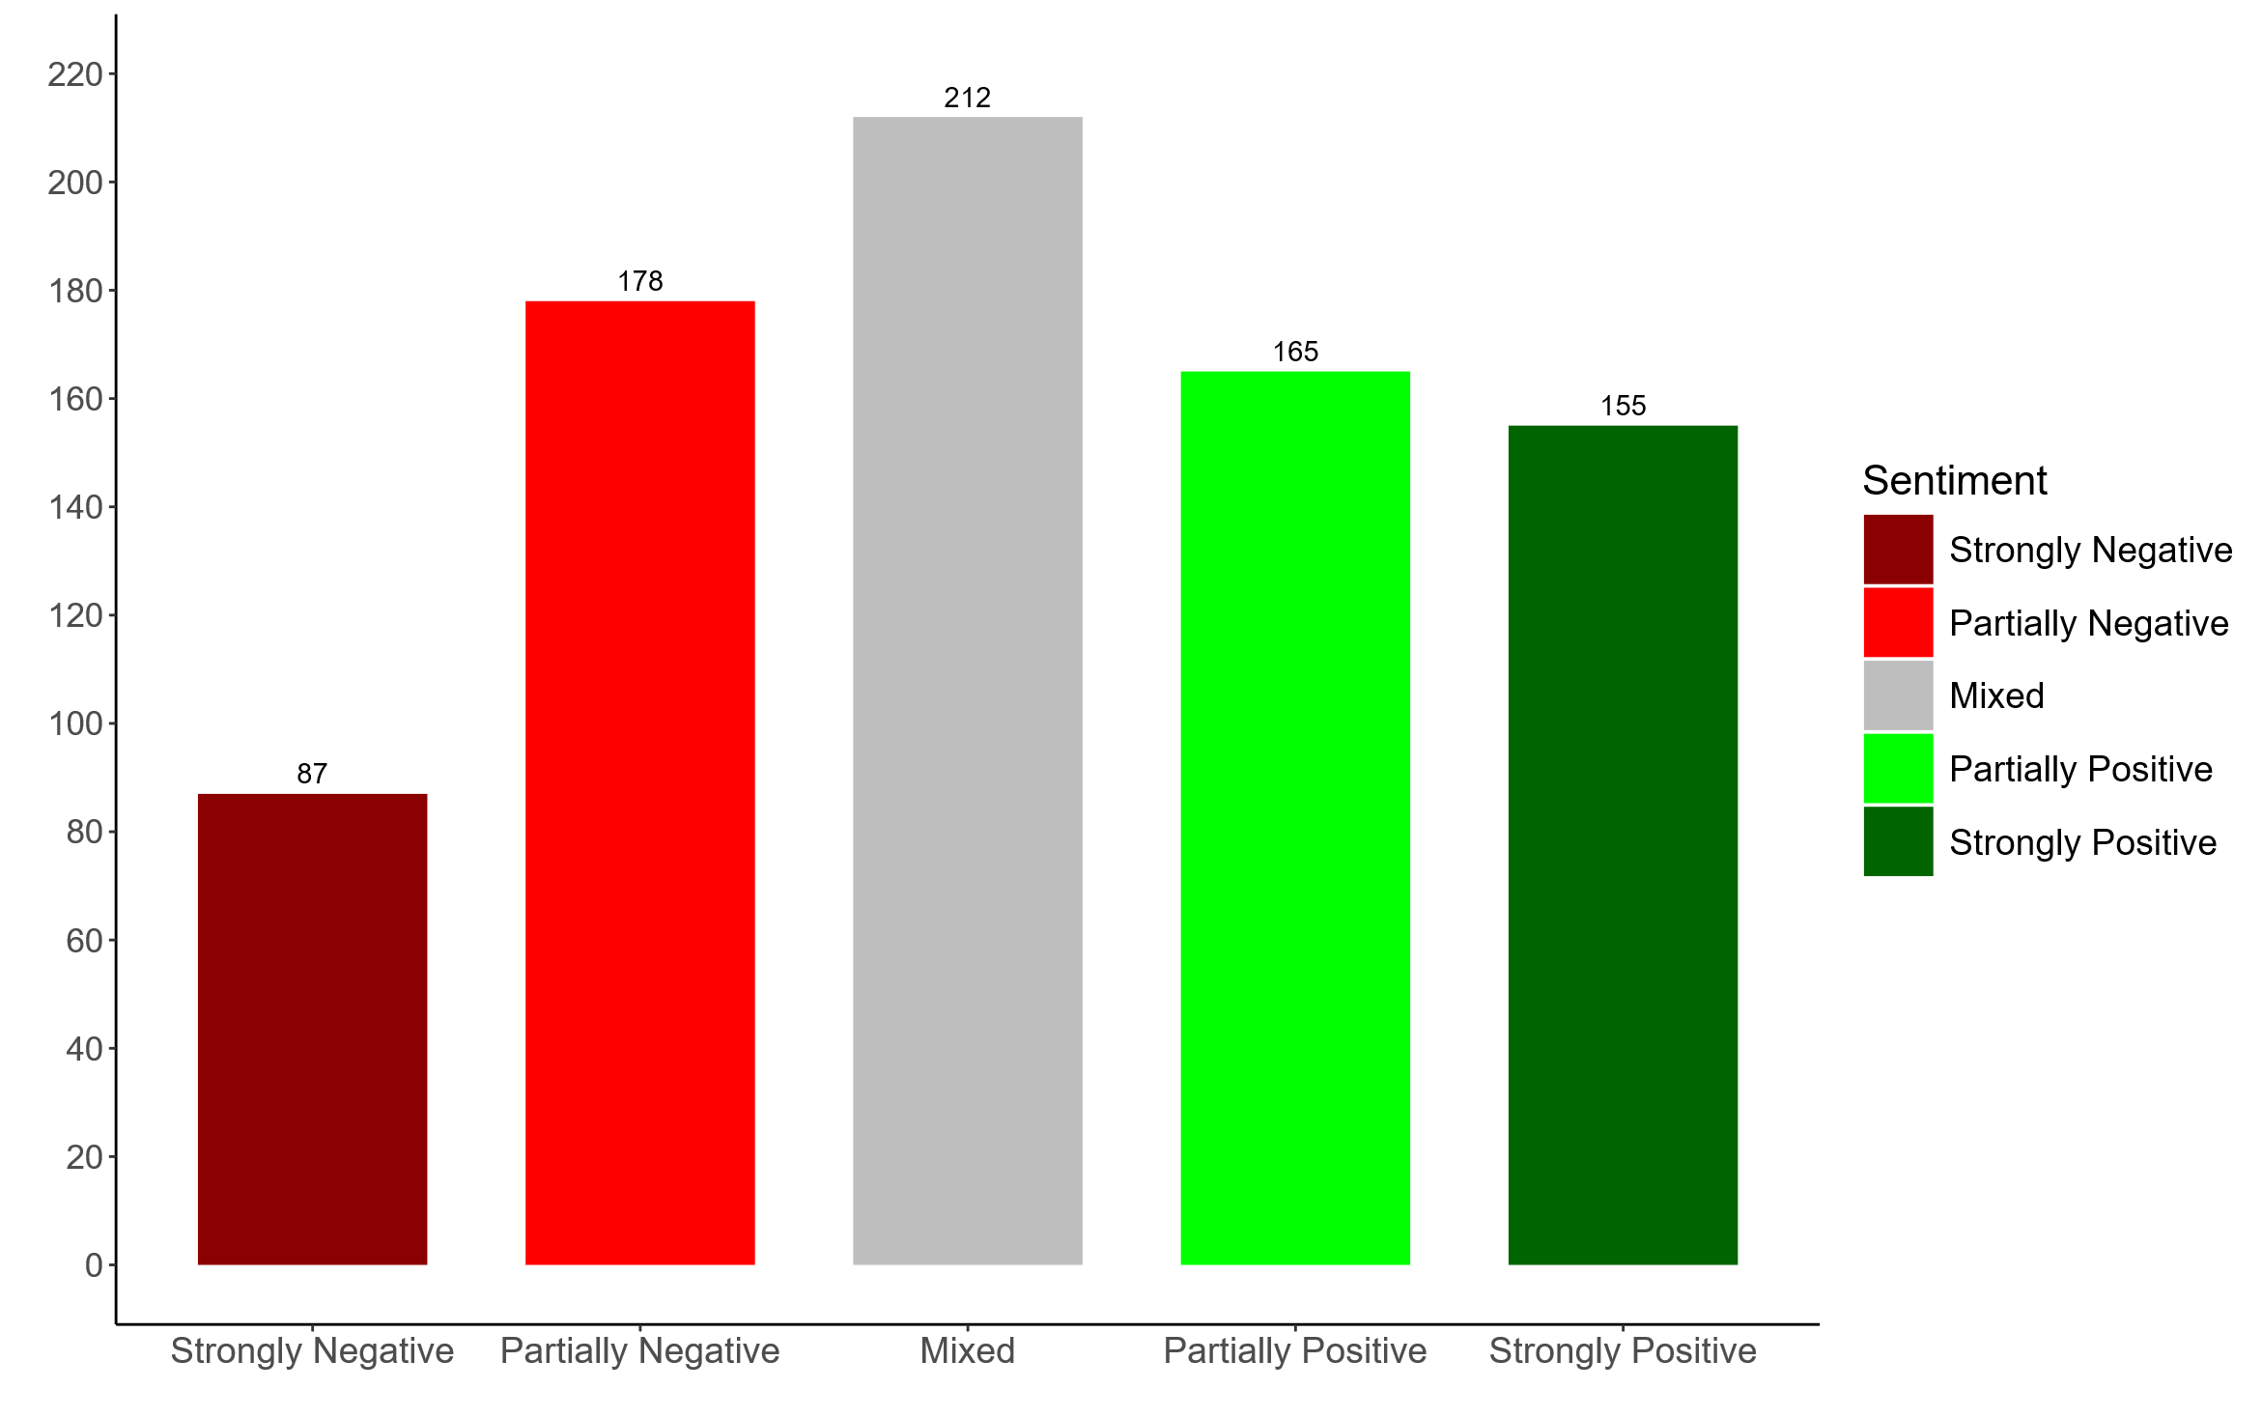
The graph below presents the timeline of submissions by their sentiment grouping as a percentage of the total sentiment submissions. This allows us to track the trend of each sentiment group across the six weeks of the consultation. While submissions from all sentiment groups were received in the first week of the consultation, the negative sentiments saw a higher proportion of their total submissions in the earlier stages.

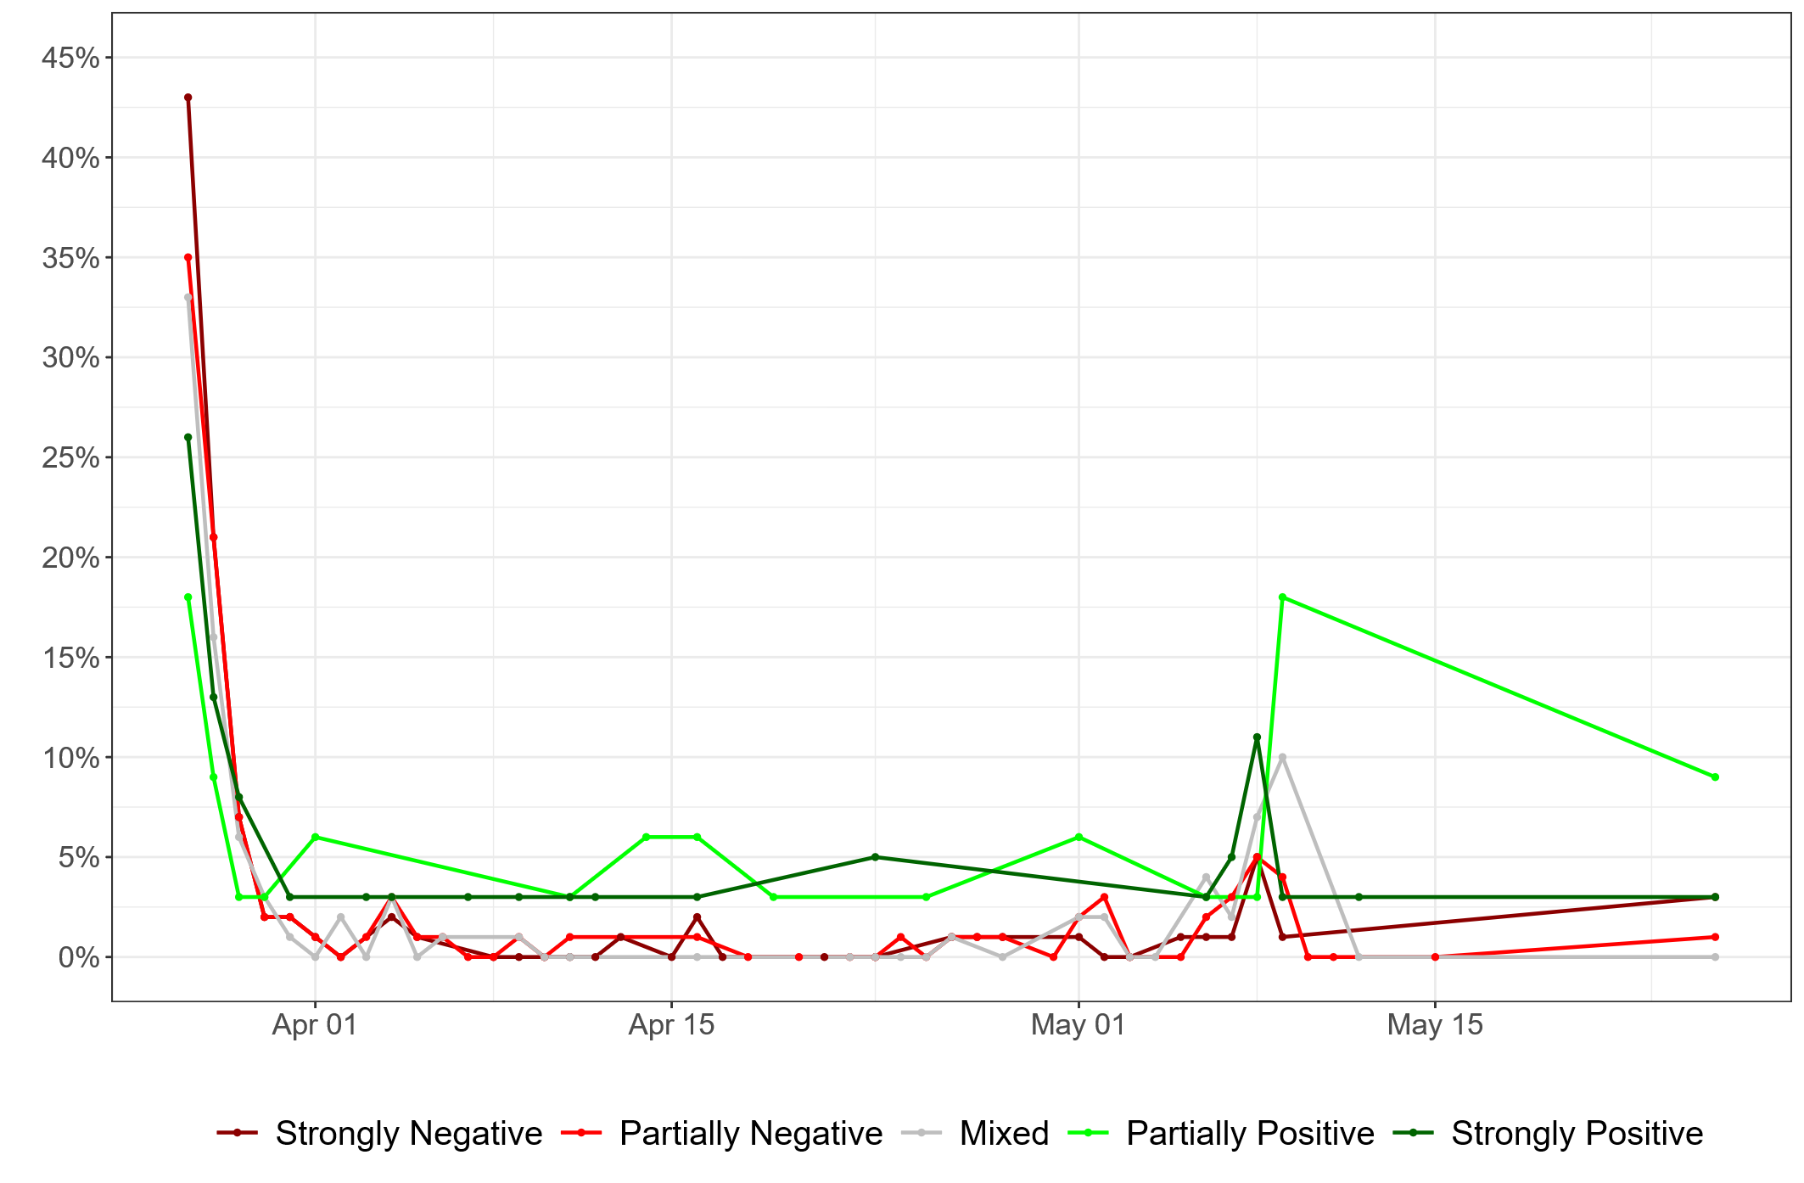

Thematic review
As shown above, the dominant sentiment towards posters emerging from the consultation was negative. However, submissions highlighted both positive and negative aspects of posters across a range of themes.
The word cloud below presents the 100 most used words throughout the submissions. Linking words and prepositions have been removed to allow the main poster related words to be captured. The top 100 words were sorted into four groupings based on the frequency in which they featured in the submissions. The size and colour of each word in the word cloud below represents their grouping and thus their frequency of inclusion in the submissions.
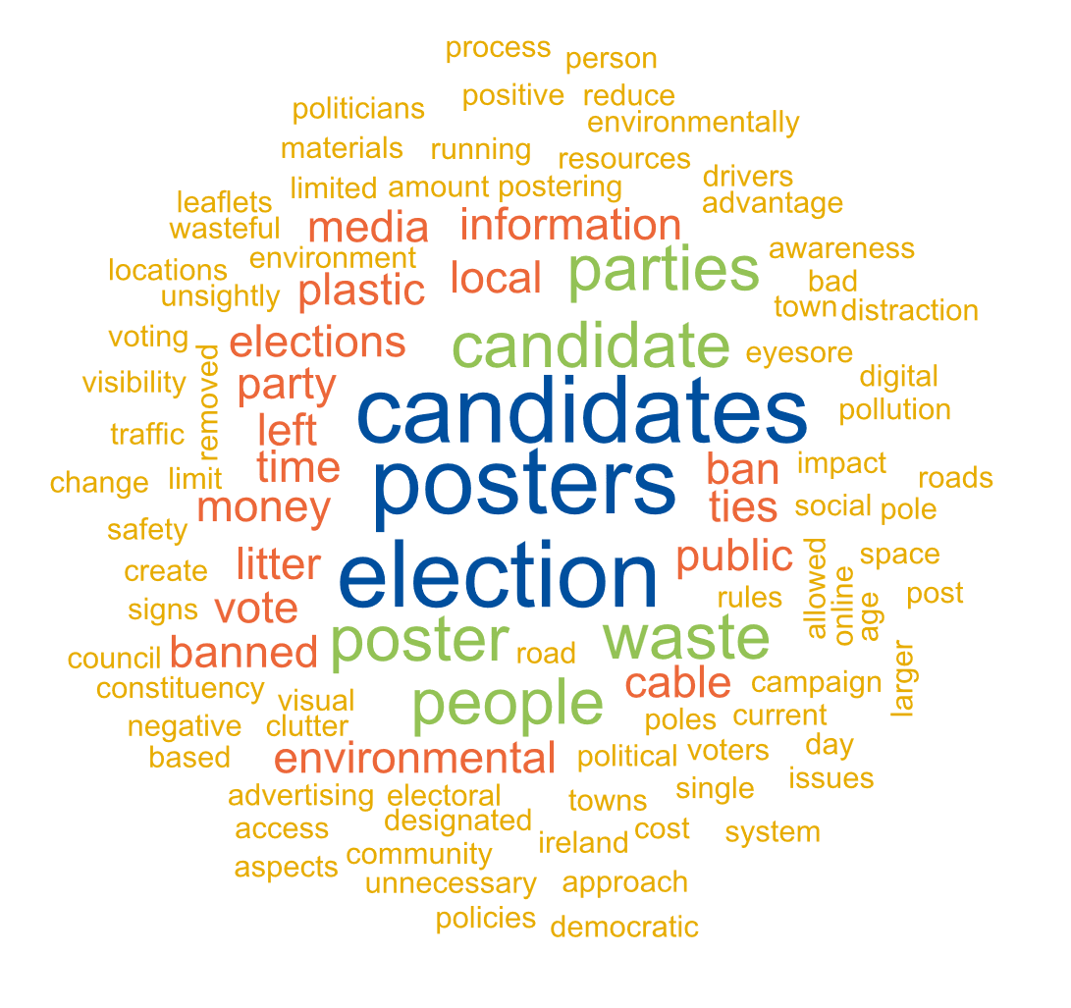
Words such as election, posters and candidates were perhaps unsurprisingly the most common amongst submissions. The word cloud also includes a number of words associated with the different questions posed in the consultation document including the advantages of posters, disadvantages and possible amendments to regulation around postering.
To further explore the issues expressed in the submissions a thematic review was carried out. Key themes were highlighted within submissions. Submissions were then assigned a theme or a number of themes based on their content. Many of the words in the above word cloud link in with the themes identified through this analysis.
The next section of this report will discuss and elaborate on the common themes identified, as shown in the table below. Selected extracts will be included to give a richer sense of the points made.
Environmental Impact | Hazard
Use of Posters as an Information Tool | Use of Posters as a Visual Tool
Aesthetic | Regulation/Enforcement
Use of other Communication Tools | Tradition

Environmental Impact
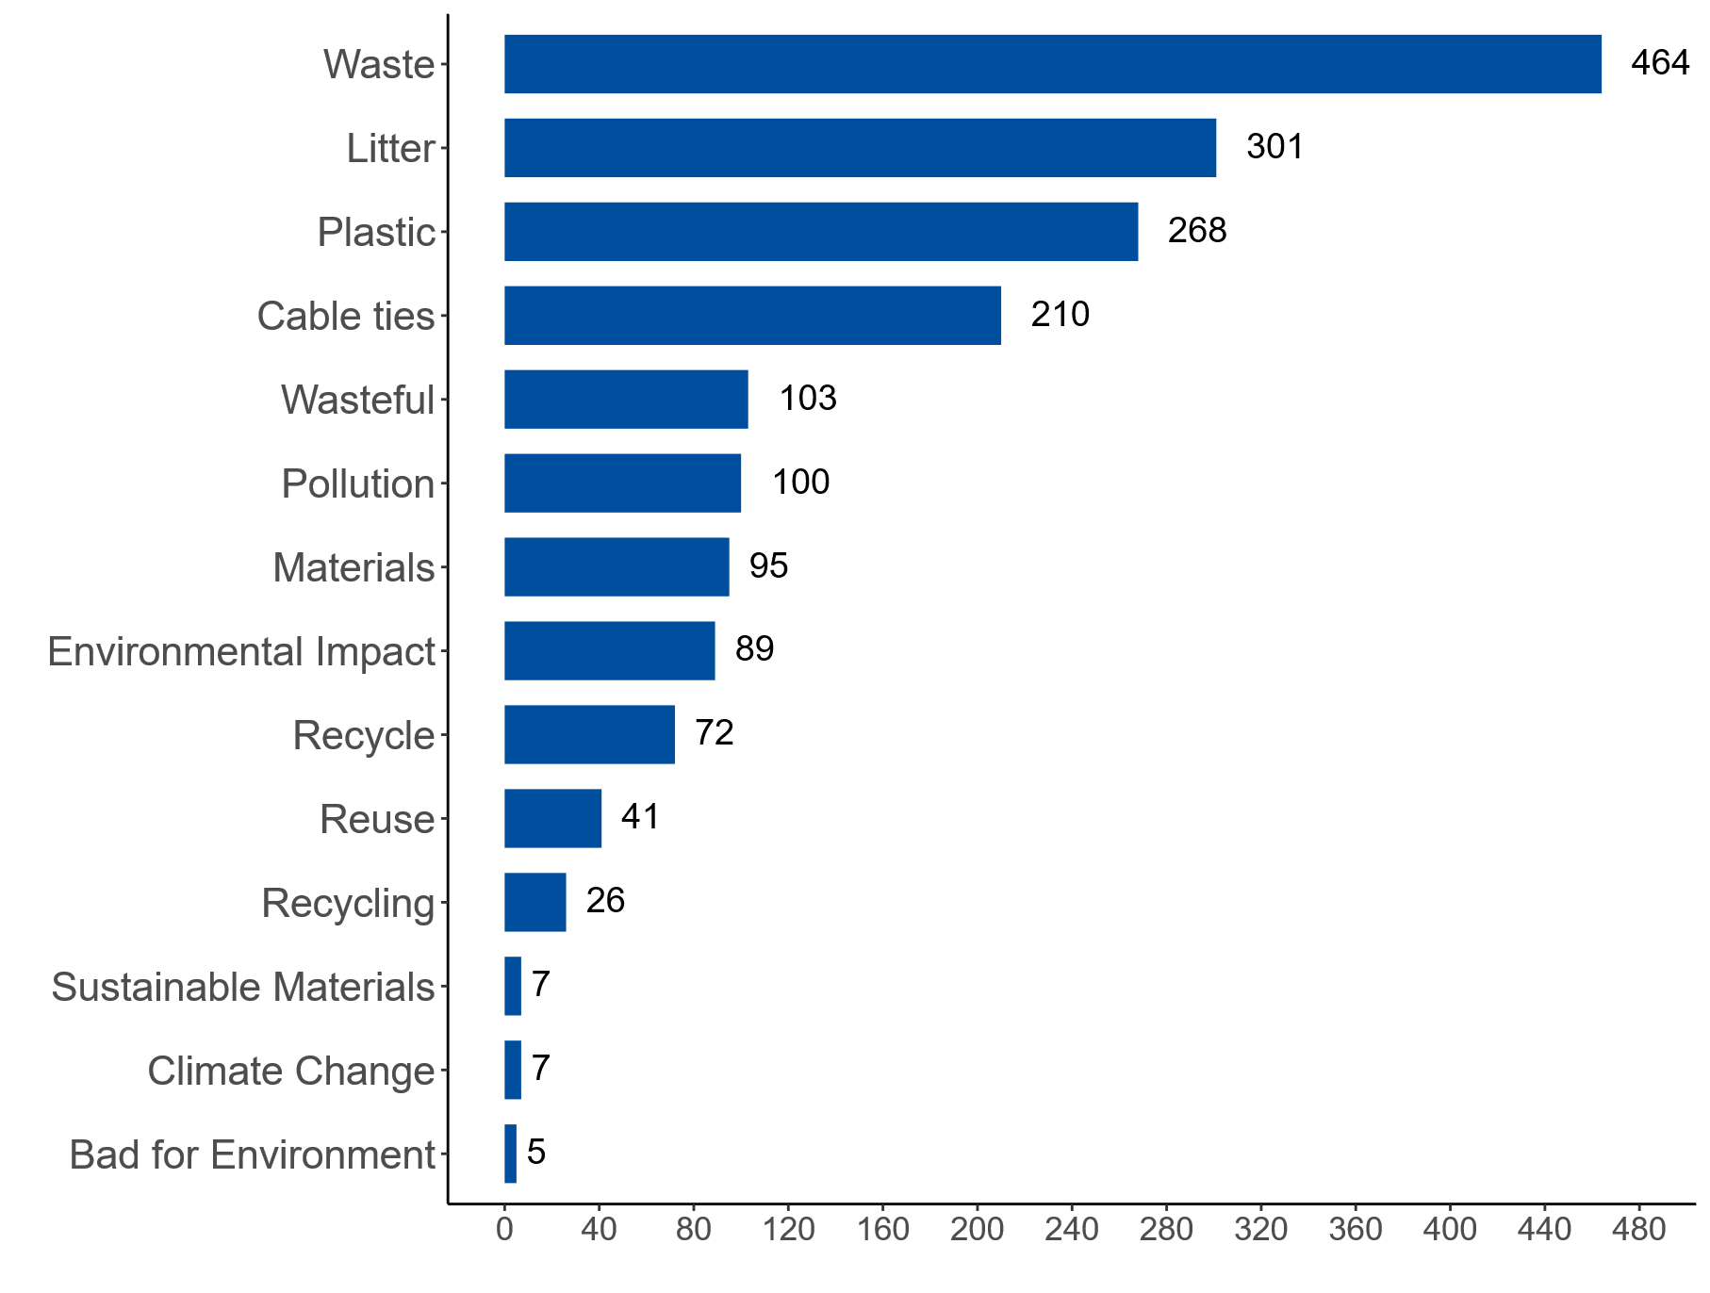
One of the primary concerns related to the use of posters was the impact they were considered to have on the environment. The words in the graphics below summarise respondents’ opinions on the environmental impact of political posters. The size of the words represents the frequency to which they were included in submissions while each word was randomly assigned a colour. Words such as waste, litter and plastic were mentioned most frequently. These words featured in 825 submissions amounting to 75% of total submissions received.

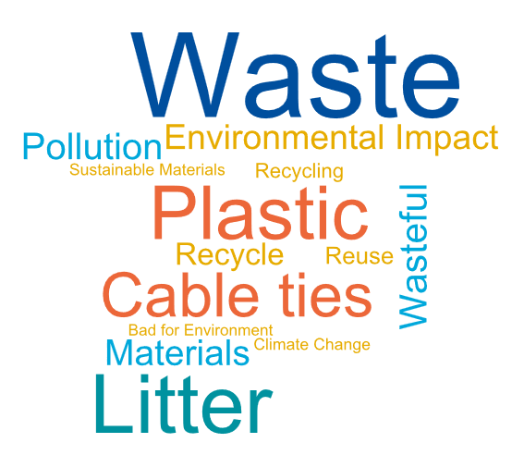

In terms of the key points raised on this theme, the main argument centred around the environmental sustainability of posters coupled with the volume of posters that are generated for an election campaign. Respondents referred to the adverse effect of electoral posters on the climate, the waste generated, litter caused and harm to the surrounding landscape.
Several respondents specifically highlighted that posters are not easily recycled with many election posters being made from corrugated plastic such as corriboard. While some responses acknowledged that such material is used to withstand the weather conditions, it was suggested that it is difficult to recycle, often being rejected by standard recycling services due to size and the ink used. This can result in posters being improperly disposed of and contributing to unnecessary waste. While it was recognised that some candidates may use recyclable material for posters, responses suggested that this is not widespread. Many suggested there are alternatives and more eco-friendly approaches than posters.
Additionally, comments noted the use of cable ties as an environmental issue, with respondents commenting on the number of plastic cable ties that remained on lamp posts after the posters had been removed.
The use of posters was also identified as being at odds with Ireland’s circular economy strategy and climate change policies, with commentators stating that if single use plastics such as plastic bags and straws are banned, single use posters and cable ties should also be banned. In addition to this, respondents noted that when election posters were left up, they were open to exposure to the weather, which could cause deterioration of posters and contribute to litter. Some relevant extracts from submissions are set out below:
“The vast majority of posters are made from plastic-based materials that contribute to unnecessary waste and pollution. Even when recyclable, many are not properly disposed of, and some remain attached to poles and street furniture long after the election is over, becoming litter.” (EP994)

“The environmental issues really concern me…. It seems deeply shocking that in a time of climate breakdown, we are allowing this much plastic to be used for such a short space of time.” (EP728)

“We see cable ties being cut and dropped at all poster sites and our volunteers end up having to collect these as part of litter picking activities” (EP1064)

Placements of Posters: Hazard
Another common theme identified through submissions was the placement of posters and potential hazards that may arise from this. Key words associated with this theme are presented in the graphics. These words identified were found in 335 submissions amounting to 30% of total submissions. The most frequently mentioned words under this theme include driver, hazard, danger and distraction.
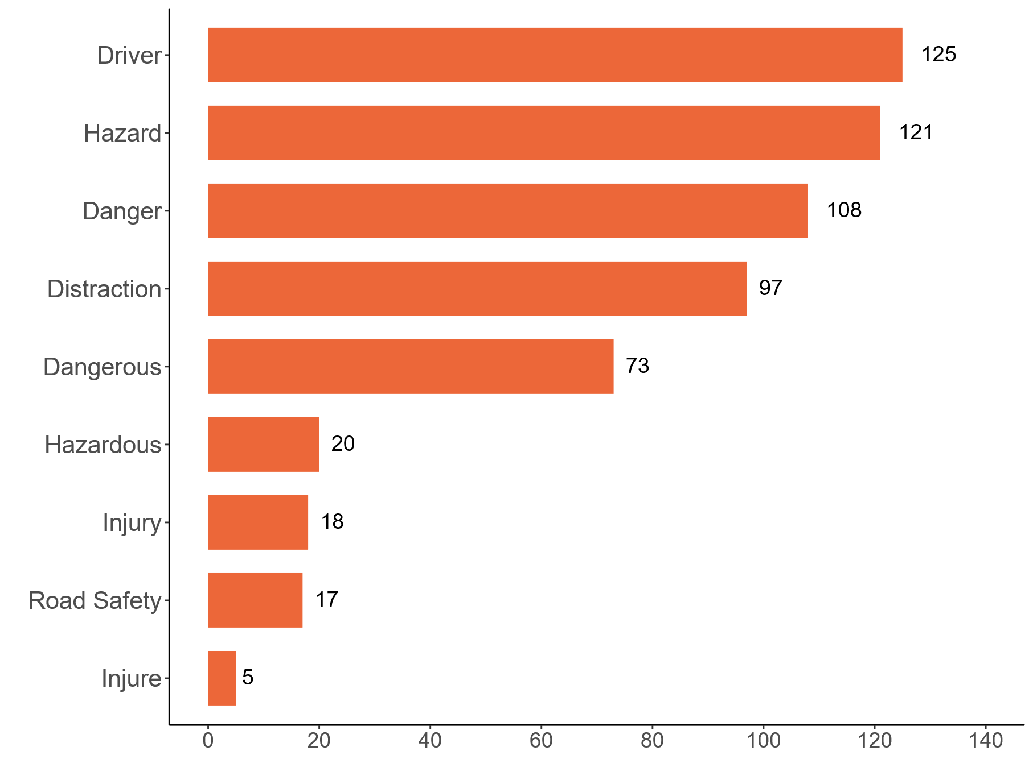
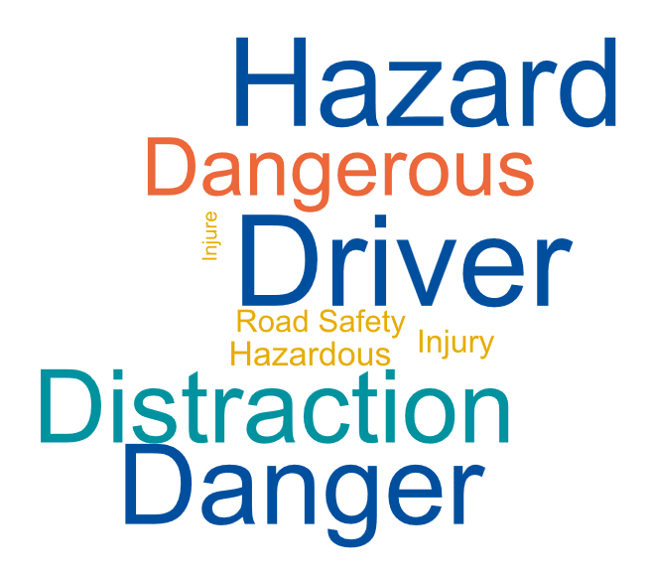

Feedback from this bank of submissions identified several hazards that could be associated with the placement of posters. Submissions noted that poorly placed posters could distract drivers or obstruct views of road signs, traffic signals or pedestrian crossings, which could increase the risk of an accident. Respondents also highlighted that posters placed below the 2.3 metre height regulation can become an obstruction to pedestrians, with multiple participants further commenting on the potential for low-level posters to be a hazard for people who are blind or have other visual impairments.
Additionally, submissions emphasised that posters could become a hazard if they become dislodged from poles during spells of harsh weather, becoming a danger to both pedestrians and motorists. Further safety issues were associated with erecting and removal of posters, as it involves working at heights near busy roadways exposing the workers to risks from falls and traffic.
Despite it being prohibited, the mounting of election posters on electrical posts was flagged as a safety hazard in several responses as it poses a risk of electric shock or burns. Furthermore, posters can interfere with utility maintenance, cover emergency pole numbers, and in extreme cases, cause poles to catch fire if they come into contact with live wires during severe weather.
“There is safety dangers associated with climbing ladders to put up posters. From personal experience, poster teams can be under pressure to put posters up, even in poor weather” (EP797)

“Proliferation of posters by roadsides and junctions create a visual distraction for drivers. Poorly placed posters obscure traffic signs” (EP1033)

“As someone who is totally blind, I have experienced firsthand the dangers they pose when candidates fail to follow the required height regulation of 2.3 meters. This not only impacts me but also others who are blind or visually impaired” (EP496)

Election Posters as an Information Tool
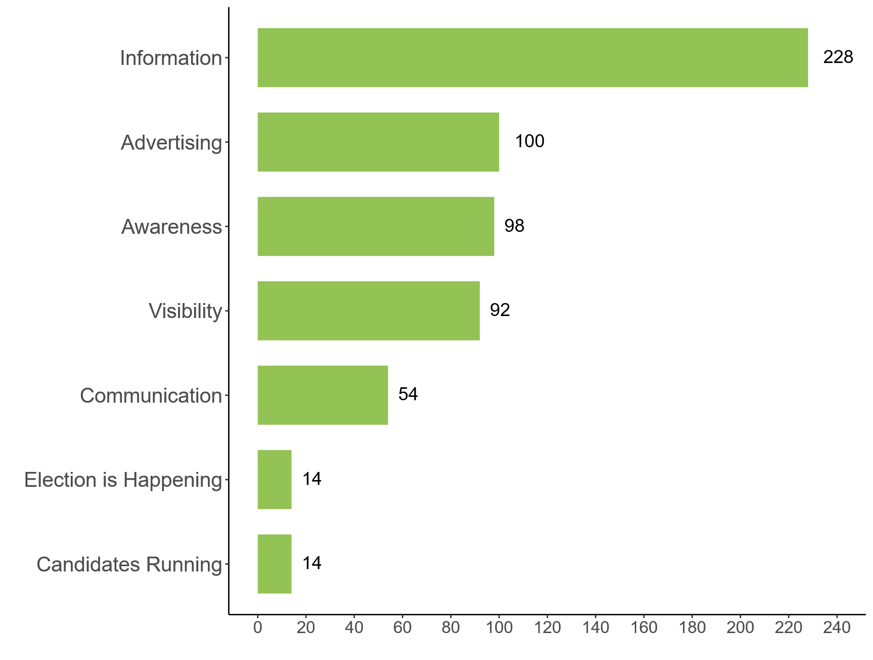
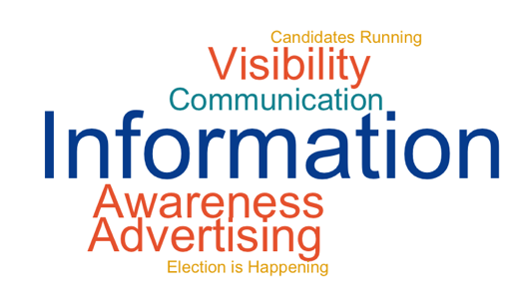
Another common theme identified through the submissions was the role of election posters as a political communication tool. Election posters were identified as important feature of Irish elections with many respondents acknowledging the role of election posters in informing the electorate that an election/referendum was taking place and of the candidates that are running. Words (such as information, advertising and awareness) associated with election posters’ role as an information tool featured in 432 submissions (39% of total submissions).

“… it gives the electorate notice the election is taking place in a tangible way. It makes the election a reality and promotes engagement with candidates.” (EP151)

“In elections they help people know who the candidates are, and when the election is on. I have lived in a few countries now, and I love the fact that it's so obvious when there's an election, In other countries you'd hardly know.” (EP481)

Those who felt positively about posters as a tool for political communication highlighted the importance of posters for promoting political engagement and raising election turnout. Respondents stated that while posters act as immediate visual reminders of upcoming elections, they also assist with identifying the candidates that will be on the ballot paper for their constituency. Some submissions also highlighted that posters had the potential to engage not only the electorate, but children as well given their presence in public spaces.
“Election posters serve an essential tool in the democratic process, providing visibility for candidates, ensuring that their messages reach a broad audience. Strategically placed posters can effectively communicate key campaign themes, policies, and values, helping voters make informed decisions. Additionally, posters create a visually engaging campaign atmosphere, fostering community awareness and involvement. They can also stimulate discussions among constituents, generating dialogue around important issues.” (EP672)

“It was a good conversation starter when driving in the car with my kids to chat about the names of the candidates / party names / and various issues as they were named on some posters and it led to good chats with them … by the day of the election my 4 and 7 year olds were well versed on all the names and parties as well as a few chants of Vote No.1” (EP352)

However, some submissions presented an alternative view on the effectiveness of posters as an information and engagement tool. A substantial number of submissions expressed that while election posters did inform the public that an election was upcoming, they do little to provide any detail beyond that. Many felt that the design of election posters was not informative beyond face and name recognition of the candidates and did little to facilitate engagement with candidates and the election generally. Others pointed to messages on posters being superficial messages, failing to address issues or provide information necessary for an informed vote.
In line with this, several respondents claimed that their choice of candidate has never been influenced by election posters, with some submissions stating they would be less likely to vote for someone with a vast number of posters.
Additionally, some respondents expressed concerns regarding poster messaging, calling attention to slogans and wording used which could be misleading, offensive or socially divisive. Respondents highlighted how this can be intimidating to the people the slogans target, without oversight or correction.
“Candidates often have complex policies and ideas, but posters cannot effectively communicate the depth or nuances of their platforms. As a result, voters may only have access to superficial messages, which can lead to poorly informed decisions. Posters are unlikely to address specific issues or concerns that may be crucial for a voter to consider, which can be particularly limiting in a diverse electoral landscape” (EP774)

“…just seeing a person's face on a poster doesn't tell you anything about their ethos or their views or values” (EP981)

“…some posters project messages that can be viewed as intolerant and borderline hateful/fascist/racist. There is no place in civilized society for that kind of advertising.” (EP768)

Submissions were received from nine political parties and constituency branches alongside responses from 11 local councillors and one senator. Many of these were largely favourable regarding posters with respondents within this cohort emphasising the effectiveness of posters in alerting the public of upcoming elections and identifying candidates. While some of these submissions expressed reservations regarding election posters, many of them ultimately viewed them as a democratic necessity to counter the natural advantage incumbents hold over new candidates and to ensure a fair opportunity for new candidates. Conversely, there were some party or political submissions who recognised the environmental impact posters have and advocated for the use of sustainable materials in their production or an outright ban. Of the nine political parties and constituency branches, while some were supportive of restrictions, overall, seven had a positive view of posters while two held more negative views, advocating for a reformed approach which called for designated areas for election poster placement.

Importance for Groups who Rely on Visual Tools
An Coimisiún also received a number of submissions which highlighted the utility of posters as an information tool for particular groups. While these submissions were not as numerous, An Coimisiún considered it important to highlight the insights provided by these submissions given their relevance to An Coimisiún’s remit and focus on under-reached or lower participating groups. It was mentioned for example that election posters are important for those who rely on visual tools as their primary resource for information regarding elections.

“Election posters are an important political communication tool for adults with literacy needs, who make up 1 in 5 of the population in Ireland. In particular, election posters help adults with literacy needs to recognise candidates. This is an essential step in the voting process, without which these voters (who are often from marginalised communities) would be excluded.” (EP1048)

“I teach English to migrants, some of who are entitled to vote in some elections. In one class they asked me about the different candidates but their familiarity was largely based on posters.” (EP59)

“It shows who to vote for and this can be matched to the photos on the ballot paper, otherwise those with reading difficulties could not read the name only.” (EP1003)

“People with Down syndrome are generally visual learners. Posters can be an aid to recognising candidates that people will see on ballot papers - any people with Down syndrome do not access information in the same way as the general population – televised and radio debates, newspaper/online articles etc” (EP1073)

However, it was also highlighted that the volume of posters may counteract their usefulness as visual aids to voters, instead causing sensory overload, distress and/or confusion amongst some voters. While acknowledging the benefit of posters to people who may be more reliant on visual tools, including those with literacy support requirements, one organisation indicated that election posters may not be easy for people with literacy needs to understand. It was highlighted that there are limitations in the information provided on a poster and that posters usually rely on people already knowing the candidate or being able to research a candidate. It was suggested that, to better support those with literacy needs, posters should provide information on accessible alternatives such as information on a physical office for in-person assistance.
“Candidates are placing far too many posters, in my constituency it is not uncommon to see one candidates posters handing on every single lamp post along the road. It is overkill and very unsightly. Also I have an autistic child who finds it very disturbing to have all of these faces looking at her, to the point that she actually dreads election time for this reason.” (EP018)

“In some areas, especially around some of the larger junctions or roundabouts, there may be too many posters competing for attention which can diminish their effectiveness” (EP1052)

Placement of Posters: Aesthetic Appeal
Another common theme that emerged throughout the submissions was the aesthetic impact of posters on their surrounding landscapes. Words that fall under this theme featured in 748 submissions (68% of total submissions received). Words such as litter, eyesore, unsightly and clutter featured heavily amongst submissions.
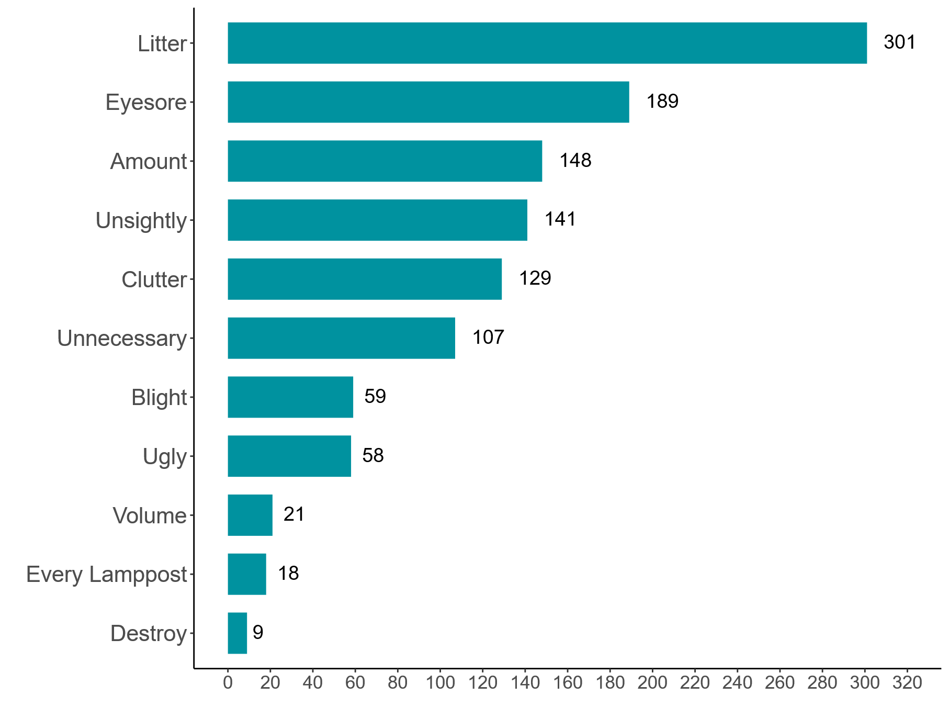
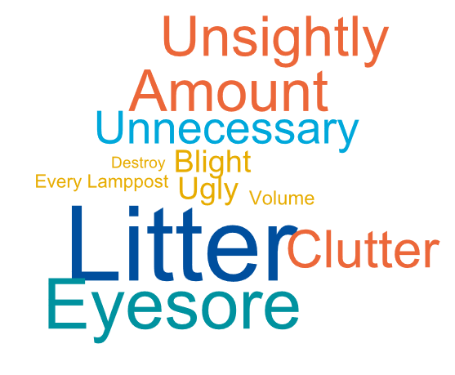

Public feedback underscored the visual clutter caused by the proliferation of posters, with commentators referencing the clustering of identical candidate posters within a small area as a significant drawback to the use of posters. Some respondents referred to posters as an eyesore and being intrusive, saying the posters detract from the appearance of an area. Respondents also highlighted that posters are open to being vandalised, defaced and intentionally damaged, which further detracts from the local aesthetic.
Additionally, concerns were raised by some Tidy Town groups that left over posters and cable ties may negatively impact their scores in the National Tidy Towns competition, emphasising the drawbacks that election posters can have in undermining the efforts of volunteer groups in attempting to maintain and enhance the local area.

“An eye sore in our beautiful environment” (EP306)

“Excess election postering and the cable ties that are frequently left behind often feature in reports from adjudicators in the National Tidy Towns Competition” (EP1022)

“Election posters, especially when placed en masse, contribute to significant visual clutter throughout the city. This not only detracts from the appearance of public spaces but also leads to confusion for residents and tourists alike” (EP420)

Regulations and Enforcement
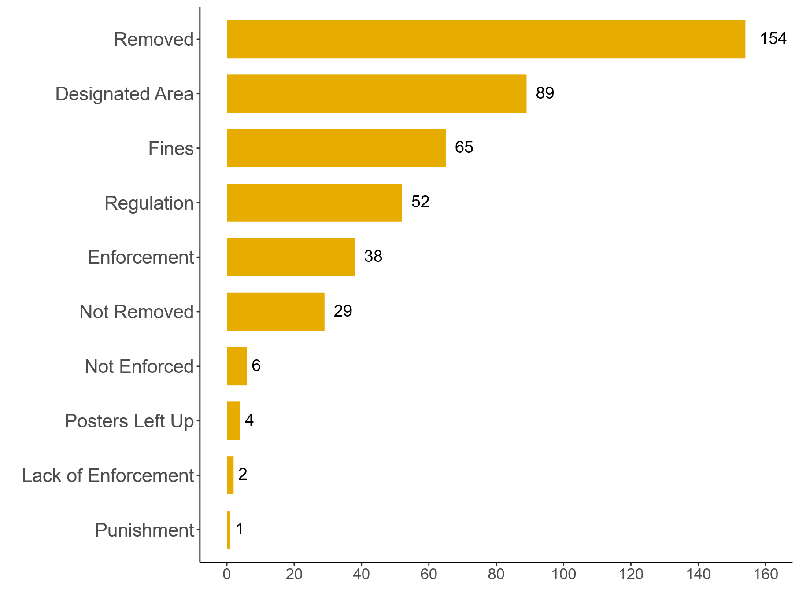
The regulation around posters and the enforcement of these regulations was an oft-cited discussion point with submissions. Words capturing concerns around the regulation of posters and their enforcement featured in 287 submissions amounting to 26% of the total submissions received. Through examining the common words around this theme, a number of regulatory and enforcement issues were highlighted.
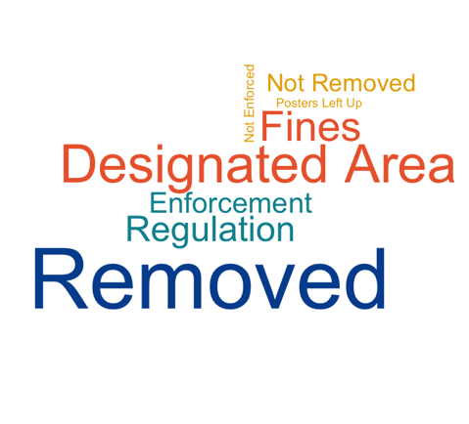

An Coimisiún note that some of the issues highlighted in the submissions, such as the placement and the timeline of posters within a campaign, are regulated under current legislation. However, many submissions suggested that the enforcement of regulations around election postering is at times inconsistent and that there are limited, if any, consequences for candidates who do not adhere to the rules laid out in the legislation.
Several respondents raised concerns about the early installation of posters. Others noted that signs for public meetings may be being used to circumvent the election timeline rules. Some submissions identified the removal of posters as a concern, with posters being left up more than seven days after the election. Respondents further noted that even when posters are removed within the allowed timeframe, oftentimes the cable ties are left behind. The height that posters were placed at was also raised as a concern, with several submissions noting that posters can be placed or fall below the minimum allowed height requirement and are often left as they are.
Some commentators expressed a lack of satisfaction with the processes around reporting those who breach postering regulations, stating that they do not get responses to complaints about breaches of the rules. Further responses mentioned that many posters do not include the required details about the name and address of the printer and publisher, the omission of which is an offense.
“Laws requiring timely poster removal are routinely ignored. Enforcement must be improved, with higher fines and clear accountability for cleanup.” (EP875)
“… rules need to be enforced. The amount of illegal posters displayed during the last election was shocking - Aswell as outright racist posters. No enforcement at all.” (EP51)

However, some respondents were satisfied with existing regulations and their enforcement highlighting that enforcement may vary across localities.
“The existing regulations around postering are quite adequate. Councils enforce the requirement for posters to be demounted after seven days….” (EP752)

Tidy Towns Poster Free Zones
The public consultation garnered significant engagement from Tidy Towns groups and Residents’ Associations, which contributed 38 submissions.
While some responses acknowledged certain advantages to election postering, such as the role posters can play in raising awareness and encouraging engagement, the overall consensus from these community groups was strongly negative. Key concerns raised centred on the volume of posters used and the issue of discarded posters and cable ties, which it was suggested results in additional clean-up for volunteers.
The majority of these Tidy Towns submissions, alongside a number of submissions from the general public, discussed Poster Free Zones initiatives that many Tidy Towns have adopted in areas throughout the country.
Tidy Towns groups advocated for the implementation of voluntary poster free zones. The feedback regarding these initiatives has been mixed, highlighting both the potential and difficulties of voluntary agreements. Several groups reported the initiative has been a success in their local areas with candidates and campaign teams supporting the initiative, while others have expressed disappointment that they are not always abided by during election campaigns.
“The level of compliance helped enormously in supporting the work of our volunteers in presenting the area in the most aesthetically pleasing and environmentally sustainable manner all year round.” (EP950)

“From a Tidy Towns perspective, despite having a no poster voluntary agreement in Westport , each election we face the proliferation of election posters in the surrounding areas and often times encroaching on our poster free zones, this presents a real challenge to the year-round efforts made by our community to maintain and enhance the town's visual appeal. While we recognise the importance of democratic engagement and the visibility that posters can offer candidates, the environmental and aesthetic costs are significant….” (EP1035)

However, some submissions expressed concern about the fairness around creating zones void of posters in an ad hoc fashion. Several submissions expressed concern about the inconsistency of poster free areas and advocated for regulation or for practices to be applied across the board. While the vast majority of submissions do not dispute the right of “poster free zones” to exist, they consider that there should be more standardisation regarding these zones.

“They need to be clarified. Some Tidy Towns organisations can be angry with candidates about putting up posters. These are not democratic organisation but will use their office to condemn a candidate if they should step out of line. As the election get closer, candidates get braver and some ignore the Tidy Towns Organisation. The rules need to be clear in all areas and should be fairly applied. Basically, either completely ban them in the whole ward/constituency or allow them.” (EP704)

“We wish to see uniformity and clarity in the declaration of poster free zones. This is not a call for banning poster free areas. Instead, it is a request for guidelines around the groups with credentials to declare a poster free area and a requirement for these to be notified to the Council prior to the poster period and published so that there is no ambiguity about where a poster can and cannot be placed.” (EP968)

Alternatives to Posters
A common theme raised throughout the submissions was the existence and effectiveness of alternatives to posters as an information tool. This was a theme where there was a wide range of views expressed with a substantial degree of polarisation in opinions. Words that were identified to capture the arguments on both sides of the debate featured in 408 submissions (37% of total submissions received).
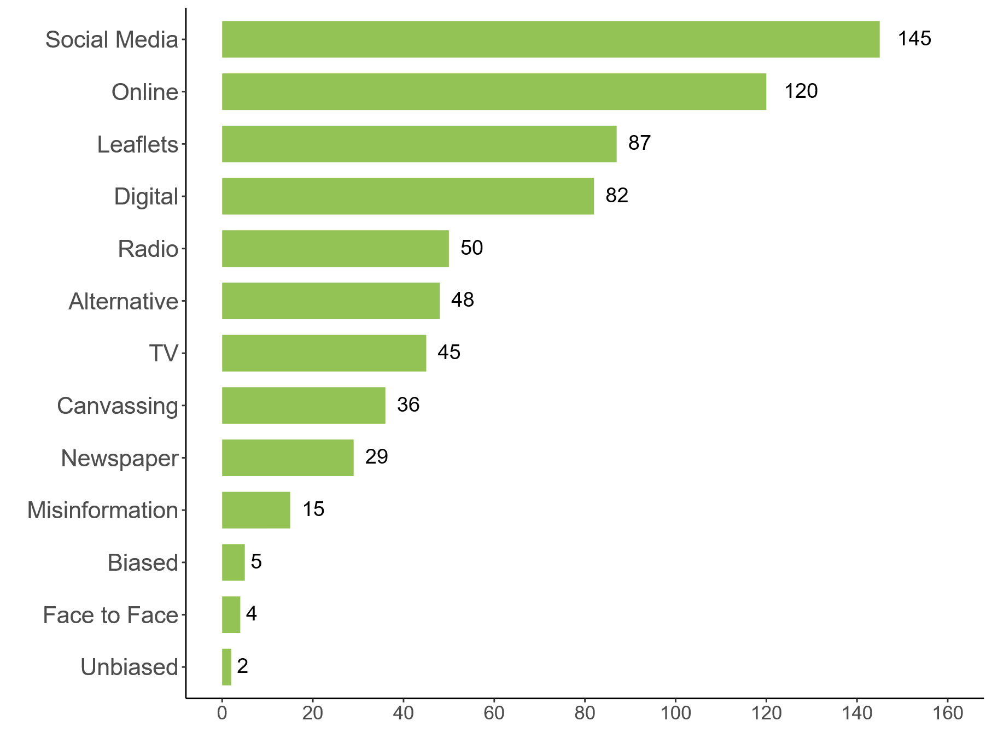
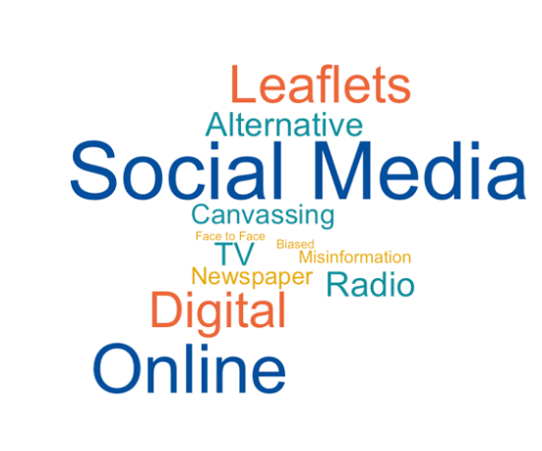

Many respondents felt that posters were obsolete in the current political landscape and that alternatives were available such as leafleting and social media. More modern sources of media such as radio, television ads and social media were highlighted as methods that could be employed by candidates instead of posters. Respondents particularly noted the growth and accessibility of digital and social media in recent years, viewing this as a more sustainable way to engage with voters, with an ability to provide regular updates and engagement with followers.
Others suggested traditional broadcast mediums, such as television, radio and newspapers could also be utilised more in place of posters. In addition, several responses highlighted the importance of face-to-face engagement, with community meetings and door to door canvassing placed as a higher priority than posters, as it allows candidates the opportunity to engage with voters and to outline and discuss their policies.
“Election posters… represent an outdated mode of communication, given the rapid expansion and accessibility of digital media. Research shows that nearly 90% of Irish adults now have internet access, which significantly decreases reliance on traditional visual communication methods such as posters…” (EP023)

“Most people have access to candidate information on the internet. Older people are more tech-savvy than most give them credit for & most of them vote for the same candidates every election anyway.” (EP459)

In contrast several submissions expressed reservations about reliance on alternative means of political communication. The importance of posters for those who are not technologically literate or have limited access to the digital technology was an oft-cited advantage to the use of political posters in Ireland.
“Posters are particularly useful in these days of a fragmented media landscape. Not every voter uses social media, or even digital technology. Almost all will see an actual poster in their neighbourhood.” (EP600)

“Publicising the names and faces of people running for office, along with the parties they are members of, where applicable, is a good thing and a physical presentation in a public place is there for all to see. Without this we would be reliant on other media, including social media and not everyone has or wants access to it.” (EP294)

“They work to inform people of all ages and abilities, including those who may not have access to the Internet, have poor reading skills, poor sight or are deaf i.e. just about everyone! They remind us to exercise our right to vote and when, whereas leaflets through the door may get covered with other things or binned by one member of the household and not seen by others.” (EP1001)

Concern was also raised around the ability of these alternatives to be manipulated, as respondents welcomed the static and impartial nature of posters. It was highlighted how media sources, in particular social media, can be biased through manipulation or by nature of the algorithm as a content curation device. It was suggested that while algorithms show users information that aligns with their existing views on social media platforms, posters ensure that all candidates are visible to everyone.

“Primarily, election posters in some form seem increasingly likely to be a beneficial method of avoiding the profit-driven algorithmic nightmare that is modern social media. A physical poster doesn't need to further corporate interests to be seen by a contingency. The only other benefit that we hear regularly from people is that the posters are a good signal to everyone that polling-time is coming up.” (EP557)

“Unlike social media, TV, or radio ads, which can be easily missed, manipulated, or even polarising, posters are static, visible in everyday public spaces, and generally straightforward. They help bring politics into the public eye in a way that's hard to ignore or distort.” (EP290)

“In an era when people consume much less traditional media, and tend to curate their social media news to topics which they consider interesting, election posters are the one form of communication that can not be missed during campaign period.” (EP848)

Fairness/ Level the playing field
There were different views from respondents regarding the fairness of posters as a means of election campaigning. There was also a polarisation of views under this theme with a wide range of arguments both positive and negative regarding posters and fairness. Words deemed to capture this theme were featured in 322 submissions (29% of total submissions received).
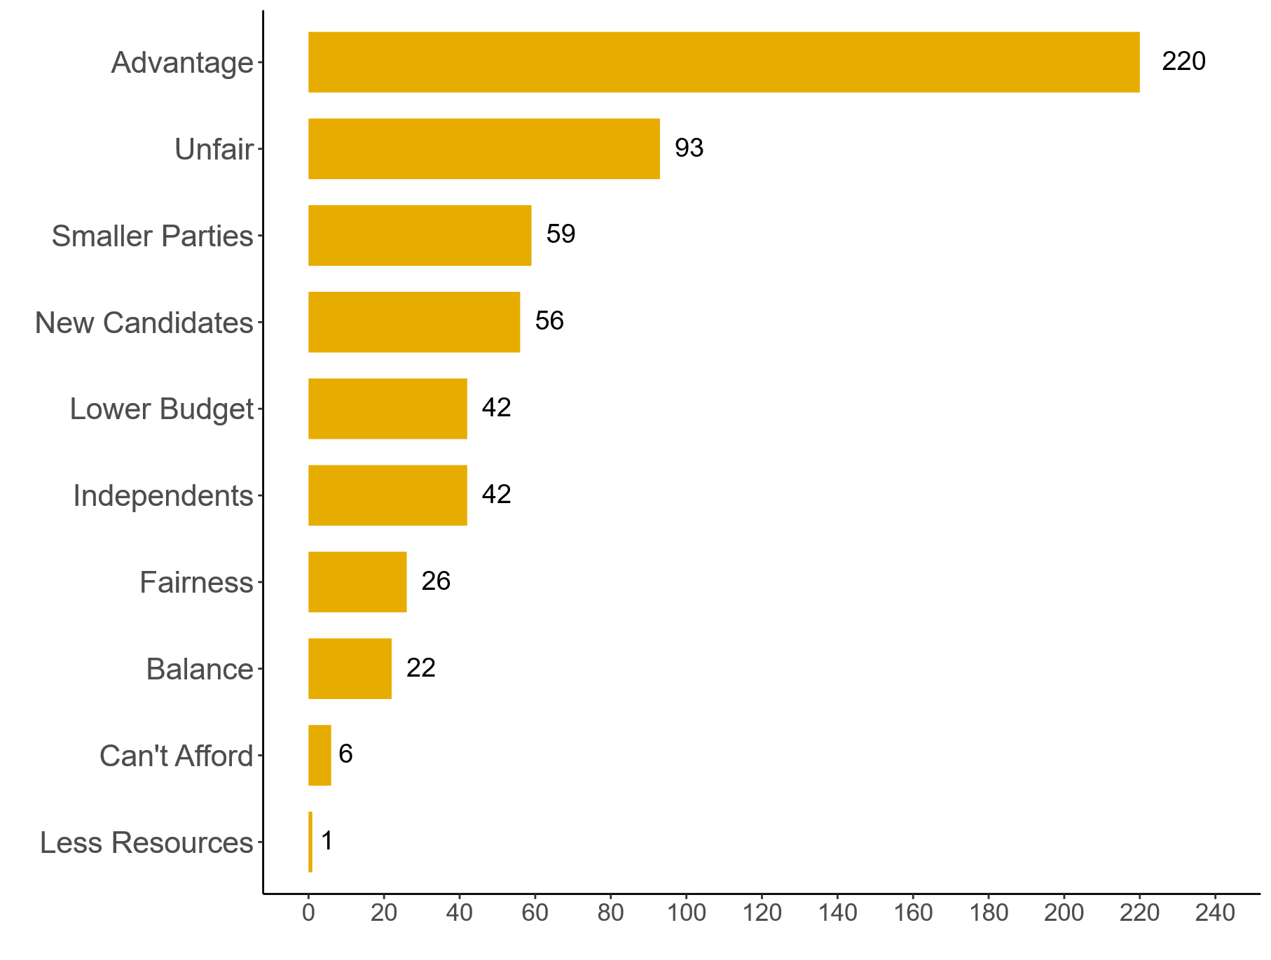
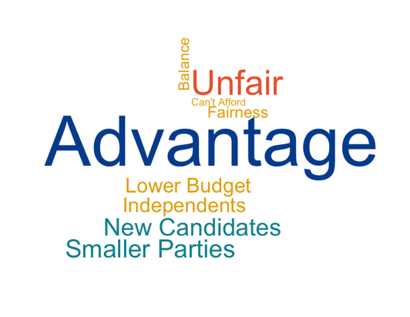

Some submissions presented the argument that posters are important to ensure fairness in elections, levelling the playing field for candidates with varying levels of resources to spend on their campaign. It was highlighted that a shift to alternative means of campaigning such as private advertising, TV and social media ads could isolate candidates with lower levels of resources and that posters are a relatively cheap method of campaigning.
Additionally, the importance of posters for newer candidates looking to break into politics was oft-cited submissions. A number of submissions felt that without posters to facilitate newer candidates gaining recognition, incumbent candidates and those with pre-established reputations would be at an unfair advantage.
“Our electoral system places high value on name/facial recognition and posters are one of the best ways of raising a candidates profile. Posters are the best way for new candidates to increase their profile before an election and without them the established candidates have an unfair advantage. posters are one of the great equalisers for candidates and parties.” (EP894)

“…Election posters have the effect of driving democratic engagement between elected representatives and the general public. They are inherently democratic, as any candidate can put up posters… incumbency is a huge factor in elections. Those who are already elected are more likely to hold onto their seats. Posters allow new candidates break through, which is healthy for Irish Democracy.” (EP153)

“Election posters help independents and smaller parties with limited finances get their image and message out to people…. If you ban posters the bigger parties will still be able to rent billboards for their campaigns. In a nearby town to where I live the centre of the town is poster free in agreement with the local tidy towns committee, but you still have billboards and shops rented by the big parties within the poster free area, which is an unfair advantage to those parties with most money.” (EP248)

However, there were contrasting views around whether posters do in fact create equal opportunities to all candidates. Several submissions addressed the fact that posters require resources that all candidates may not have at their disposal. The cost of producing and distributing posters was highlighted and it was suggested that those with access to more funds are better able to absorb the costs of paying for posters compared with those with smaller budgets. Independents may struggle with the cost of posters whereas candidates for large parties can better afford the cost through party funding. Some submissions stated this may create a sense of imbalance with wealthier candidates gaining more visibility than those with less funding available to them, which could result in the level of a candidate’s reach being dictated by their budget. Other respondents suggested that candidates with a disability may be at a further disadvantage, as they may face physical barriers related to putting up the posters.
“It provides an unfair advantage with to established parties and candidates with personal or family wealth. This disadvantages candidates with smaller resources in particular disabled candidates. Postering requires not only the materials for postering, but access to vans/cars, ladder etc. Postering is a very physical activity and candidates such as disabled people may not be able to do it or afford a team of people to do it and are less likely to be chosen as candidates by parties and thus less likely to have the resources of parties” (EP932)

“The ability to pay for and distribute posters heavily favours parties that have the financial resources to do so. It favours those who can get out first and place them in the most visible locations first.” (EP494)

“While they are meant to raise awareness, in reality they often create an unfair advantage for candidates with more money, as they can afford to put up far more posters than others. For example, during the last election in our town, some candidates had an overwhelming number of posters, while others had just one or two. This creates a sense of imbalance and inequality, where visibility is based on budget rather than merit or contribution to the community.” (EP985)

Tradition and Culture
A common theme that emerged throughout the consultation was the cultural impact of posters and their place within Irish electoral tradition. There were contrasting views on the place of posters in the political landscape in modern Ireland with some feeling that they are worth maintaining while others felt they are no longer necessary.

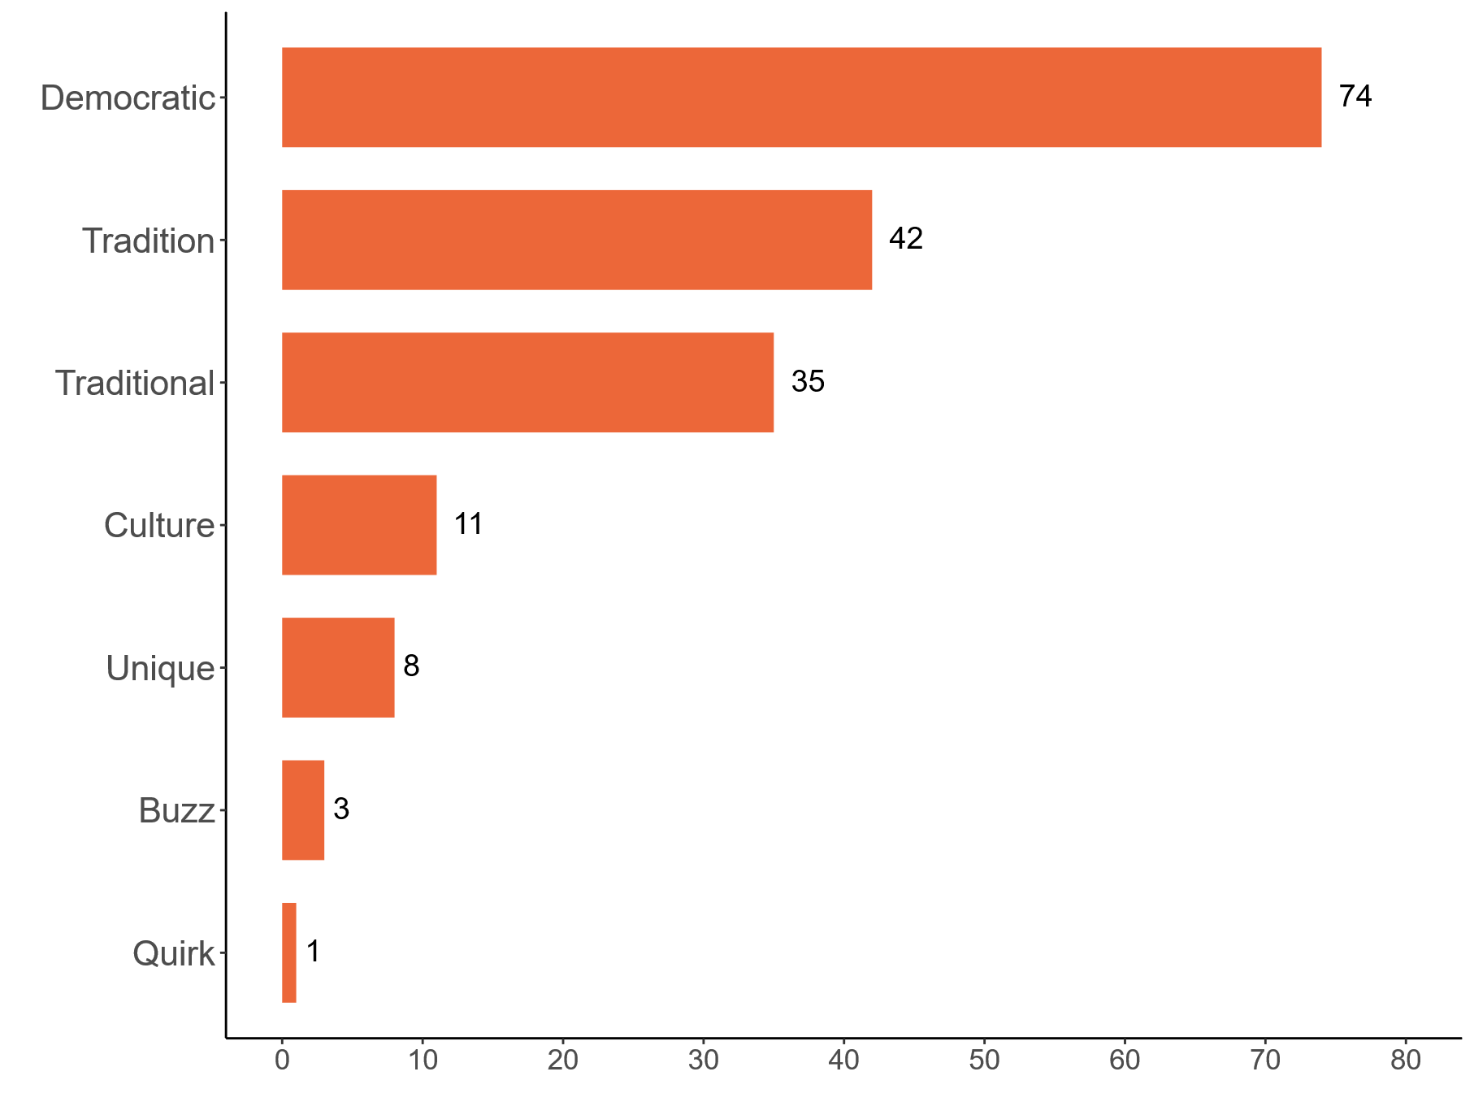
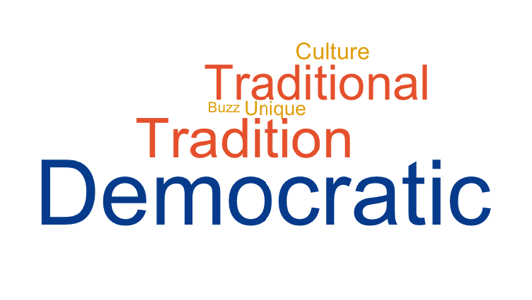

Some submissions highlighted that posters create an atmosphere around electoral events, claiming that the elimination of posters would be removing a core part of Ireland’s electoral culture.

“Posters add to the colour and let people know that there is an election on. In an era when many people do not get their news from national radio or television, or local/national newspapers, something is needed to make people aware that there is an election on. In 1982, the year of multiple general elections, I was a primary school pupil, and I remember the variety of cardboard posters listing candidates names that were found stapled together on every lamppost.” (EP880)

“It is a traditional form of campaigning and helps create a sense of energy and momentum around elections, reminding citizens that an election is approaching” (EP954)

While acknowledging the traditional nature of posters in elections in Ireland and the need for posters in the past, some respondents argued that tradition alone is not a valid reason to keep posters. These respondents believe that postering has become an outdated activity - a legacy from a time where information was not widely available - arguing that the wide availability of other information sources, such as digital platforms, diminishes the need for election posters, and that the disadvantages of poster use outweigh the advantages.
“Tradition is a poor excuse for lack of modernisation.” (EP542)

Recommendations for changes to rules and regulations around posters
The latter section of the public consultation document provided respondents with the opportunity to suggest changes to legislation and regulations around political postering. Submissions fell across a spectrum of degrees of change falling between a do-nothing scenario and an outright ban on posters. The graph below summarises the positions of submissions in this regard.
It should be noted in reviewing the totals below that a large number of respondents left this section blank .
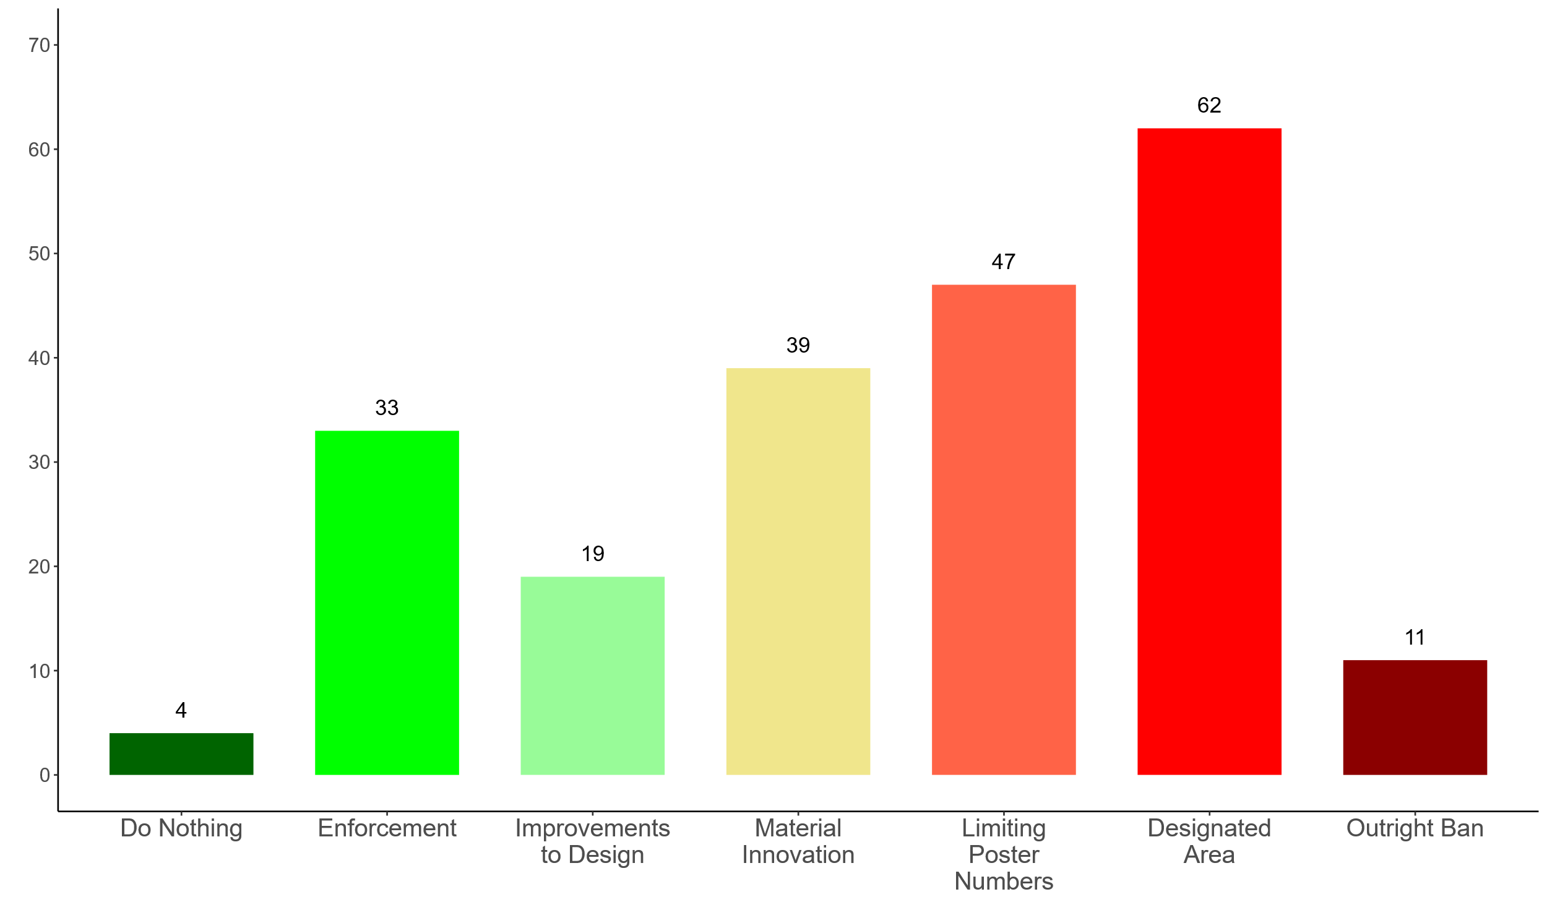

Do Nothing/Maintain the Current System
While the general sentiment around posters was negative, a number of submissions were content with the current system and advocated against any changes to the current regulations and culture around political postering.
“Election posters are an essential fabric of Ireland's democracy and should be interfered with by authorities to the least extent possible.” (EP013)

Enforcement
A number of submissions supported the current system of election postering in Ireland but advocated that the regulations should be enforced more consistently and fairly across all electoral areas. It was highlighted that there should be stronger mechanisms in place to report posters that are placed hazardously, outside of campaign timelines, or contain misinformation. Ensuring fines are dispensed, and potentially raising these fines, for those who leave posters and cable ties up after the election date was another recommendation provided for in submissions. Other commentators stated that there should be enforcement measures for posters that contain misinformation. Several respondents suggested that once regulations are strictly enforced, posters serve as a beneficial part of the electoral process.

“I'd like to see the fines for non-compliance with poster erection/taking down strictly enforced and the candidates' names published. I do hear occasionally news of one or two candidates getting punished but there are certainly more guilty than what is reported. Finally, something needs to be done about the cable ties used to erect the posters. The paths are either littered with the ties as the person taking them down just cuts the tie, takes the poster away and lets the tie fall to the ground. Alternatively, the poster is just pulled away and the tie remains on the pole. I would suggest different the use of different colour ties for each candidate or codes on the ties so the council can enforce fines etc. for candidates who leave the ties remaining after the poster is taken down.” (EP127)

“If properly controlled and rules enforced they are a good thing and part of our way of electioneering” (EP470)

“Fines for breaches of regulations should be significantly increased, in order to make non compliance financially prohibitive” (EP633)

Improvements to Poster Design
Many submissions referenced their lack of meaningful information about candidates as a disadvantage of posters. There were a number of recommendations made on potential avenues to improve the use of posters as a political communication tool. Some responses suggested that posters should contain a QR code, linked to information about the candidates’ priorities and policies. Others suggested there should be a mechanism in place for posters to be fact checked before they are permitted to be put up to ensure they are not spreading misinformation or harmful material.
“Require a QR code to be included with links to a campaign website for each candidate/party, making it easy to scan and find out full details. This would also mean less election literature needs to be printed and sent to homes” (EP66)

“I do wish there was more information on them about what people stood for, or how to find out that information at least.” (EP820)

Innovations in Materials and Circularity of Posters
A key concern voiced by many respondents was the adverse environmental impact of posters. Some participants identified potential approaches to negate harmful environmental impacts. Encouraging and facilitating the recycling of posters was often cited as a way to lower waste, while promoting the use of more sustainable materials was also highlighted as a mechanism to lessen the impact of posters on the climate. In addition, several submissions were supportive of posters being numbered or scanned and tracked, to ensure all posters are accounted for post-election, preventing litter and ensuring posters and cable ties are recycled properly.
“If posters are still allowed, enforce the use of biodegradable or recyclable materials and water-based inks to reduce environmental damage.” (EP978)

A number of submissions also called for more structural change to the postering landscape such as enacting limits on the number of posters permitted and the areas in which they can be placed.

Limiting Poster Numbers
In line with criticism around posters as unesthetic and hazardous, a number of submissions suggested that limits be set out in legislation/regulations around the volume of posters candidates can erect over the course of an election campaign. There was no consensus across submissions as to how these limits should be calculated and enforced, some suggested a blanket maximum number for each candidate while others suggested limits would be unique for each electoral area and dependent on election type. Some other submissions suggested the calculation of caps by population while others by land area.
“Unfortunately, posters are required and are an important part of any election campaign, particularly for new candidates. New candidates find it harder to get their name out there and let people know that they are running. That said, there should be significantly reduced number of postering allowed. There should be a maximum per candidate.” (EP790)

“I think the number of posters erected should be limited to so many per head of population in an electoral area. While I don't know the current number, I would suggest 25 posters for every 1000 people in the electoral area.” (EP007)

Designated Area
Other submissions called for restrictions around the locations where posters are allowed to be placed. Putting in place a designated area in which posters could be displayed was a commonly cited recommendation. Several submissions highlighted that this was a system employed in several countries in Europe and internationally. There were a range of ideas as to how these designated areas would look in practice.
Suggestions included the use of poster boards, which would be placed in central locations with high footfall such as public transport hubs and community centres to maximise reach. Each candidate would be allowed to place one poster of a set size, ensuring equal visibility and fair communication for every candidate.
Other suggestions ranged from the local councils regulating where posters can be placed, ensuring historic sites and residential areas are kept poster free; to restricting posters in public places and encouraging posters be placed on private property.

“We should move to a more French style of public advertising, where designated posting areas at train-stations and other public areas are set-up with each party/candidate being given an equal amount of advertising space.” (EP006)

“Yes, there should be designated poster boards. These would be in central locations near public transport, churches, community centres, shopping centres and other locations as set by a local authority. These boards would allow A4 posters for each candidate in the area, which would ensure that electors are informed in multiple locations.” (EP419)

“Ireland has the opportunity to modernise its election campaigning practices by learning from other European countries. Germany allows election posters but limits their use to specific timeframes and designated areas. Local councils often regulate where posters may be placed, avoiding sensitive zones such as historic sites or residential areas. (EP776)

Outright Ban
Finally, a number of submissions advocated for an outright ban. Many submissions felt that alternatives, particularly digital media, are a sufficient replacement and saw posters as no longer essential to inform the population of an election. Other respondents in favour of an outright ban on posters suggested a single booklet providing information about all candidates could be produced for each constituency and delivered to every house. Many of these submissions cited that any benefits of election posters were not sufficient to warrant the environmental impact and waste of posters.
However, some submissions directly opposed these views expressing that the environmental cost of postering was a cost worth paying to ensure that election information was available.

Conclusion
An Coimisiún Toghcháin welcomes the large number of submissions received to this consultation process as a positive indication of interest in its research work. These submissions have been provided to the independent researchers engaged to conduct this research project on postering. Their research report is being published today alongside An Coimisiún’s recommendations on the matter.
An Coimisiún would like to thank all those who participated in the public consultation process.

Appendix 1: Detailed Breakdown of Individual Submissions
The public consultation on political postering received 1104 submissions. These submissions consisted of both individual submissions from the public and submissions from a range of organisations. The public consultation form asked respondents, providing an individual submission, a number of demographic questions including their age cohort, gender, county of residence and whether they lived in an urban or rural area. The following paragraphs present the breakdown of individual submissions by these demographic characteristics.

Age Group
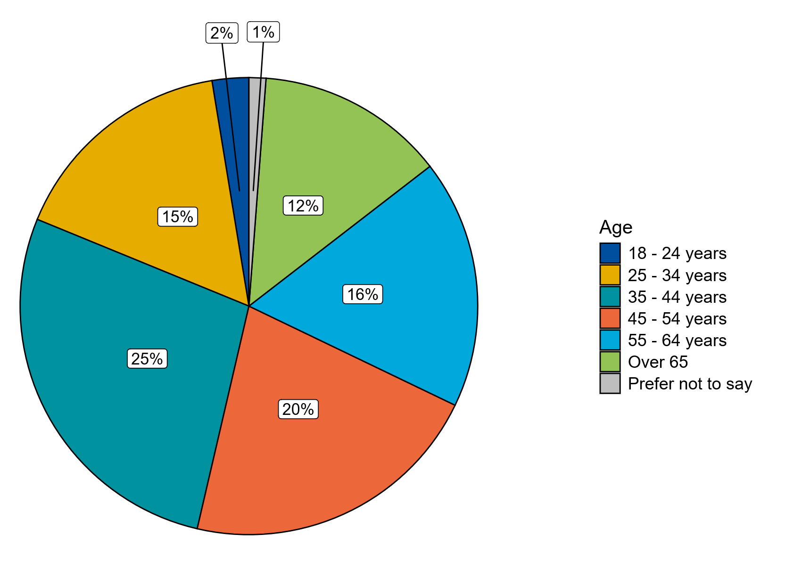

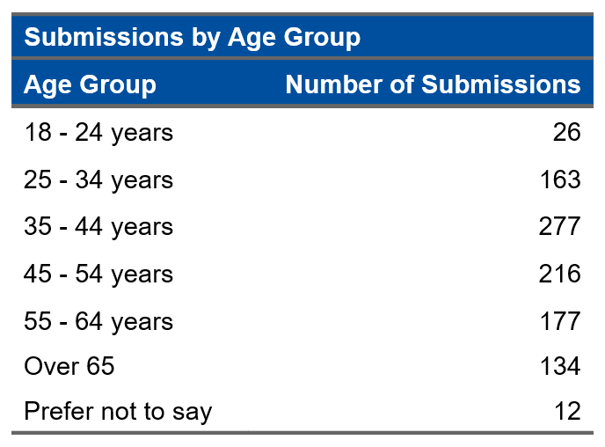

All voting age cohorts were represented through the submissions to the public consultation. The largest percentage of submission were received from the 35–44-year-old age cohort at 25% of the total submissions. The lowest level of submissions was received from the 18–24-year-old cohort with this group accounting for only 2% of total submissions received.

Gender
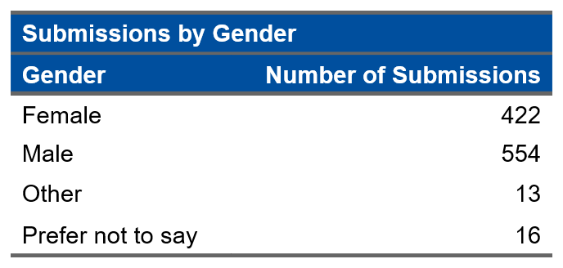
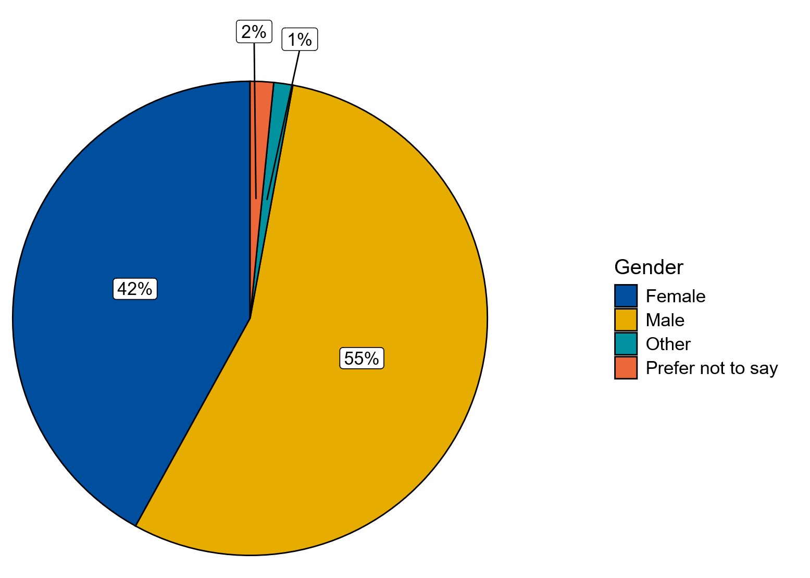

There was a relatively even gender spread across the public consultation submissions with 55% of submissions from Males, 42% from Female, 1% who identified as Other and 2% who opted for the prefer not to say option.

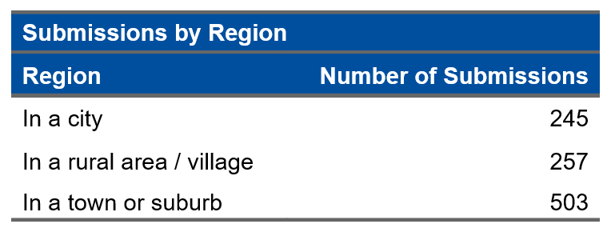
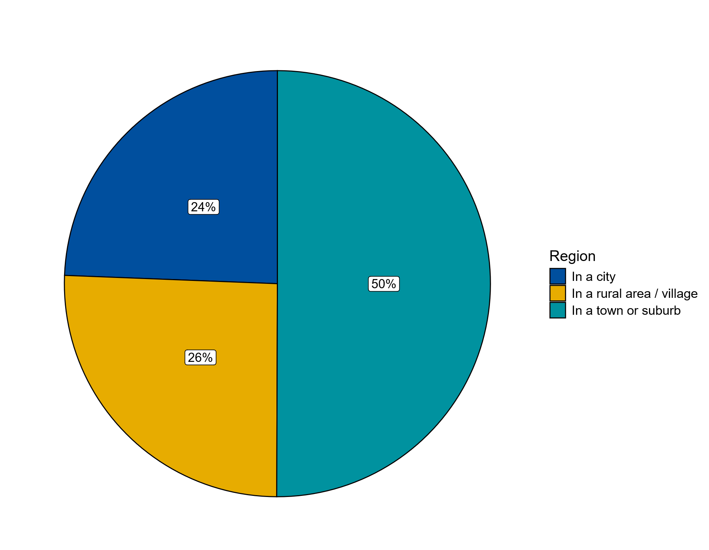
Region of Submission

Half of the submissions received were from respondents residing in a town or a suburb, 26% of respondents were residing in a rural area or village and 24% of respondents were residing in a city.

County of Residence
The public consultation received at least one submission from every county and several submissions from outside Ireland. The full breakdown of submissions by county can be found in Appendix 2, with the percentage breakdown of counties presented in the map below.
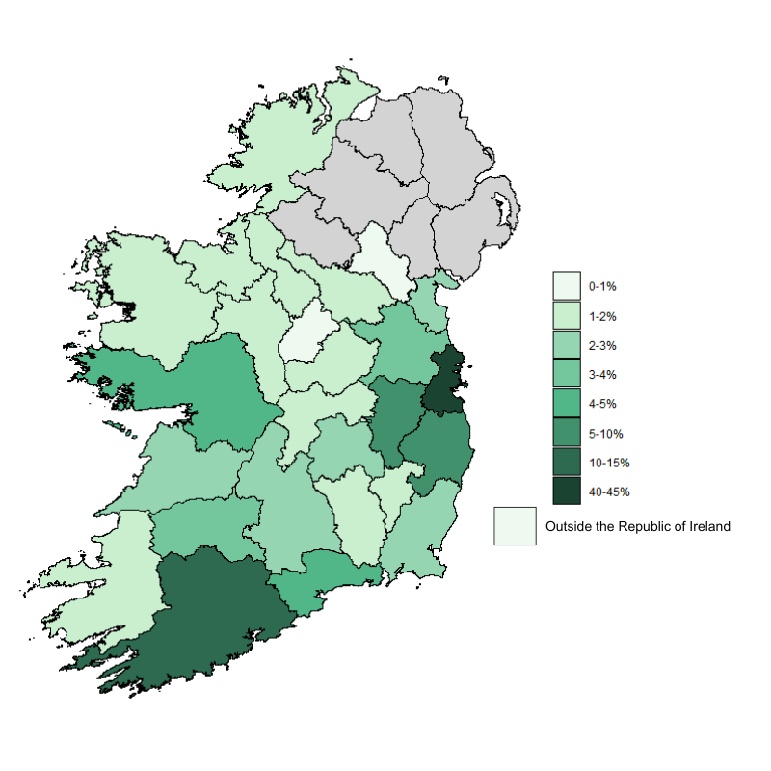
The largest percentage of submissions were received from Dublin (41%) followed by Cork (11%), Kildare (7%) and Wicklow (6%). The counties with the lowest levels of submissions to the public consultation were Monaghan and Longford with only 2 submissions from each.

Appendix 2: Public Consultation Paper

CONSULTATION PAPER
ELECTORAL POSTERING
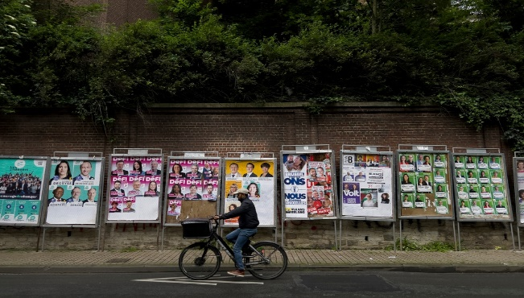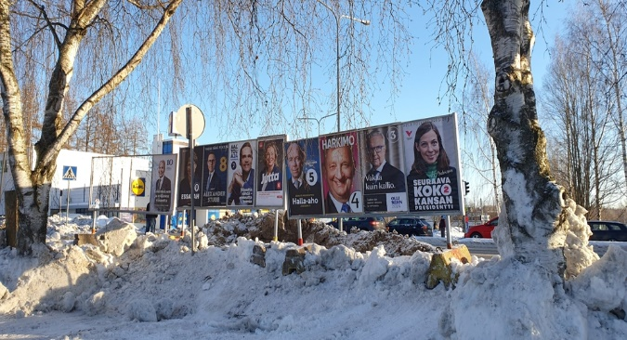

Introduction
An Coimisiún Toghcháin (An Coimisiún), Ireland’s independent electoral commission, was established on 9 February 2023. An Coimisiún’s powers are set out in the Electoral Reform Act 2022 and include conducting or commissioning electoral research. An Coimisiún may also make recommendations based on this research to the Minister and Government.
An Coimisiún ran a public consultation on its draft Research Programme in November 2023. Informed by the submissions received, An Coimisiún published its first Research Programme 2024-2026 in July 2024. This identifies several research topics for An Coimisiún for the period to 2026 including the use of election posters.
An Coimisiún is now beginning this research on posters supported by an external research team. It will look at the rules and practices around postering in other countries while taking account of Ireland’s particular electoral and democratic system. It will examine the existing rules in Ireland and how they work as well as the evidence regarding posters, their objectives and any advantages and disadvantages of their use.
Posters affect everyone living in Ireland as they are widely displayed throughout the country during electoral periods. The views of stakeholders and the public will therefore be an important factor as we consider the future of election postering in Ireland.

Public Consultation
We would welcome your views on the following questions, drawing on your own knowledge and experience. Feel free to answer some or all of the questions below:

- Do you see positive aspects/advantages to election posters? If yes, please explain.

- Do you see negatives aspects/disadvantages to election posters? If yes, please explain.

- Do you think Ireland’s rules and approach to election posters should change? If yes, please explain the changes you’d like to see and the reasons for this.

- Is there anything else you would like to say about the use of election posters in Ireland?

Responses should be through our dedicated consultation page available at (update ORL) www.electoralcommission.ie. You can also respond by email to research@electoralcommission.ie with ‘Electoral Postering Consultation’ in the subject line by 5pm on Friday 9 May 2025

Responses may also be sent by post and addressed to Research Unit, An Coimisiún Toghcháin, Block M, Dublin Castle, Dublin 2, D02 X8X8.

Respondents are advised that An Coimisiún is subject to the Freedom of Information Act 2014, the European Communities (Access to Information on the Environment) Regulations 2007-2014 and Data Protection legislation. It is intended that all submissions received will be published on our website following the publication of the final research report and thus may be liable to be disclosed.

Background

Legislation
The rules around the display of election posters in Ireland including timing, placement, and certain required content are set out in primary legislation.
Under Section 19 of the Litter Pollution Act 1997, as amended, election posters may only be erected after the official polling date is set and for a maximum of thirty days before the election. In the case of referendums, posters may not be erected before the official polling date is set. Posters must be removed within seven days following polling day. The responsibility for enforcement of litter law lies with the local authority. Any election/referendum posters in place before or after the stipulated timeframe are deemed to be in breach of the legislation with non-compliance subject to a fine of €150.
Local authorities are also responsible for the removal of posters which constitute a hazard to either pedestrians or road users.
Posters may not be placed within fifty metres of a polling station on election / referendum day as per section 147 of the Electoral Act 1992, as amended, with violations carrying penalties including imprisonment of up to two years.
However, in conducting its Post Electoral Event Reviews (PEERs) for the elections in 2024 An Coimisiún has noted a lack of clarity in relation to the enforcement of these rules.

Context of Project
For many years, the use of posters during Irish election and referendum campaigns has been the topic of considerable discussion and debate among experts, stakeholders, the media and the wider public. This topic was also raised in several submissions received by An Coimisiún during its public research consultation.
The use of election posters in Ireland is highly personalised. These characteristics reflect the distinctive candidate-centric qualities of Ireland’s political landscape, which are connected with Ireland’s proportional representation electoral system
(PRSTV) and its political culture. The Seanad debate on the Regulation of Display of Electoral and Polling Posters and Other Advertisements Bill 2022 gives an overview of recent discussion in this area including potential political, economic, social, cultural and environmental ramifications.
In certain ways Ireland is an outlier regarding its use of posters, with more permissive regulations than many other countries in terms of the placement, dimensions, and general usage of posters. Some organisations and members of the public have called for the use of posters to be restricted or banned entirely due to potential environmental impacts, visual pollution, safety concerns for the public, and fears that posters may disadvantage candidates who do not have access to significant funding to pay for posters. Several communities in Ireland have already requested that candidates refrain from erecting posters, or that they restrict their usage to designated areas.
However, from an electoral perspective the presence of posters helps raise awareness that a vote is about to take place and provides visual cues of who voters will see on the ballot paper. Ireland’s political system is significantly candidate-based. Postering has long been a key medium for political and electoral communication and can be seen as a visual manifestation of the close relationship between candidates and their constituencies.
To these ends, concerns have been raised that excessive regulation of posters could reduce awareness of and information about elections. Some commentators suggest that a more restrictive approach could even potentially deprive cohorts of the population that find it more difficult to engage with the political process of a valuable source of information, potentially exacerbating issues of marginalisation and inaccessibility.
Reflecting the input received on this topic during the research programme consultation process the following are particular areas of interest of the research:

- the role of posters as a political communication tool in election campaigns in Ireland and elsewhere compared to other methods of political communication, both traditional and online;
- how and whether posters impact political engagement and electoral awareness among the electorate, including amongst people who may be marginalised from the political process; and
- the environmental impacts of posters.
In thinking about these questions your views are very important to us, and we would encourage you to participate and tell us what you think.
Remember the closing date for submissions is Friday 9 May at 5pm

Appendix 3: List of Organisations
Organisation | Category
Abbeyleix Tidy Towns | Tidy Towns Group/Residence Association
Annagassan Tidy Towns | Tidy Towns Group/Residence Association
Ardee Tidy Towns | Tidy Towns Group/Residence Association
Baldoyle Tidy Towns | Tidy Towns Group/Residence Association
Bray Tidy Towns Association | Tidy Towns Group/Residence Association
Castlebar Tidy Towns | Tidy Towns Group/Residence Association
CASTLEBELLINGHAM TIDY TOWNS | Tidy Towns Group/Residence Association
Castleknock Tidy Towns | Tidy Towns Group/Residence Association
Castlepollard Tidy Towns | Tidy Towns Group/Residence Association
Cherrywood Tidy Town | Tidy Towns Group/Residence Association
Clare County Council | City/County Council
Clashmore and Kinsalebeg Community Council | Tidy Towns Group/Residence Association
Clashmore Tidy Towns | Tidy Towns Group/Residence Association
Clonsilla Tidy Towns | Tidy Towns Group/Residence Association
Clontarf Residents Association | Tidy Towns Group/Residence Association
Cobh TidyTowns | Tidy Towns Group/Residence Association
Collon Tidy Towns | Tidy Towns Group/Residence Association
Corofin Tidy Towns | Tidy Towns Group/Residence Association
DAlC, Mountjoy Square, Dublin 1 | Education/Advocacy Group
Down Syndrome Ireland | Disability Organisation
Dromiskin Tidy Towns | Tidy Towns Group/Residence Association
Fianna Fáil | Political Party
Fine Gael | Political Party
Green Party | Political Party
Green Party Fingal Constituency Branch | Political Party Constituency Branch
Irish Non-Neurotypical Disabled Persons Organisation | Disability Organisation
Julianstown & District Community Association | Tidy Towns Group/Residence Association
Killasmeestia Tidy Town Group | Tidy Towns Group/Residence Association
Killenard Tidy Towns | Tidy Towns Group/Residence Association
Kinvara Tidy Towns | Tidy Towns Group/Residence Association
Knockbridge Tidy Towns/Stephenstown Pond Trust LTD | Tidy Towns Group/Residence Association
Labour Kildare North | Political Party Constituency Branch
Loughrea Tidy Towns | Tidy Towns Group/Residence Association
Louth Tidy Towns Together | Tidy Towns Group/Residence Association
Louth village tidy towns | Tidy Towns Group/Residence Association
Lower Glanmire Road Residents Association | Tidy Towns Group/Residence Association
Milltownpass TidyTowns | Tidy Towns Group/Residence Association
National Adult Literacy Agency (NALA) | Education/Advocacy Group
National Disability Authority (NDA) | Statutory Body
Omeath Tidy Towns | Tidy Towns Group/Residence Association
People Before Profit | Political Party
Pike of Rushall tidy towns | Tidy Towns Group/Residence Association
Portarlington Tidy Towns | Tidy Towns Group/Residence Association
Roscommon Tidy Towns Association | Tidy Towns Group/Residence Association
See Her Elected | Election Engagement Group
Smartvote.ie | Election Engagement Group
Social Democrats | Political Party
Solidarity | Political Party
South Dublin County Council | City/County Council
Stabannon Tidy Towns | Tidy Towns Group/Residence Association
Strokestown Tidy Town Group | Tidy Towns Group/Residence Association
Strokestown Tidy Towns Group | Tidy Towns Group/Residence Association
The Labour Party | Political Party
Tidy Towns | Tidy Towns Group/Residence Association
Tipperary TIdy Towns | Tidy Towns Group/Residence Association
Vision Ireland | Disability Organisation
Voice of Vision Impairment (VVI) | Disability Organisation
Westport Tidy Towns | Tidy Towns Group/Residence Association

Appendix 4: Words Searched in Thematic Analysis
Theme | Words Searched
Environmental Impact | "Litter”, “Waste”, “Plastic”, “Pollution”, “Bad for Environment”, “Environmental Impact”, “Climate Change”, “Wasteful”, “Cable ties”, “Materials”, “Sustainable Materials”, “Recycling”, “Recycle”, “Reuse”
Poster Placement: Hazard | “Hazard”, “Hazardous”, “Danger”, “Dangerous”, “Distraction”, “Road Safety”, “Driver”, “Injury”, “Injury”
Poster Placement: Aesthetic | “Eyesore”, “Blight”, “Litter”, “Ugly”, “Unsightly”, “Clutter”, “Every Lamppost”, “Destroy”, “Unnecessary”, “Amount”, “Volume"
Information Tool | “Information”, “Communication”, “Candidates”, “Running”, “Awareness”, “Election is Happening”, “Advertising”, “Visibility"
Regulation and Enforcement | “Regulation”, “Enforcement”, “Removed”, “Not removed”, “Designated Area”, “Not enforced”, “posters left up”, “lack of enforcement”, “Break Rules”, “Fines”, “Punishment"
Alternatives to Postering | “Alternative”, “social media”, “online”, “tv”, “radio”, “newspaper”, “leaflets”, “digital”, “unbiased”, “biased”, “misinformation”, “canvassing”, “face to face"
Fairness | “Unfair”, “Fairness”, “Balance”, “Advantage”, “New Candidates”, “Smaller Parties”, “Independents”, “Less Resources”, “Lower Budget”, “Can’t Afford”
Culture/Tradition | “Democratic”, “Tradition”, Traditional”, “Culture”, “Buzz”, “Quirk”, “Unique”

Appendix 5: Words Searched in Regulation Recommendations Analysis
Regulation Change | Words Searched
Do Nothing | “Do Nothing”, “Keep as Is”, “Not interfere”
Enforcement | “Rules enforce”, “Fines”, Punishment”
Improvement to Poster Design | “Improve Design”, “Accessible”, “Meaningful”, “Policy”, “Accurate”
Material Innovation and Circularity | “Sustainable Materials”, “Recycling”, “Recycle”, “Biodegradable”
Limiting Poster Numbers | “Reduced Number”, “Limit”, “Cap”
Designated Areas | “Designated Area”, “Central locations”
Outright Ban | “Outright Ban”



These submissions represented 57 different groups with one group (Strokestown Tidy Towns Association) providing dual submissions.
Group 1: Over 1000 mentions, Group 2: 500-1000 mentions, Group 3: 500-250 mentions, Group 4: 250-96 mentions
Words searched for within each theme analysed are presented in a table in Appendix 4
Respondents who explicitly declared their role through their name within their submissions.
Words searched for within each recommendation are presented in a table in Appendix 5
Regulation of Display of Electoral and Polling Posters and Other Advertisements Bill 2022: First Stage – Seanad Éireann (26th Seanad) – Wednesday, 11 May 2022 – Houses of the Oireachtas

