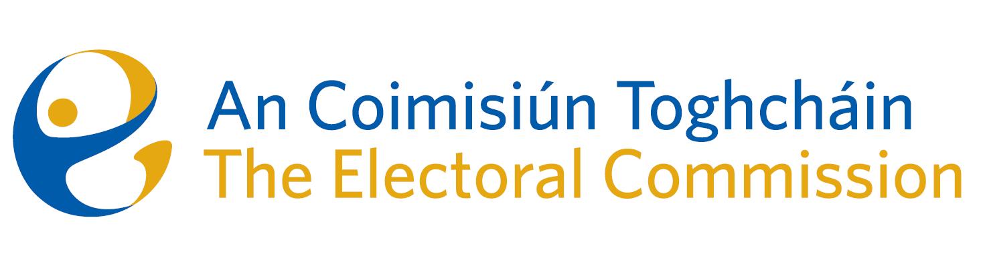
Minutes

Meeting of An Coimisiún Toghcháin

8.00am – 10:00am | 12 February 2026 | Dublin Castle

Attendance
An Coimisiún:
The Honourable Ms. Justice Marie Baker (Chairperson), John Curran (JC), Ger Deering (GD), Elaine Gunn (EG) and Maura Quinn (attended remotely).

Invited Guests
Prof Caroline Fennell (CF), Alex Attwood (AA),

Executive:
Art O’Leary (AOL), Diane Duggan (DD), Seán Garvey (SG), Karen Kehily (KK), Kieran Lenihan, Dr Mary-Clare O’Sullivan (MCOS), Muireann Ní Thuairisg, (Secretariat), Sarah Keaveney- Operations and Education
------------------------------------

The Chairperson welcomed EG to the meeting, following her appointment as Clerk of Dáil Éireann and Secretary General of the Houses of the Oireachtas Service.

  - Draft Minutes

The draft minutes of the meeting held on 11 December 2025 were approved.

  - Conflict of Interest

There were no conflicts of interest.

2. Political Finance

Members discussed an updated paper on political finance circulated in advance of the meeting, ‘Review of political financing regime in Ireland’. The paper outlines the culmination of review to date, the fundamentals to be considered and the legal principles and draft recommendations.

It was agreed to undertake a more detailed breakdown of the paper’s recommendations and to set out what a public consultation with stakeholders would entail, for discussion at the meeting on 19 March 2026.

3. Transparency and Targeting of Political Advertising (TTPA) Update

Members discussed the latest updates on Transparency and Targeting of Political Advertising.
As the Competent Authority and National Contact Point for the implementation of certain aspects of the TTPA Regulation in Ireland, it was agreed to convene four Information Sessions in collaboration with Coimisiún na Meán and the Data Protection Commission.

The Code of Practice for Political Advertisers and FAQ’s will be published in due course on the website.

4. Education Strategy update

Members received a briefing on the Education Working Groups.

The Formal Education Working Group met four times to review 237 public submissions on voter education. Membership included teachers, the Department of Education, ISSU, academics, the NCCA, an Oireachtas Education Officer, and an expert from the Canadian Electoral Commission. Key themes identified were improving voter education delivery, enhancing understanding of the electoral system, tackling apathy and mis/disinformation, engaging under-represented groups, encouraging politician–public engagement, considering voting incentives, and centralising voter information. The Group recommended developing new resources, providing teacher training, strengthening Student Councils, increasing political engagement initiatives, enhancing CSPE/Politics & Society supports, improving media literacy, and promoting voter registration and turnout.

The Adult and Community Education Working Group met twice and considered 17 public submissions. Membership included representatives from adult education practice, ETBI, NALA, AONTAS, the Women’s Collective, and an international expert from The Democracy Box. Consultation themes highlighted the need for inclusive civic education, digital voting and modernisation, community outreach, support for marginalised groups, strengthened trust and digital literacy, and broader electoral reform. The Group recommended increased funding, engagement through existing community structures, resource development, continued tutor and teacher training, a sustained focus on democratic education, and undertaking a literacy audit.

5. (a) Research update and Call for Submission of Proposals
An Coimisiún were provided with an update on the Research Programme and a draft Call for Submission of Proposals, entitled ‘Research to support Elections and Democracy in a Changing World’.

6. Financial Position, yearend 2025.

An Coimisiún noted the overview of the financial 2025 end of year position.

- Any Other Business

It is understood that an invitation from the OSCE to participate in an election observation mission in Hungary is forthcoming. Once this is confirmed, details will be circulated, and interested members may indicate their availability to participate alongside a member of the Senior Team.

_________________
Ms. Justice Marie Baker
Chairperson

